**Jenkins:**

**Pre Requisites:**

Any one of SCM / VCS

Any one of the build tool: Any, Maven, Shell or Batch

**CI:**

**Continuous Integration** (CI) is a development practice that requires developers to **integrate** code into a shared repository several times a day. Each check-in is then verified by an automated build, allowing teams to detect problems early.

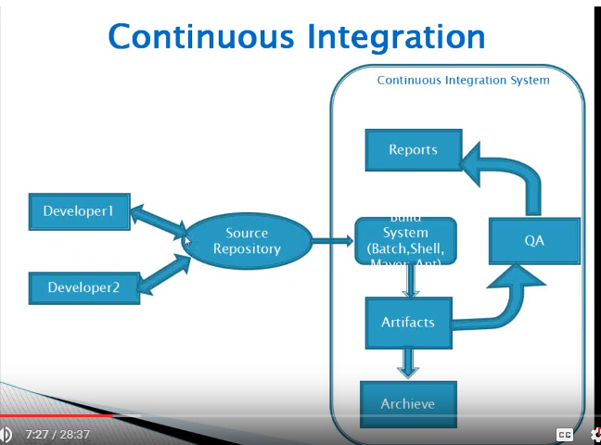

**Jenkins Installation:**

Download the latest version of the Jenkins war file from <https://jenkins.io/index.html>

**Standalone installation:**

You should install Java before install Jenkins

Go to Jenkins war download folder and give the below command

**Java –jar Jenkins.war**

This will run on the default port 8080. Once installation is complete you can check

<http://Ipaddress:8080>

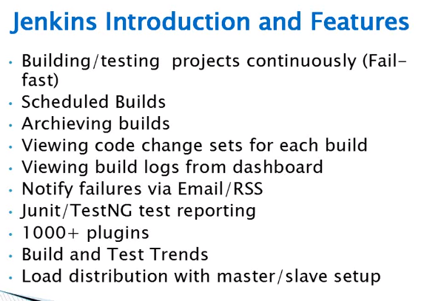

**Configuring Jenkins:**

System

User authentication

Plugins

Managing nodes

**Job Types:**

Freestyle projects/ Job (Ant build)

Maven projects

Monitor external jobs

Build multi configuration projects

**Managing Builds:**

Running builds

Viewing changes

Download Artifacts (Artifact is a output of your build)

Build / Test Trends

Tagging builds

**Creating Job in Jenkins:**

Click New Item

Fill Job name in Item Name and Select what kind of project. (Freestyle project for Ant) and press OK

(Mandatory things are what is the build tool using and what is SCM used)

Select your SCM tool and enter the URL and enter the credential for SCM to access the files.

Check Out Strategy: Use SVN update as much as possible

Build:Invoke Ant (Depends open the build tool)

Target: Windows

Build File: build.xml

**Post Build Action:**

Archive the artifacts

File to archive: target\connectfour.jar

Press save button.

**Build Now:**

We have created job and now we are going to build by clicking build now option in left side panel.

We can see the build status by clicking the build number.

**Post Build Action:**

We can test our build by selecting Publish Junit test report.

Test report XML: target/target-results\*.xml

And build again to test your build.

The Jenkin status always showing the latest build actions.

**Trigger Build:**

We can trigger a build after a build in this case the first build is the upstream project build from second one.

Build periodically: we can schedule a build at certain time.

Poll SCM: It will schedule the SCM for update is any update find the build will perform.

**Email server configuration in Jenkins:**

Jenkins -> Configuration -> Email server

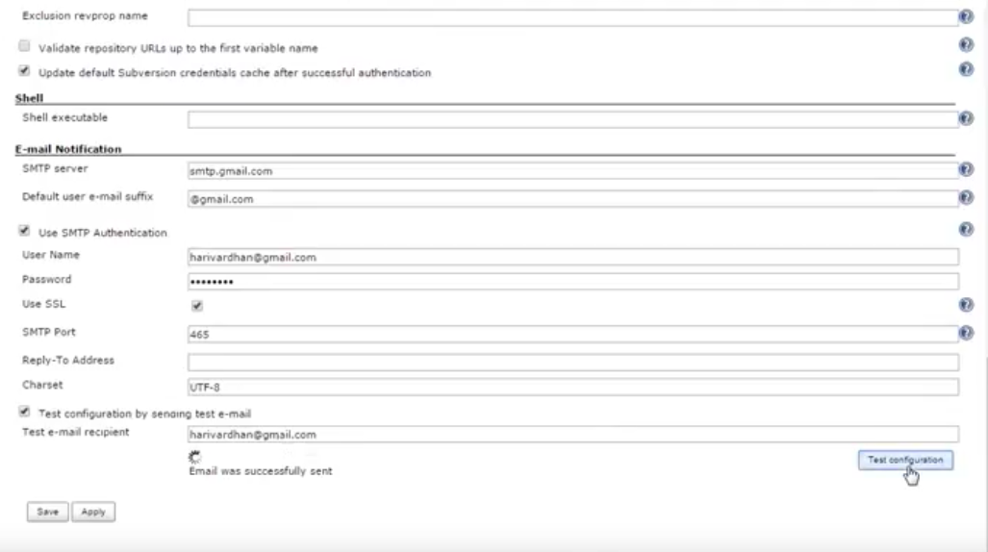

We can send an email in post build action -> send email notification.

We can enable figure printed also. – It is used to identify the .jar files build.

We can delete old builds as well.

Keep this build forever for the release build.

Tag the successful build for next release or bug fixing or future enhancement.

**Jenkins -> Manage Jenkins:**

Configure system:

Configure environment variable for deferent application such as Ant. JDK, Maven, Etc…,

Email notification:

We can set an email notification in this part.

**Configure Global Security:**

Enable security and use Jenkins own database for small organization. And check allow user to sign up for first time so that only we can create a user account.

Logout and login again.

Jenkins->Manage Jenkins -> User manage (To create new user account)

We can change the permissions under Configure Global Security -> Matrix based security and project based security.

And we can override the permission under Projects -> Configuration

**Reload Configuration from Disk:**

We can make the changes in Jenkins conf file under Jenkins home folder the we should reload the configuration from disk will sync those changes with Jenkins without restart.

**Manage Plugins:**

We can download the plugins from available plugins

Manual plugins are added in Advanced plugins

**Master Slave Configuration:**

Jenkins -> Manage Jenkins -> Manage nodes

Click New node and give name and select dumb slave and press OK.

Give remote PS root: D:/directory/Slave1

Lable: Lable1

Usage: Use this node as much as possible.

Launch method: SSH or Web start in Advanced option we can give the IP address of the machine.

If it is SSH we should select any one credential.

In Advanced option you should give Tunnel connection option.

Tunnel connection option=ipaddress:port

Port number we can find from Jenkins -> Configuration -> Syatemlogs

And this port number is keep on changing so fix this, Open **Global security and give fix port**

If you need set environment variable otherwise press save.

And press launch to start slave. Save that java file and run the java file to start slave.

**Assigning jobs to Slave:**

Open project configuration and

Select restrict where the project can be done.

Label Expression: Slave node name

**Script Console:**

Write a groovy script to view the Jenkins reports. Build reports Slave reports and all

**Jenkins cli:**

To run Jenkins in cmd prompt and linux.