Kindly follow the below process to standardize your GitLab work process.

Purpose of this document, Developer need to push their codes into GitLab for each and every change instead of saving it in local system. Try to create different branch or tag to do modifications or bug fixing in existing codes.

After changes done create merge request to merge your changes to master branch with new tag (Version) name.

1. Create git repository using “git init” in your workspace.
2. Set git configuration.

$ git config --global user.name "raja.radha"

$ git config --global user.email [raja.radha@bcause.in](mailto:raja.radha@bcause.in)

1. Add your GilLab remote repository

git remote add origin http://bcause-gitlab.openshift.loc/raja.radha/test.git

1. Add all the files in git repository using “git add .” command
2. Commit your codes into git repository “git commit -m “commit message” -s”
3. push your codes into GitLab “git push origin master”

**Note: Create tag for your initial push and update your tags for each and every enhancement.**

**Follow the below process to create tag:**

**Create milestone:**

Create milestone (target date) to achieve or enhance your existing code.

**Create issue:**

Title: purpose of your enhancement.

Description: Describe your enhancement or modification.

Assignee: assign this issue to concern person.

Milestone: select your mailstone

Labels: Select your label. It may be Development, testing, staging or you can create your custom lable.

Submit issue.

**Create tag for new update:**

$ git tag -a v1.4 -m "my version 1.4"

Update or do modification in your code and push into v1.4 tag

Git push origin –tags “or” git push origin v1.4

You can create tag for your existing commits using below command:

$ git log --pretty=oneline

b26be047772a4e2b5b08123cc0f6dbcd15dad022 uid changed

e3a1fe909f76d01ccc1a2f5fe2dcf9d994fa231a Volume updated

c1ddcb4d8955c97646ed5779c5ab3a8ce42dcf1a Volume added

f5662808327ac8efce0f487b87d41f2669e6fc11 Disabled all copy commands

993e89c905f7e0979b70745f9e318c08c19d1506 Copy files are mentioned

310774d634761253d500446518ea302eeeffdc92 Copying homeagent files

3bdf950659a04c9fef1e05e888bb52e7e3ba5ece Update copy in Dockerfile

a235fa5b6f35ad83a182552ee0d8adb373b07ffa Update Dockerfile

b08e4ccc27915c28996b62de9e00caa866180ee1 port changed to 8080

79112b95676f7ab12aec06a5b5ef0313983b8ef4 Update Dockerfile

94a7f7d93fe127e8445fdc86109ffb89ae6ac795 Delete README.txt

6039916a81447510ccebf3fd54107608f475bec6 Inital docker file with home agent with README file

34c999d095c7a1b349c600121b578e26a5b24aca Inital docker file with home agent

3f0635f7aeaa51949d1c35969d282831735b2c7e Inital commit

Git tag -a v1.1 b26be04 -m ”Tag information”

GUI mode to create tag:

1. Select your project
2. Select repository

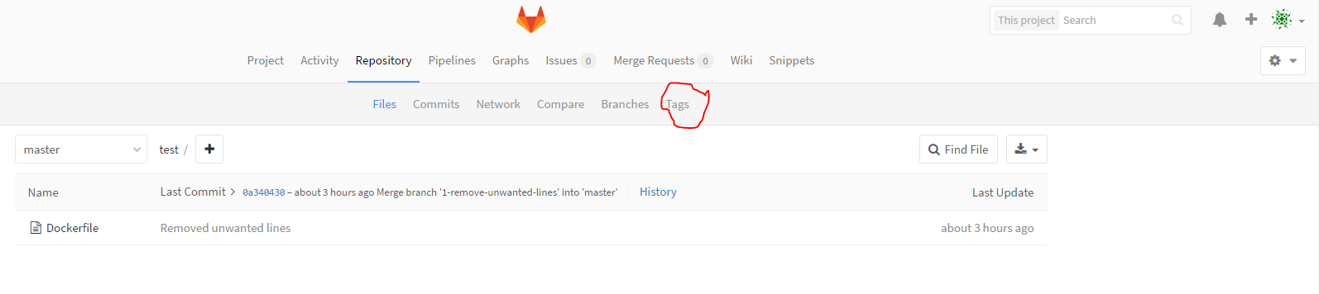

1. Select tag

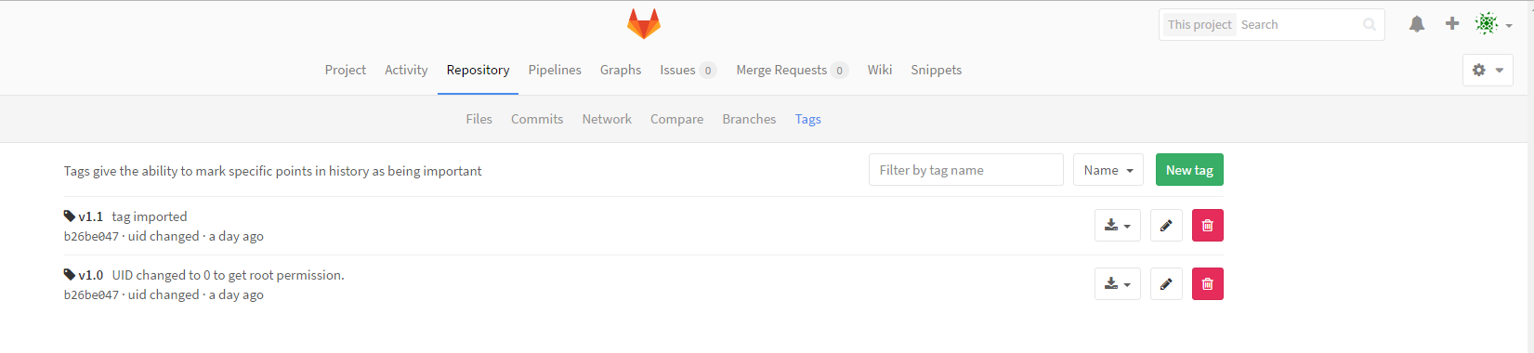

1. Create new tag from existing branch:

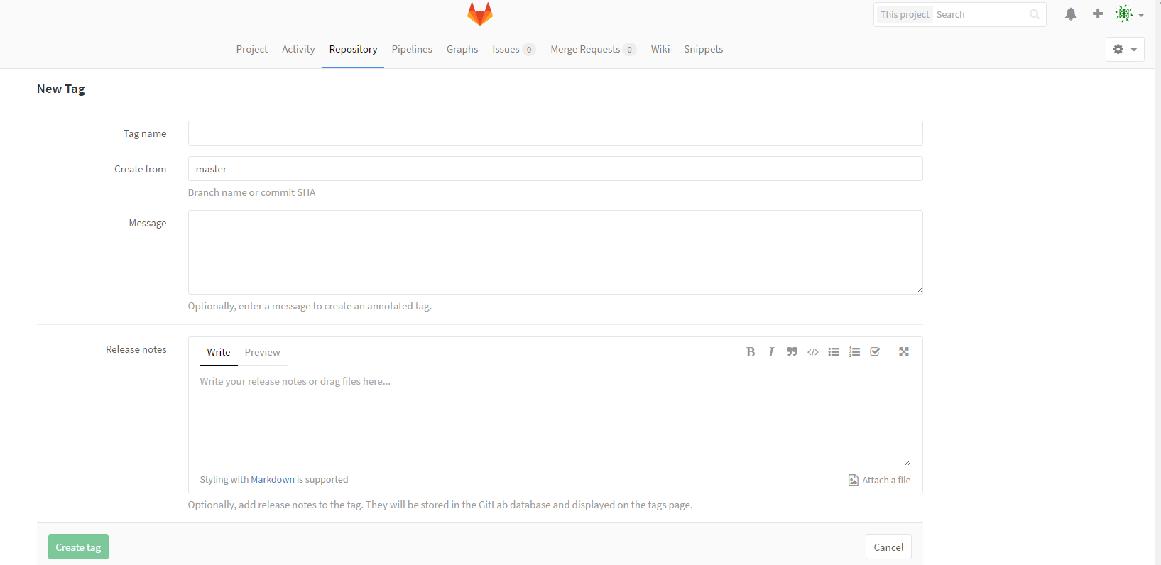

**Create merge request:**

1. Click your project and Merge request

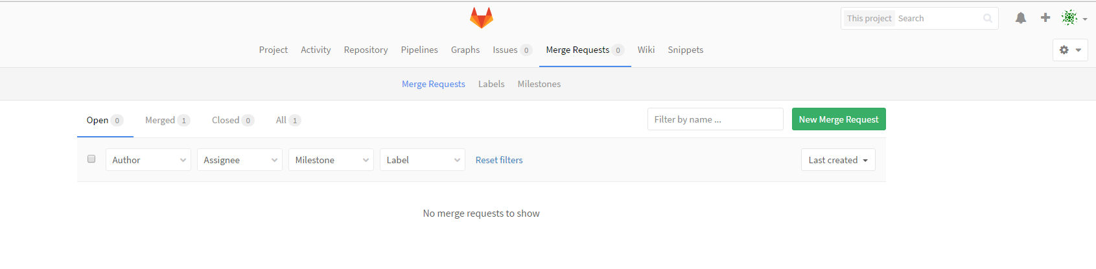

1. Click new merge request

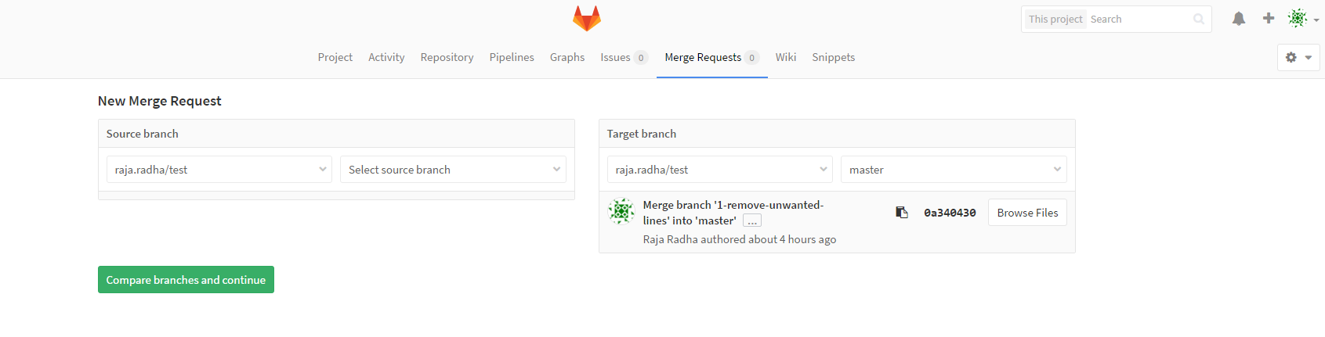

1. Select your source and target branch.
2. Fill title and description
3. Assign this request to approver
4. Select your milestone
5. Select your label
6. Select source and target branch
7. Submit your merge request.

Note: you can see the changes between two branches in Changes option.

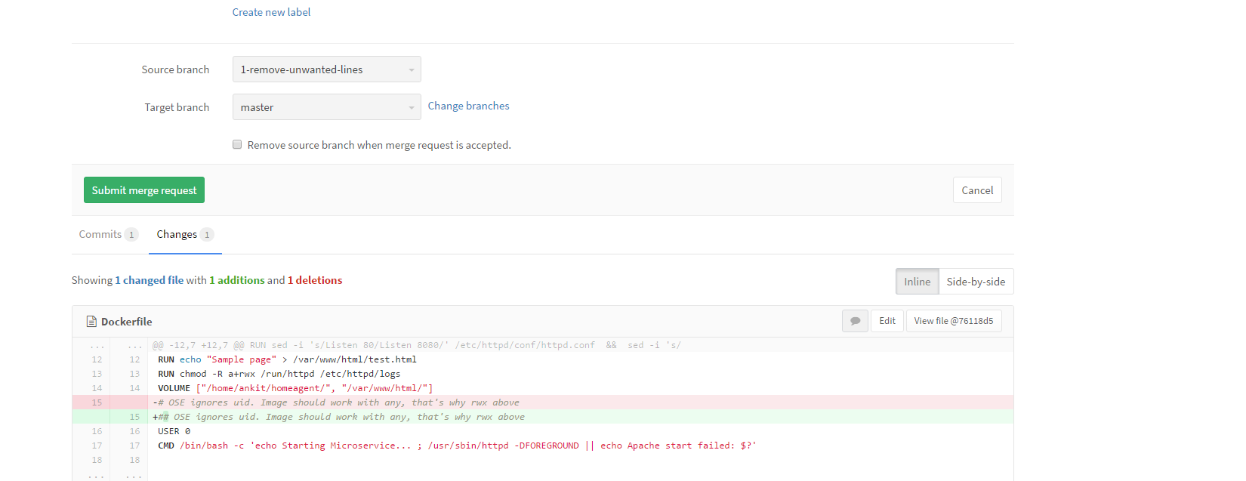

**Some of the tag reference:**

**Show all tags:**

Git tag

**Two types of tag:**

lightweight and annotated

**Lightweight:**

$ git tag v1.4-lw

**Annotated:**

$ git tag -a v1.4 -m "my version 1.4"

**To view info about your tag:**

$ git show v1.4

**To set tag existing commit.**

First find all commit:

git log --pretty=oneline

$ git log --pretty=oneline

b26be047772a4e2b5b08123cc0f6dbcd15dad022 uid changed

e3a1fe909f76d01ccc1a2f5fe2dcf9d994fa231a Volume updated

c1ddcb4d8955c97646ed5779c5ab3a8ce42dcf1a Volume added

f5662808327ac8efce0f487b87d41f2669e6fc11 Disabled all copy commands

993e89c905f7e0979b70745f9e318c08c19d1506 Copy files are mentioned

310774d634761253d500446518ea302eeeffdc92 Copying homeagent files

3bdf950659a04c9fef1e05e888bb52e7e3ba5ece Update copy in Dockerfile

a235fa5b6f35ad83a182552ee0d8adb373b07ffa Update Dockerfile

b08e4ccc27915c28996b62de9e00caa866180ee1 port changed to 8080

79112b95676f7ab12aec06a5b5ef0313983b8ef4 Update Dockerfile

94a7f7d93fe127e8445fdc86109ffb89ae6ac795 Delete README.txt

6039916a81447510ccebf3fd54107608f475bec6 Inital docker file with home agent with README file

34c999d095c7a1b349c600121b578e26a5b24aca Inital docker file with home agent

3f0635f7aeaa51949d1c35969d282831735b2c7e Inital commit

Git tag -a v1.1 b26be04 -m ”Tag information”

**To push your tag in gitLab:**

Git push origin v1.1

Git push origin --tags