Ex.No: 11 | Calculator Application using java AWT packages
Date: | Calculator Application using java AWT packages

Aim:

To create a Java GUI application that mimics the basic and advanced functionalities of a scientific calculator.

Algorithm:

Step 1 | Start the Process
Step 2 | Display Text View and Number Pad and Option Pads
Step 3 | If user presses any number get the existing numbers in Text View add them up and display
Step 4 | If user press Operators
 | Step 4.1 | Get the Text View content as Operant 1 and Set the display to null.
 | Step 4.2 | If user pressed “+” button set operator as plus
 | Step 4.3 | If user pressed “-” button set operator as minus
 | Step 4.4 | If user pressed “x” button set operator as multiply
 | Step 4.5 | If user pressed “/” button set operator as divide
 | Step 4.6 | Goto step 3
Step 5 | If user pressed “=” button then proceed following steps.
 | Step 5.1 | Get the Text View content as Operant 2 and Set the display to null.
 | Step 5.2 | If operator is “plus” then display Text View as Operant 1 + Operant 2
 | Step 5.3 | If operator is “minus” then display Text View as Operant 1 - Operant 2
 | Step 5.4 | If operator is “multiply” then display Text View as Operant 1 * Operant 2
 | Step 5.5 | If operator is “divide” then display Text View as Operant 1 / Operant 2
 | Step 5.6 | Goto step 4
Step 6 | If advanced button pressed
 | Step 6.1 | Change Operant Types [+,-,x,/ into sin, cos, tan, log] and goto step 2
Step 7 | If user pressed any of the operator
 | Step 7.1 | Get the Text View content as Operant 1 and Set the display to null.
 | Step 7.2 | If user pressed “sin” button set display the sin value of Operant 1
 | Step 7.3 | If user pressed “cos” button set display the cos value of Operant 1
 | Step 7.4 | If user pressed “tan” button set display the tan value of Operant 1
 | Step 7.5 | If user pressed “log” button set display the log value of Operant 1
 | Step 7.6 | Goto step 7
Step 8 | If advanced pressed again then revert the button changes and return back to normal
Step 9 | Repeat the process until user presses the close button then Stop the Process.

Coding:

import java.awt.BorderLayout;
import java.awt.Button;
import java.awt.Font;
import java.awt.Frame;
import java.awt.GridLayout;
import java.awt.Panel;
import java.awt.TextField;
import java.awt.event.ActionEvent;
import java.awt.event.ActionListener;
import java.awt.event.WindowAdapter;
import java.awt.event.WindowEvent;
import java.awt.event.WindowListener;

class Numpan extends Panel implements ActionListener{

Button n0,n1,n2,n3,n4,n5,n6,n7,n8,n9,point,equal;
Button plus,minus,multiply, divide;
Button m_plus,m_minus,clear,advanced;
TextField display;
String op1,op2,result;
String op_flag;
String data;
double dop1,dop2,dresult;
boolean flag_advanced=true;
public Numpan(TextField display) {
this.display = display;
setLayout(new GridLayout(0,4));

n0 = new Button("0");
n0.setActionCommand("zero");
n0.addActionListener(this);

n1 = new Button("1");
n1.setActionCommand("one");
n1.addActionListener(this);

n2 = new Button("2");
n2.setActionCommand("two");
n2.addActionListener(this);

n3 = new Button("3");
n3.setActionCommand("three");
n3.addActionListener(this);

n4 = new Button("4");
n4.setActionCommand("four");
n4.addActionListener(this);

n5 = new Button("5");
n5.setActionCommand("five");
n5.addActionListener(this);

n6 = new Button("6");
n6.setActionCommand("six");
n6.addActionListener(this);

n7 = new Button("7");
n7.setActionCommand("seven");
n7.addActionListener(this);

n8 = new Button("8");
n8.setActionCommand("eight");
n8.addActionListener(this);

n9 = new Button("9");
n9.setActionCommand("nine");
n9.addActionListener(this);

point = new Button(".");
point.setActionCommand("point");
point.addActionListener(this);

equal = new Button("=");
equal.setActionCommand("equal");
equal.addActionListener(this);

plus = new Button("+");
plus.setActionCommand("plus");
plus.addActionListener(this);

minus = new Button("-");
minus.setActionCommand("minus");
minus.addActionListener(this);

multiply = new Button("x");
multiply.setActionCommand("multiply");
multiply.addActionListener(this);

divide = new Button("/");
divide.setActionCommand("divide");
divide.addActionListener(this);

m_plus = new Button("M+");
m_plus.setActionCommand("m_plus");
m_plus.addActionListener(this);

m_minus = new Button("M-");
m_minus.setActionCommand("m_minus");
m_minus.addActionListener(this);

clear = new Button("C");
clear.setActionCommand("clear");
clear.addActionListener(this);

advanced = new Button("ADV");
advanced.setActionCommand("advanced");
advanced.addActionListener(this);

add(m_plus);
add(m_minus);
add(clear);
add(advanced);
add(n1);
add(n2);
add(n3);
add(plus);
add(n4);
add(n5);
add(n6);
add(minus);
add(n7);
add(n8);
add(n9);
add(multiply);
add(point);
add(n0);
add(equal);
add(divide);
}
public String getDisplayText(){
return display.getText().toString();
}
public void setDisplay(String text){
display.setText(text);
}
public void clearDisplay(){
System.out.println("Clear Called");
setDisplay("");
data = "";
}

public void changeAdvanced(boolean toAdvanced){
if(toAdvanced){
plus.setLabel("sin");
plus.setActionCommand("sin");
//System.out.println("cos in");
minus.setLabel("cos");
minus.setActionCommand("cos");
//System.out.println("cos out");
multiply.setLabel("tan");
multiply.setActionCommand("tan");
divide.setLabel("log");
divide.setActionCommand("log");

}
else{
plus.setLabel("+");
plus.setActionCommand("plus");
minus.setLabel("-");
minus.setActionCommand("minus");
multiply.setLabel("x");
multiply.setActionCommand("multiply");
divide.setLabel("/");
divide.setActionCommand("divide");
}
}
@Override
public void actionPerformed(ActionEvent e) {

data = getDisplayText();

switch(e.getActionCommand()){
case "zero":
setDisplay(data+"0");
break;
case "one":
setDisplay(data+"1");
break;
case "two":
setDisplay(data+"2");
break;
case "three":
setDisplay(data+"3");
break;
case "four":
setDisplay(data+"4");
break;
case "five":
setDisplay(data+"5");
break;
case "six":
setDisplay(data+"6");
break;
case "seven":
setDisplay(data+"7");
break;
case "eight":
setDisplay(data+"8");
break;
case "nine":
setDisplay(data+"9");
break;

case "plus":
op1 = data;
op_flag = "plus";
clearDisplay();
break;
case "minus":
op1 = data;
op_flag = "minus";
clearDisplay();
break;
case "multiply":
op1 = data;
op_flag = "multiply";
clearDisplay();
break;
case "divide":
op1 = data;
op_flag = "divide";
clearDisplay();
break;
case "clear":
clearDisplay();
break;
case "advanced":
if(flag_advanced){
changeAdvanced(true);
flag_advanced = false;
}
else{
changeAdvanced(false);
flag_advanced = true;
}
break;

case "sin":
op1 = data;
setDisplay(String.valueOf(Math.sin(Double.valueOf(op1))));
break;
case "cos":
op1 = data;
setDisplay(String.valueOf(Math.cos(Double.valueOf(op1))));
break;
case "tan":
op1 = data;
setDisplay(String.valueOf(Math.tan(Double.valueOf(op1))));
break;
case "log":
op1 = data;
setDisplay(String.valueOf(Math.log(Double.valueOf(op1))));
break;
case "equal":
switch(op_flag){
case "plus":
op2 = data;
clearDisplay();
dop1 = Double.parseDouble(op1);
dop2 = Double.parseDouble(op2);
dresult = dop1 + dop2;
result = String.valueOf(dresult);
setDisplay(result);
op_flag = "";
break;
case "minus":
op2 = data;
clearDisplay();
dop1 = Double.parseDouble(op1);
dop2 = Double.parseDouble(op2);
dresult = dop1 - dop2;
result = String.valueOf(dresult);
setDisplay(result);
op_flag = "";
break;

case "multiply":
op2 = data;
clearDisplay();
dop1 = Double.parseDouble(op1);
dop2 = Double.parseDouble(op2);
dresult = dop1 * dop2;
result = String.valueOf(dresult);
setDisplay(result);
op_flag = "";
break;

case "divide":
op2 = data;
clearDisplay();
dop1 = Double.parseDouble(op1);
dop2 = Double.parseDouble(op2);
dresult = dop1 / dop2;
result = String.valueOf(dresult);
setDisplay(result);
op_flag = "";
break;

}
}
}
}

class Calculator extends Frame {
TextField display;
public Calculator() {
display = new TextField();
display.setFont(new Font("Times New Roman", Font.BOLD, 50));
setLayout(new BorderLayout());
add(new Numpan(display),BorderLayout.CENTER);
add(display,BorderLayout.NORTH);
setVisible(true);
setSize(500,500);
addWindowListener(new WindowAdapter() {
@Override
public void windowClosing(WindowEvent e) {
dispose();
}
});
}

}
public class Main {

public static void main(String[] args) {
new Calculator();
}

}
Output:

Calculator:

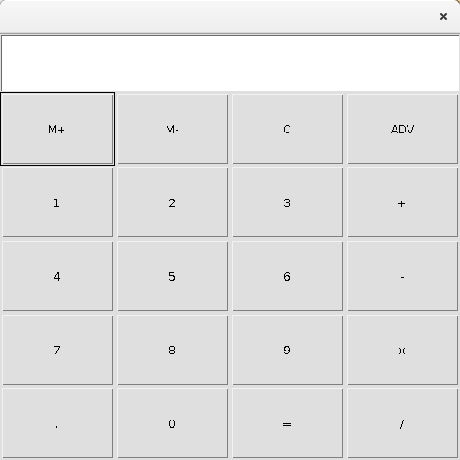

Basic Operations

Addition [12 + 12]

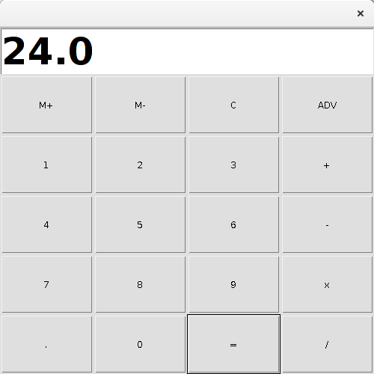

Subtraction [90 – 32]:

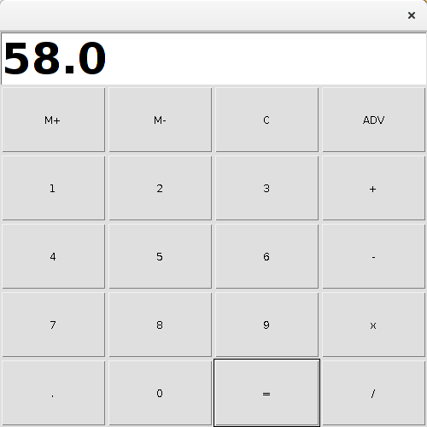
Multiplication [36 X 2]

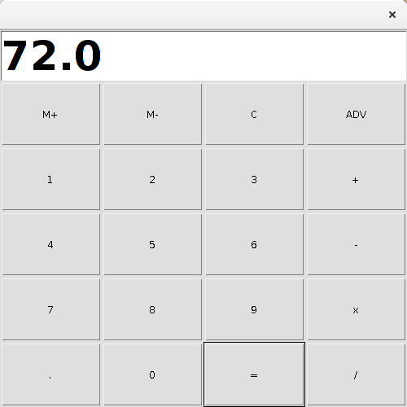
Division [45 / 2]

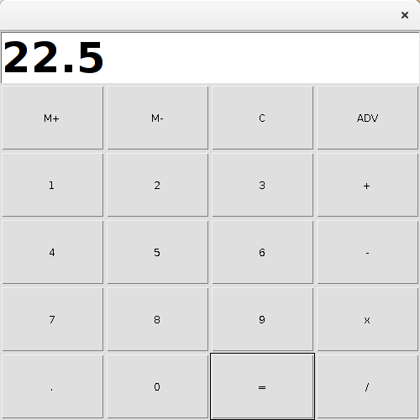
Scientific Operations:

Sin 30

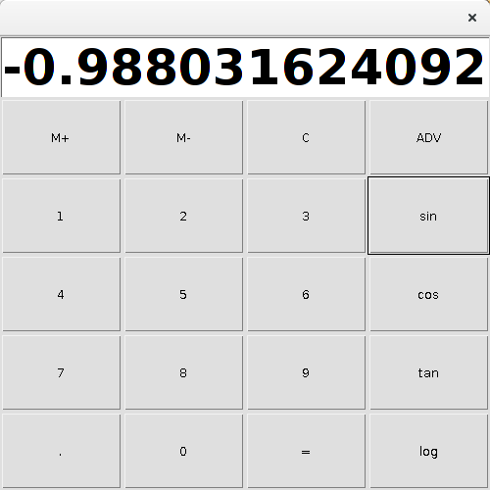
Cos 40:

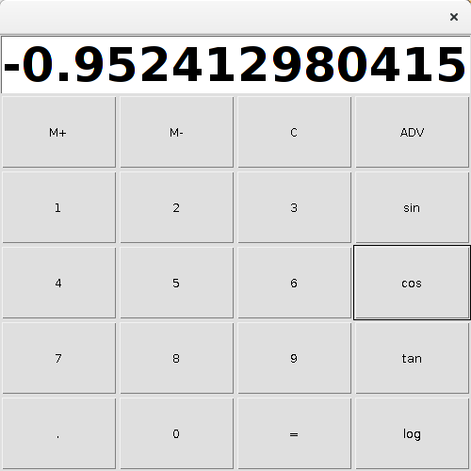

Tan 23

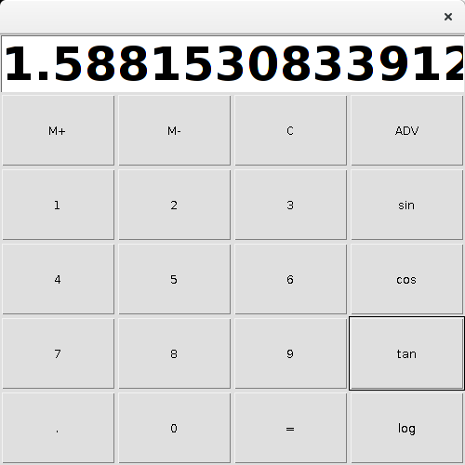
Log 60

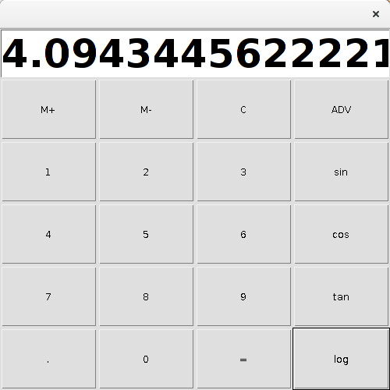

Result:

The java GUI application for calculator with basic and advanced functionalities was developed and tested successfully.

