Ex.No: 6 | Java Application to Find the Area of different Shapes
Date: | Java Application to Find the Area of different Shapes

Aim:

To create a Java console application to find the area of different shapes using abstract class concept in java.

Algorithm:

Step 1 | Start the Process
Step 2 | Prompt user with List Operation Choices  1. Rectangle 2. Triangle 3. Circle 4, Exit  Get the choice from user.
Step 3 | If user selects Rectangle
 | Step 3.1 | Get the Length and Breath from the user
 | Step 3.2 | Compute Area = Length * Breath
 | Step 3.3 | Display Area
Step 4 | If user selects Triangle
 | Step 3.1 | Get the Length and Height from the user
 | Step 3.2 | Compute Area = Length * Height * 0.5
 | Step 3.3 | Display Area
Step 5 | If user selects Circle
 | Step 5.1 | Get the Radius of the Circle
 | Step 5.2 | Compute Area = 3.14 * Radius * Radius
 | Step 5.3 | Display Area
Step 6 | If user selects exit end the process
Step 7 | Stop the Process

Coding:

Shape.java

package com.raja.oopslanb.shapes;

public abstract class Shape {
double length = 0.0;
double hight = 0.0;
public abstract void printArea();
}

Rectangle.java

package com.raja.oopslanb.shapes;

import java.util.Scanner;

public class Rectangle extends Shape {
double area = 0.0;

@Override
public void printArea() {
System.out.println("\nRectangle");
System.out.println("---------\n");
Scanner input = new Scanner(System.in);
System.out.println("Enter Length of Rectangle : ");
this.length = input.nextDouble();
System.out.println("Enter Breadth of Rectangle : ");
this.hight = input.nextDouble();
this.area = this.length * this.hight;
System.out.println("Area of the Rectangle is : " + this.area);
}

}

Triangle.java

package com.raja.oopslanb.shapes;

import java.util.Scanner;

public class Triangle extends Shape {
double area = 0.0;

@Override
public void printArea() {
System.out.println("\nTriangle");
System.out.println("---------\n");
Scanner input = new Scanner(System.in);
System.out.println("Enter Length of Triangle : ");
this.length = input.nextDouble();
System.out.println("Enter Hight of Triangle : ");
this.hight = input.nextDouble();
this.area = 0.5 * this.length * this.hight;
System.out.println("Area of the Triangle is : " + this.area);
}

}

Circle.java

package com.raja.oopslanb.shapes;

import java.util.Scanner;

public class Circle extends Shape {
double area = 0.0;

@Override
public void printArea() {
System.out.println("\nCircle");
System.out.println("-------\n");
Scanner input = new Scanner(System.in);
System.out.println("Enter Radius of Circle : ");
this.length = input.nextDouble();
this.area = Math.PI * this.length * this.length;
System.out.println("Area of the Circle is : " + this.area);
}

}

Main.java

import com.raja.oopslanb.shapes.Rectangle;
import com.raja.oopslanb.shapes.Shape;
import com.raja.oopslanb.shapes.Triangle;

import java.util.Scanner;

import com.raja.oopslanb.shapes.Circle;

public class Main {
public static void main(String[] args) {
Scanner userInput = new Scanner(System.in);
int choice = 0;
do {
System.out.println("Finding Area");
System.out.println("************");
System.out.println(
"\n1. Rectangle" + "\n2. Triangle" + "\n3. Circle" + "\n4. Exit" + "\n\nEnter your choice: ");
choice = userInput.nextInt();
switch (choice) {
case 1:
Shape rt = new Rectangle();
rt.printArea();
break;
case 2:
Shape tr = new Triangle();
tr.printArea();
break;
case 3:
Shape cr = new Circle();
cr.printArea();
break;
case 4:
System.out.println("\n\nThank You !!!");
userInput.close();
break;
default:
System.out.println("Please enter valid input");
break;
}
} while (choice != 4);
}
}

Output:

Choice

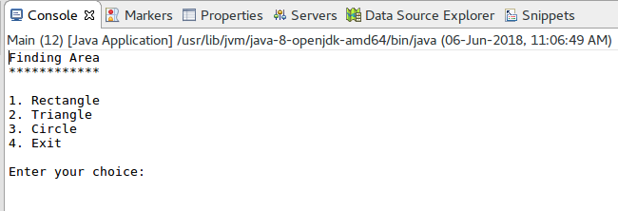
Rectangle

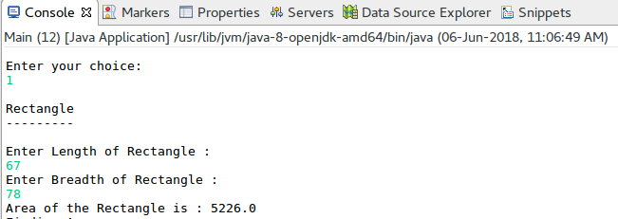

Triangle

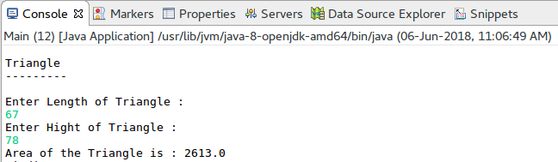

Circle

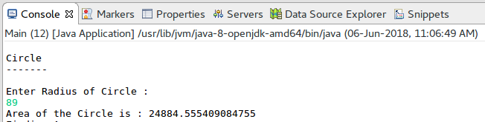

Result:

The Java console application to find the area of different shapes using abstract class concept in java was developed and tested successfully.

