Ex.No: 3 | Employee Payroll System
Date: | Employee Payroll System

Aim:

To create a Java console application for employee payroll process management. This project includes Employee and they further classified as Programmer, Assistant Professor, Associate Professor, Professor.

Algorithm:

Step 1 | Start the process
Step 2 | Prompt the user with converter choice 1. Programmer 2. Assistant Professor 3. Associate Professor 4. Professor 5. Exit and get the choice.
Step 3 | If user selects a Programmer then proceed to step 4
Step 4 | Get the user details [Name, ID, Address, Mail ID and Mobile Number] and goto step 5
Step 5 | Proceed to Programmers Payment Processing
 | Step 5.1 | Get the basic pay of Programmer
 | Step 5.2 | If user enters -1 assume basic pay as 30000 and goto step 15
 | Step 5.3 | Else directly go to step 15
Step 6 | If user selects Assistant Professor step 7
Step 7 | Get the user details [Name, ID, Address, Mail ID and Mobile Number] and goto step 8
Step 8 | Proceed to Assistant Professor Payment Processing
 | Step 8.1 | Get the basic pay of Assistant Professor
 | Step 8.2 | If user enters -1 assume basic pay as 25000 and goto step 15
 | Step 8.3 | Else directly go to step 15
Step 9 | If user selects Associate Professor step 10
Step 10 | Get the user details [Name, ID, Address, Mail ID and Mobile Number] and goto step 11
Step 11 | Proceed to Associate Professor Payment Processing
 | Step 11.1 | Get the basic pay of Associate Professor
 | Step 11.2 | If user enters -1 assume basic pay as 40000 and goto step 15
 | Step 11.3 | Else directly go to step 15
Step 12 | If user selects Professor step 13
Step 13 | Get the user details [Name, ID, Address, Mail ID and Mobile Number] and goto step 14
Step 14 | Proceed to Professor Payment Processing
 | Step 14.1 | Get the basic pay of Professor
 | Step 14.2 | If user enters -1 assume basic pay as 70000 and goto step 15
 | Step 14.3 | Else directly go to step 15
Step 15 | Compute Per_Day_Pay = original_basic_pay / no_of_days_in_the_current_month
Step 16 | Get the number of days worked from user that include Cl, WH, FH and exclude the LOP
Step 17 | Check no_days_worked <= no_of_days_in_the_current_month. Else display “Error Message” and goto step 18
Step 18 | Compute Current_Basic_Pay = Per_Day_Pay * no_days_worked
Step 19 | Compute Following and Store  DA = (Current_Basic_Pay/100) * 97  HRA = (Current_Basic_Pay/100) * 12  PF = (Current_Basic_Pay/100) * 0.1  GROSS_PAY = Current_Basic_Pay + DA + HRA + PF  NET_PAY = GROSS_PAY - PF
Step 17 | Display Payment Details [Name, ID, Address, Mail ID, Mobile Number, BASIC PAY, DA, HRA,PF,GROSS_PAY, NET_PAY].
Step 18 | Stop Processing

Coding

Employee.java

package com.raja.oopslab.employee;
import java.util.Calendar;
import java.util.GregorianCalendar;
import java.util.Scanner;

package com.raja.oopslab.employee;

import java.util.Calendar;
import java.util.GregorianCalendar;
import java.util.Scanner;

class Employee {
String emp_name;
String emp_id;
String emp_address;
String emp_mail_id;
String emp_mobile_no;
int basic_pay;
int per_day_pay;
int current_basic_pay;
int da, hra, pf, gross_pay;
int net_pay;
int no_of_days_in_current_month;
int no_of_days_worked;
Calendar cal;
Scanner input;

Employee() {
input = new Scanner(System.in);
cal = new GregorianCalendar();
no_of_days_in_current_month = cal.getActualMaximum(Calendar.DAY_OF_MONTH);
getUserBasicDetails();
}

public void generatePaySlip() {
this.da = (this.current_basic_pay / 100) * 97;
this.hra = (this.current_basic_pay / 100) * 12;
this.pf = (int) ((this.current_basic_pay / 100) * 0.1);
this.gross_pay = this.current_basic_pay + da + hra + pf;
this.net_pay = gross_pay - pf;
}

public void displayPaySlip() {
System.out.println("Name: " + this.emp_name);
System.out.println("ID: " + this.emp_id);
System.out.println("Address: " + this.emp_address);
System.out.println("MailID: " + this.emp_mail_id);
System.out.println("Mobile No: " + this.emp_mobile_no);
System.out.println("\nEarnings");
System.out.println("--------");
System.out.println("BASIC Pay: " + current_basic_pay + " Rs");
System.out.println("DA : " + da + " Rs");
System.out.println("HRA : " + hra + " Rs");
System.out.println("\nDeductions");
System.out.println("----------");
System.out.println("PF : " + pf + " Rs");
System.out.println("GROSS Pay: " + gross_pay + " Rs");
System.out.println("NET Pay: " + net_pay + " Rs");
}

public void getUserBasicDetails() {
System.out.println("Enter Details");
System.out.println("Name: ");
this.emp_name = input.next();
System.out.println("ID: ");
this.emp_id = input.next();
System.out.println("Address: ");
this.emp_address = input.next();
System.out.println("MailID: ");
this.emp_mail_id = input.next();
System.out.println("Mobile No:");
this.emp_mobile_no = input.next();
}

public void computeCurrentBasicPay(String empType) {
this.per_day_pay = this.basic_pay / no_of_days_in_current_month;
System.out.println("\nBasic Pay of " + empType + " " + this.basic_pay + " for "
+ this.no_of_days_in_current_month + " days");
System.out.println("This month this " + empType + " gets " + this.per_day_pay + " INR as basic pay per day");
System.out.println("Enter no.of days worked by " + empType + " including CL, WH, FH and excluding LWP:");
this.no_of_days_worked = input.nextInt();
if (no_of_days_worked <= no_of_days_in_current_month) {
this.current_basic_pay = this.per_day_pay * no_of_days_worked;
System.out.println("Programmer");
System.out.println("----------");
generatePaySlip();
} else {
System.out.println("Sorry Please Enter Valid Days");
}
}

protected void finalize() {
input.close();
System.exit(0);
}
}

Programmer.java

package com.raja.oopslab.employee;

public class Programmer extends Employee {

public Programmer() {
super();
computeProgrammerPay();

}

public void computeProgrammerPay() {
System.out.println("Enter Basic pay of Programmer [enter -1 for Default [BP = 30000]]:");
this.basic_pay = input.nextInt();
if (this.basic_pay == -1) {
this.basic_pay = 30000;
System.out.println("Default Pay Taken");
}
computeCurrentBasicPay("Programmer");
generatePaySlip();
displayPaySlip();
}

}

Assistant Professor.java

package com.raja.oopslab.employee;

public class AssistantProfessor extends Employee {
public AssistantProfessor() {
super();
computeAssistantProfessorPay();
}

public void computeAssistantProfessorPay() {
System.out.println("Enter Basic pay of AssistantProfessor [enter -1 for Default [BP = 25000]]:");
this.basic_pay = input.nextInt();
if (this.basic_pay == -1) {
this.basic_pay = 25000;
System.out.println("Default Pay Taken");
}
computeCurrentBasicPay("AssistantProfessor");
generatePaySlip();
displayPaySlip();
}
}

Associate Professor

package com.raja.oopslab.employee;

public class AssociateProfessor extends Employee {
public AssociateProfessor() {
super();
computeAssociateProfessorPay();
}

public void computeAssociateProfessorPay() {
System.out.println("Enter Basic pay of AssociateProfessor [enter -1 for Default [BP = 40000]]:");
this.basic_pay = input.nextInt();
if (this.basic_pay == -1) {
this.basic_pay = 40000;
System.out.println("Default Pay Taken");
}

computeCurrentBasicPay("AssociateProfessor");
generatePaySlip();
displayPaySlip();
}
}
Professor

package com.raja.oopslab.employee;

public class Professor extends Employee {
public Professor() {
super();
computeProfessorPay();
}

public void computeProfessorPay() {
System.out.println("Enter Basic pay of Professor [enter -1 for Default [BP = 70000]]:");
this.basic_pay = input.nextInt();
if (this.basic_pay == -1) {
this.basic_pay = 70000;
System.out.println("Default Pay Taken");
}
computeCurrentBasicPay("Professor");
generatePaySlip();
displayPaySlip();
}
}
Main.java

import java.io.BufferedReader;
import java.io.IOException;
import java.io.InputStreamReader;
import java.util.Scanner;

import com.raja.oopslab.employee.AssistantProfessor;
import com.raja.oopslab.employee.AssociateProfessor;
import com.raja.oopslab.employee.Programmer;
import com.raja.oopslab.employee.Professor;

public class Main {

public static void main(String[] args) throws IOException {
Programmer aProgrammer;
AssistantProfessor aAssistantProfessor;
AssociateProfessor aAssociateProfessor;
Professor aProfessor;
String choice;
int n_choice = 0;
Scanner userInput = new Scanner("System.in");

while (n_choice != 5) {
System.out.println("\n\nEmployee Payroll System");
System.out.println("***********************\n");
System.out.println("1. Programmer\n2. Assistant Professor\n" + "3. Associate Professor\n4. Professor\n"
+ "5. Exit\n\nEnter Your Choice");
choice = new BufferedReader(new InputStreamReader(System.in)).readLine();
n_choice = Integer.parseInt(choice);
switch (n_choice) {
case 1:
System.out.println("Programmer Selected");
aProgrammer = new Programmer();
break;
case 2:
System.out.println("AssistantProfessor Selected");
aAssistantProfessor = new AssistantProfessor();
break;
case 3:
System.out.println("AssociateProfessor Selected");
aAssociateProfessor = new AssociateProfessor();
break;
case 4:
System.out.println("Professor Selected");
aProfessor = new Professor();
case 5:
System.out.println("Thank You !!!");
userInput.close();
break;
default:
System.out.println("Enter valid choice !!!");
break;
}
}
}

}

Output:

Choices

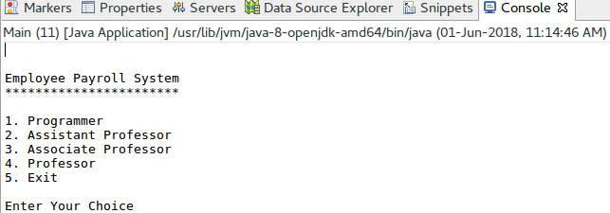

Basic Details

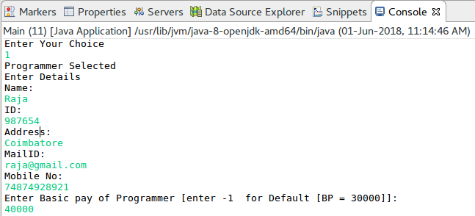

Programmer

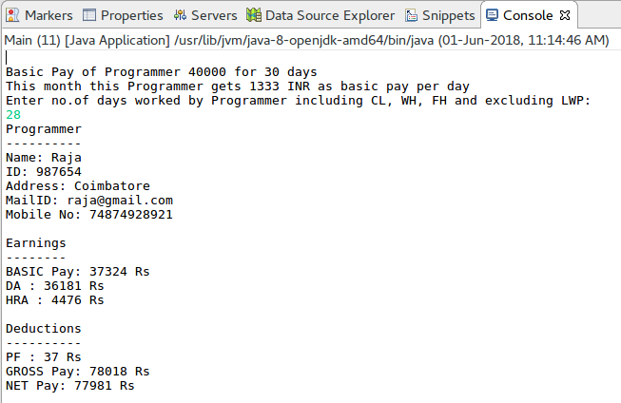
Assistant Professor

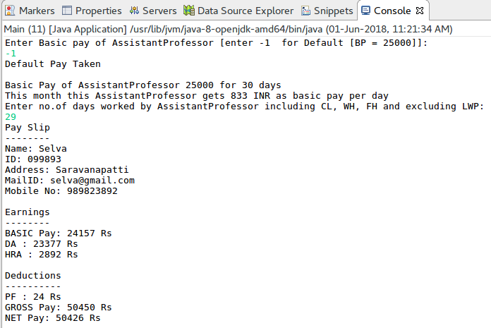
Associate Professor

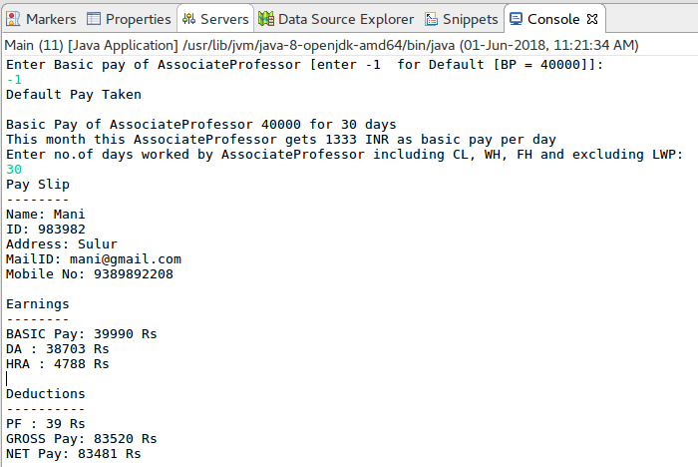
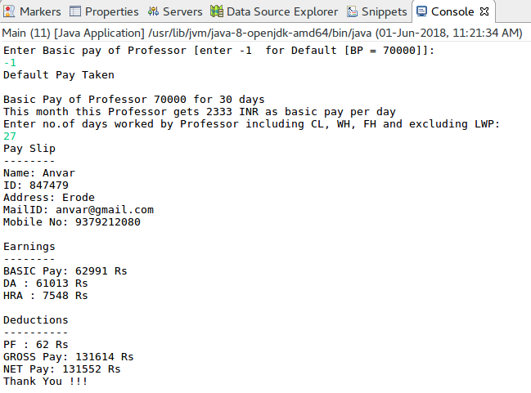
Professor

Result:

The java console application for employee payroll system was developed and tested successfully.

