Ex.No: 10 | Java Application for Generic Max Finder
Date: | Java Application for Generic Max Finder

Aim:

To create a Java console application that finds the maximum in a array based on the type of the elements using generic functions in java.

Algorithm:

Step 1 | Start the Process
Step 2 | Create a array of number and array of strings and pass it to generic function.
Step 3 | If the array is Integer type
 | Step 3.1 | Assume first element as MAX
 | Step 3.2 | Compare [Numeric Perspetive] this element with MAX
 | Step 3.3 | If it is greater than MAX then store current element as MAX
 | Step 3.4 | Else do nothing
 | Step 3.5 | Goto step 3.1 until all the elements has been processed.
Step 4 | If the array is String type
 | Step 4.1 | Assume first element as MAX
 | Step 4.2 | Compare [Dictionary Perspective] this element with MAX
 | Step 4.3 | If it is greater than MAX then store current element as MAX
 | Step 4.4 | Else do nothing
 | Step 4.5 | Goto step 3.1 until all the elements has been processed.
Step 5 | Stop the Process

Coding:

class GenericMax {
public <T extends Comparable<T>> void maxFinder (T[] array){
T max = array[0];
for(T element: array){
System.out.println(element);
if(element.compareTo(max) > 0)
max = element;
}
System.out.println("Max is : "+max);
}
}

public class Main {

public static void main(String[] args) {
GenericMax max = new GenericMax();
Integer[] numbers = {14,3,42,5,6,10};
String[] strings = {"R","Ra","Raj"};
max.maxFinder(numbers);
max.maxFinder(strings);
}

}

Output:

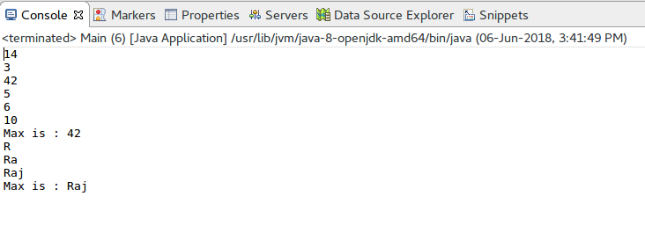

Result:

The java console application for finding generic max of given elements was developed and tested successfully.

