Ex.No: 9 | Java Application for Multithreading
Date: | Java Application for Multithreading

Aim:

To create a Java console application the uses the multithreading concepts in java. The Application has 3 threads one creates random number, one thread computes square of that number and another one computes the cube of that number.

Algorithm:

Step 1 | Start the Process
Step 2 | Create a thread that generates random number
Step 3 | Obtain one random number and check is odd or even
 | Step 3.1 | If number is even then create and start thread that computes square of a number
 | Step 3.2 | Compute number * number and display the answer
 | Step 3.3 | Notify to Random number thread and goto step 4
 | Step 3.4 | If number is odd then create and start thread that computes cube of a number
 | Step 3.4 | Compute number * number * number and display the answer
 | Step 3.5 | Notify to Random number thread and goto step 4
Step 4 | Wait for 1 Second and Continue to Step 3 until user wants to exits.
Step 5 | Stop the Process

Coding:

RandomNumberThread.java

package com.raja.oopslab.threading;

import java.util.Random;

public class RandomNumberThread extends Thread{
Random num = new Random();
int value;
@Override
public void run(){
while(true){
try {
this.sleep(1000);
} catch (InterruptedException e) {

}
value = num.nextInt(1000);
System.out.println("RandomNumberThread generated a number "+value);
if(value % 2 == 0)
new SquareGenThread(value).start();
else
new CubeGenThread(value).start();
}

}
}

SquareGenThread.java

package com.raja.oopslab.threading;

public class SquareGenThread extends Thread{
int number;
int squre;
public SquareGenThread(int number) {
this.number = number;
}
@Override
public void run(){
try {
this.sleep(3000);
} catch (InterruptedException e) {

}
this.squre = this.number * this.number;
System.out.println("SquareGenThread--> Square of "+number+" is "+squre);
}
}

CubeGenThread.java

package com.raja.oopslab.threading;

public class CubeGenThread extends Thread{
int number;
int squre;
public CubeGenThread(int number) {
this.number = number;
}
@Override
public void run(){
try {
this.sleep(2000);
} catch (InterruptedException e) {

}
this.squre = this.number * this.number * this.number;
System.out.println("CubeGenThread--> Square of "+number+" is "+squre);
}
}

Main.java

import java.util.Random;
import com.raja.oopslab.threading.RandomNumberThread;
public class Main {
public static void main(String[] args) {
new RandomNumberThread().start();
}
}

Output:

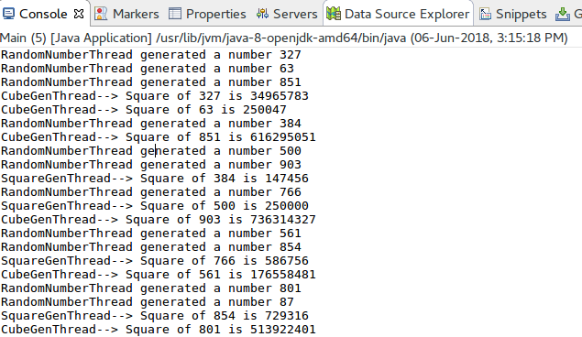

Result:

The java console application for multithreading was developed and tested successfully.

