Ex.No: 4 | Java Application for ADT Stack using Interfaces
Date: | Java Application for ADT Stack using Interfaces

Aim:

To create a Java console application using interface concepts of java for abstract data type stack. Stack operations must be controlled by exception handling techniques.

Algorithm:

Step 1 | Start the process.
Step 2 | Get the Stack’s maximum limit from user.
Step 3 | Create an array with the limit and initialize all the elements as -1 and initialize current_position with 0
Step 4 | Prompt the user with choice for stack operations  1. PUSH 2.POP 3.PEEK 4.DISPLAY 5.EXIT
Step 5 | Get the choice from user and goto step 6
Step 6 | If user selects to PUSH
 | Step 6.1 | Get the number from user to push.
 | Step 6.2 | Try to assign the value to array assuming that array index is current position.
 | Step 6.3 | If exception rises display message “Stack is full try to pop someting” and goto step 9.
 | Step 6.4 | Else increment current position with the value 1 and display element pushed index and goto step 9.
Step 7 | If user selects to POP
 | Step 7.1 | Try to set previous position of current position to -1
 | Step 7.2 | If exception rises display message “Stack is empty try to push something” and goto step 9.
 | Step 7.3 | Else decrement current position with the value 1 and display popped element and goto step 9.
Step 8 | If user selects to PEEK display element display current_position -1 element in the array
Step 9 | If user selects to DISPLAY
 | Step 9.1 | Display array reversely and elements which is not equal to -1 and goto step 4
Step 10 | Exit from the process.
Step 11 | Stop the process.

Coding

StackOpeations.java [Interface]

package com.raja.oopslab.stackadt;

public interface StackOperations {

boolean push(int number);

boolean pop();

void peek();

void display();
}

CustomStack.java

package com.raja.oopslab.stackadt;

public class CustomStack implements StackOperations {
int[] stack_array;
int limit;
int current_position = 0;

public CustomStack(int limit) {
this.limit = limit;
stack_array = new int[limit];
initStack();
}

public void initStack() {
for (int i = 0; i < limit; i++)
stack_array[i] = -1;
}

@Override
public boolean push(int number) {

try {

stack_array[current_position] = number;
current_position++;
System.out.println("The element " + number + " pushed in the position " + current_position);
display();
return true;
}

catch (ArrayIndexOutOfBoundsException e) {
System.out.println("Sorry Stack Full Please do some POP's");
}
return false;

}

@Override
public boolean pop() {
int poped_element;
try {
poped_element = stack_array[current_position - 1];
stack_array[current_position - 1] = -1;
current_position--;
System.out.println("Poped element is : " + poped_element);
display();
return true;
} catch (ArrayIndexOutOfBoundsException e) {
System.out.println("Sorry Stack is Empty try to do some push");
}
return false;
}

@Override
public void display() {

System.out.println("\nStack Display");
System.out.println("*************\n");
for (int i = limit - 1; i >= 0; i--)
if (stack_array[i] != -1)
System.out.println(stack_array[i]);
System.out.println("\n*************");
}

@Override
public void peek() {
int peek_element = 0;
peek_element = stack_array[current_position - 1];
System.out.println("Peek Element of the Stack is " + peek_element);
}

}
Main.java

import java.util.Scanner;
import com.raja.oopslab.stackadt.*;

public class Main {
public static void main(String[] args) {
Scanner input = new Scanner(System.in);
System.out.print("Enter the size of stack :");
CustomStack mystack = new CustomStack(input.nextInt());
int choice = 0;
while (choice != 5) {
System.out.println("\n1.PUSH\n2.POP\n3.PEEK\n4.DISPLAY\n5.EXIT");
System.out.println("Please Enter Your Choice : ");
choice = input.nextInt();
switch (choice) {
case 1:
System.out.println("Enter the Element to PUSH : ");
mystack.push(input.nextInt());
break;
case 2:
mystack.pop();
break;
case 3:
mystack.peek();
break;
case 4:
mystack.display();
break;
case 5:
System.out.println("!!! Thank You !!!");
break;
}

}
input.close();
System.exit(0);
}

}

Output:

Choice:

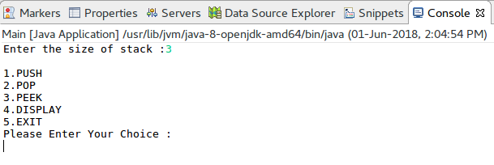
Push Operation:

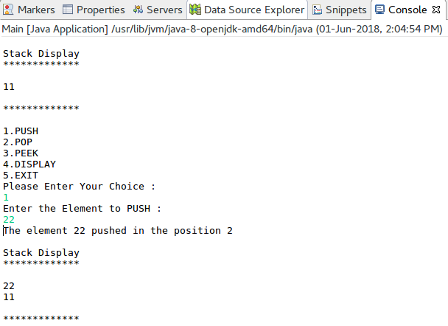
Pop and Peek Operation:

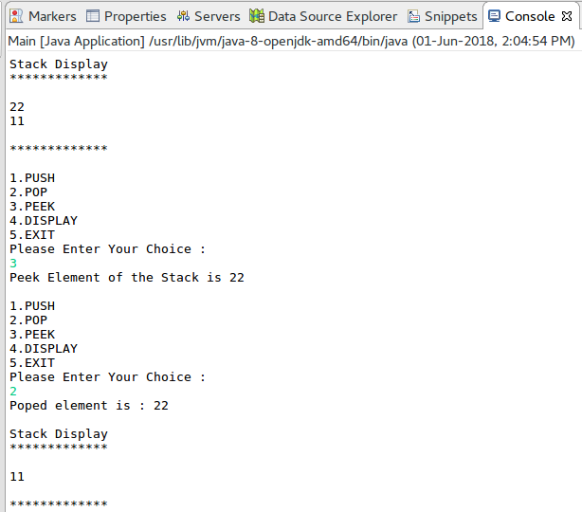

Stack Empty Error:
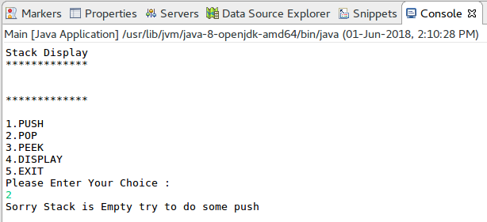
Stack Full Error:

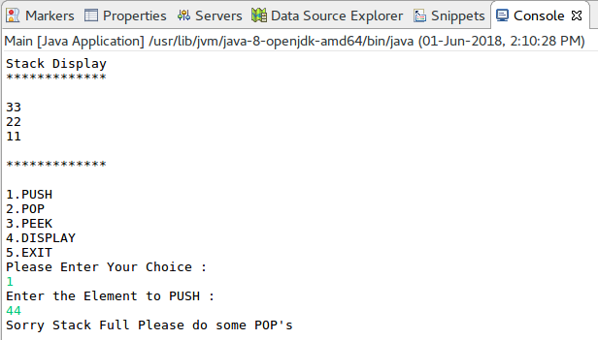

Result:

The java console application for abstract data type stack using java interface concepts is developed and tested successfully.

