Ex.No: 5 | Java Application for String Operations using ArrayList
Date: | Java Application for String Operations using ArrayList

Aim:

To create a Java console application for string list operations [Append, Insert at particular Index, Search a string in a list, Display all the strings that begins with a character] using ArrayList in java.

Algorithm:

Step 1 | Start the Process
Step 2 | Prompt user with List Operation Choices  1. Append 2. Insert at particular Index 3. Search a string in a list  4. Display all the strings in a list 5. Display all the strings that begins with a character  6. Exit
Step 3 | If user selects option 1 then get the string from user and add at last position of the list.
Step 4 | If user selects option 2
 | Step 4.1 | Get the string and position from the user
 | Step 4.2 | Check the position exceeds from list size
 | Step 4.3 | If exceeds then prompt an error “Sorry Position is not in the list limit” and goto step 2.
 | Step 4.4 | Else create temporary list
 | Step 4.5 | Add all the elements of the list upto current position one by one.
 | Step 4.6 | Add current element to the list
 | Step 4.7 | Add remaining elements one by one.
 | Step 4.8 | Assign temporary list as source list and goto step 2
Step 5 | If user selects option 3 then get the string to be searched from the user.
 | Step 5.1 | Check every string one by one for string match
 | Step 5.2 | If match found and display the string and position and goto step 2
 | Step 5.3 | Else prompt an error message “String not found in the list” and goto step 2
Step 6 | If user selects option 4 the display all the strings one by one. After that goto step 2.
Step 7 | If user selects option 5 then proceed following
 | Step 7.1 | Get the character from user
 | Step 7.2 | Get all the string one by one and match first letter with character entered by the user
 | Step 7.3 | If character matches display the string
 | Step 7.4 | Else move to next string.
 | Step 7.5 | At the end goto step 2
Step 8 | If user selects option 6 exit from process and stop processing

Coding:

StringList.java

package com.raja.oopslab.stringlist;

import java.util.ArrayList;

public class StringList {
ArrayList<String> listOfStrings;

public StringList() {
listOfStrings = new ArrayList<String>();
}

public boolean addString(String aString) {
boolean result = listOfStrings.add(aString);
return result;
}

public void insertStringAt(int position, String aString) {
int list_size = listOfStrings.size();
int cur_pos = 0;
ArrayList<String> templist = new ArrayList<String>();
if (position > list_size)
System.out.println("Sorry Position is not in the list limit");
else {
for (String elememt : listOfStrings) {

if (cur_pos == position)
templist.add(aString);

templist.add(elememt);
cur_pos++;
}
}
listOfStrings = templist;
}

public void displayList() {
int i = 0;
for (String element : listOfStrings){
System.out.println(i+"."+element);
i++;
}
}

public void searchString(String aString) {

int cur_pos = 0;
int foundAt = -1;

for (String element : listOfStrings) {
if (element.equalsIgnoreCase(aString)) {
foundAt = cur_pos;
break;
} else
cur_pos++;
}
if (foundAt >= 0)
System.out.println("Your string " + aString + " found at position " + cur_pos);
else
System.out.println("String not found in the list");
}

public void displayStringsBeginWith(String aLetter) {
System.out.println("The String's Begins with Letter ["+aLetter+"]\n");
for (String element : listOfStrings) {
String firstLetter = String.valueOf(element.charAt(0));
if (aLetter.equals(firstLetter))
System.out.println(element);
}
}
}

Main.java

import java.io.BufferedReader;
import java.io.IOException;
import java.io.InputStream;
import java.io.InputStreamReader;
import java.util.Scanner;

import com.raja.oopslab.stringlist.StringList;

public class Main {
public static void main(String[] args) {
StringList stringList = new StringList();
Scanner userInput = new Scanner(System.in);
String aString = null;
int choice = 0;
int position = 0;
while (choice != 6) {
System.out.println("\nString List Operations");
System.out.println("************************");
System.out.println(
"1. Append a String\n"
+ "2. Insert a String at Position\n"
+ "3. Search a String\n"
+ "4. List all Strings\n"
+ "5. Display String's Begins with a Letter\n"
+ "6.Exit");

choice = userInput.nextInt();

switch (choice) {
case 1:
System.out.println("Enter a String: ");
stringList.addString(userInput.next());
break;
case 2:
System.out.println("Enter a String: ");
aString = userInput.next();
System.out.println("Enter a Position to Insert: ");
position = userInput.nextInt();
stringList.insertStringAt(position, aString);
break;
case 3:
System.out.println("Enter a String to Be Searched: ");
aString = userInput.next();
stringList.searchString(aString);
break;
case 4:
System.out.println("\nList Contains");
System.out.println("-------------");
stringList.displayList();
break;
case 5:
System.out.println("Enter a letter");
stringList.displayStringsBeginWith(userInput.next());
break;
case 6:
System.out.println("\n\nThank You !!!");
userInput.close();
System.exit(0);
break;
default:
System.out.println("Please enter valid input");
break;
}
}
}
}
Output:

List Choices:

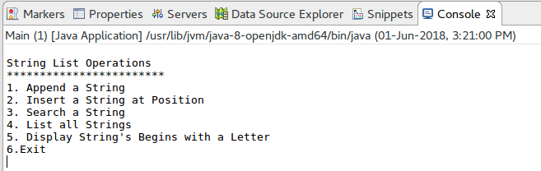

Append a string:

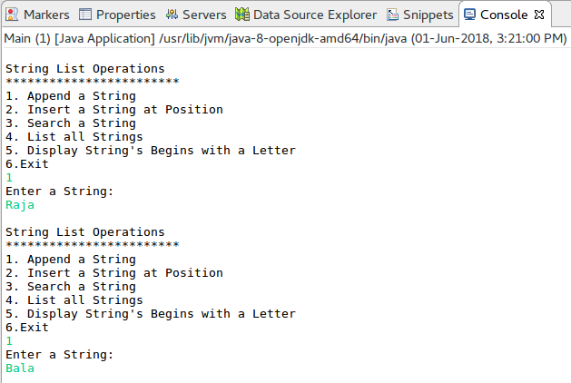
Display List:

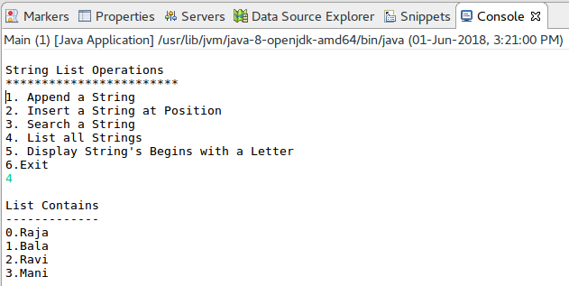
Insert At Position:

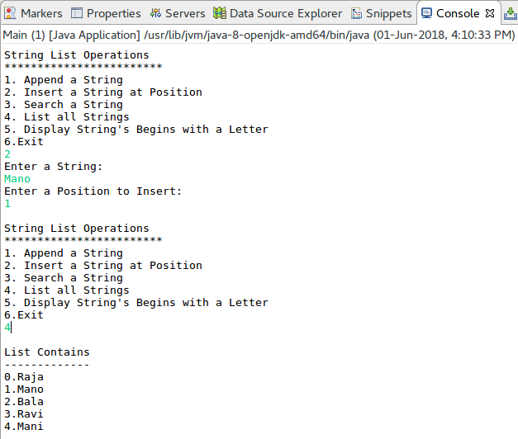
Search a String:

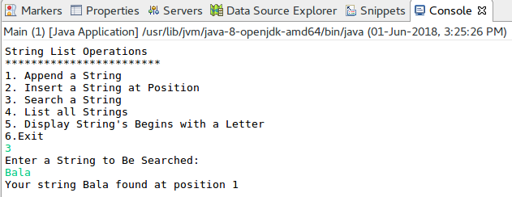
List the string’s that begins with a letter “R”:

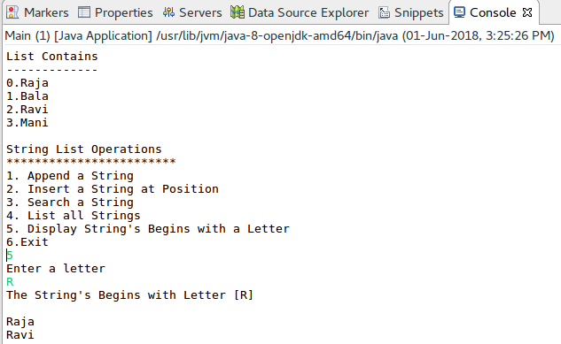

Result:

The java console application for string list operations was developed and tested successfully.

