Ex.No: 7 | Bank Transaction System with User Exceptions
Date: | Bank Transaction System with User Exceptions

Aim:

To create a Java console application for Banking transaction system that helps the users to do their credit and debit transactions and it rises user defined exception while encountering errors in transaction and also it should be solved using exception handling techniques.

Algorithm:

Step 1 | Start the Process
Step 2 | Prompt user with List Operation Choices  1. Add Money 2. Get Money 3. Details 4. Exit  Get the choice from user.
Step 3 | If user selects Add Money
 | Step 3.1 | Get the amount to be added to balance from the user
 | Step 3.2 | If the amount is less than 0 then throw Invalid Credit Exception and goto step 3.4
 | Step 3.3 | Else add amount to balance and goto step 2
 | Step 3.4 | Prompt user with “Enter valid credit amount” and goto step 3.1
Step 4 | If user selects Get Money
 | Step 4.1 | Get the amount to be debited to balance from the user
 | Step 4.2 | If the amount is greater than existing balance then throw Invalid Debit Exception and goto step 4.4
 | Step 4.3 | Else deduct amount from balance and goto step 2
 | Step 4.4 | Prompt user with “Enter valid debit amount” and goto step 4.1
Step 5 | If user selects Details then display Customer Details [Name, Account Number, Current Balance]
Step 6 | If user wants to exit display “Thank You !!!” and end process
Step 7 | Stop the Process

Coding:

Customer.java

package com.raja.oopslab.exception.bank;

import java.util.Scanner;

public class Customer {
String name;
int accNo;
int balance;

public Customer(String name, int accNo) {
this.name = name;
this.accNo = accNo;
this.balance = 0;
}

public void creditTransaction(int amount) {
Scanner input = new Scanner(System.in);
try {
if (amount < 0)
throw new InvalidCredit();

else
balance = balance + amount;
} catch (InvalidCredit e) {
amount = input.nextInt();
creditTransaction(amount);
}

}

public void debitTransaction(int amount) {
Scanner input = new Scanner(System.in);
try {
if (amount > balance)
throw new InvalidDebit();

else
balance = balance - amount;
} catch (InvalidDebit e) {
amount = input.nextInt();
debitTransaction(amount);
}

}

public void displayDetails(){
System.out.println("Customer Details");
System.out.println("****************");
System.out.println("Customer Name : "+this.name);
System.out.println("Customer AccNo : "+this.accNo);
System.out.println("Customer Current Balance : "+this.balance);
}

}

InvalidCredit.java

package com.raja.oopslab.exception.bank;

public class InvalidCredit extends Exception {
public InvalidCredit() {
System.out.print("Please enter valid credit amount");
}
}

InvalidDebit.java

package com.raja.oopslab.exception.bank;

public class InvalidDebit extends Exception {
public InvalidDebit() {
System.out.print("Please enter valid debit amount");
}
}

Main.java

import java.util.Scanner;
import com.raja.oopslab.exception.bank.*;
public class Main {
public static void main(String[] args) {
Scanner input = new Scanner(System.in);
String name;
int acc_no;
System.out.println("Enter Customer Name");
name = input.next();
System.out.println("Enter account number");
acc_no = input.nextInt();
Customer aCustomer = new Customer(name, acc_no);
int choice = 0;
while(choice != 4){
System.out.println("\n1. Add Money\n2. Get Money\n3. Details\n4. Exit");
choice = input.nextInt();
switch(choice){
case 1:
System.out.println("Enter the amount");
aCustomer.creditTransaction(input.nextInt());
break;
case 2:
System.out.println("Enter the amount");
aCustomer.debitTransaction(input.nextInt());
break;
case 3:
aCustomer.displayDetails();
break;
case 4:
System.out.println("Thank You !!!");
break;
}
}
}
}

Output:

Choice:

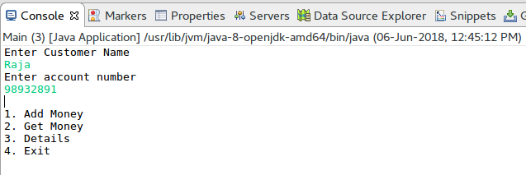
Display Details:

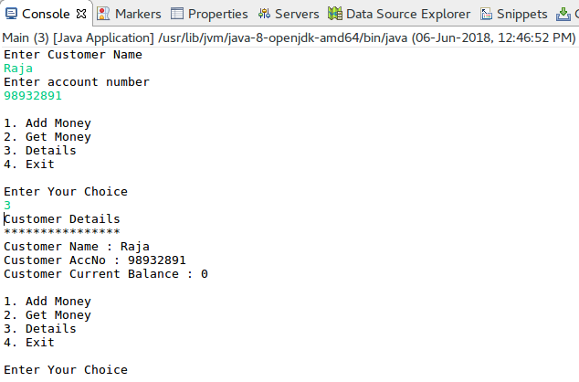
Add Money:

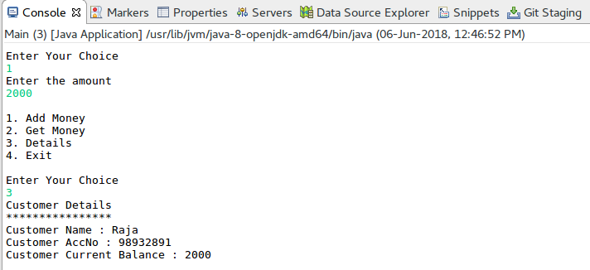

Get Money:

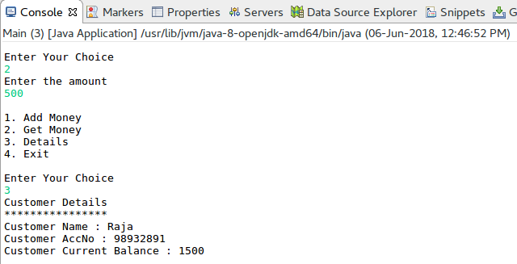
Exception in Add Money:

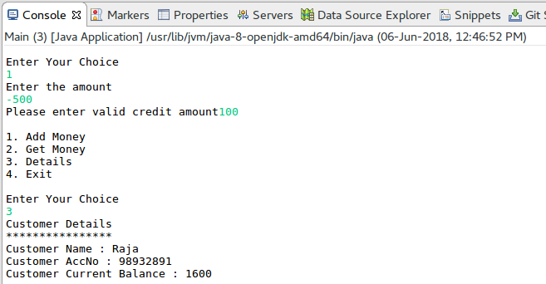

Exception in Get Money:

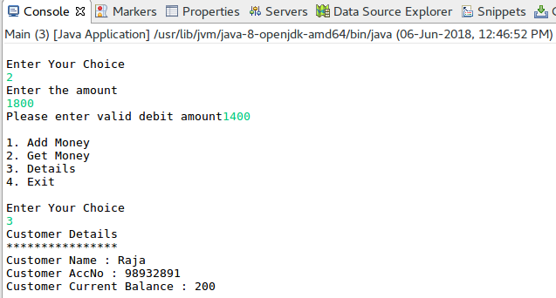

Result:

The java console application that uses user defined exception handling techniques was developed and tested successfully.

