Ex.No: 8 | Java Application for File Handling
Date: | Java Application for File Handling

Aim:

To create a Java console application to handle the files and find the file properties [Availability, Readable or Writeable or Both, Length of the File].

Algorithm:

Step 1 | Start the Process
Step 2 | Prompt the user to enter the file name with path
Step 3 | Get the file name
 | Step 3.1 | Check the file is exits
 | Step 3.2 | If file exists then proceed to step 3.3 else proceed to step 3.8
 | Step 3.3 | Check the File is Both Readable and Writeable
 | Step 3.4 | If yes display file is “Read and Writeable”
 | Step 3.5 | Else check is readable if yes display “Read Only” else move to step 3.6
 | Step 3.6 | Else check is writeable if yes display “Write Only”
 | Step 3.7 | Compute file size and display
 | Step 3.8 | If file not existing then display “File Not Found”
Step 4 | Stop the Process

Coding:

UserFileHandler.java

package com.raja.oopslab.files;

import java.io.File;
public class UserFileHandler{
File aFile;
boolean isReadable = false;
boolean isWriteable = false;
boolean isExists = false;
int length = 0;
public UserFileHandler(String path) {
aFile = new File(path);
this.isExists = aFile.exists();
this.isReadable = aFile.canRead();
this.isWriteable = aFile.canWrite();
this.length = (int) aFile.length();
}
public void fileDetails(){
if(isExists){
System.out.println("The File "+aFile.getName()+" is Available at:"+aFile.getParent());
if(isReadable && isWriteable)
System.out.println("File is Readable and Writeable");
else if(isReadable)
System.out.println("File is Only Readable");
else if(isWriteable)
System.out.println("File is Only Writeable");
System.out.println("Total length of the file is :"+this.length+" bytes");
}
else
System.out.println("File does not exists ");
}
}

Main.java

import java.io.File;
import java.util.Scanner;
import com.raja.oopslab.files.*;
public class Main {

public static void main(String[] args) {
String file_path = null;
Scanner input = new Scanner(System.in);
System.out.println("File Handler");
System.out.println("************");
System.out.println("Enter the file path");
file_path = input.next();
new UserFileHandler(file_path).fileDetails();
}
}

Output:

Availability of File:

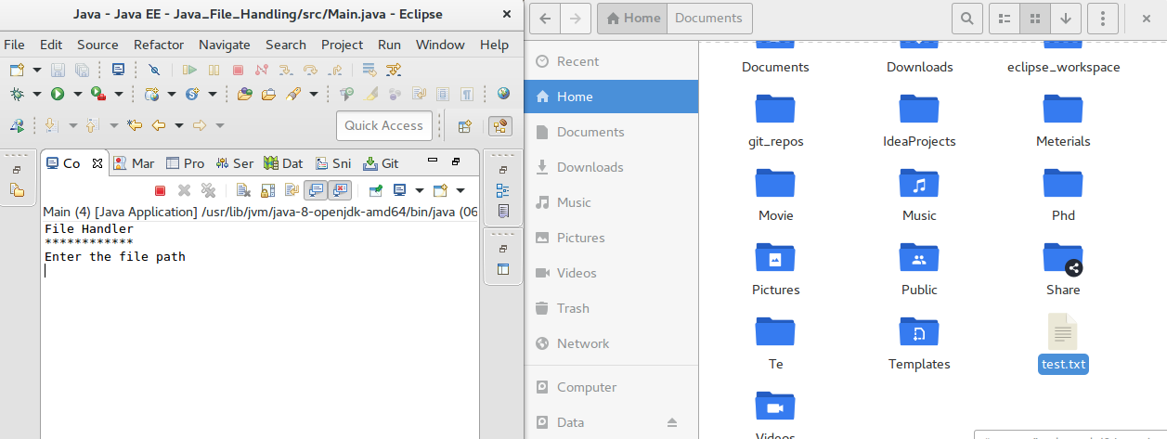

File Read and Writeable:

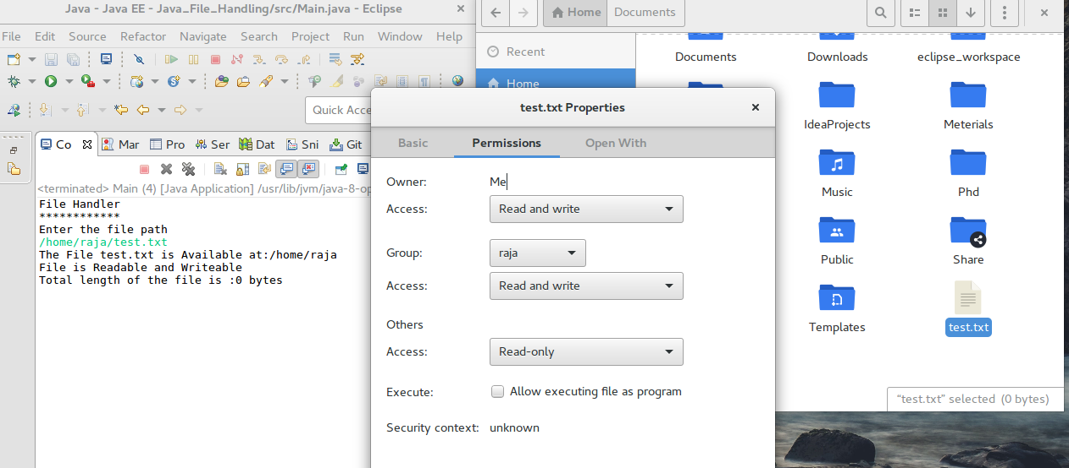

File Size:

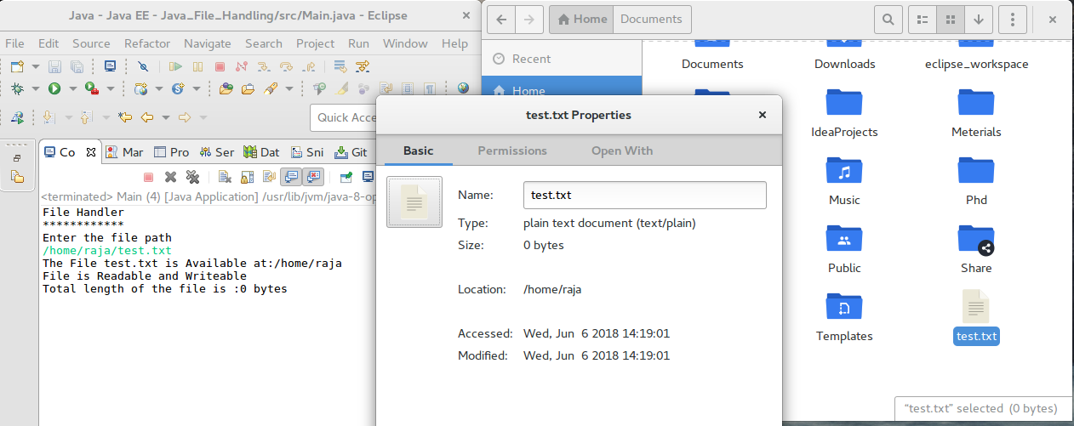

File Not Exists:

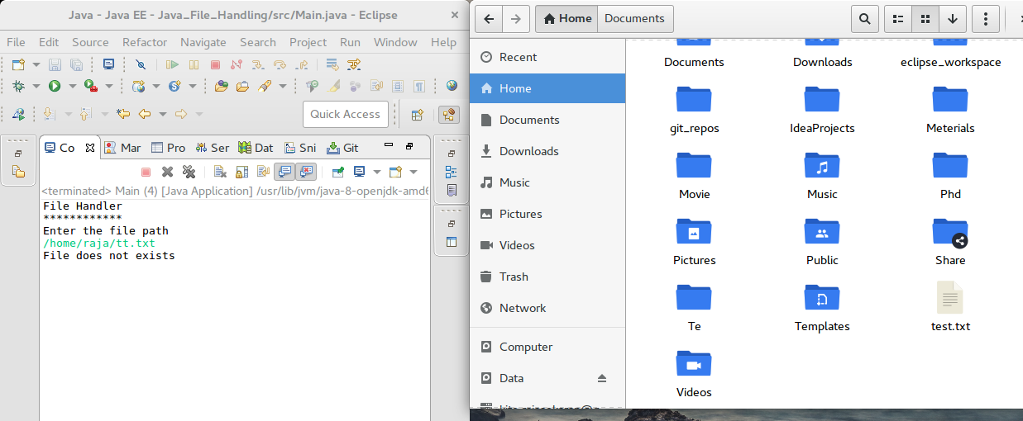

Result:

The java console application for handling files was developed and tested successfully.

