Ex.No:1 | Compute GCD of two numbers

Aim:

To develop a python program to find the GCD of given two numbers using Euclidian Algorithm.

Algorithm:

Step 1: | Start Process
Step 2: | Get 2 numbers from user and store it in num1 and num2
Step 3: | Assign num1 to a and num2 to b
Step 4: | If a is greater than b compute a – b and store in a
Step 5: | Else compute b – a and store in b
Step 6: | Compare a and b
Step 7: | If a is not equal to b and goto Step 4
Step 8: | Else print GCD of given numbers num1 and num2 is a
Step 9: | Stop Process

Flow Chart:
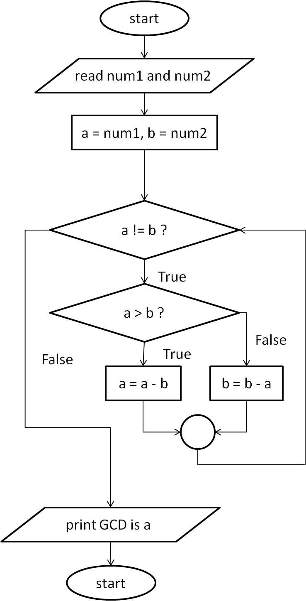

Pseudo Code:

START
READ num1 and num2
ASSIGN a = num1
ASSIGN b = num2
WHILE a not equal to b
IF a is greater than b THEN
a = a - b
ELSE
b = b - a
END IF
END WHILE
PRINT “GCD of given numbers ” num1 “and” num2 is “a”
STOP

Program:

gcd.py

print("GCD Finder")
print("----------")
print("Enter NUMBER 1 :")
num1 = int(input())
print("Enter NUMBER 2 :")
num2 = int(input())

a = num1
b = num2

while(a!=b):
if(a>b):
a = a - b
else:
b = b - a
print("GCD of given numbers",num1,"and",num2,"is",a)

Output:

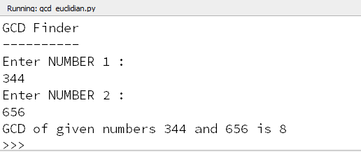

Result:

Thus the program to find the GCD of the given two number using Euclidian Algorithm was developed and tested successfully.

