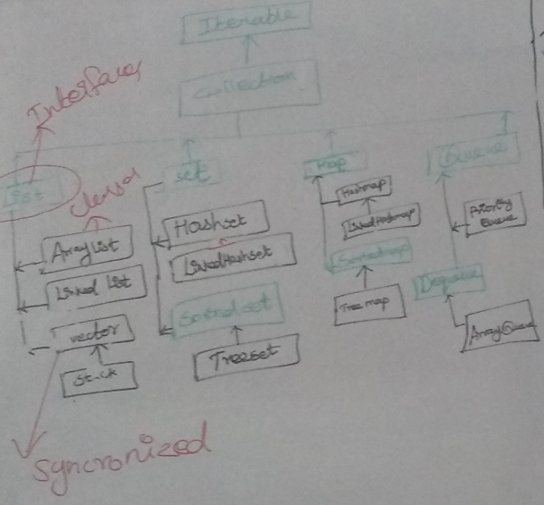

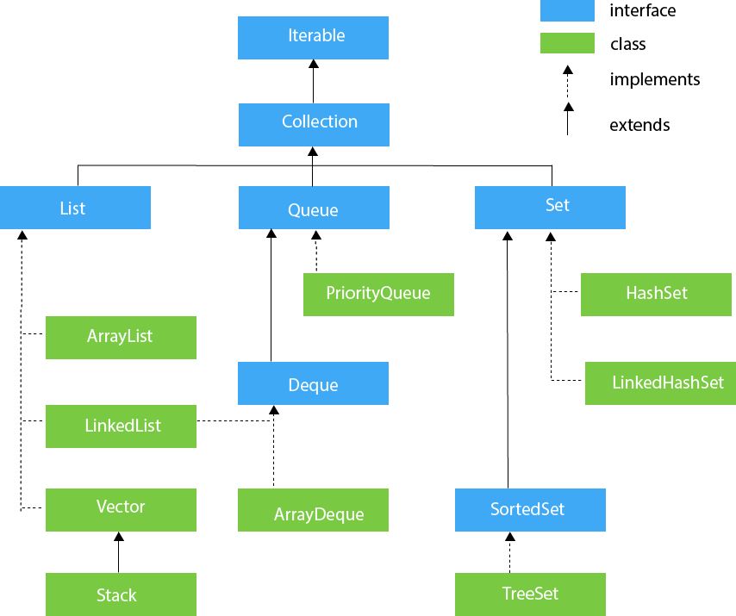

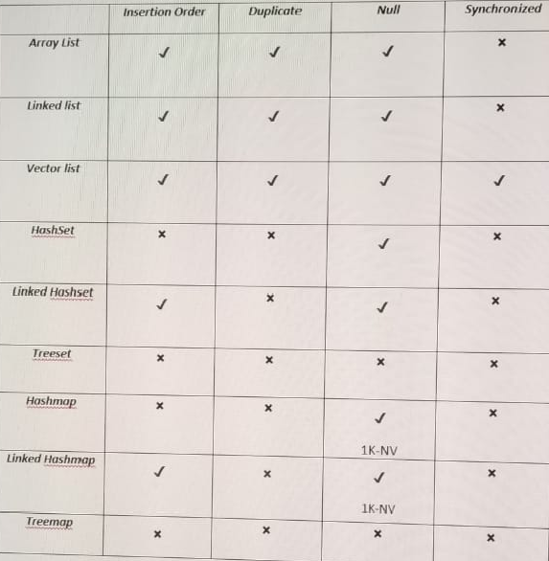

ArrayList:

LinkedList:

Vector:

HashSet:

LinkedHashSet:

TreeSet:

PriorityQueue:

Examples:

import java.util.\*;

class TestJavaCollection1{

public static void main(String args[]){

ArrayList<String> list=new ArrayList<String>();//Creating arraylist

list.add("Ravi");//Adding object in arraylist

list.add("Vijay");

list.add("Ravi");

list.add("Ajay");

//Traversing list through Iterator

Iterator itr=list.iterator();

while(itr.hasNext()){

System.out.println(itr.next());

// for (String str : list) {

// System.out.println(str);

}

}

}

Using Constructor Array List:

import java.util.\*;

class Book {

int id;

String name,author,publisher;

int quantity;

public Book(int id, String name, String author, String publisher, int quantity) {

this.id = id;

this.name = name;

this.author = author;

this.publisher = publisher;

this.quantity = quantity;

}

}

public class ArrayListExample {

public static void main(String[] args) {

//Creating list of Books

ArrayList<Book> list=new ArrayList<Book>();

//Creating Books

Book b1=new Book(101,"Let us C","Yashwant Kanetkar","BPB",8);

Book b2=new Book(102,"Data Communications & Networking","Forouzan","Mc Graw Hill",4);

Book b3=new Book(103,"Operating System","Galvin","Wiley",6);

//Adding Books to list

list.add(b1);

list.add(b2);

list.add(b3);

//Traversing list

for(Book b:list){

System.out.println(b.id+" "+b.name+" "+b.author+" "+b.publisher+" "+b.quantity);

}

}

}

Stack:

import java.util.\*;

public class TestJavaCollection4{

public static void main(String args[]){

Stack<String> stack = new Stack<String>();

stack.push("Ayush");

stack.push("Garvit");

stack.push("Amit");

stack.push("Ashish");

stack.push("Garima");

stack.pop();

Iterator<String> itr=stack.iterator();

while(itr.hasNext()){

System.out.println(itr.next());

}

}

}

Map:

Java Map Example: Generic (New Style)

import java.util.\*;

class MapInterfaceExample{

public static void main(String args[]){

Map<Integer,String> map=new HashMap<Integer,String>();

map.put(100,"Amit");

map.put(101,"Vijay");

map.put(102,"Rahul");

for(Map.Entry m:map.entrySet()){

System.out.println(m.getKey()+" "+m.getValue());

}

}

}

//Non-generic:

import java.util.\*;

public class MapExample1 {

public static void main(String[] args) {

Map map=new HashMap();

//Adding elements to map

map.put(1,"Amit");

map.put(5,"Rahul");

map.put(2,"Jai");

map.put(6,"Amit");

//Traversing Map

Set set=map.entrySet();//Converting to Set so that we can traverse

Iterator itr=set.iterator();

while(itr.hasNext()){

//Converting to Map.Entry so that we can get key and value separately

Map.Entry entry=(Map.Entry)itr.next();

System.out.println(entry.getKey()+" "+entry.getValue());

}

}

}

Deque -> ArrayDeque:

import java.util.\*;

public class TestJavaCollection6{

public static void main(String[] args) {

//Creating Deque and adding elements

Deque<String> deque = new ArrayDeque<String>();

deque.add("Gautam");

deque.add("Karan");

deque.add("Ajay");

//Traversing elements

for (String str : deque) {

System.out.println(str);

}

}

}