1. Create repository in GIT UI.

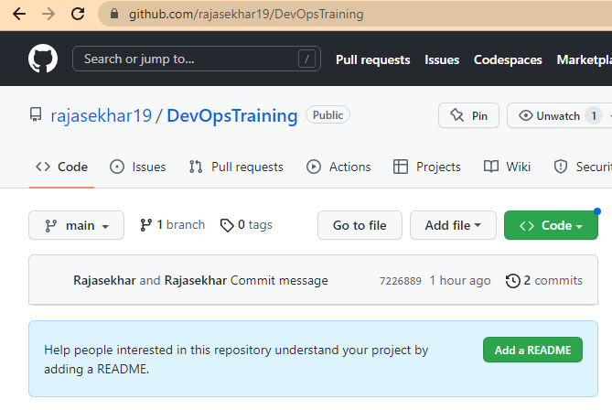

Clone Repository “DevOpsTraining” and initialize.

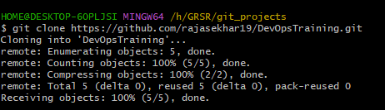



Create a text file with name “gitAssignment.txt”, add first line as “***This is first commit”***, commit and push.

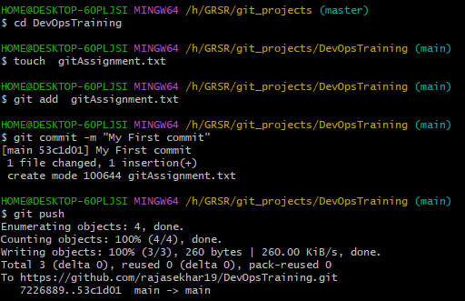

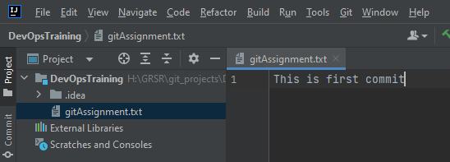

1. Create a feature branch f1, in this branch change this txt file and add second line as “***this is feature1***”

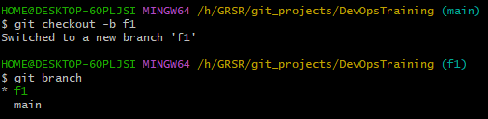

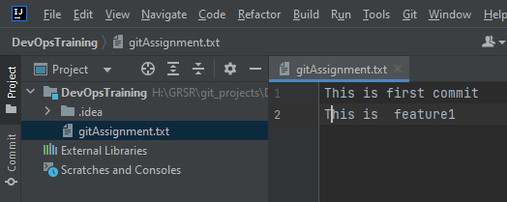

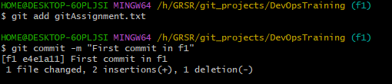

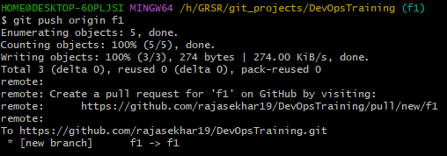

1. From master, create another feature branch f2, add in txt file second line as “this is feature2”

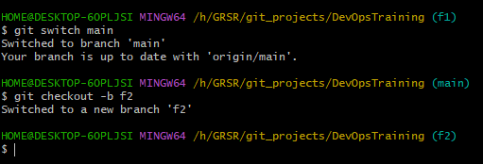

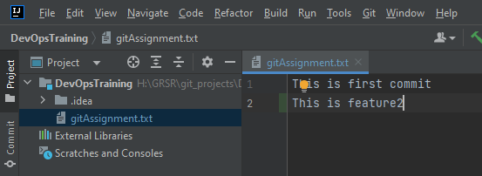

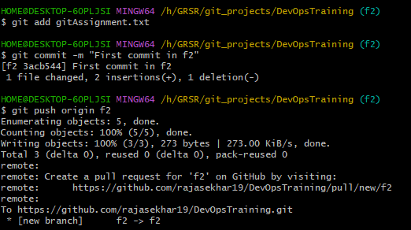

1. Merge f1 on master

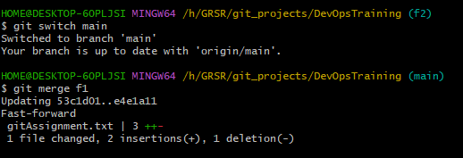

Now master has code as 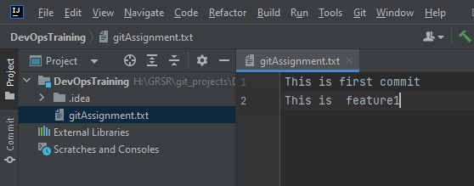

1. While merging f2 there were some errors, resolve the errors and submit the github repo.

Below are the conflicts while merging f2 to main.

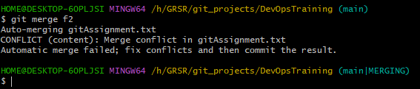

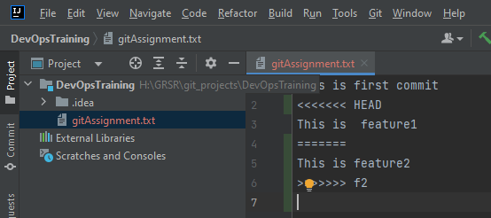

**Solution**:

Resolved the conflicts by accepting both changes and pushed again

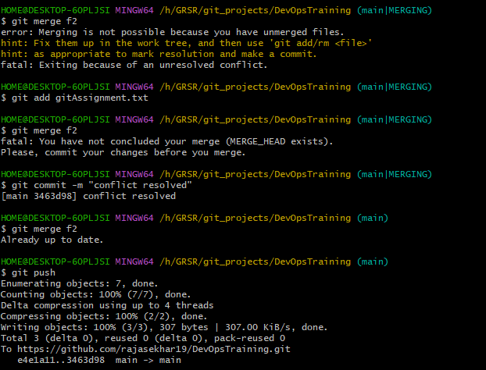

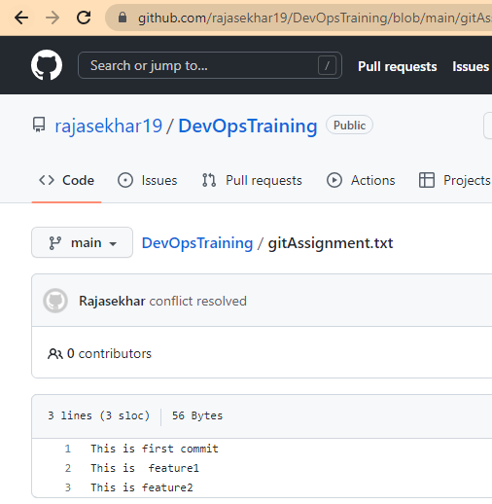

Repository: https://github.com/rajasekhar19/DevOpsTraining.git