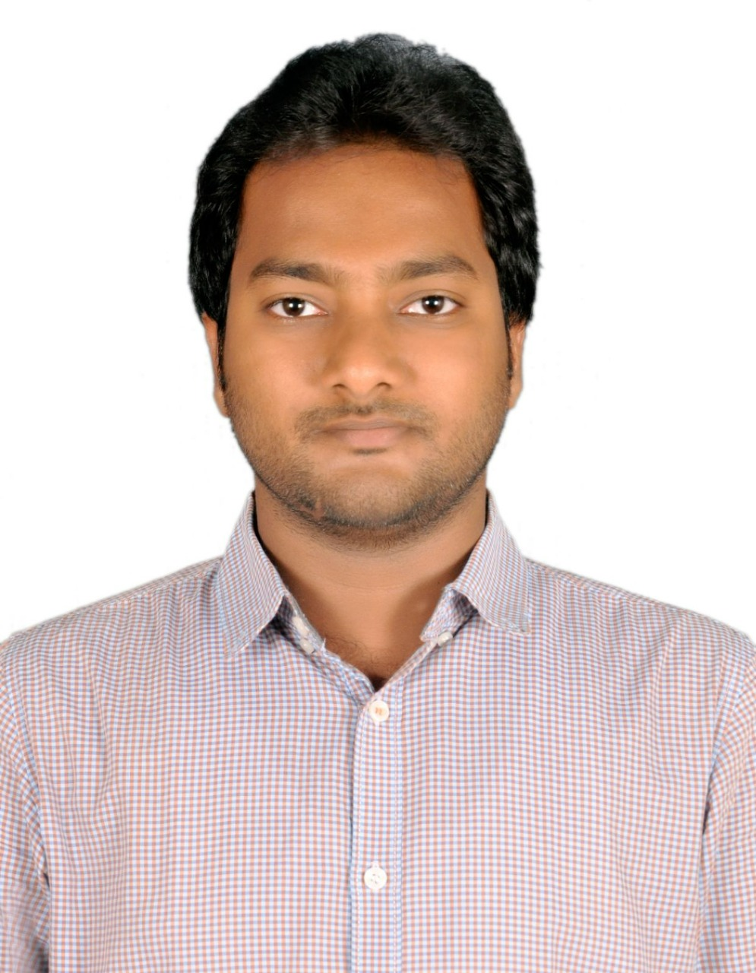

**Gurugubelli Rajasekhar**

DevOps Engineer

**PROFESSIONAL SUMMARY**

* Over two years of experience in cloud, DevOps, Infrastructure, and automation.
* Experience on implementing and deploying multiple applications on cloud.
* Experience on DevOps, CI/CD, and developing multiple internal applications.
* Experience on cloud technologies like Microsoft Azure and AWS (like S3, EC2, R53, VPC, RDS, Cloud Watch, SNS, EC2 solutions like ELB, Auto scaling).
* Experience in Configuration, Release, management and version control tools (Ansible, Jenkins, Github)
* Experienced in creating CI/CD pipelines by integrating Git, GitHub, Jenkins, and Ansible.
* Experienced in automating build process used for Java, and NodeJS applications using Jenkins.
* Worked on Roles, Playbooks in Ansible for Application Deployment Automation, and Cloud Infrastructure Automation.
* Experience on windows 2003/2008/2012/2016 servers administration. Configuration and Managing.

**SKILLS**

|  |  |
| --- | --- |
| * AWS Components: VPC, EC2, EBS, EFS, S3, ELB * Azure Components: Virtual Machines, Load Balancers, VMSS, Azure Storage | * Cloud: AWS, Azure * DevOps Tools: Git, Jenkins, Ansible, Docker * OS Platforms: Linux, Windows, Centos, Ubuntu, Amazon Linux |

**WORK HISTORY**

**SmartQE Project, DevRabbit, Hyderabad**

**Roles &Responsibilities:**

* Ownership for Azure SQL server DB deployment & managed the continues integration and Continuous Deployment.
* Worked in all areas of Jenkins setting up CI for new branches, build automation, plugin management and securing Jenkins and setting up master/slave configurations.
* Created Docker images for future usage and pushed the images into the docker repositories.
* Involved in designing and deploying multitude applications utilizing almost all AWS stack (Including EC2, S3, AMI, Route53, RDS, SNS, SQS, IAM) focusing on high stack (Including EC2, high- availability, fault tolerance, and Auto-Scaling in AWS Cloud Formation.)
* Managing Windows 2012 servers, troubleshooting IP issues and working with different supporting teams.
* Using Power shell to write, debug scripts to automate the processes and do migration of VM.
* Provided Build support for different applications, built and deployed to the production environment.
* Analyze and resolve conflicts related to merging of source code for GIT.
* Provided project support by configuring AD, DNS, DHCP, GPOs and Active Directory changes and implementation as needed.

**EDUCATION**

**M.Tech, GITAM, vishakapatnam**