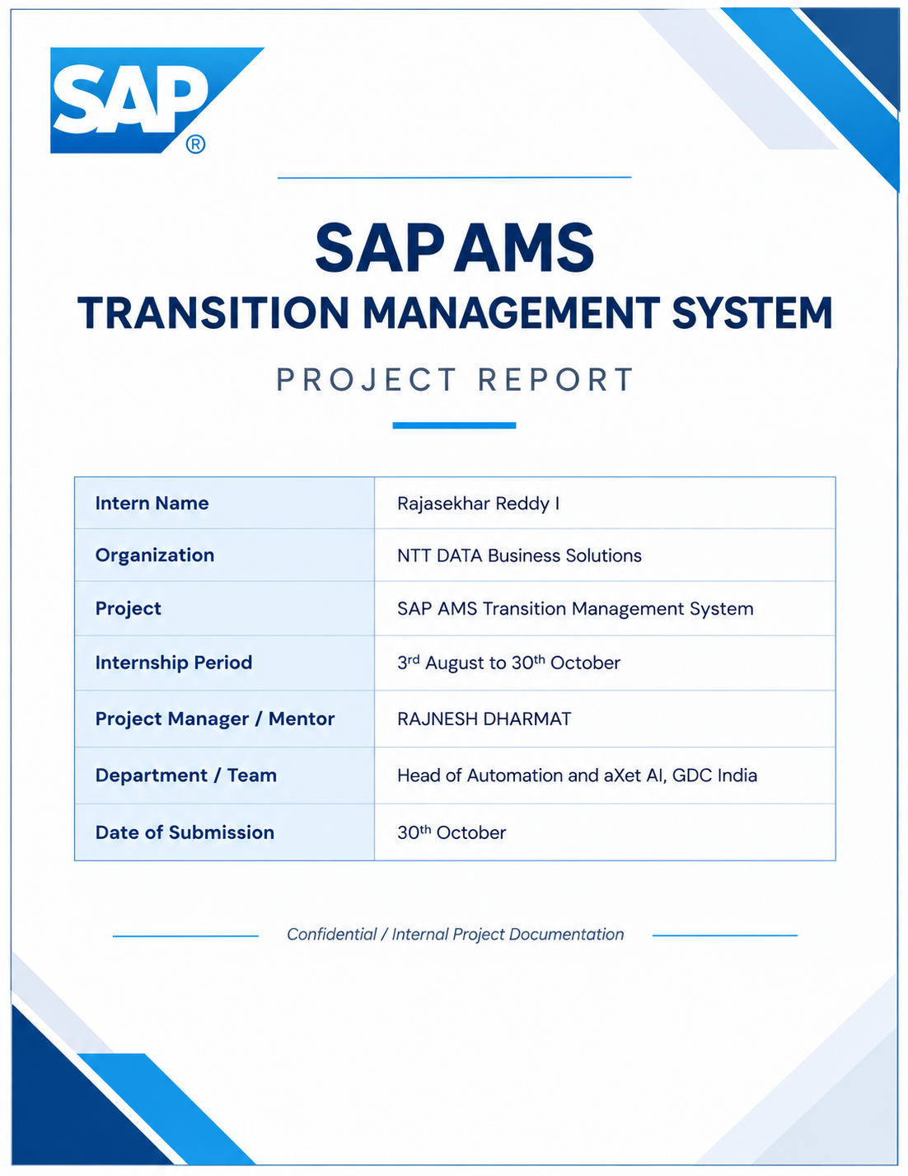

1. Executive summary
The SAP AMS Knowledge & Transition Platform is a web application intended to bring operational knowledge, support workflows, collaboration, transition coordination, onboarding, and selected AI-assisted tools into one authenticated workspace. The repository contains a React client, an Express API, and PostgreSQL integration, organized around feature-specific screens and route groups.
The project is a broad workflow platform rather than a single-purpose portal. Its visible client includes knowledge articles, support requests, chat and notifications, transition dashboards, certifications, contact information, administration, AI search, and ResumeIQ. The server also exposes onboarding, training, access provisioning, shadow assignment, and readiness-related APIs. The availability and completeness of API-only workflows may vary by deployment.
This report describes what can be established from the checked-in repository and its maintained project notes. It is not a production-readiness certification or a claim that every route, integration, or workflow was exercised against a live deployment.

1.1 Key takeaways
- Single workspace. The platform brings knowledge, support, collaboration, transition coordination, onboarding, and AI-assisted tools into one authenticated workspace.
- Three-tier design. A React client calls an Express API, which reads and writes PostgreSQL and any configured integrations.
- API-only areas. Some onboarding and readiness capabilities exist as backend route groups without a standalone client page, so availability depends on the deployment.
- Qualified claims. Items described as requested, planned, or configuration-dependent are called out as such and are collected in Section 8.
- Evidence base. Findings come from reviewing the repository and project notes; no live deployment was exercised.

1.2 How this report is organised
Sections 2 and 3 describe who the platform is for and what it offers. Section 4 walks through representative workflows, and Sections 5 and 6 cover the technical architecture, data, security, and configuration. Section 7 explains local setup, Section 8 records current status and known limitations, Section 9 proposes next steps, and Section 10 documents the sources and scope of the review.

1.3 Intended readers
The report is written for delivery leads, transition managers, engineers, and reviewers who need a shared, accurate picture of what the repository contains before planning deployment, enhancement, or handover work.

2. Product purpose and users
The application is designed to help AMS and support teams find and maintain reusable operational knowledge, request assistance, coordinate service transitions, and manage onboarding and readiness activities. Administrative screens support shared platform structures and user-facing operations.
User group (as represented in the project notes) | Typical needs
Employee / support user | Find trusted knowledge, raise or follow support requests, use collaboration tools, and view relevant transition or onboarding information.
Expert / L1 or L2 support | Respond to requests, share expertise, contribute or review knowledge, and coordinate operational work.
Team Lead | Coordinate transition tasks and team activities; exact permissions depend on server-side role configuration.
Administrator | Manage selected user, role, tag, team, certification, and directory-related functions. Admin navigation is role-conditioned in the client.

2.1 Platform objectives
- Findability. Help teams locate reusable operational knowledge quickly instead of re-solving known issues.
- Assistance. Give users a structured route to request assistance from experts and support staff.
- Transition coordination. Track transition work using tasks, phases, assignments, due dates, and sign-off where supported.
- Onboarding and readiness. Support onboarding and readiness through training, assignments, shadowing, access provisioning, and assessments.
- Shared administration. Let administrators maintain shared structures such as roles, tags, teams, certifications, and the phone directory.

2.2 Roles and access considerations
The client conditions navigation on the signed-in user's role, but the project notes make clear that effective permissions are decided on the server. Team Lead capabilities in particular depend on server-side role configuration, and administrator functions cover only selected areas. Before a deployment is relied on, the role-to-permission mapping should be confirmed for each user group listed above.

2.3 How the groups interact
Employees raise needs, experts and L1/L2 support respond and contribute knowledge, team leads coordinate transition and team activity, and administrators keep the shared reference data healthy. Knowledge created by experts feeds back into what employees can find, which is the core loop the platform is built around.

3. Application capabilities
Capability area | What the repository indicates
Knowledge management | Article browsing, authoring, editing, classification, tags, visibility, attachments, and review/publishing states.
Support and expertise | Support request and expert request route groups, with related client screens for support requests and expert requests.
Communication | Chat and notification route groups and corresponding client pages.
Transition management | A client transition dashboard and server routes for transition work, checklists, and attachments; project transition concepts include tasks, phases, assignments, due dates, and sign-off where supported.
Onboarding and readiness | Backend route groups for onboarding, approvals, training modules/assignments, shadow assignments, access provisioning, assessments, progress, and dashboard data. Some are API-only or lack a standalone client page.
AI-assisted tools | AI search, AI bot, article AI review, and ResumeIQ/resume matching. Provider keys, network access, and model configuration may be required.
Administration | Client pages and APIs for roles, tags, requests, teams, phone directory, and certification administration.

3.1 Reading the capability map
Each row above reflects what the repository indicates, not a verified production behavior. Four qualifiers recur throughout this report:
- Client and API. The capability has client screens and matching server routes.
- API-only. Server route groups exist but no standalone client page was identified.
- Configuration-dependent. Provider keys, network access, email settings, or storage paths must be supplied by the deployment.
- Requested. The feature is a request or plan and has not been verified as implemented.

3.2 Dependencies that affect capabilities
- AI tools: AI search, the AI bot, article AI review, and ResumeIQ need provider keys, outbound network access, and model configuration.
- Notifications: Email and notification behavior depends on environment-specific integration settings.
- Uploads: Attachments rely on a configurable upload path and size limit on the server.
- Administration: Administration screens and menu items are role-conditioned in the client and must be enforced by the API.

4. Representative workflows

4.1 Knowledge article lifecycle
- Browse or search available articles.
- Create or update an article, optionally adding classification, tags, visibility, co-author information, and attachments.
- Save a draft or submit it for review.
- Reviewers can approve or reject content through the available workflow; published content can then be reused.
Statuses represented in the backend/database include draft, under review, co-author pending, published, and rejected. The status constraint must be present in the target database for the relevant workflow to operate correctly.

4.2 Support and collaboration
Users can access support-request and expert-request screens and use chat or notifications. Assignment, escalation, service-level expectations, and notification-provider behavior should be confirmed in the target deployment rather than inferred from the presence of route groups.

4.3 Transition work
The current client provides a transition dashboard. Related backend routes address transition work, checklists, and attachments; users may review progress and update work subject to their permissions and the data available in the deployed database.

4.4 AI-assisted experiences
AI features are intended as assistive tools. AI-generated content and ResumeIQ matching results should be reviewed by a person and should not be treated as authoritative decisions, particularly for hiring-related use.

4.5 Points to verify before relying on a workflow
- Confirm the article status constraint exists in the target database.
- Confirm role permissions for reviewers, team leads, and administrators.
- Confirm notification, email, and AI-provider configuration for the environment.
- Confirm the upload path, size limit, and storage location are set and protected.

5. Technical architecture
The system follows a browser-to-API architecture. The React application sends HTTP requests to the Express API, which routes requests through middleware and feature handlers to PostgreSQL and configured integrations.
Layer | Technology / implementation
Web client | React 19, React Router 6, Material UI 5, Axios; built with Create React App / react-scripts 5.
API server | Node.js with Express 5 using CommonJS; feature route groups are mounted beneath /api.
Persistence | PostgreSQL accessed through the pg package and a shared server connection pool.
Authentication | JWT-based authentication; bcrypt/bcryptjs dependencies are present for password-related handling. Validate the deployed role and permission configuration.
AI and document processing | Google GenAI SDK plus document/PDF parsing, Office document extraction, image OCR, upload, email, and scheduling dependencies.
Repository organization | client/ contains the React UI; server/ contains configuration, routes, controllers, services, repositories, middleware, and SQL; memory-bank/ contains maintained project context.

5.1 Typical request flow
- Browser: A user opens a page in the React application, routed by React Router.
- Client call: The page uses Axios to send an HTTP request to a route beneath /api.
- Middleware: Middleware, including authentication, runs before the feature handler.
- Feature handler: The matching route group hands the request to controllers, services, and repositories.
- Persistence: Repositories query PostgreSQL through the shared connection pool and the result returns to the browser.

5.2 Design observations
The server is organised by feature, with route groups mounted beneath /api and supporting layers for controllers, services, repositories, middleware, and SQL. This separation makes it practical to extend one feature without reworking others. The client mirrors that structure with feature-specific pages. The Create React App toolchain is noted for periodic review in Section 9.

5.3 Integration points
- AI: The Google GenAI SDK supports the AI-assisted features.
- Documents: Document and PDF parsing, Office document extraction, and image OCR support content ingestion.
- Messaging: Email and scheduling dependencies support notifications and background activity.

6. Data, security, and configuration
- PostgreSQL is the primary relational store. SQL setup and migration files are under server/db/. The project notes caution that there is no single verified, authoritative migration runner/order for every SQL file.
- Authentication is implemented at the API boundary. Hiding a screen or menu item in the React client is not a substitute for server-side authorization; verify role checks for each protected operation.
- The backend supports uploaded files using a configurable upload path and size limit. Uploaded documents and user records should not be committed to source control or included in reports.
- AI services and email/notification integrations depend on environment-specific configuration. Keep secrets in server/.env and out of source, logs, screenshots, and documentation.
- The project notes identify a client API-origin caveat: inspected API modules use the literal local URL http://localhost:3001/api. A deployment on a different origin should configure or revise this before release.

6.1 Security and configuration checklist
- Verify server-side role checks for every protected operation rather than relying on hidden menu items.
- Keep secrets in server/.env and out of source control, logs, screenshots, and documentation.
- Set the upload path and size limit deliberately, and keep uploaded files outside the repository.
- Review SQL files in server/db/ against the intended database before applying them, as no single migration order is verified.
- Configure the client API origin for the target environment before release.
- Confirm what content is sent to AI providers and whether that is acceptable for the deployment.

6.2 Data handling
Uploaded documents and user records are sensitive by nature. They should stay out of source control and out of reports such as this one, and the team should decide how long they are retained, who can access them, and how they are backed up.

6.3 Environment separation
Use separate configuration for local, test, and production environments, and never reuse local credentials or secrets elsewhere. Each environment should have its own database, its own JWT secret, and its own upload location.

7. Local development setup
The repository documents separate client and server installs and processes. A PostgreSQL instance and valid environment settings are prerequisites. Do not copy real credentials into source files.
- Install server dependencies from server/ with npm install.
- Create server/.env from server/.env.example and configure the database, JWT secret, upload settings, and any integrations that are needed.
- Install client dependencies from client/ with npm install.
- Start the API from server/ with npm run dev (or npm start).
- Start the client from client/ with npm start. The documented local defaults are client port 3000, API port 3001, and PostgreSQL port 5432.
Available client commands include npm start, npm test, and npm run build. Server commands include npm start, npm run dev, and npm run embedding. The server package manifest does not define a test script.

7.1 Prerequisites
- A Node.js runtime with npm, compatible with the installed dependencies.
- A reachable PostgreSQL instance and a database prepared for the application.
- A valid server/.env created from server/.env.example, without copying real credentials into source files.

7.2 Default local ports
- Client: port 3000.
- API server: port 3001.
- PostgreSQL: port 5432.

7.3 Practical notes
- Start the API first so the client has something to call.
- The client currently calls http://localhost:3001/api, so keep the API on port 3001 for local work.
- The server defines no test script, and npm run embedding is available for the embedding-related task.

7.4 Troubleshooting pointers
- If the client cannot reach the API, confirm the server is running on port 3001.
- If the server reports database errors, check the database settings in server/.env and that PostgreSQL is running.
- If an article workflow fails on status, check that the status constraint exists in the database.

8. Current status and known limitations
Topic | Status / implication
Multi-project transition planning | A requested enhancement, not verified as implemented. Project identity, plan ownership, dashboard metrics, editing permissions, schema/API changes, and cross-project isolation remain to be designed.
Database initialization | A full clean initialization and canonical ordering of all SQL files have not been verified. Review migrations against the intended database before applying them.
API-only functionality | Several onboarding/readiness workflow route groups are present, but not every route has a corresponding standalone client page or verified deployment exposure.
Deployment readiness | Production hosting, backups, monitoring, scaling, service levels, and a production security sign-off are not documented or verified.
Test evidence | This report is based on repository and project-note review. No fresh client test/build or live integration test was run while generating this report.

8.1 Interpreting status
The table above separates what is requested, what is unverified, and what is undocumented. None of these items is evidence of a defect; each marks a point where the repository does not yet prove the behavior.

8.2 Risk summary
- Database: An unverified initialization order can produce inconsistent databases between environments.
- Hosting: A fixed local API origin will break the client when it is hosted separately from the API.
- Testing: With no server test script, regressions in authentication and authorization could go unnoticed.
- Scope: Multi-project transition planning needs design work on identity, ownership, permissions, and isolation before implementation.
- Operations: Hosting, backups, monitoring, scaling, and security sign-off are not documented.

8.3 What this report does not claim
This report does not claim that every route works, that every integration has been exercised, or that the platform is ready for production. It records what the repository indicates and where further verification is needed.

9. Recommended next steps
- Confirm the target deployment environment and document a safe, repeatable database initialization and migration process.
- Move the client API origin into a documented build-time configuration and verify the client works when hosted separately from the API.
- Define the multi-project transition feature: stable project IDs, data relationships, user access rules, dashboard scope, editable fields, and audit/versioning expectations; then implement server-side isolation and tests.
- Add or maintain automated coverage for critical authentication, article lifecycle, support, transition, and authorization workflows.
- Document operational controls for uploads, secrets, AI-provider failures, backups, logging, and monitoring before production use.
- Review dependency health and build tooling on a scheduled basis, especially the Create React App toolchain, and record any accepted dependency risk.

9.1 Suggested sequencing
- Foundation. Steps 1 and 2: confirm the deployment target, database initialization, and client API origin.
- Build and protect. Steps 3 and 4: design the multi-project transition feature and build automated coverage around critical workflows.
- Operate and maintain. Steps 5 and 6: document operational controls and review dependency health on a schedule.

9.2 Signs the platform is ready for wider use
- A repeatable database setup works on a clean environment.
- The client runs against an API on a different origin.
- Authorization is tested for the main roles.
- Backups, logging, and monitoring are documented and exercised.
- AI-provider failures and upload limits are handled and documented.

9.3 Ownership and tracking
Assign an owner to each step, agree target dates, and record outcomes in the maintained project notes so that progress against these recommendations stays visible to everyone involved.

10. Source basis and scope
This report was prepared from the repository?s memory-bank documents, client and server package manifests, server route registration, and the visible client page inventory. Important reference files include memory-bank/projectbrief.md, memory-bank/productContext.md, memory-bank/systemPatterns.md, memory-bank/techContext.md, memory-bank/activeContext.md, memory-bank/progress.md, client/package.json, server/package.json, and server/routes/index.js.
Interpretation note: Where the repository describes a feature as requested, planned, API-only, or configuration-dependent, this report preserves that qualification instead of presenting it as a verified production capability.

10.1 Limitations of this review
- No fresh client test or build was run, and no live integration test was performed.
- Route availability was taken from registration and page inventory, not from calls to a deployed system.
- This is not a production-readiness certification.

10.2 Key reference files
- memory-bank/ documents: Project context, product context, system patterns, technology context, active context, and progress notes.
- client/package.json and server/package.json: Dependency and script inventory for the client and the server.
- server/routes/index.js: Registration of the server route groups.

10.3 Keeping this report current
Refresh this report when route groups are added, deployment decisions are made, or any limitation in Section 8 is resolved, so that readers always see qualified claims rather than outdated ones.

10.4 Terminology
- Requested: A feature described in the project notes as an enhancement that has not been confirmed as built.
- Planned: A feature the repository describes as intended for later work.
- API-only: Backend routes exist, but no standalone client page was identified.
- Configuration-dependent: Behavior that depends on environment settings, keys, or services.

