1. Population pushed below poverty line by household health expenditure

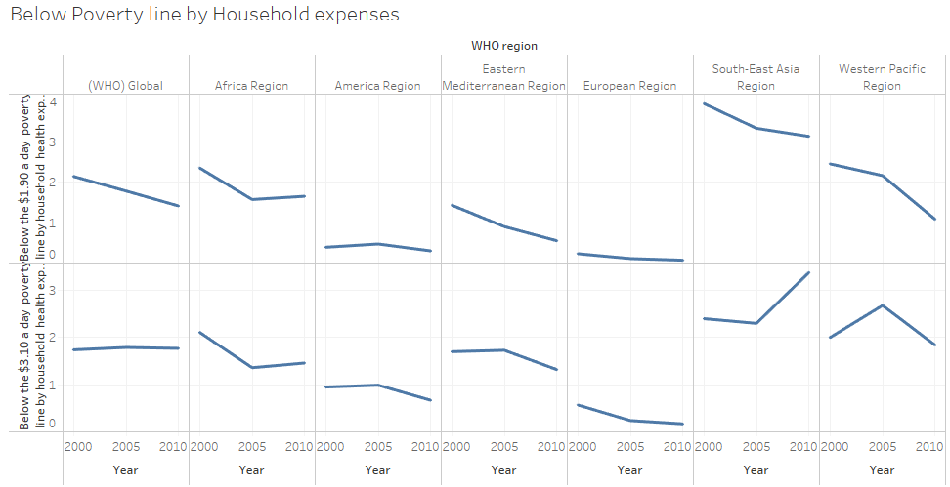

Of all the regions we can see that there is an increasing trend of population pushed below poverty line by household expenses of both $1.90 & $3.10 a day. Also a steep raise is seen for South-East Asia region trend of population pushed below poverty line by household expenses of $3.10 a day.

1. Household Expenditure

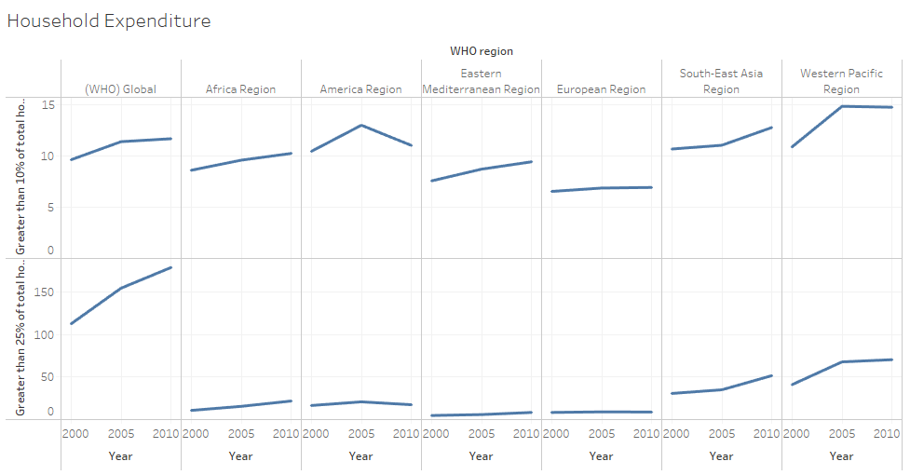

Only in American Region the Household expenditure of greater than 10% & 25% are showing a decreasing trend, rest all the other regions have an increasing trend for both these parameters.

1. Co-relation of Expenditure of Households on Poverty line

WHO Global

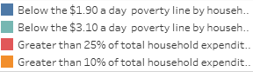

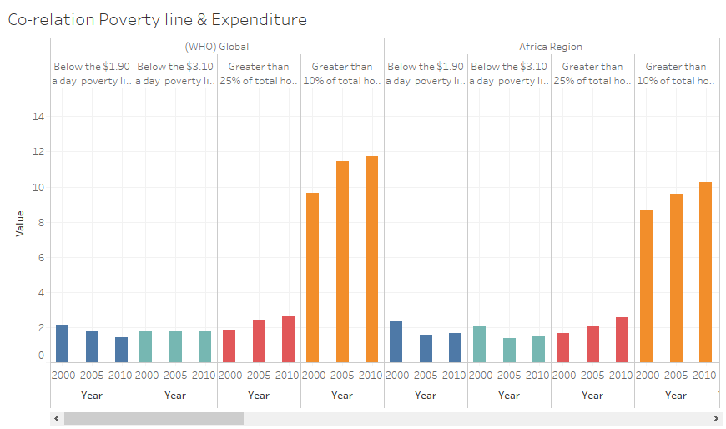

We can see that with increase in expenditure greater than 10% & 20% lesser people are pushed below the poverty line of $1.90 & $3.10 a day. The proportion of greater than 10% in African region is higher than 25% expenditure.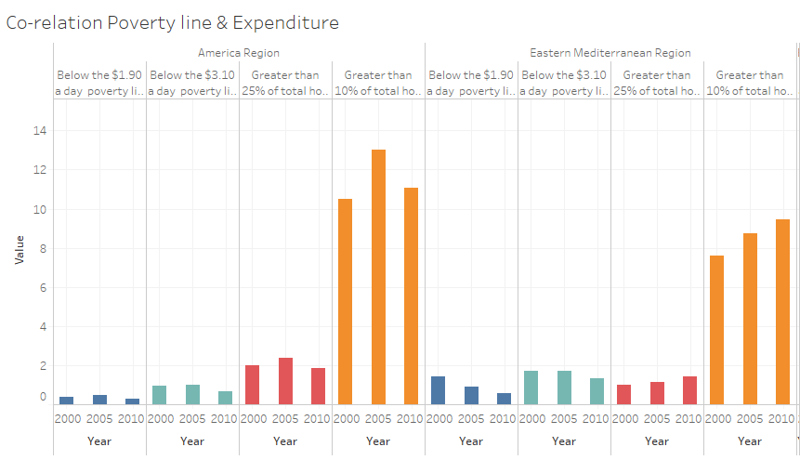

In the American region expense & poverty line has the same trend hence not indication a strong relation in terms of proportionate change. For EM region as expenditure increases the number of people below poverty line falls.

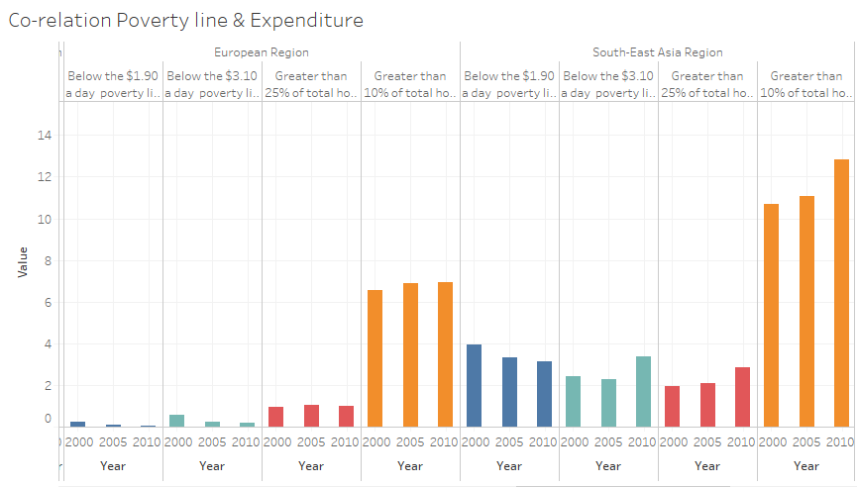

In European region the number of people below poverty line is lowering down in spite of the fact that there is no significant increase in the expenditure. Strangely in South-East Asia although the expenditure of the households are consistently increasing we can see increase in the number of people pushed to poverty line of $3.10 per day.

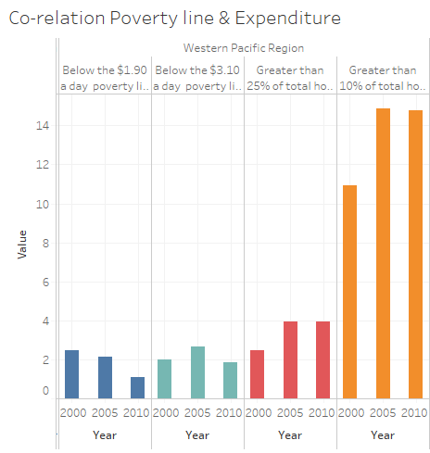

In the Western Pacific region we can see a negative correlation of expenditure and poverty line. With increase of household expenditure the number of people pushed below poverty line is decreasing.

Health Spends

Compulsory Financing Arrangements (CFA) as % of Current Health Expenditure (CHE)

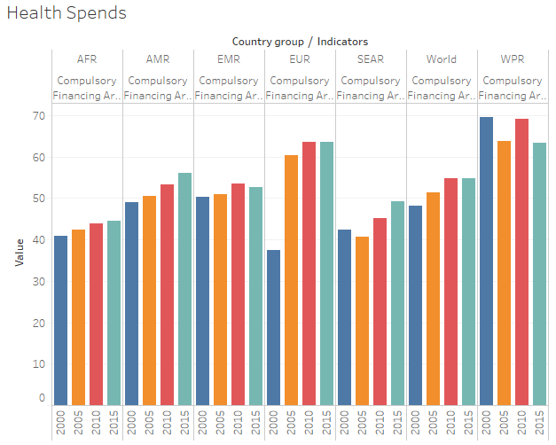

African region has the least Compulsory Financing Arrangements as of Current Health Expenditure

Compulsory Financing Arrangements (CFA) as % of General Government Expenditure (GGE)

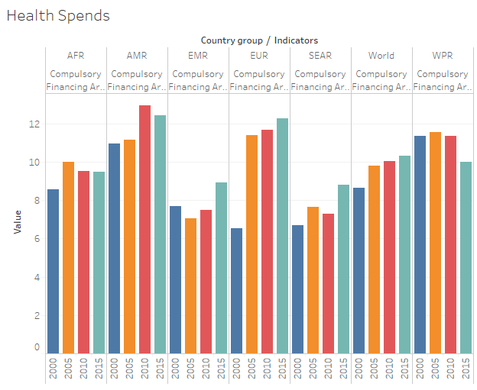

South-East Asia has the lowest Compulsory Financing Arrangements as of General Government Expenditure

Compulsory Financing Arrangements (CFA) per Capita in PPP Int$

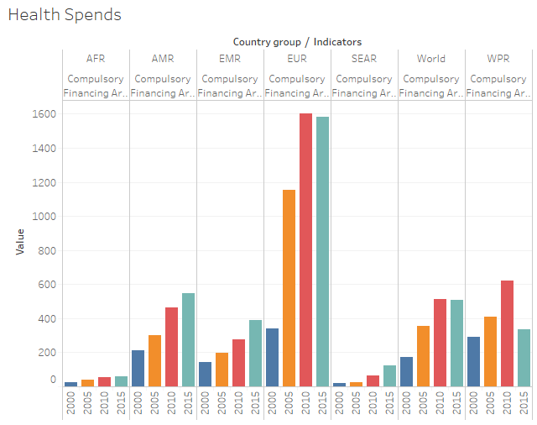

African region has the lowest Compulsory Financing Arrangements per Capita in PPP Int$

Compulsory Financing Arrangements (CFA) per Capita in US$

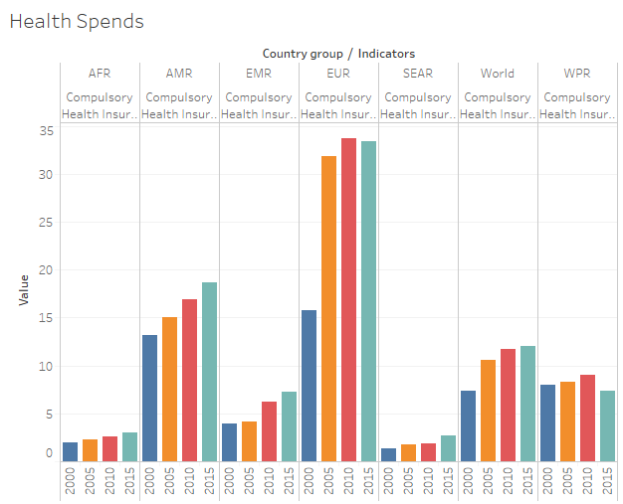

Africa & South East Asian region has the lowest Compulsory Financing Arrangements per Capita in US$

Compulsory Health Insurance (CHI) as % of Current Health Expenditure (CHE)

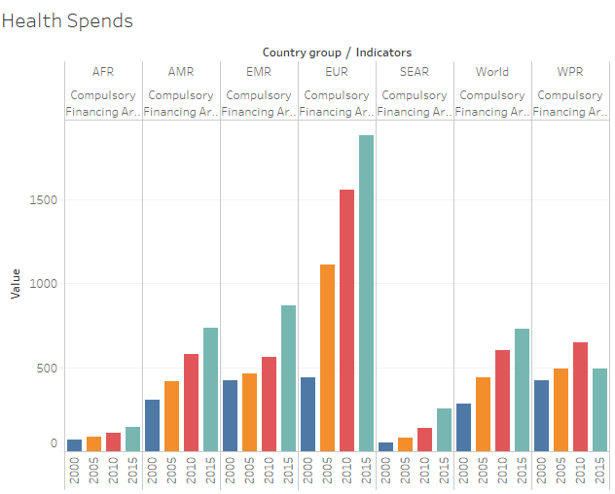

African region has the lowest Compulsory Health Insurance as % of Current Health Expenditure

Current Health Expenditure (CHE) as % Gross Domestic Product (GDP)

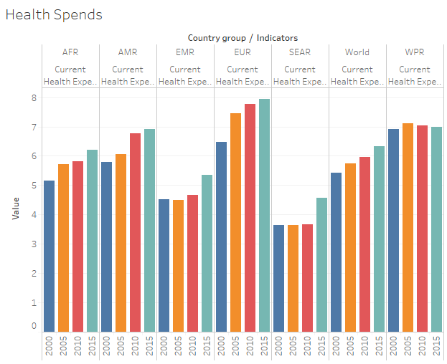

South- East Asia has the least Current Health Expenditure as % Gross Domestic Product

Current Health Expenditure (CHE) per Capita in PPP

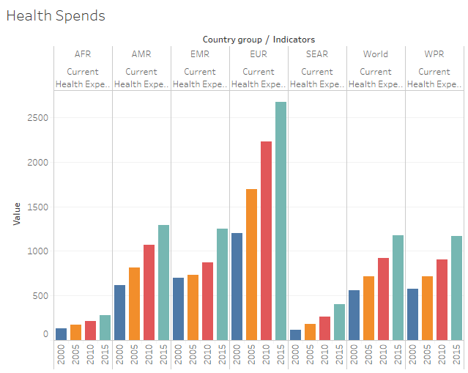

African region has the lowest Current Health Expenditure per Capita in PPP

Current Health Expenditure (CHE) per Capita in US$

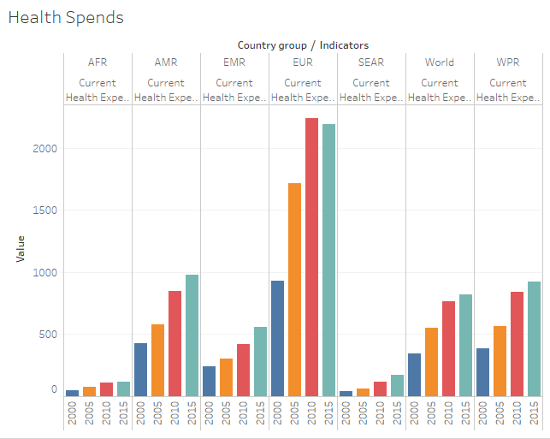

African region has the lowest Current Health Expenditure per Capita in US$

Domestic General Government Health Expenditure (GGHE-D) as % Current Health Expenditure (CHE)

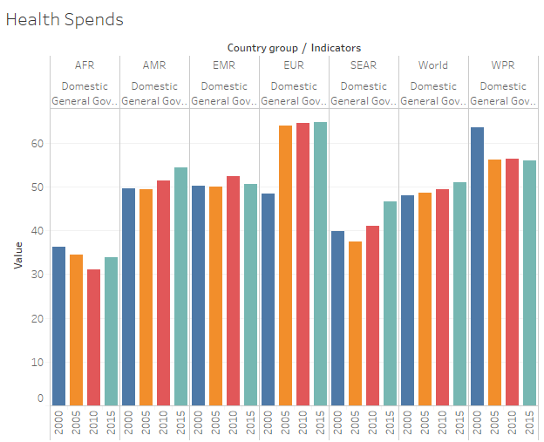

African region has the lowest Domestic General Government Health Expenditure as % Current Health Expenditure

Domestic General Government Health Expenditure (GGHE-D) as % General Government Expenditure (GGE)

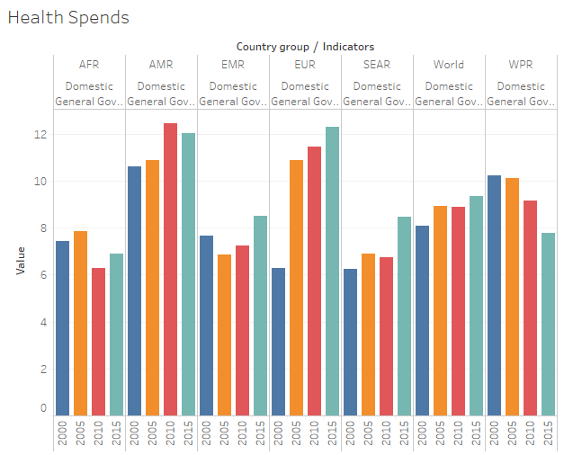

African region has the lowest Domestic General Government Health Expenditure as % General Government Expenditure

Domestic General Government Health Expenditure (GGHE-D) as % Gross Domestic Product (GDP)

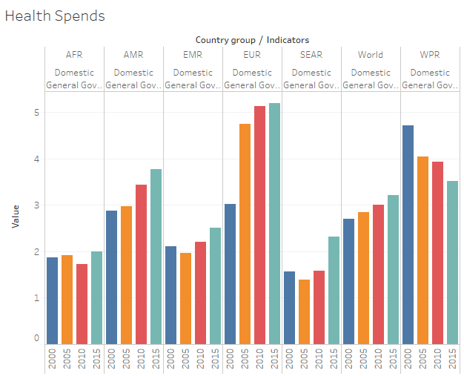

African region has the lowest Domestic General Government Health Expenditure as % Gross Domestic Product

Domestic General Government Health Expenditure (GGHE-D) per Capita in PPP Int$

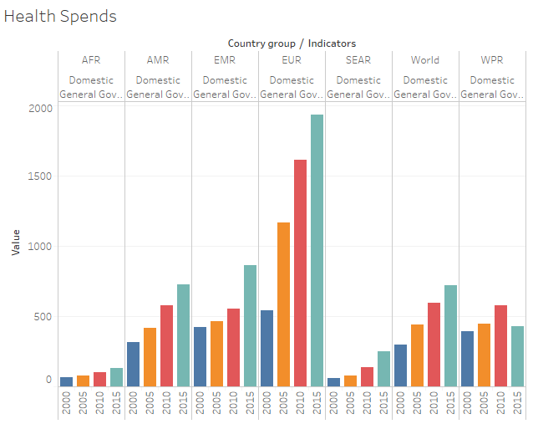

African region has the lowest Domestic General Government Health Expenditure per Capita in PPP Int$

Domestic General Government Health Expenditure (GGHE-D) per Capita in US$

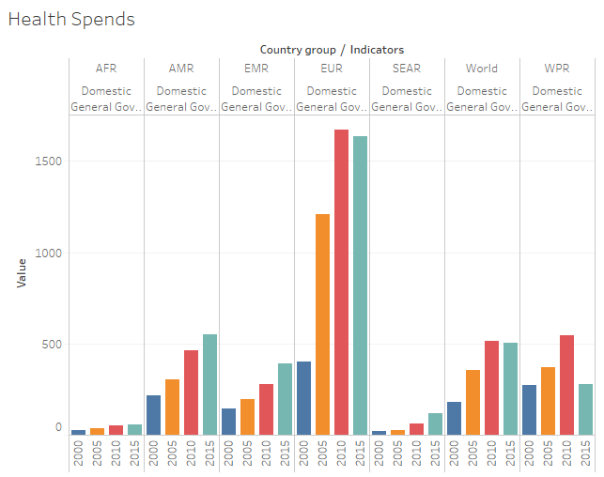

African region has the lowest Domestic General Government Health Expenditure per Capita in US$

Domestic Health Expenditure (DOM) as % of Current Health Expenditure (CHE)

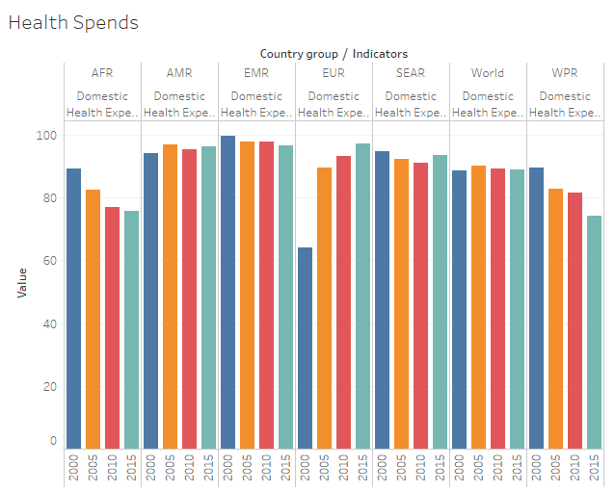

African region has the lowest and declining Domestic Health Expenditure (DOM) as % of Current Health Expenditure (CHE)

Domestic Private Health Expenditure (PVT-D) as % Current Health Expenditure (CHE)

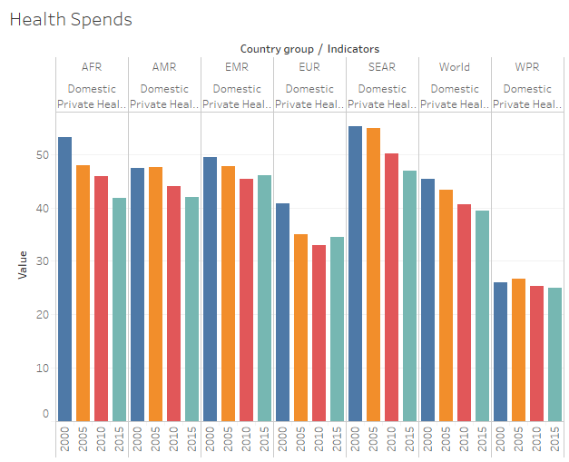

West Pacific region has the least Domestic Private Health Expenditure as % Current Health Expenditure

Domestic Private Health Expenditure (PVT-D) per Capita in PPP Int$

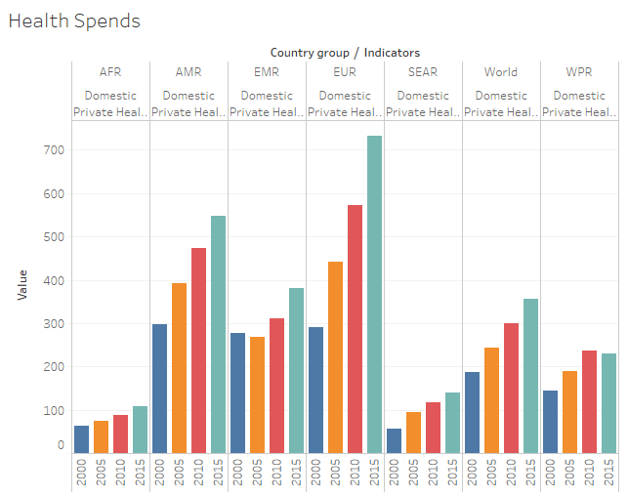

African region has the lowest although increasing trend of Domestic Private Health Expenditure (PVT-D) per Capita in PPP Int$

Domestic Private Health Expenditure (PVT-D) per Capita in US$

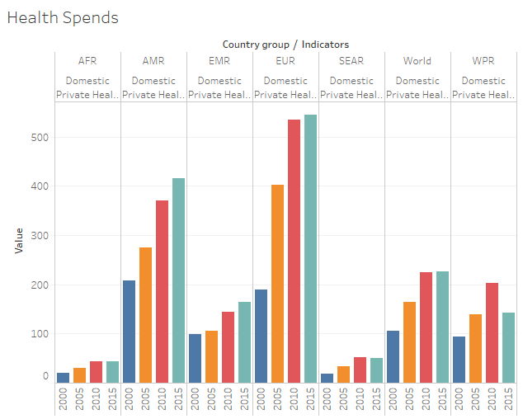

African region has the lowest Domestic Private Health Expenditure per Capita in US$

External Health Expenditure (EXT) as % of Current Health Expenditure (CHE)

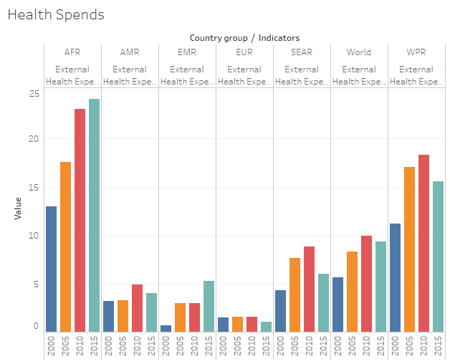

African region has the highest External Health Expenditure as % of Current Health Expenditure and the European region.

External Health Expenditure (EXT) per Capita in PPP Int$

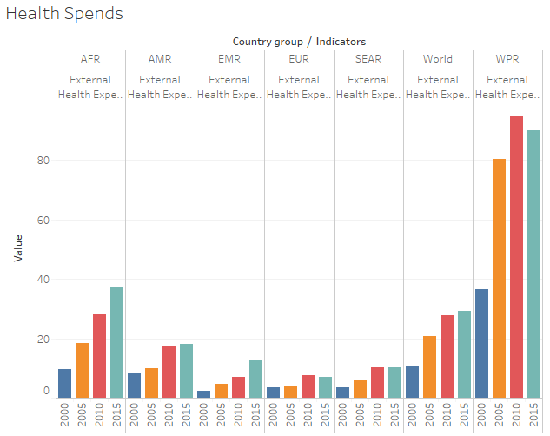

European region has the lowest External Health Expenditure per Capita in PPP Int$

External Health Expenditure (EXT) per Capita in US$

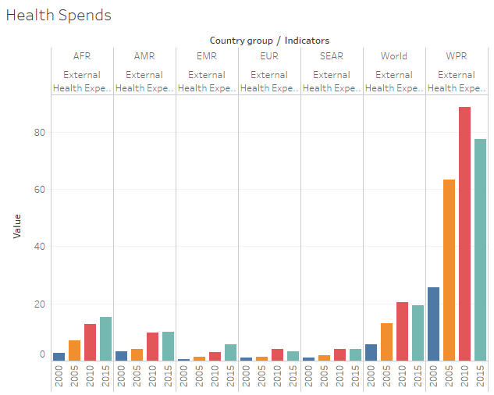

West Pacific region has the highest External Health Expenditure (EXT) per Capita in US$

External Health Expenditure Channelled through Government (EXT-G) as % of External Health Expenditure (EXT)

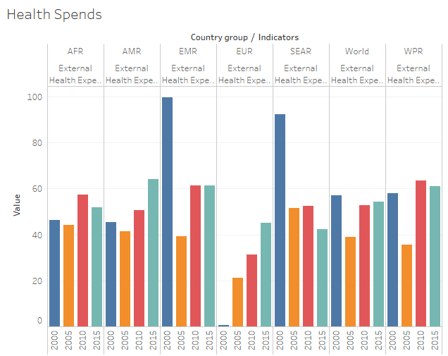

European region has the lowest External Health Expenditure Channelled through Government as % of External Health Expenditure

Government Budget Transfers to Social Health Insurance (SHI-G) as % of Social Health Insurance (SHI)

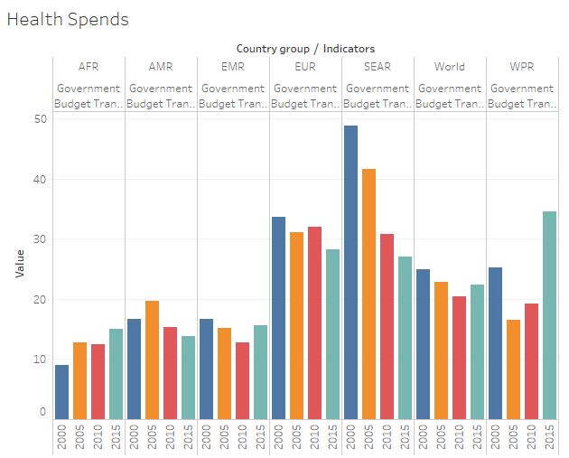

African region has the lowest Government Budget Transfers to Social Health Insurance as % of Social Health Insurance

Government Financing Arrangements (GFA) as % of Current Health Expenditure (CHE)

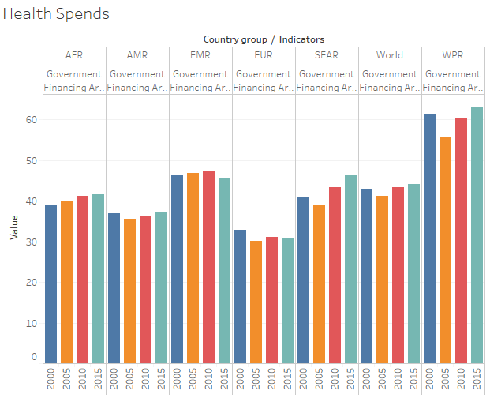

European region has the lowest Government Financing Arrangements as % of Current Health Expenditure

Health Capital Expenditure (HK) % Gross Domestic Product (GDP)

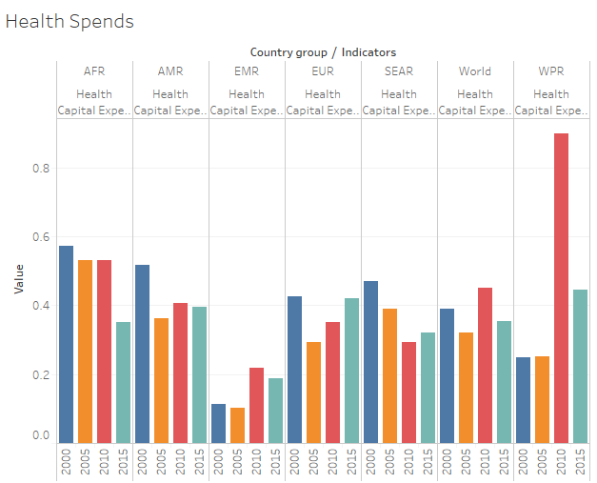

West Pacific region has seen the highest fall in Health Capital Expenditure % Gross Domestic Product in from 2010 to 2015.

.

Other Financing Arrangements as % of Current Health Expenditure (CHE)

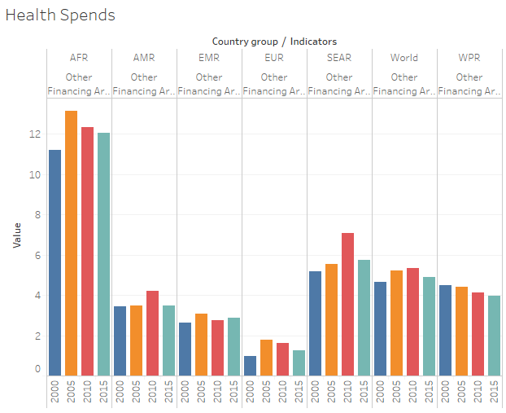

African region has the highest and European region has the lowest Other Financing Arrangements as % of Current Health Expenditure

Out-of-pocket (OOPS) as % of Current Health Expenditure (CHE)

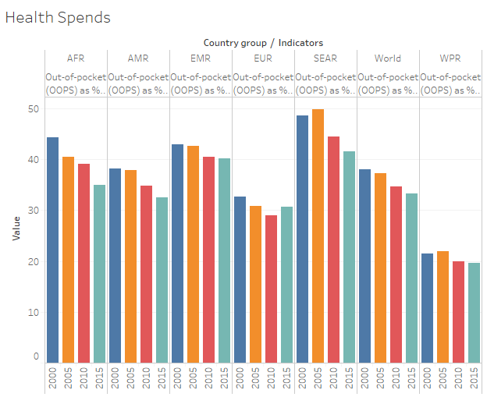

West Pacific region has the lowest Out-of-pocket as % of Current Health Expenditure

Out-of-Pocket Expenditure (OOPS) per Capita in PPP Int$

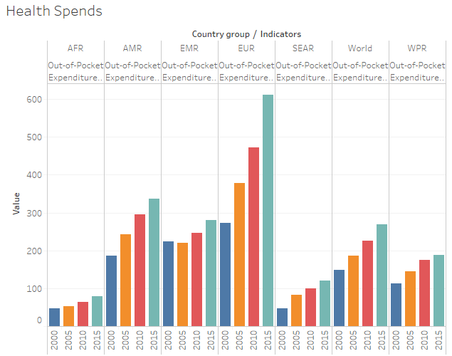

African region has the lowest Out-of-Pocket Expenditure per Capita in PPP Int$

Out-of-Pocket Expenditure (OOPS) per Capita in US$

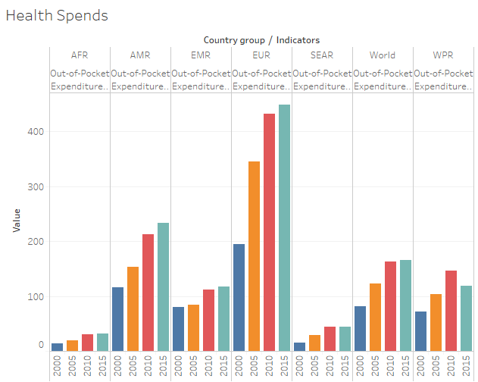

Out-of-Pocket Expenditure (OOPS) per Capita in US$

Social Health Insurance (SHI) as % of Current Health Expenditure (CHE)

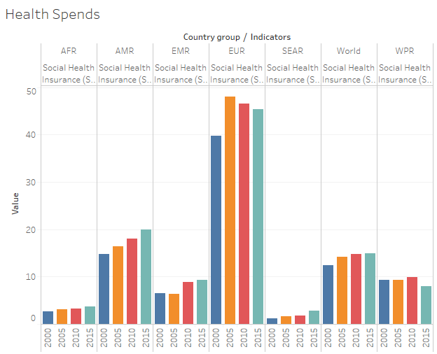

European region has the highest Social Health Insurance as % of Current Health Expenditure whereas South-East Asian and African region has very low Social Health Insurance (SHI) as % of Current Health Expenditure

Voluntary Financing Arrangements (VFA) as % of Current Health Expenditure (CHE)

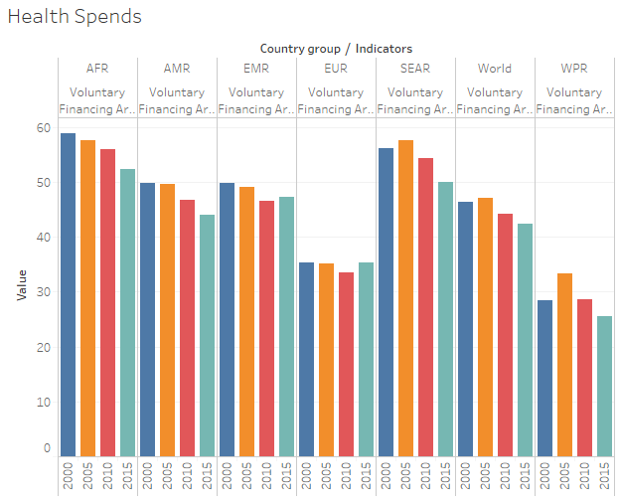

African region has the highest Voluntary Financing Arrangements as % of Current Health Expenditure which is consistently declining and West pacific region has the lowest arrangements

Voluntary Financing Arrangements (VFA) per Capita in PPP Int$

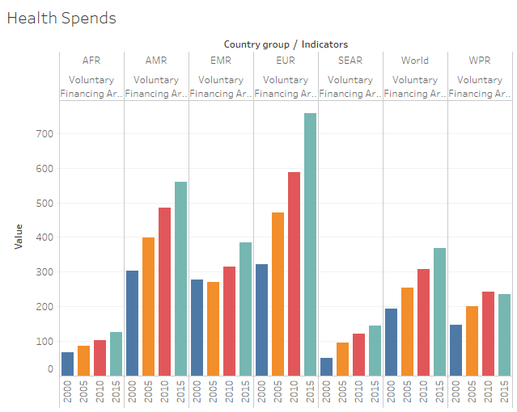

African region has the lowest Voluntary Financing Arrangements per Capita in PPP Int$

Voluntary Financing Arrangements (VFA) per Capita in US$

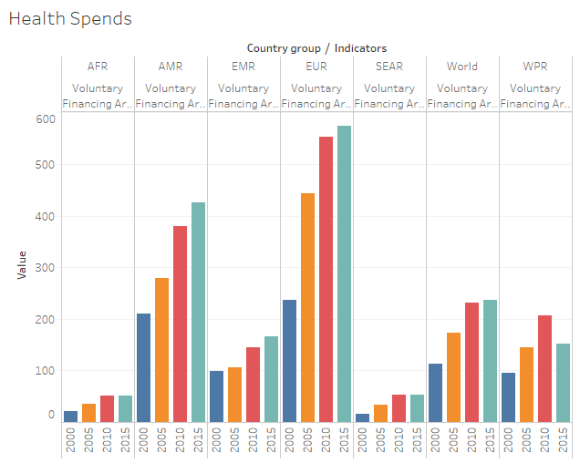

African & South-East Asian region has the lowest Voluntary Financing Arrangements per Capita in US$

Voluntary Health Insurance (VHI) as % of Current Health Expenditure (CHE)

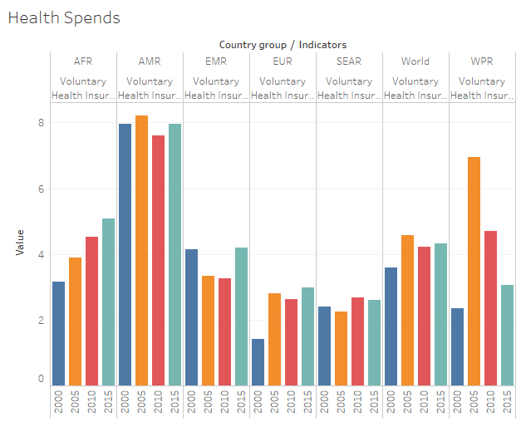

Only African region shows a consistent increasing trend in Voluntary Health Insurance (VHI) as % of Current Health Expenditure

Hence, from the above analysis of region wise Health expenditure with its various indices we can see that African region and South-East Asian region requires as lot of work and attention in regards to the Public health and welfare

Causes of Death

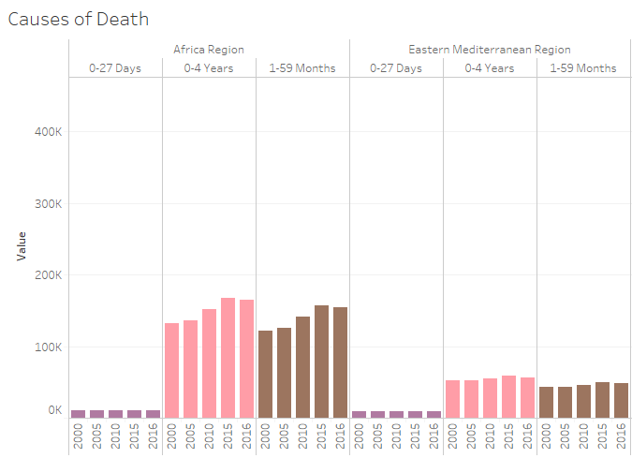

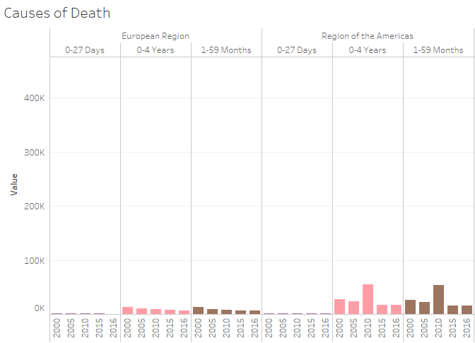

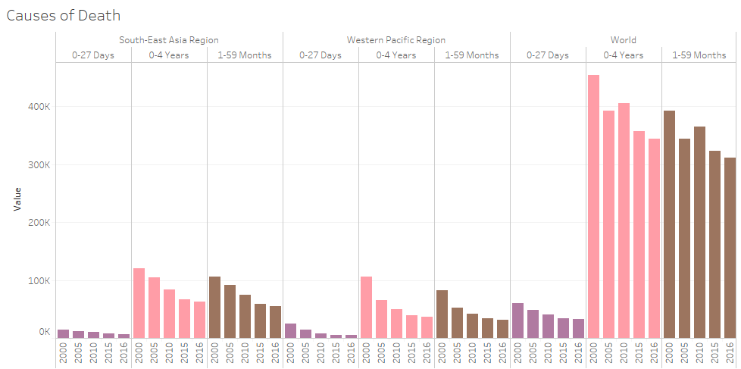

African region has the highest number of deaths in each category from 0-27 days, 0-4 years & 1-59 months

Health Expenditure per Capita USD

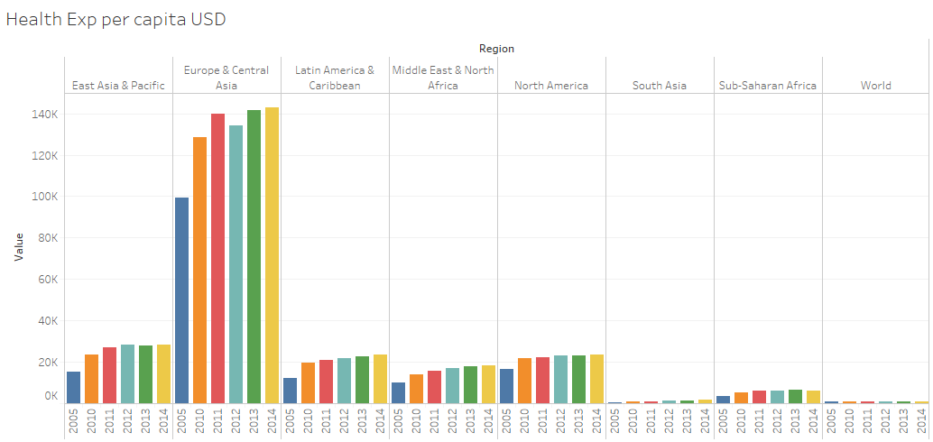

South Asia & Sub-African region has the lowest Health Expenditure per Capita USD

Total Health Expenditure % GDP

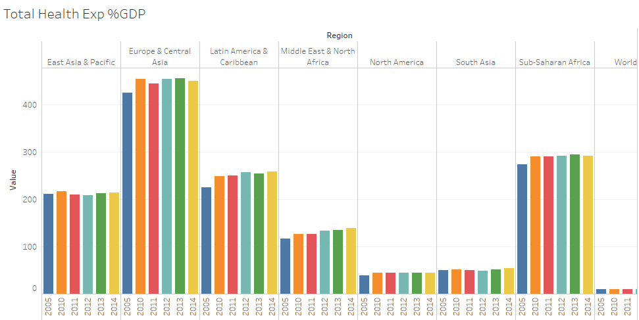

South Asia & North American region has the lowest Total Health Expenditure % GDP

Conclusion: From the above visualisation we can see that African and South Asian region needs the most attention in terms of improvement in implementation of strategies in order to reduce deaths and improve public health. Sub- Saharan /African region shows a lot of scope to study and analyse to provide required recommendations. Hence, we choose the Sub-Saharan region for further analysis in our study.