**Project Description**

* Prediction of Diabetes based on Diagnostic measures.
* Task: **Binary Classification**

**Team Members**

|  |  |  |
| --- | --- | --- |
| Banoth Rajshekhar | 19BT30008 | banothrajkumar9959@gmail.com |
| Nishant Gahlaut | 19BT30015 | nishantgahlaut@gmail.com |
| Venkata Tharun Raj | 19BT30033 | tharunrajvenkat@gmail.com |

**Dataset**

* Given Diabetes dataset contains following Diagnsotic measure
  + Pregnancies Glucose
  + BloodPressure
  + SkinThickness
  + Insulin
  + BMI
  + DiabetesPedigreeFunction
  + Age
* Label Column: Outcome
* Sample Data:

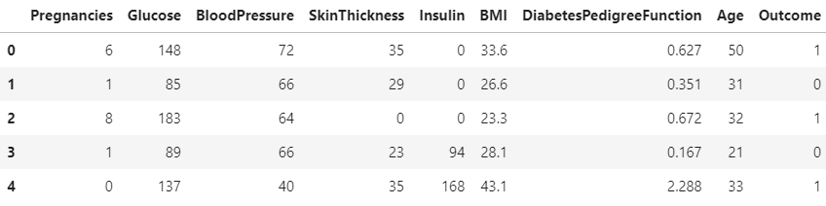

* Number of datapoints: 768

**Data Visualization**

* Label Distribution:

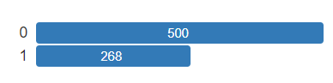

* + 0: No Diabetes
  + 1: Has Diabetes
* Correlation Plot

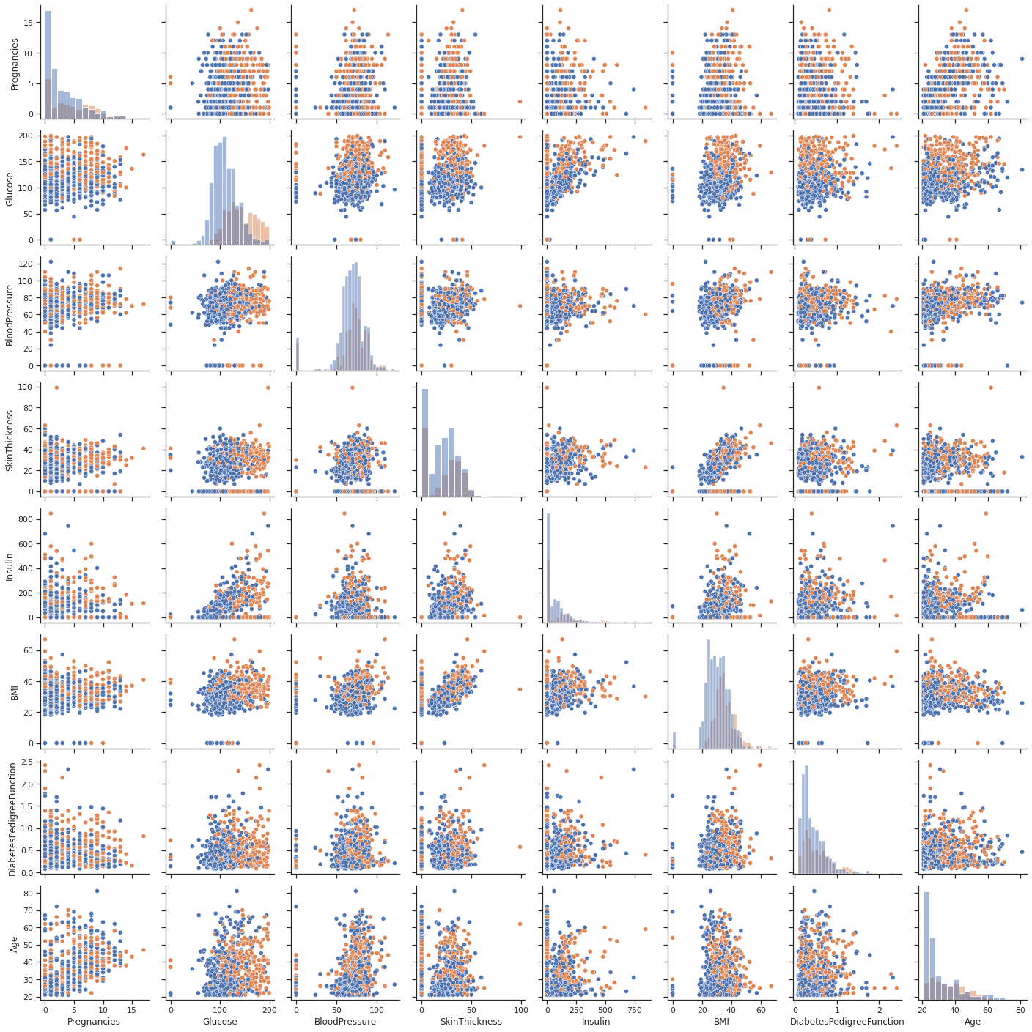

**Data Pre-processing**

|  |  |  |  |
| --- | --- | --- | --- |
| **Column** | **Type** | **Fill NaN** | **Preprocessing** |
| Pregnancies | Categorical | No NaN | Label Encoding |
| Glucose | Continuous | No NaN | MinMax Scaling |
| BloodPressure | Continuous | No NaN | MinMax Scaling |
| SkinThickness | Continuous | No NaN | MinMax Scaling |
| Insulin | Continuous | No NaN | MinMax Scaling |
| BMI | Continuous | No NaN | MinMax Scaling |
| DiabetesPedigreeFunction | Continuous | No NaN | MinMax Scaling |
| Age | Continuous | No NaN | MinMax Scaling |

**ML Model Training**

* Data Splitting Details

|  |  |
| --- | --- |
| Training | 0.72 |
| Validation | 0.18 |
| Testing | 0.1 |

* 5-Fold CV Training
* Library used: scikit-learn
* ML Algorithms Trained
  + Logistic Regression
  + SVM
  + KNN
  + Decision Tree
  + Random Forest
  + Histogram Gradient Boosting
* Evaluation Metric:

**Results**

|  |  |
| --- | --- |
| **Model** | **Test Data AUROC** |
| Logistic Regression | 0.777 |
| SVM | 0.657 |
| KNN | 0.602 |
| Decision Tree | 0.760 |
| Random Forest | 0.806 |
| Histogram Gradient Boosting | 0.773 |

* **Best Model: Radom Forest**