Nashville Housing Classification

Rajashekar Korutla
Applied Machine Intelligence, Roux Institute at Northeastern University
ALY 6020: Predictive Analytics

Nashville Housing Classification
In this project, I use the algorithms such as decision tree, random forest classifier and gradient boosting, while I have also used linear regression, I would not lay much focus upon it as it is not basically used for classification purposes, but just felt to see the effect of it being used in the project.
A decision tree is a non-parametric supervised learning algorithm, which is utilized for both classification and regression tasks. It has a hierarchical, tree structure, which consists of a root node, branches, internal nodes and leaf nodes.
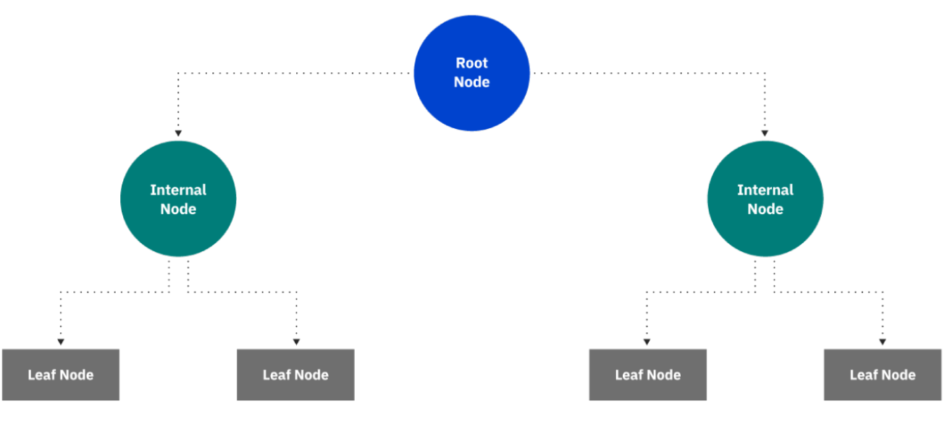
As you can see from the diagram above, a decision tree starts with a root node, which does not have any incoming branches. The outgoing branches from the root node then feed into the internal nodes, also known as decision nodes. Based on the available features, both node types conduct evaluations to form homogenous subsets, which are denoted by leaf nodes, or terminal nodes. The leaf nodes represent all the possible outcomes within the dataset.
Random forests or random decision forests is an ensemble learning method for classification, regression and other tasks that operates by constructing a multitude of decision trees at training time. For classification tasks, the output of the random forest is the class selected by most trees. For regression tasks, the mean or average prediction of the individual trees is returned. Random decision forests correct for decision trees habit of overfitting to their training set. Random forests generally outperform decision trees. but their accuracy is lower than gradient boosted trees. However, data characteristics can affect their performance.
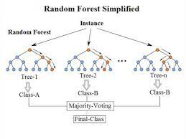
In gradient boosting machines, or simply, GBMs, the learning procedure consecutively fits new models to provide a more accurate estimate of the response variable. The principle idea behind this algorithm is to construct the new base-learners to be maximally correlated with the negative gradient of the loss function, associated with the whole ensemble. The loss functions applied can be arbitrary, but to give a better intuition, if the error function is the classic squared-error loss, the learning procedure would result in consecutive error-fitting. This high flexibility makes the GBMs highly customizable to any particular data-driven task. It introduces a lot of freedom into the model design thus making the choice of the most appropriate loss function a matter of trial and error. However, boosting algorithms are relatively simple to implement, which allows one to experiment with different model designs.
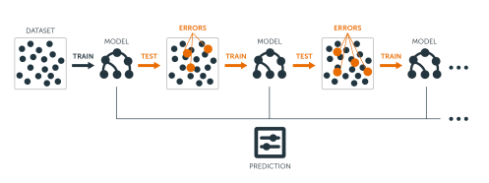
The housing Dataset contains 26 features which give a variety of information regarding the apartments in Nashville.
It contains the columns such as : 'Unnamed: 0', 'Parcel ID', 'Land Use', 'Property Address', 'Suite/ Condo #', 'Property City', 'Sale Date', 'Legal Reference', 'Sold As Vacant', 'Multiple Parcels Involved in Sale', 'City', 'State', 'Acreage', 'Tax District', 'Neighborhood', 'Land Value', 'Building Value', 'Finished Area', 'Foundation Type', 'Year Built', 'Exterior Wall', 'Grade', 'Bedrooms', 'Full Bath', 'Half Bath', 'Sale Price Compared To Value'.
Shape of the dataset that I would be working on is (22651, 26) , which mentions that the dataset has 22651 rows and 26 columns.
Exploratory Data Analysis
From the Nashville housing dataset, it can clearly be seen that there are certain columns which are not required in the analysis, which needs to be eliminated as they do not serve any purpose in the dataset.
In order to find the correlation between the columns, I used this following line of code:
df.corr() ,which gave an output of:
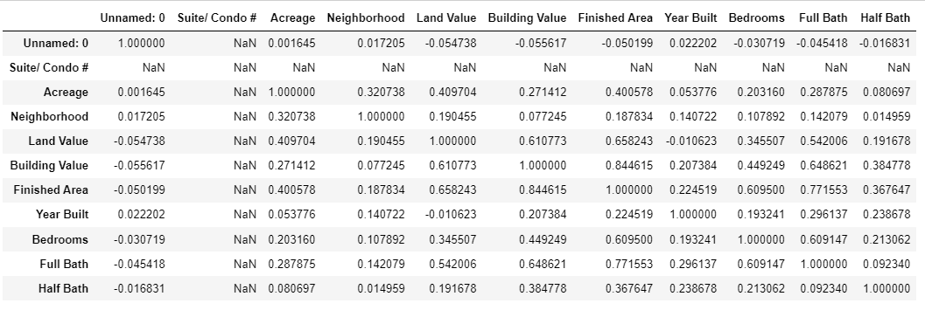

the drop command has been used to get rid of the columns which are highly correlated , those which contains NAN values and those which may not help in further analysis. This command takes axis as an argument to state if the item we wish to drop is a row or a column. To drop a column, one must specify the axis as 1, similarly, to drop a row, the axis is to be specified as 0.
df.isna().sum() , would give the sum of all the nan values in the columns:
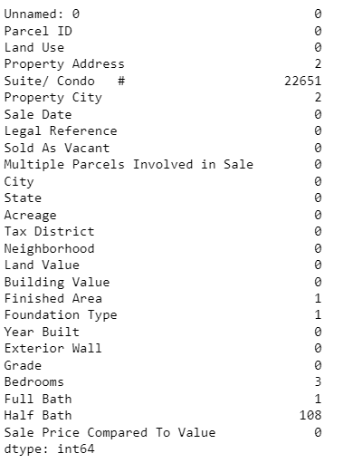
Then, dropped the columns that do not serve the purpose in the further analysis:
df = df.drop(labels = ['Suite/ Condo #','Parcel ID','Unnamed: 0','Property Address','Legal Reference','Multiple Parcels Involved in Sale','Tax District','Neighborhood','Grade'],axis = 1)
df = df.dropna()
now, the rows with the nan values and columns that are not useful are dropped .
Then, I tried to view the data with the head function. I found out that the data is clean :
df.head()
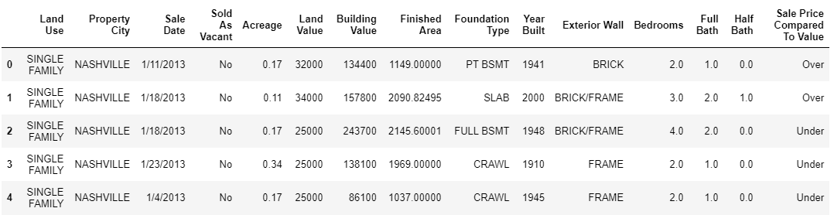

I made a separate column named ‘sale year’, which only has year in which the apartment has been sold, for this, the existing column of ‘sale date’ has been first converted into datetime.

df['Sale Date']=pd.to_datetime(df['Sale Date'])
df['sale year'] = pd.DatetimeIndex(df['Sale Date']).year
then, I have created two new columns named ‘age’ and ‘total value’ , where I calculated the age of house and the total value of the house, then dropped the old columns of ‘sale year’, ‘Land Value’, ‘Building Value’, ‘Sale Date' :

df['age'] = df['sale year'] - df['Year Built']
df['Total Value'] = df['Building Value'] + df['Land Value']
df = df.drop(labels = ['sale year','Land Value','Building Value','Sale Date'],axis = 1)
df.head()

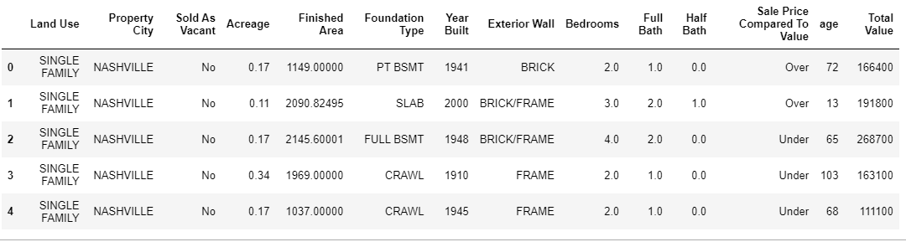
Then when the dataset is further analyzed, I found the columns to possess object datatypes, which is to be converted into categories to proceed further. Then I used label encoder function from sklearn library to convert the datatype from object to integer, this function of label encoder would create a separate numeric value for every category in the column.
It happened with the following lines of code:

le = LabelEncoder()

df['Land Use'] = le.fit_transform(df['Land Use'])
df['Property City'] = le.fit_transform(df['Property City'])
df['Sold As Vacant'] = le.fit_transform(df['Sold As Vacant'])
df['Foundation Type'] = le.fit_transform(df['Foundation Type'])
df['Exterior Wall'] = le.fit_transform(df['Exterior Wall'])
df['Sale Price Compared To Value'] = le.fit_transform(df['Sale Price Compared To Value'])

above lines of code would convert the datatype from object to numeric, which can be used to proceed for further analysis, but I prefer the data to be categorized, for which I convert the numerical data into categorical data using this line of code:
df['Land Use'] = df['Land Use'].astype('category')
df['Property City'] = df['Property City'].astype('category')
df['Sold As Vacant'] = df['Sold As Vacant'].astype('category')
df['Foundation Type'] = df['Foundation Type'].astype('category')
df['Exterior Wall'] = df['Exterior Wall'].astype('category')
df['Sale Price Compared To Value'] = df['Sale Price Compared To Value'].astype('category')
this is the output:
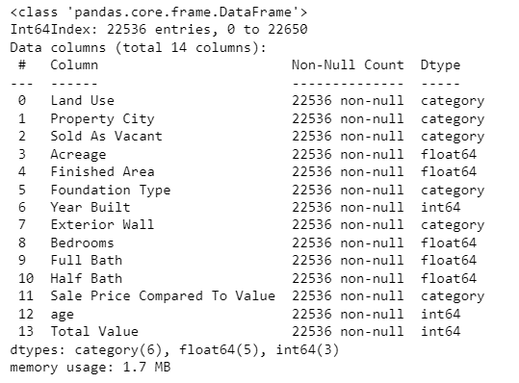
Building the model
The target variable has been separated as ‘y’, which is the ‘ Sale Price Compare To Value ’. All the other features have been put together into 'x’, to form the feature matrix. The data has been split for training data and test data, as 70% for training and the remaining 30% for test data.
Using decision tree classifier:
Then, the Decision Tree Classifier has been imported from the sci-kit learn library. With the criterion of ‘entropy’ , the accuracy is found to be 76% .
This is the code for the model with entropy criterion:
dec_model = DecisionTreeClassifier(random_state=10, criterion="entropy", max_depth=10)
here are the results of the classifier:
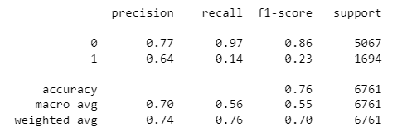

Then, the decision tree classifier has been used with the criterion of ‘gini’ :
dec_model_3= DecisionTreeClassifier(random_state=0, criterion="gini",max_depth=9)
here are the results of classifier:
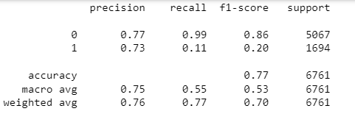

to calculate the roc_auc_score:
roc_auc_score(y_test,dec_model_fit_3.predict_proba(x_test)[:,1])
which was found out to be 0.5963898401327757
I have also plotted the roc curve:
fpr, tpr, thresholds = roc_curve(y_test, predicted_3)
plt.plot(fpr, tpr)
plt.xlabel('False Positive Rate or (1 - Specifity)')
plt.ylabel('True Positive Rate or (Sensitivity)')
plt.title('Receiver Operating Characteristic')
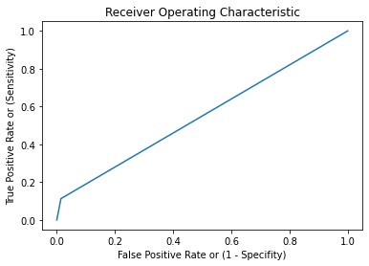

Using random forest classifier:
From sklearn.ensemble , random forest classifier has been imported, with about 10 estimators,the model has been ran , code for the same :
from sklearn.ensemble import RandomForestClassifier
begin_time = datetime.datetime.now()
rf_model=RandomForestClassifier(n_estimators=10,random_state=0)
rf_model_fit= rf_model.fit(x_train,y_train)
y_pred=rf_model_fit.predict(x_test)
print(datetime.datetime.now() - begin_time)

output: 0:00:00.723244

processing time for this algorithm is found to be 0.72 seconds , while the accuracy is found to be 74.3 %
when the same random forest classifier is run with about 10k estimators:
from sklearn.ensemble import RandomForestClassifier
begin_time = datetime.datetime.now()
rf_model2=RandomForestClassifier(n_estimators=10000,random_state=0)
rf_model_fit2= rf_model.fit(x_train,y_train)
y_pred2=rf_model_fit2.predict(x_test)
print(datetime.datetime.now() - begin_time)
output: 0:00:00.716407
processing time for this algorithm is found to be 0.71 seconds, while the accuracy is found to be 74.3 %
Using gradient boosting algorithm:
Gradient boosting is also imported from the same library of sklearn.ensemble , through the estimators size of 10k , the code is as follows:
from sklearn.ensemble import GradientBoostingClassifier
begin_time = datetime.datetime.now()
gb_model= GradientBoostingClassifier(n_estimators=10000,random_state=0)
gb_model.fit(x_train,y_train)
y_pred_gb=gb_model.predict(x_test)
print(datetime.datetime.now() - begin_time)
output: 0:08:50.788093
it is found out that this algorithm is giving an accuracy of 72.9% , but the major disadvantage is the processing time , which is approximately 9 minutes long.
Evaluation Of Model
The metrics used for evaluation are classification report, confusion matrix, roc_auc_score and accuracy score. The classification report shows a representation of the main classification metrics such as precision, recall, f1-score. This gives a deeper intuition of the classifier behavior over global accuracy. The metrics are defined in terms of true and false positives, and true and false negatives. a true positive is when the actual class is positive as is the estimated class. A false positive is when the actual class is negative, but the estimated class is positive.
Confusion matrix is a performance measurement for machine learning classification problem where output can be two or more classes. It is a table with 4 different combinations of predicted and actual values.

The name AUC stands for “area under the curve”. The curve in our case is the receiver operating characteristics (ROC) curve. It’s a statistical measure that we can use to evaluate the model predictions using a probabilistic framework. Briefly, the ROC curve shows the relationship between false-positive rate and true positive rate for different probability thresholds of model predictions.
So, after obtaining all the accuracy measures from a variety of algorithms like decision tree, random forest, gradient boost, the task of classification of the target variable for a given set of features is being efficiently performed by the decision tree model. I can say this as I found that the accuracy of the model to be higher for the decision tree algorithm than for the other algorithms like random forest and gradient boost.

