
WEEK 2 TASK REPORT
Exploratory Data Analysis and Visualization
Dataset: Online Retail
Python | Pandas | NumPy | Matplotlib | Seaborn
Prepared by: Ponnam Raja Shekar


Table of Contents
Contents
Table of Contents 2
1. Introduction 3
2. Objectives 3
3. Dataset Description 3
4. Tools and Technologies 3
5. Data Acquisition and Initial Exploration 3
6. Data Quality Assessment 4
7. Descriptive Statistics 5
8. Univariate Analysis 5
9. Time-Based Analysis 6
10. Country Analysis 8
11. Product Analysis 9
12. Customer Analysis 10
13. Bivariate Analysis 11
14. Correlation and Multivariate Analysis 12
15. Key Findings 14
16. Critical Interpretation and Business Implications 14
17. Challenges and Limitations 14
18. Conclusion 15
19. References 15
Appendix A — Evidence and Reproducibility 15

1. Introduction
This report presents an exploratory data analysis and visualization of the Online Retail dataset. Python was used to examine transaction behavior, revenue patterns, products, customers, countries, and time-based trends. The analysis also considers missing values, duplicate records, cancellations, negative quantities, zero-price records, and extreme observations.

2. Objectives
- Understand the structure and characteristics of the Online Retail dataset.
- Perform descriptive and exploratory statistical analysis.
- Identify patterns and trends in transaction volume and revenue.
- Analyze product, customer, country, day, and hourly behavior.
- Create clear and appropriately labeled visualizations.
- Investigate relationships and correlations among variables.
- Critically interpret anomalies, limitations, and analytical decisions.

3. Dataset Description
The analysis used 541,909 transaction records, 25,900 unique invoices, 4,070 unique products, 4,372 identified customers, and 38 countries.
- Transaction records: 541,909
- Unique invoices: 25,900
- Unique products: 4,070
- Identified customers: 4,372
- Countries: 38

4. Tools and Technologies
- Python
- Pandas
- NumPy
- Matplotlib
- Seaborn
- Jupyter Notebook / VS Code

5. Data Acquisition and Initial Exploration
The Online Retail Excel dataset was loaded with Pandas. Initial exploration examined dimensions, columns, descriptive statistics, missing values, duplicates, categorical frequencies, and numerical distributions. The raw dataset was retained while visualization-specific transformations were applied only where needed for readability.
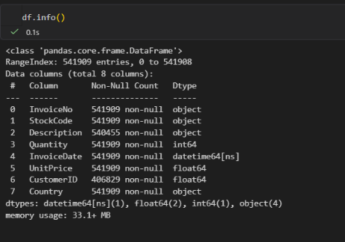
Figure 1. Initial dataset structure and dimensions

6. Data Quality Assessment
The EDA identified several data-quality characteristics. These were not automatically treated as errors because some can represent legitimate retail transactions.
- Duplicate records: 5,268
- Missing CustomerID values: 135,080
- Negative quantity records: 10,624
- Zero UnitPrice records: 2,515
- Cancelled invoice records: 9,288
Missing CustomerID values limit customer-level analysis, so customer analyses were restricted to records with an identified CustomerID. Negative quantities may represent returns and cancelled invoices may represent reversals. Extreme values were handled through visualization-specific restrictions rather than indiscriminate deletion.
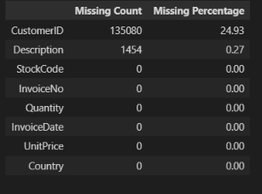
Figure 2. Missing-value assessment
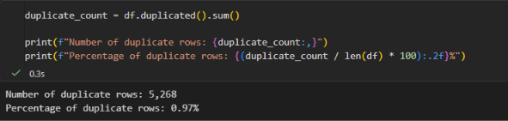
Figure 3. Duplicate-record assessment

7. Descriptive Statistics
Total net transaction revenue was 9,747,747.93. Average transaction revenue was 17.99, while the median was 9.75. Average quantity was 9.55 compared with a median of 3.00. The higher means relative to the medians indicate skewed distributions and the influence of high-value or high-quantity observations.

8. Univariate Analysis
Univariate analysis examined Quantity, UnitPrice, Country, product descriptions, day of week, and hour. Quantity and UnitPrice were strongly affected by extreme observations. Restricted ranges were used for selected histograms to make typical observations visible while keeping the underlying data unchanged.
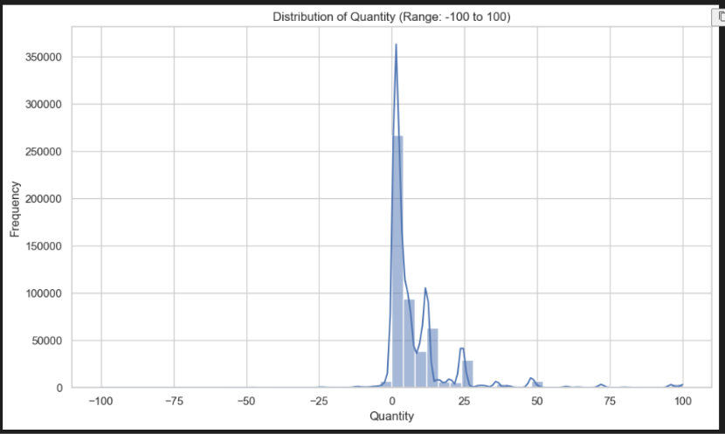
Figure 4. Distribution of Quantity for the typical transaction range
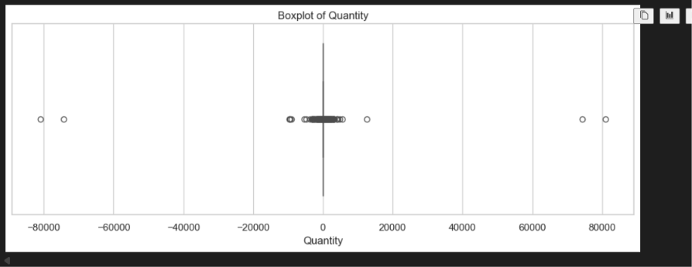
Figure 5. Boxplot of Quantity
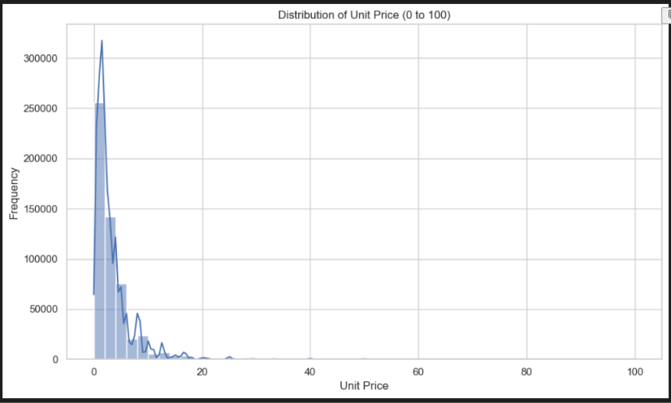
Figure 6. Distribution of Unit Price for the typical price range

9. Time-Based Analysis
Time-based analysis used year, month, day, and hour features. November 2011 recorded the highest observed transaction volume with 84,711 records and the highest observed revenue of 1,461,756.25.
December 2011 contained 25,525 observed records and 433,668.01 in revenue. However, the dataset ends on December 9, 2011, so December is incomplete and should not be interpreted as a full-month decline.
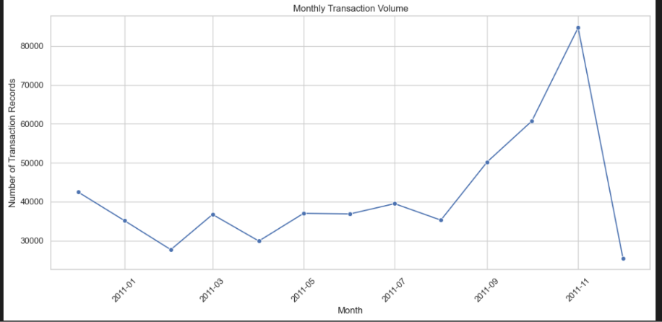
Figure 7. Monthly transaction volume
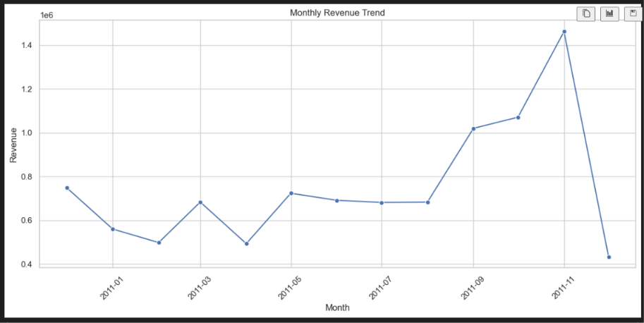
Figure 8. Monthly revenue trend
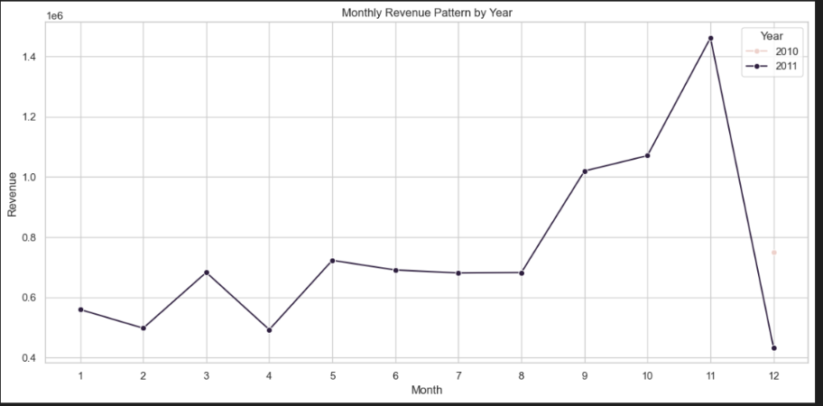
Figure 9. Monthly revenue pattern by year

10. Country Analysis
Country-level analysis showed strong geographical concentration. The United Kingdom generated 8,187,806.36 in net transaction revenue, far above the Netherlands at 284,661.54. Other high-revenue countries included EIRE, Germany, France, and Australia.
Because the United Kingdom dominates the scale, a second transaction-volume-versus-revenue visualization excluded the UK only for display clarity. The source dataset was not modified.
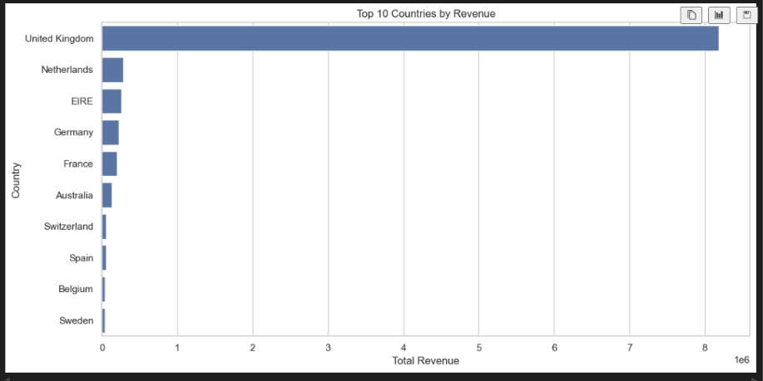
Figure 10. Top 10 countries by net transaction revenue
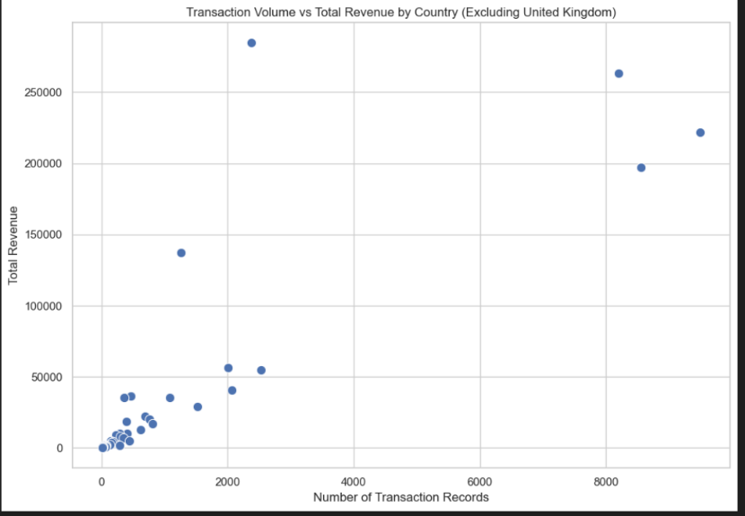
Figure 11. Transaction volume versus revenue by country, excluding the United Kingdom

11. Product Analysis
Product analysis examined transaction frequency, total quantity, and total revenue. The correlation between product transaction frequency and total revenue was approximately 0.67, indicating a moderately strong positive relationship. Frequently recorded products generally tend to generate higher total revenue, although frequency alone does not determine revenue.
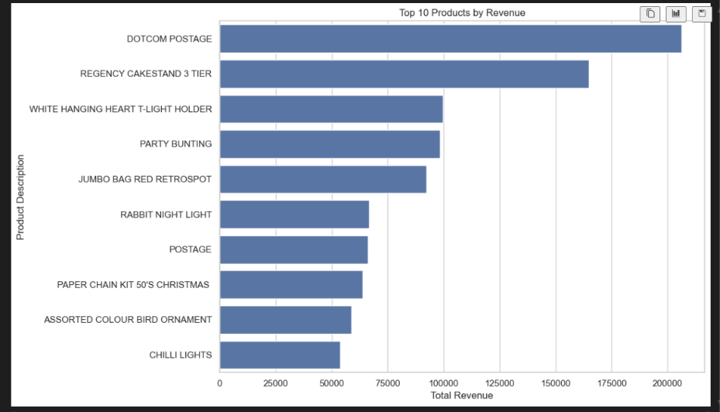
Figure 12. Top 10 products by total revenue
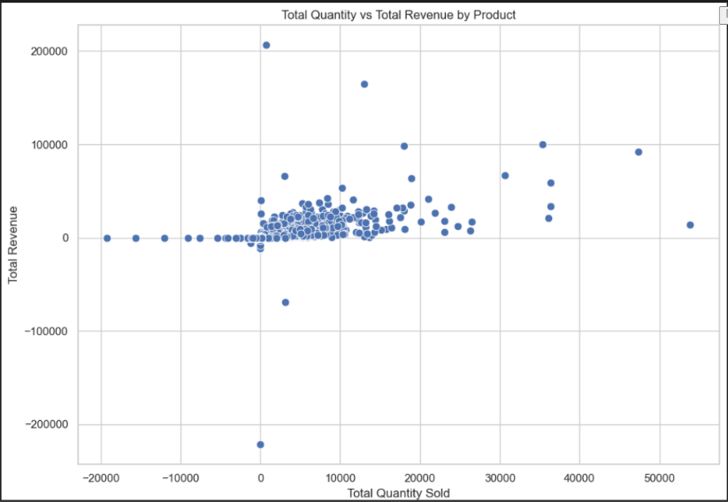
Figure 13. Product-level quantity versus total revenue

12. Customer Analysis
Customer-level analysis was performed for records with an identified CustomerID. The top 10% of identified customers accounted for 60.01% of customer revenue, indicating substantial revenue concentration among a relatively small customer group.
This finding can support customer-retention and high-value-customer strategies, but revenue concentration alone does not prove customer loyalty or causation.
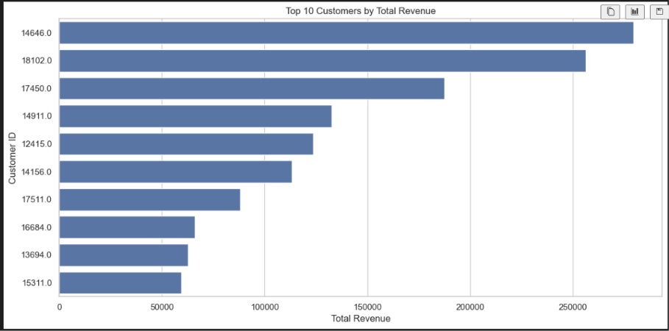
Figure 14. Top 10 customers by total revenue
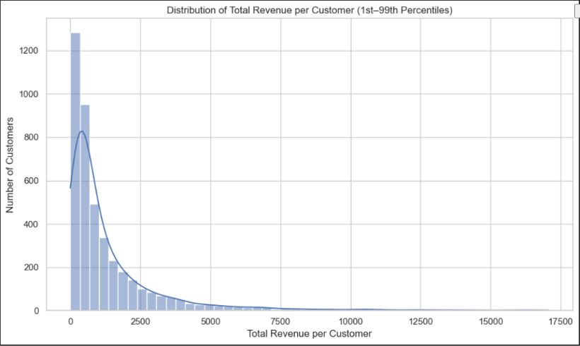
Figure 15. Distribution of total revenue per customer
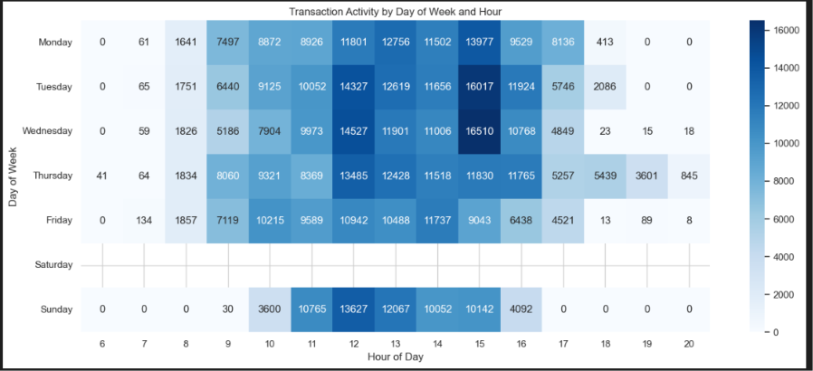
Figure 16. Transaction activity by day of week and hour

13. Bivariate Analysis
Bivariate analysis examined relationships between Quantity, UnitPrice, Revenue, country-level measures, customer measures, and time dimensions. Scatter plots and heatmaps were used to identify patterns, clusters, and anomalies. Visualization-specific ranges were used when extreme observations made the majority of points unreadable.
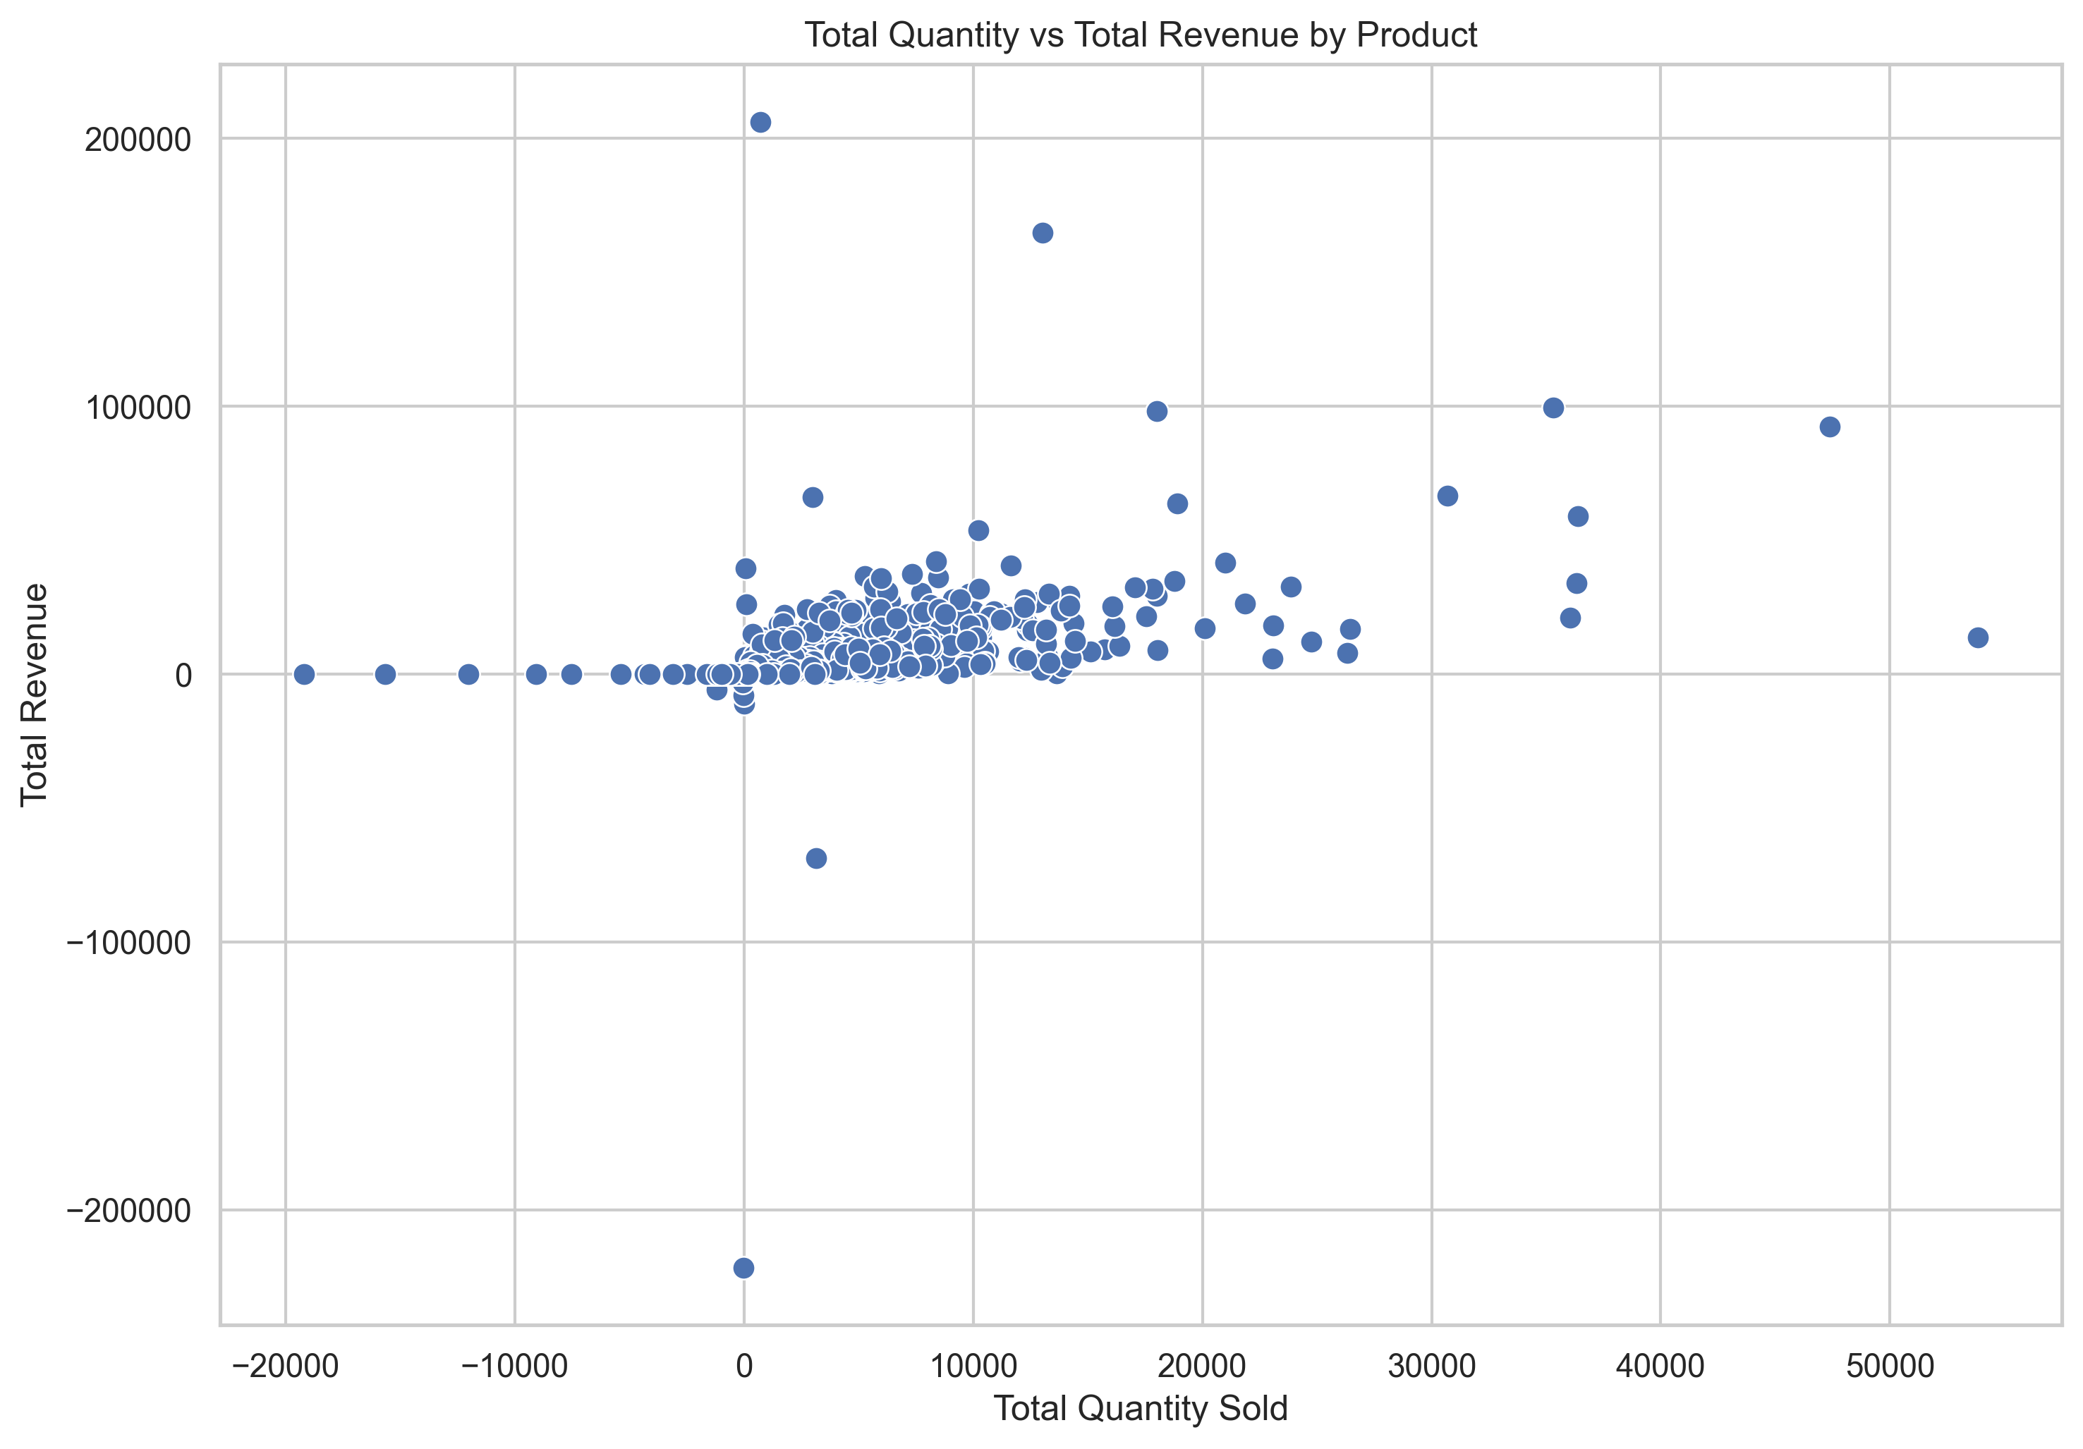
Figure 17. Product-Level Quantity versus Total Revenue

14. Correlation and Multivariate Analysis
Correlation analysis was performed for numerical transaction variables and customer-level measures. Correlations were interpreted carefully because some variables have mathematical relationships. In particular, Revenue is derived from Quantity multiplied by UnitPrice, so a strong association between these variables is expected and should not be presented as an independent causal discovery.
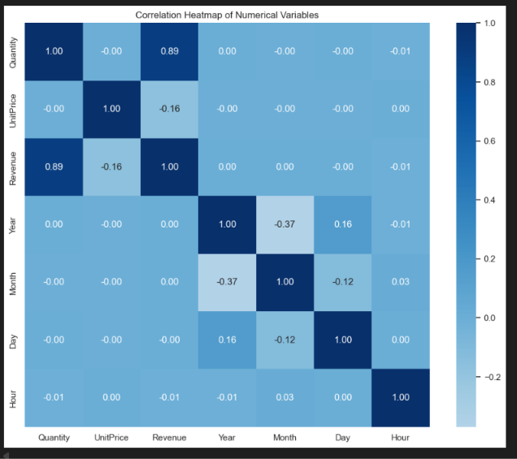
Figure 18. Correlation heatmap of numerical variables
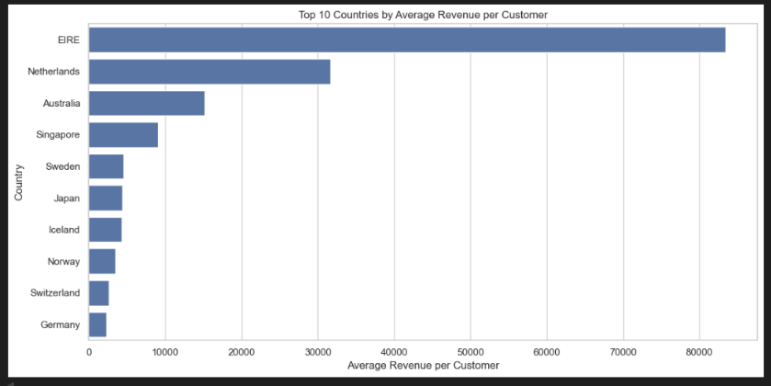
Figure 19. Top countries by average revenue per identified customer
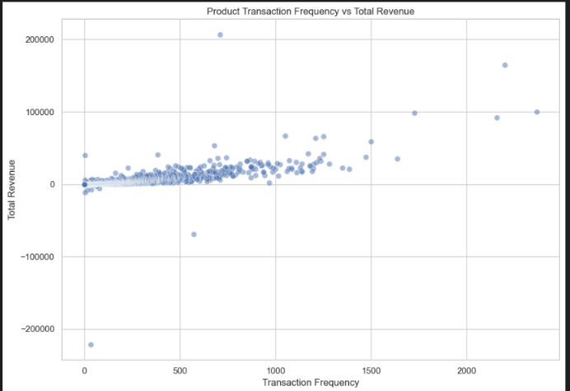
Figure 20. Product transaction frequency versus total revenue

15. Key Findings
- The dataset contains 541,909 transaction records across 25,900 invoices, 4,070 products, 4,372 identified customers, and 38 countries.
- Transaction revenue is strongly right-skewed: mean 17.99 versus median 9.75.
- Quantity is strongly skewed: mean 9.55 versus median 3.00.
- The United Kingdom dominates observed net transaction revenue at 8,187,806.36.
- November 2011 recorded the highest observed transaction volume and revenue.
- December 2011 is incomplete because records end on December 9, so it cannot be compared directly with full months.
- The top 10% of identified customers account for 60.01% of customer revenue.
- Product transaction frequency and total revenue have a correlation of approximately 0.67.
- The dataset contains duplicates, missing customer identifiers, negative quantities, zero-price records, and cancellations that require contextual treatment.
- Extreme values materially affect visualization scale and require transparent handling.

16. Critical Interpretation and Business Implications
The EDA indicates that revenue is concentrated geographically and at the customer level. The United Kingdom strongly influences overall country-level totals, while the top 10% of identified customers contribute 60.01% of customer revenue.
Product frequency is useful for understanding revenue contribution, but should be considered alongside price and quantity. Time-based peaks should be interpreted with awareness of the dataset's coverage and incomplete periods.
A central methodological principle was to distinguish legitimate transactional behavior from clear data-quality problems. Negative quantities can represent returns, while extreme quantities may represent bulk purchases. Therefore, potentially meaningful observations were not blindly removed.

17. Challenges and Limitations
- Missing CustomerID values limit complete customer-level analysis.
- Duplicate and cancelled records require business-context interpretation.
- Extreme values can dominate standard visualizations.
- December 2011 is only partially represented.
- Revenue is derived as Quantity × UnitPrice, so correlations involving these variables require caution.
- The dataset alone cannot establish causal explanations for observed patterns.

18. Conclusion
This exploratory analysis provided a comprehensive view of transaction, product, customer, country, and time-based behavior in the Online Retail dataset. The analysis identified strong skewness and extreme observations, substantial geographical and customer revenue concentration, meaningful temporal patterns, and a moderate positive relationship between product transaction frequency and revenue. The work also demonstrated the importance of contextual data-quality assessment and transparent visualization decisions. These findings provide a sound foundation for subsequent segmentation, forecasting, statistical modeling, or predictive analytics.

19. References
Online Retail dataset and public dataset documentation.
Pandas, NumPy, Matplotlib, and Seaborn documentation.

Appendix A — Evidence and Reproducibility
The complete executable analysis is contained in the Week2_EDA.ipynb notebook. Final PNG visualizations are stored in the project's visualizations folder. Replace each figure placeholder with the corresponding exported PNG before submission.

