JAVA ASSIGNMENT-12 (23/11/2018)

1)Write a java program to write the Districts of Telangana

package raj;

import java.io.BufferedWriter;
import java.io.FileWriter;
import java.io.IOException;

public class FileWriteOp {

public static void main(String[] args) {
try{
FileWriter fw=new FileWriter("/home/scls-host22/Desktop/236/districts.txt");
BufferedWriter br=new BufferedWriter(fw);
br.write("Districts Of Telangana");
br.newLine();
br.write("--------------------------");
br.newLine();
br.write("Adilabad");
br.newLine();
br.write("Bhadradri Kothagudem");
br.newLine();
br.write("Hyderabad");
br.newLine();
br.write("Jagtial");
br.newLine();
br.write("Jangaon");
br.newLine();
br.write("Jayashankar Bhupalpally");
br.newLine();
br.write("Jogulamba Gadwal");
br.newLine();
br.write("Kamareddy");
br.newLine();
br.write("Karimnagar");
br.newLine();
br.write("Khammam");
br.newLine();
br.write("Kumuram Bheem");
br.newLine();
br.write("Mahabubabad");
br.newLine();
br.write("Mahabubnagar");
br.newLine();
br.write("Mancherial");
br.newLine();
br.write("Medak");
br.newLine();
br.write("Medchal");
br.newLine();
br.write("Nagarkurnool");
br.newLine();
br.write("Nalgonda");
br.newLine();
br.write("Nirmal");
br.newLine();
br.write("Nizamabad");
br.newLine();
br.write("Peddapalli");
br.newLine();
br.write("Rajanna Sircilla");
br.newLine();
br.write("Rangareddy");
br.newLine();
br.write("Sangareddy");
br.newLine();
br.write("Siddipet");
br.newLine();
br.write("Suryapet");
br.newLine();
br.write("Vikarabad");
br.newLine();
br.write("Wanaparthy");
br.newLine();
br.write("Warangal (Rural)");
br.newLine();
br.write("Warangal (Urban)");
br.newLine();
br.write("Yadadri Bhuvanagiri");
br.flush();
fw.close();
br.close();
}
catch(IOException e){
System.out.println("IOException occured");
}

}

}
Output:
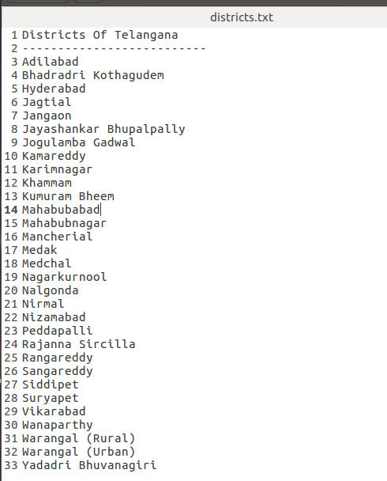

OR
package raj;

import java.io.BufferedWriter;
import java.io.FileWriter;
import java.io.IOException;

public class FileWriteOp2 {

public static void main(String[] args) {
String s[]={"Adilabad", "Bhadradri Kothagudem", "Hyderabad", "Jagtial", "Jangaon", "Jayashankar Bhupalpally", "Jogulamba Gadwal", "Kamareddy", "Karimnagar", "Khammam", "Kumuram Bheem", "Mahabubabad", "Mahabubnagar", "Mancherial", "Medak", "Medchal", "Nagarkurnool", "Nalgonda", "Nirmal", "Nizamabad", "Peddapalli", "Rajanna Sircilla", "Rangareddy", "Sangareddy", "Siddipet", "Suryapet", "Vikarabad", "Wanaparthy", "Warangal (Rural)", "Warangal (Urban)", "Yadadri Bhuvanagiri"};
try
{
FileWriter fw=new FileWriter("/home/scls-host22/Desktop/236/districts2.txt");
BufferedWriter br=new BufferedWriter(fw);
br.write("Districts Of Telangana");
br.newLine();
br.write("----------------------------");
br.newLine();
for(int i=0;i<31;i++)
{
br.write(s[i]);
br.newLine();
br.flush();

}
br.close();
fw.close();
}
catch(IOException e)
{
System.out.println("IOException occurred");
}
}

}

Output:

