Business analysis report

On

USA Housing Listings
Sacred heart university
BUSINESS STRATEGY & ANALYSIS BUAN-685-CO
Prof. Sabbir Hassan

11/23/2024

Team Members:
1. Ananth Kanna
2. Chaithanya Sankar Varma Pandeti
3. Chandra Shekar Reddy Bhoomireddy
4. Rajashree Guduru
5. Rupert Munnings

1. Introduction
The dataset pertains to the real estate sector, which significantly influences consumer decisions, investment strategies, and market forecasting. It provides critical insights for real estate agents, investors, developers, and policymakers to evaluate housing market behaviors and set competitive strategies.

2. Objectives
The objective of this project is to optimize rental pricing, increase occupancy rates, and enhance property appeal. The desired outcomes include maximizing revenue, reducing vacancy periods, and improving tenant satisfaction. Success metrics include revenue growth, occupancy rates, and tenant retention.

3.1 Data Collection
The dataset was sourced from Kaggle, a platform hosting diverse datasets. It comprises 384,977 records with 21 variables, including numerical features such as prices and square footage and categorical features like property type and location. Initial data exploration revealed missing values and potential multicollinearity, which were addressed through preprocessing.

3.2 Data Analysis Techniques
Several analytical techniques were employed, including descriptive analytics for trend identification, predictive analytics using regression models, A/B testing for strategy evaluation, and time series analysis for seasonal demand assessment. Data visualization techniques, such as scatter plots and heatmaps, provided additional insights into key variables.

4.1 Dataset Overview
The dataset provides a detailed snapshot of housing listings in the USA, including features like property size, amenities, and location. Unique characteristics include allowances for pets, smoking, and EV charging, offering granular insights into tenant preferences.

4.2 Variables and Definitions
Variables include:
- Price: Rental price of the property.
- SqFeet: Property size in square footage.
- Beds: Number of bedrooms.
- Baths: Number of bathrooms.
- Type: Property type (e.g., apartment, house).
These variables are critical for analyzing tenant preferences and optimizing pricing strategies.

5. Identification of the Business Problem
The key business problem is optimizing rental pricing, increasing occupancy rates, and enhancing property appeal to maximize revenue. Failure to address these challenges could lead to high vacancy rates, reduced income, and diminished market competitiveness.

6. Data Analysis and Findings
Analysis revealed trends in rental prices and property sizes, regional pricing variations, and correlations between amenities and tenant preferences. Visualizations such as scatter plots, heatmaps, and density plots highlighted opportunities for targeted pricing.
Correlation Matrix
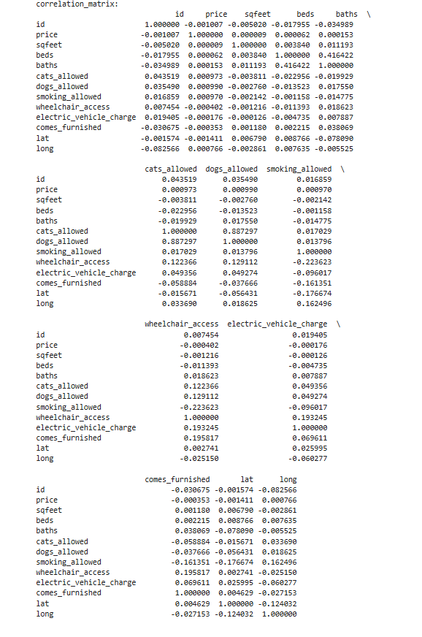
Scatter plot of Rental Price vs. Square Footage by Property Type
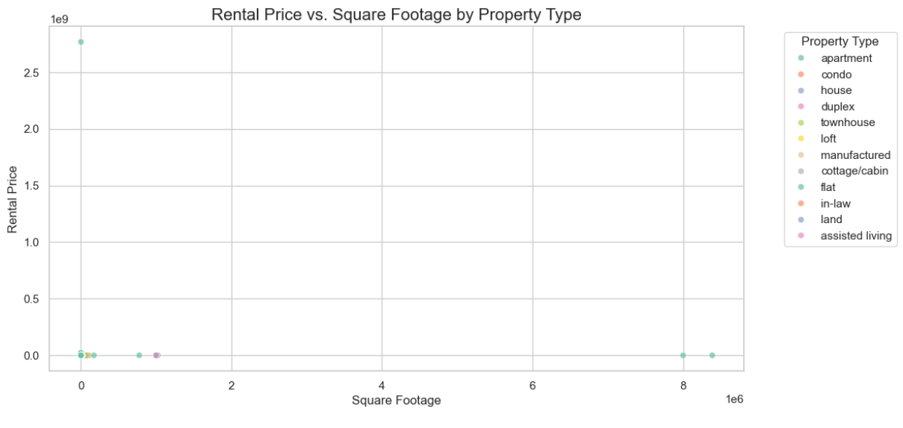
Heatmap of correlations between rental price and key property features:
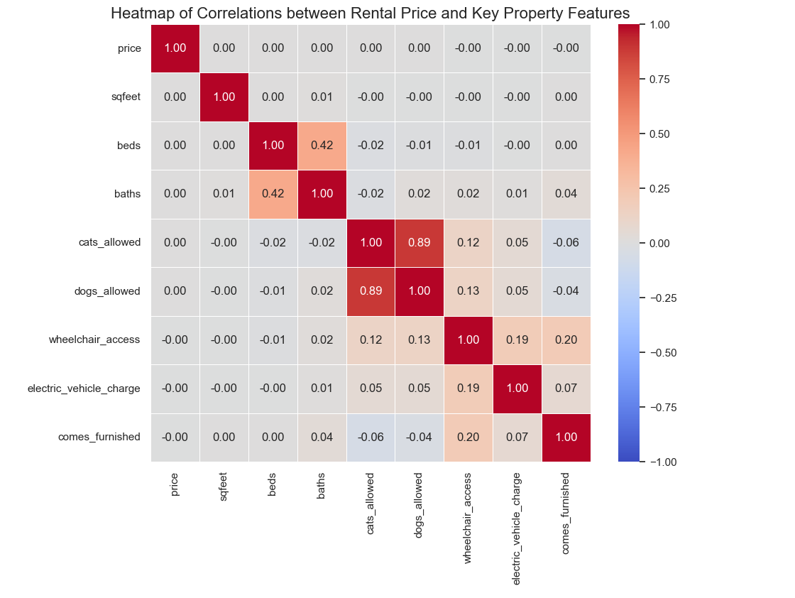

Bar chart of amenity counts across properties. :
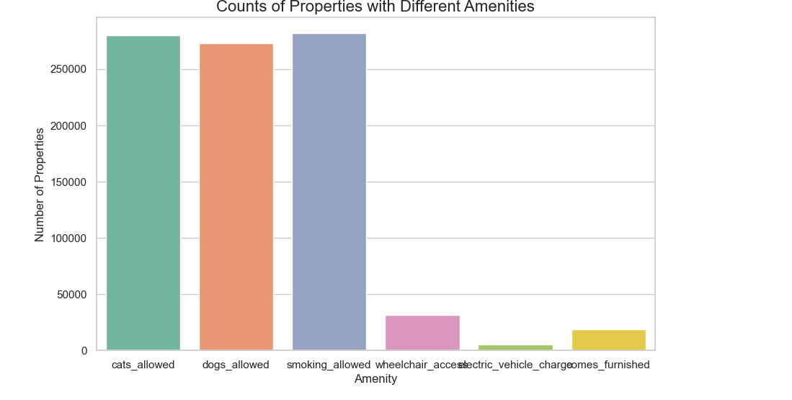
Boxplot for 'price' by 'type' (Property type)
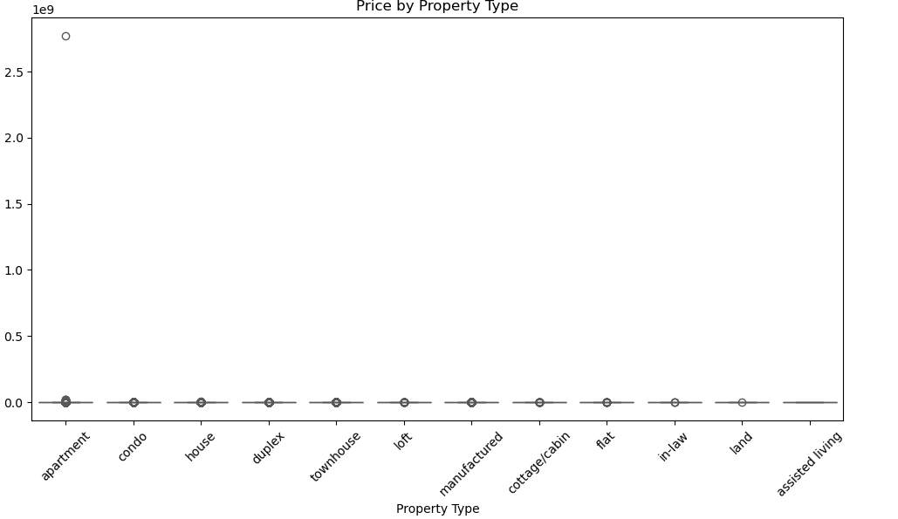

7.1 Solution Approach
The proposed solution includes:
- Descriptive analytics for trend identification.
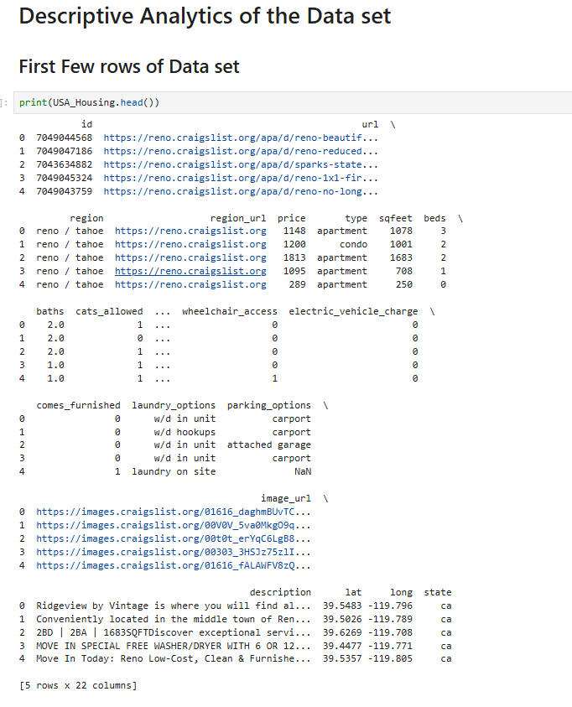

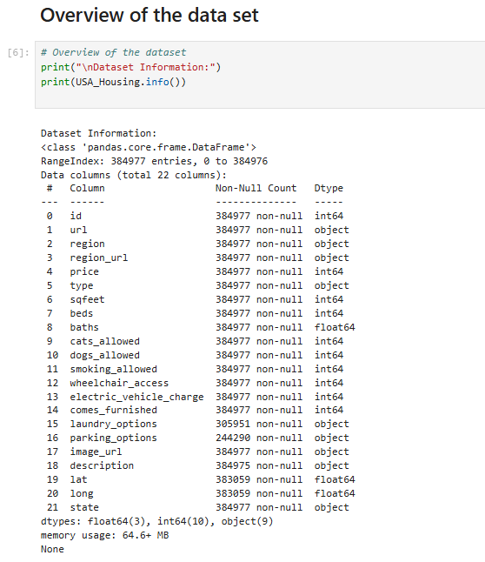\
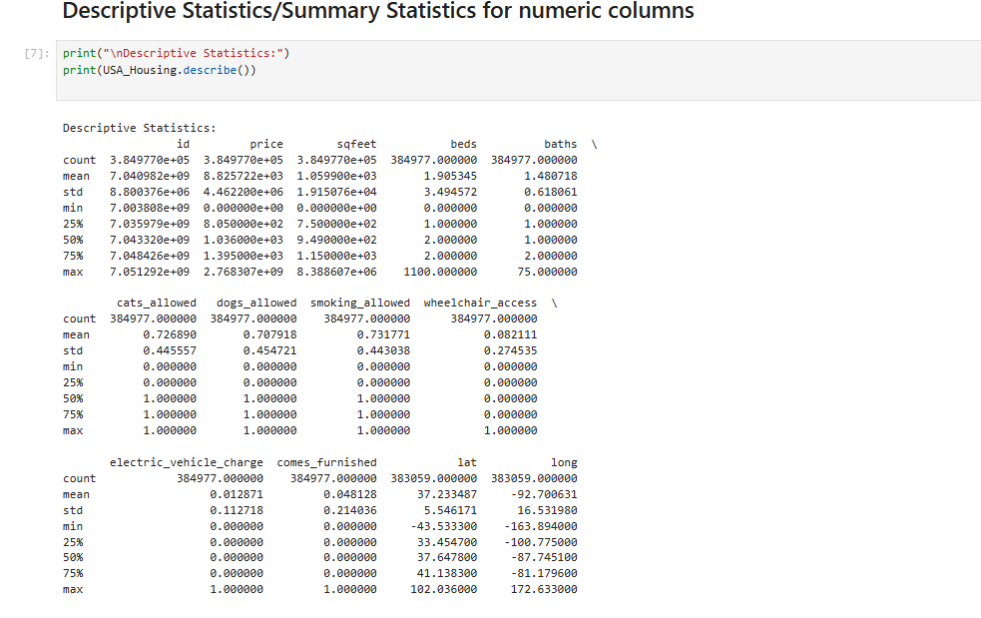

- Predictive analytics for forecasting rental prices and occupancy.(Regression Analysis)
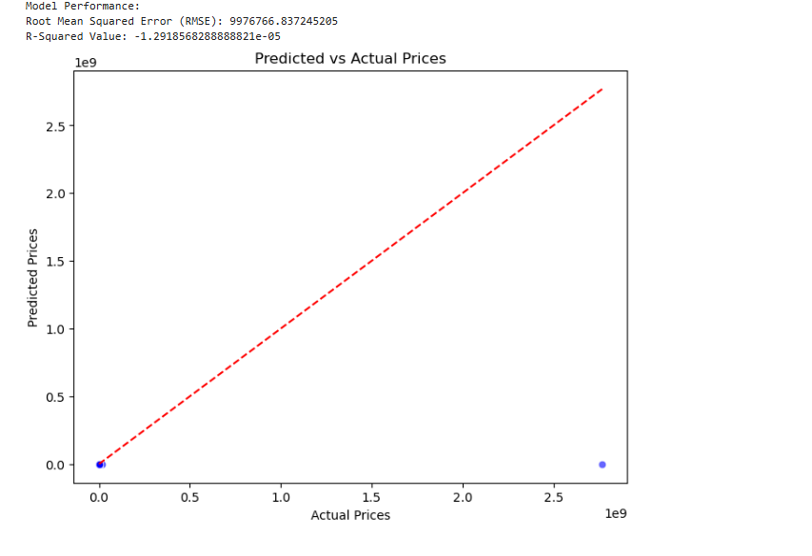
- A/B testing for strategy validation.
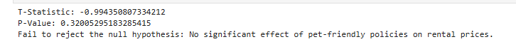
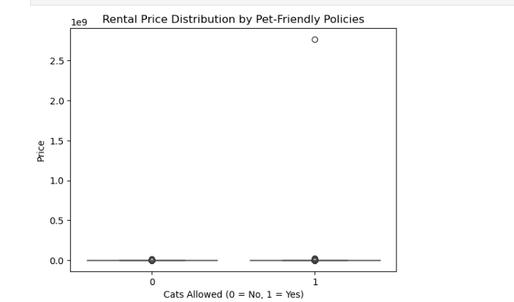
- Time series analysis for seasonal adjustments.
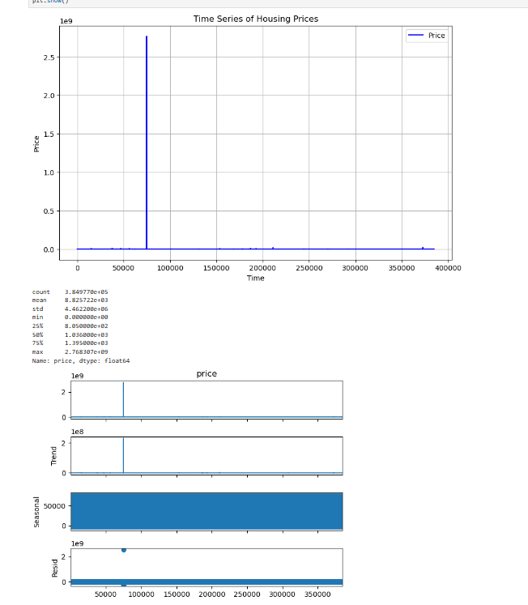
These methods were validated through rigorous performance evaluation and aligned with organizational goals.

7.2 Recommended Actions
Recommended actions include:
- Dynamic pricing strategies based on market trends.
- Enhancing high-value amenities to attract tenants.
- Implementing targeted marketing campaigns for high-demand regions.

7.3 Potential Benefits and Risks
Benefits:
- Increased revenue through optimized pricing.
- Improved tenant satisfaction and retention.
- Enhanced property value and market competitiveness.
Risks include data inaccuracies and market fluctuations, which can be mitigated through continuous monitoring and adjustment.

8. Resource Allocation
Required resources include data analytics tools, trained personnel, and a budget for marketing and amenity enhancements. Collaboration with property management experts is also recommended.

9. Conclusion
Overall, the above visualizations and analyses suggest that pricing based on property size and features, targeted amenity upgrades, and strategic location-based pricing can optimize rental pricing, increase occupancy, and boost property appeal, helping the business stay competitive in the rental market.
Adapting to changing market conditions and leveraging data for strategic decision-making will be essential as the real estate industry continues to evolve. Companies that prioritize these capabilities can enhance their existing portfolios while gaining a competitive edge in identifying and capitalizing on opportunities in emerging markets. The report highlights a clear pathway for using analytical insights to drive growth and profitability in the real estate sector. Additionally, it underscores the vital importance of resource allocation in transforming data-driven strategies into actionable results.

10. References
Kaggle Dataset: USA Housing Listings. Retrieved from: https://www.kaggle.com/datasets/austinreese/usa-housing-listings/data?select=housing.csv%5D

11. Contribution
Member 1: Ananth Kanna
He contributed significantly to data cleaning and preprocessing by encoding categorical variables ('region' and 'state') with Label Encoder and removing duplicates to ensure data integrity. Missing values in numeric columns ('sqfeet,' 'beds,' 'bathtubs') were filled with medians, while categorical and binary columns were handled with 'Unknown' and 0, respectively. Numerical features were scaled using StandardScaler, and categorical variables were transformed with One Hot Encoding. Finally, Column Transformer was employed for efficient preparation, ensuring the dataset was clean, consistent, and ready for analysis and modeling.

Member 2: Chaithanya Sankar Varma Pandeti
His contributions were pivotal in enhancing data analysis and modeling by focusing on outlier detection and removal. He Identified and eliminated outliers in key numerical fields, including 'sqfeet,' 'price,' 'beds,' and 'baths,' improving data accuracy and model reliability.
He also contributed to data segmentation by implementing price binning, dividing real estate values into quantiles. This approach enabled a detailed analysis of market segments and provided insights into varying behaviors across different pricing levels.
Member 3: Chandra Shekar Reddy Bhoomireddy
He evaluated the predictive model's performance by calculating metrics like explained variance and R-squared, highlighting its strengths and limitations. Additionally, I contributed to resolving Business Problem 1, enhancing data quality and analytical depth, and establishing a solid foundation for market analysis and predictive modeling.
He optimize performance by experimenting with algorithms, ensuring model interpretability, and collaborating with stakeholders to derive actionable insights. In real estate, He address supply-demand mismatches through data analysis, using techniques like data visualization, descriptive statistics, and regression reliability.
Member 4: Rajashree Guduru
She contributed by ensuring accurate data collection and cleaning, enhancing the model through feature engineering, and optimizing performance with various algorithms. Her analysis of model outputs highlighted discrepancies in price predictions across property types and states, identifying patterns of underestimation and overestimation. This analysis led to targeted investment and development recommendations.
She contributed by ensuring accurate data collection and cleaning, enhancing the model through feature engineering, and optimizing performance with various algorithms. I focused on model interpretability and collaborated with stakeholders to extract actionable insights. My analysis of model outputs highlighted discrepancies in price predictions across property types and states, identifying patterns of underestimation and overestimation. This analysis led to targeted investment and development recommendations.
Final Report Made by Rajashree
Member 5: Rupert Munnings
In the project, He played a crucial role in gathering and cleaning data to ensure its accuracy. I leverage analytical skills in feature engineering to enhance the model's predictive power. During model selection and training,
Heatmap-Based Correlation Analysis: He created a heatmap to show the relationship between numerical characteristics across price ranges, providing information about key market variables and pointing out possible avenues for investment.

He made a substantial contribution to the project's improvement of data quality and analytical depth through these efforts, giving rise to a strong foundation for perceptive market analysis and successful predictive modelling.

