

DESIGN OF A BIO-INSPIRED MICRO AERIAL VEHICLE



April 2022

MENTORS:

Dr. Rajesh Senthil Kumar T

Dr. Balajee Ramakrishnananda

Ananthu S Nair - Propulsion Engineer

Jerome Alex Revanth - Design/ Autonomous System Engineer

Thayalan K - Materials and Manufacturing Engineer

DONE BY:

Rajashree Srikanth - CB.EN.U4AEE18030

Sandhitha Patnaik - CB.EN.U4AEE18034

Sanjiv Krishna - CB.EN.U4AEE18037

Yashas - CB.EN.U4AEE18049

# New Methodology for Weight Estimation

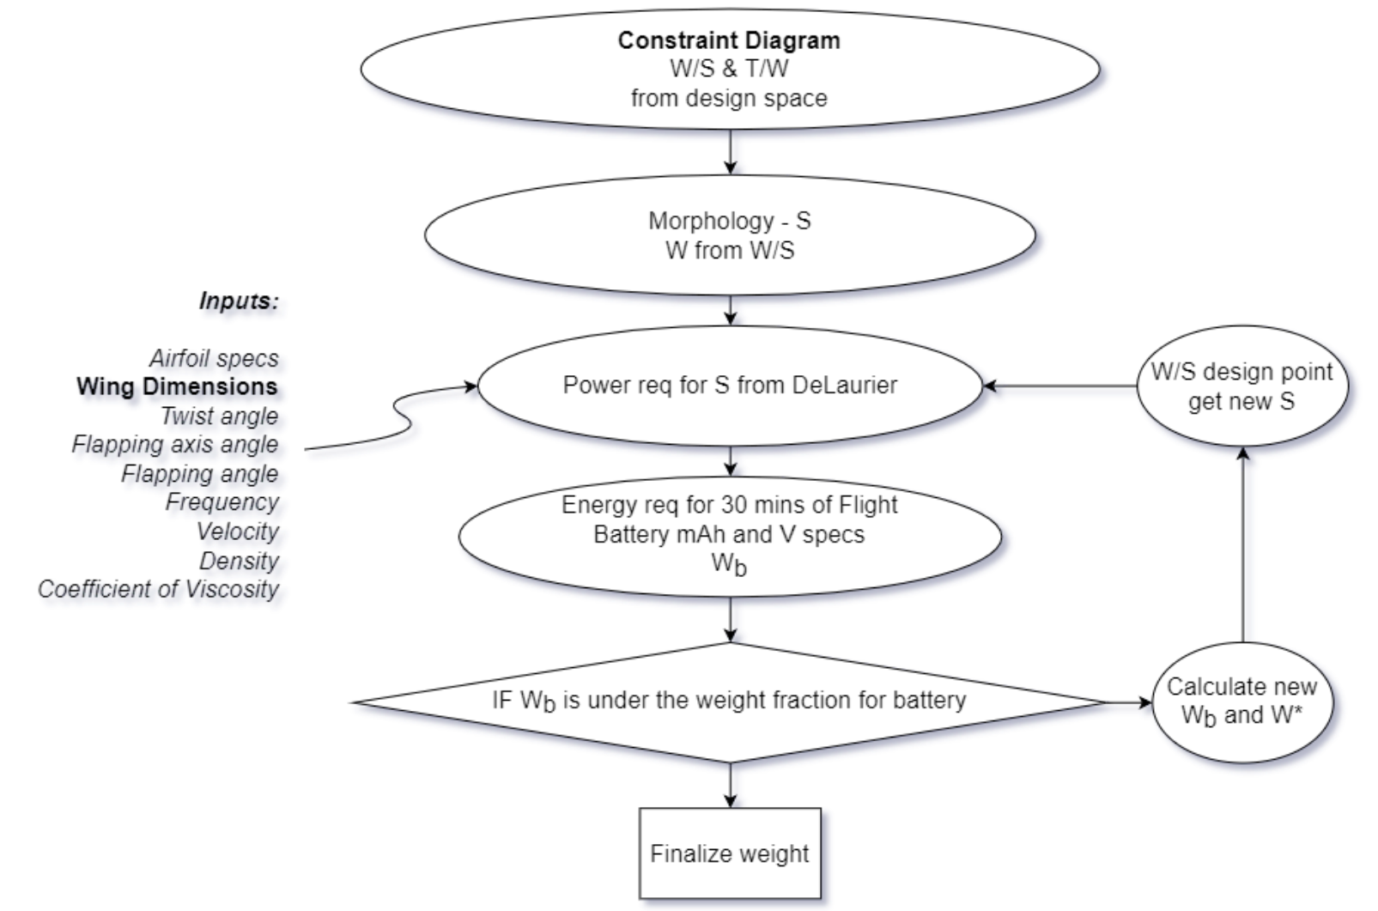

Figure 1: Weight Estimation Methodology

The above mentioned flowchart is the approach followed for weight estimation. It was found that it was not possible to achieve weight convergence iteratively since this process adds up on the battery weight due to the trend of increasing power with increasing area (keeping wing loading constant). Additionally, battery specifications do not follow a statistical trend.

For a given wing loading, the Strouhal number and velocity were varied to achieve minimum required power for flapping. A suitable battery was chosen such that it enabled achieving the required flight time of 30 minutes, and this process was repeated for a range of wing loading values, to fix the physical dimensions of the MAV, namely, the wingspan and the wing planform area. It is to be noted that the power required for flapping was obtained from DeLaurier’s aerodynamic model [6].

The table below shows all the values obtained from the calculations mentioned above.



Figure 2: Wing Loading Iteration for Weight Estimation

The columns in green correspond to the morphological wing loading and wing dimensions.

In order to maintain the size as small as possible, a higher wing loading was chosen. W/S of 20 N/m2 was chosen, and the corresponding dimensions are other relevant parameters obtained are as follows:

|  |  |
| --- | --- |
| **Parameter** | **Value** |
| Wing Loading | 20 N/m2 |
| Wing span | 0.9482 m |
| Wing area | 0.1086 m2 |
| Velocity | 8 m/s |
| Strouhal Number | 0.28 |
| Maximum Flapping Angle | 550 |
| Power required (flapping) | 14.86 W |
| Propulsive efficiency | 29.72% |
| **Weight of MAV** | **220.9 g** |
| Battery Weight | 33 g |
| mAh available | 2000 mAh |

For all these calculations the battery with the highest rating with the lowest weight was chosen, from a detailed literature survey. Two of the batteries with higher performance specifications are mentioned below [8][9]:

|  |  |  |  |  |  |
| --- | --- | --- | --- | --- | --- |
| **Company** | **Battery Type** | **Battery Rating (mAh)** | **V** | **Battery weight** | **Specific energy density** |
| Turnigy | Lipo | 1200 | 3.7 | 20.5 | 58.53658537 |
| Turnigy | Lipo | 2000 | 3.7 | 33 | 60.60606061 |

## Weight Breakdown

|  |  |  |
| --- | --- | --- |
| **Weight component** | **Statistical relation (wt in g)** | **R2 value** |
| Structure weight | $$0.1137 m^{1.2667}$$ | 0.9848 |
| Battery weight | $$0.5572 m^{0.7561}$$ | 0.9225 |
| Electronics weight | $$1.0816 m^{0.7223}$$ | 0.9267 |

The weight breakdown based on the statistical formulae is given below:

|  |  |
| --- | --- |
| Structural weight | 106 g |
| Battery weight | 33 g |
| Electronics weight | 54 g |
| Payload (given specification) | 3 g |
| Additional weight | 28 g |

The additional weight can be used to accommodate other electronics such as additional payload, battery for improved endurance, etc. The additional weight is obtained due to minor errors from the statistical formulation of the weight breakdown.

# Layout

## Flapping Mechanism

A six bar linkage mechanism with single crank is chosen for the flapping motion [7].

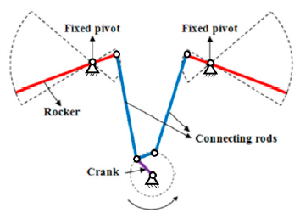

Figure 3: Working of 6-linkage mechanism

The linkage lengths were fixed based on the methodology specified in [7].

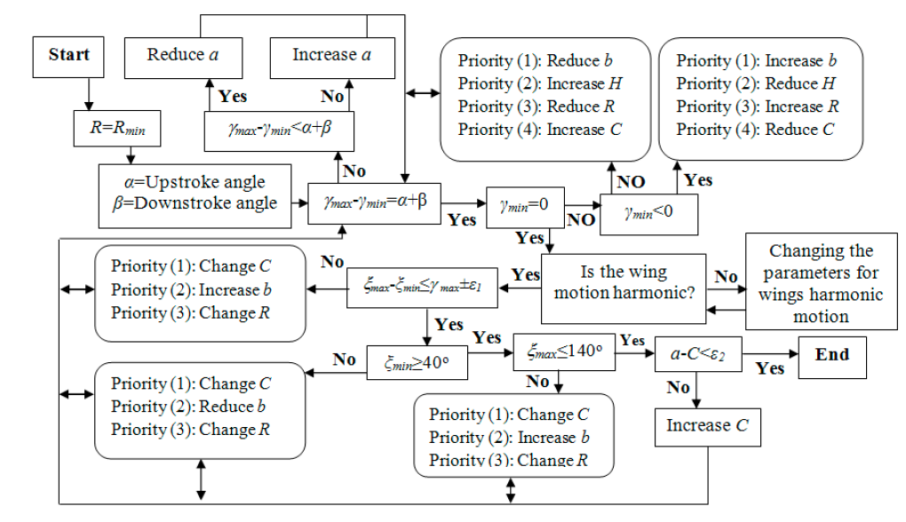

Figure 4: Methodology for Finding Linkage Dimensions

An initial estimate of the linkage lengths is required, which was obtained through scaling of the linkage lengths provided in [7]. These dimensions are then iterated as shown in the figure above in order to obtained final lengths that enable the required specified flapping angle of 550.

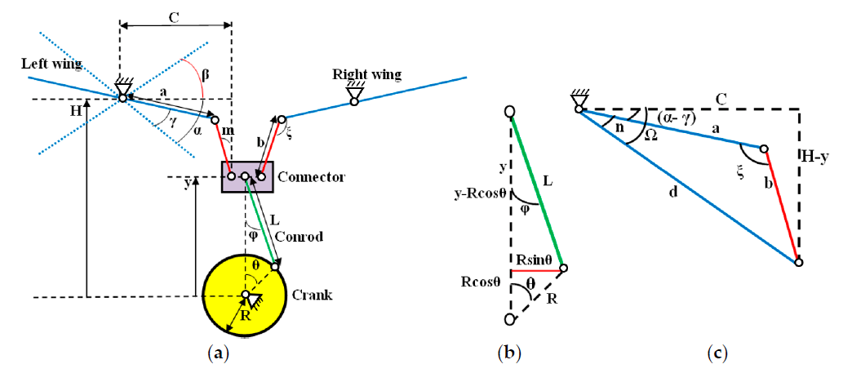

Figure 5: Schematic of Flapping Mechanism

The dimensions of the linkages are as follows:

|  |  |
| --- | --- |
| $$L/R$$ | 4 |
| $$C$$ | 8.4857 mm |
| $$R$$ | 11.3284 mm |
| $$H$$ | 64.8591 mm |
| $$b$$ | 19.3757 mm |
| $$a$$ | 18.3857 mm |

## Determination of Torque and Power for Flapping Mechanism

Parameters like the flapping angle and the angular velocity of the flapping arm were found out as a function of time for one period (0 to 2*pi).

The angular velocity of the crank was set as [7]

$$ω = 2πf$$

where $f$ is the flapping frequency. The torque was found using the formula

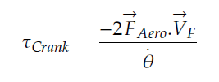

Where,

$V_{F}$ is the linear velocity of the wing expressed by [7]:

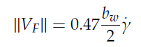

and $F_{Aero}$ is found from the instantaneous lift value obtained for one flapping cycle from the DeLaurier aerodynamic model.

Power is then found from the relation

$$P =τ ω$$

The final values obtained are as follows:

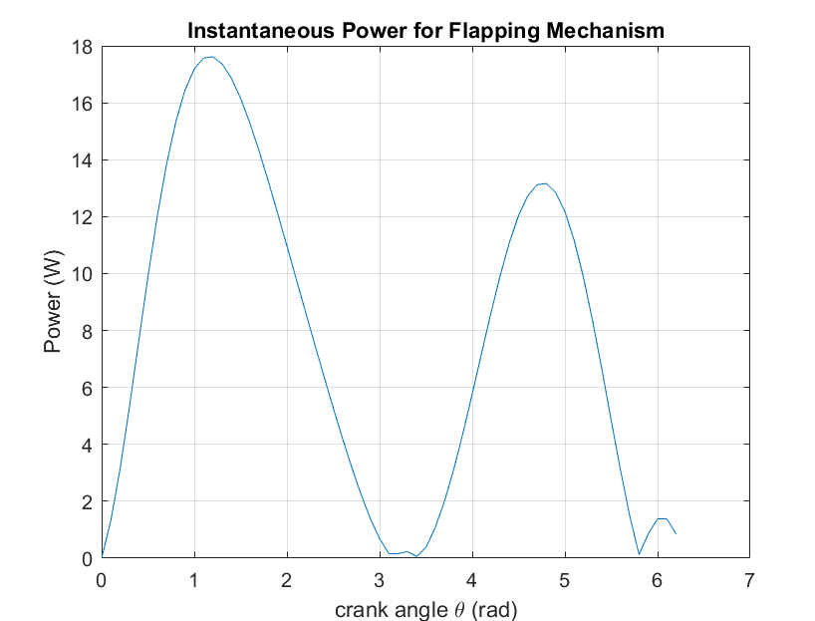

Figure 6: Instantaneous Power Curve for Flapping Mechanism

|  |  |
| --- | --- |
| Maximum Absolute Torque | 560.8148 N-mm |
| Maximum Power for Flapping Mechanism ($P_{in}$) | 17.6185 W |
| Power required for Flapping (from DeLaurier aerodynamic model) ($P_{out}$) | 14.86 W |
| Transmission efficiency (mechanism) | $P_{out}/P_{in}$ = 0.8433 |

## Structure

A summary of literature data on the structural specifications in similar bat-inspired models are specified below:

|  |  |  |  |  |  |  |
| --- | --- | --- | --- | --- | --- | --- |
| **S No** | **Model** | **MTOW (g)** | **Frame Material** | **Density**  **(g/cc)** | **Skin Membrane** | **Ref** |
| 1 | Tailless bat | 289 | Carbon fibre composite | 1.55 - 1.6 | Polyester fiber material | [1] |
| 2 | B2 Bat Bot | 93 | Carbon fibre tubes | 1.55 - 1.6 | ultrathin silicone based membrane - 0.056mm thickness | [2][3] |
| 3 | B2.0 | 90 | Carbon fibre tubes | 1.55 - 1.6 | 2 layered silicone membrane - 0.33+0.31 mm thickness | [3] |
| 4 | RoboFalcon FWAV | 600 | 3k carbon fibre rods - 2mm, 1.5mm | 1.55 - 1.6 | Ripstop polyester fabric - 210T | [4] |
| 5 | Bionic Flying Fox | 580 | Body - foam skeleton - milled carbon rods, 3d printed parts | 1.4 | Knitted elastane fabric | [5] |

## Fuselage

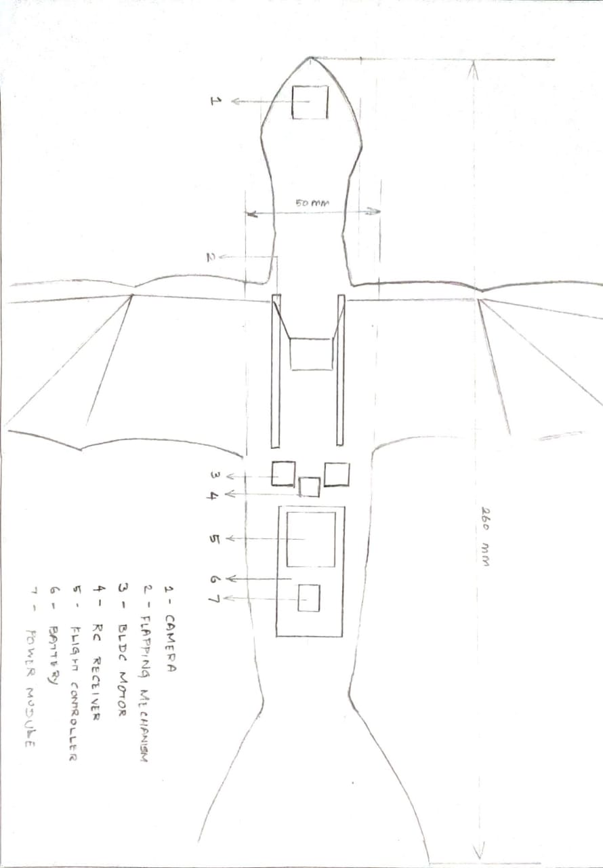

Figure 7: Top View

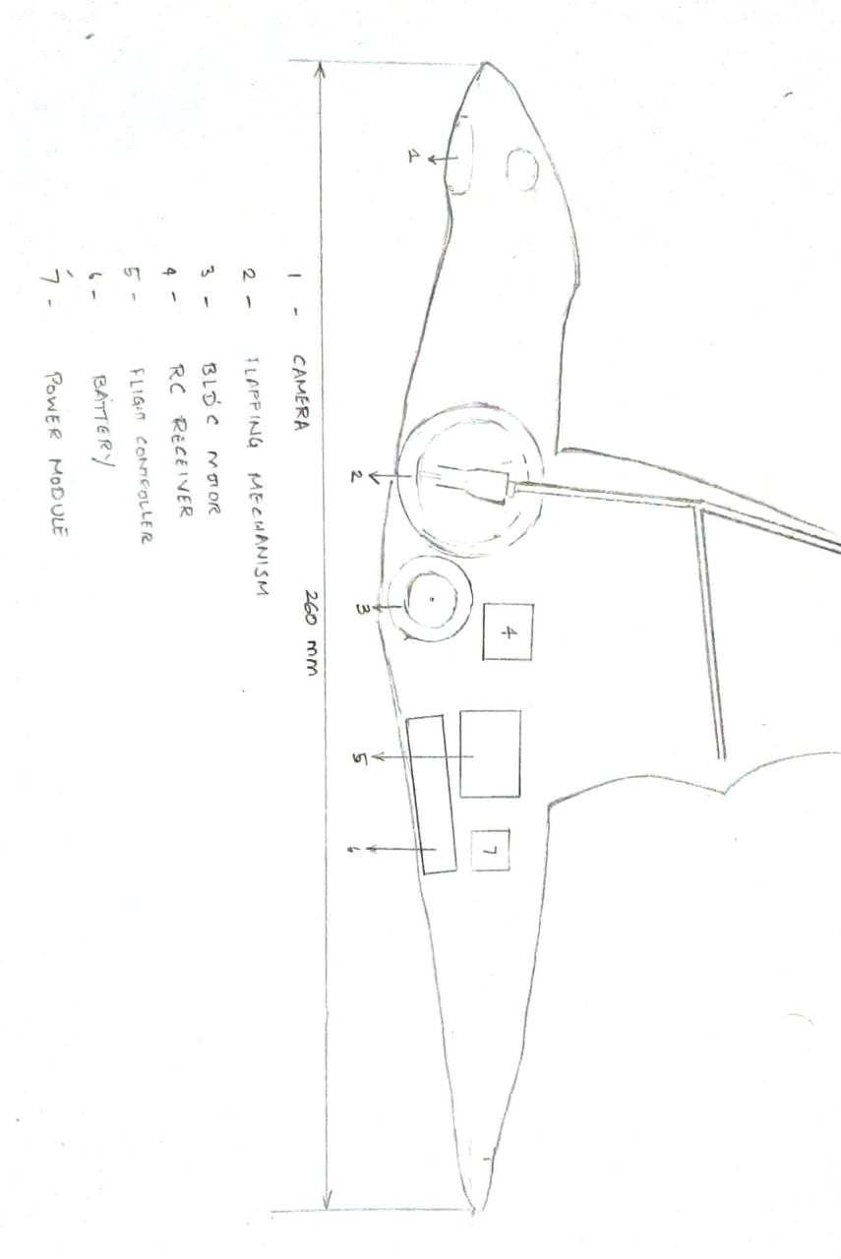

Figure 8: Side View

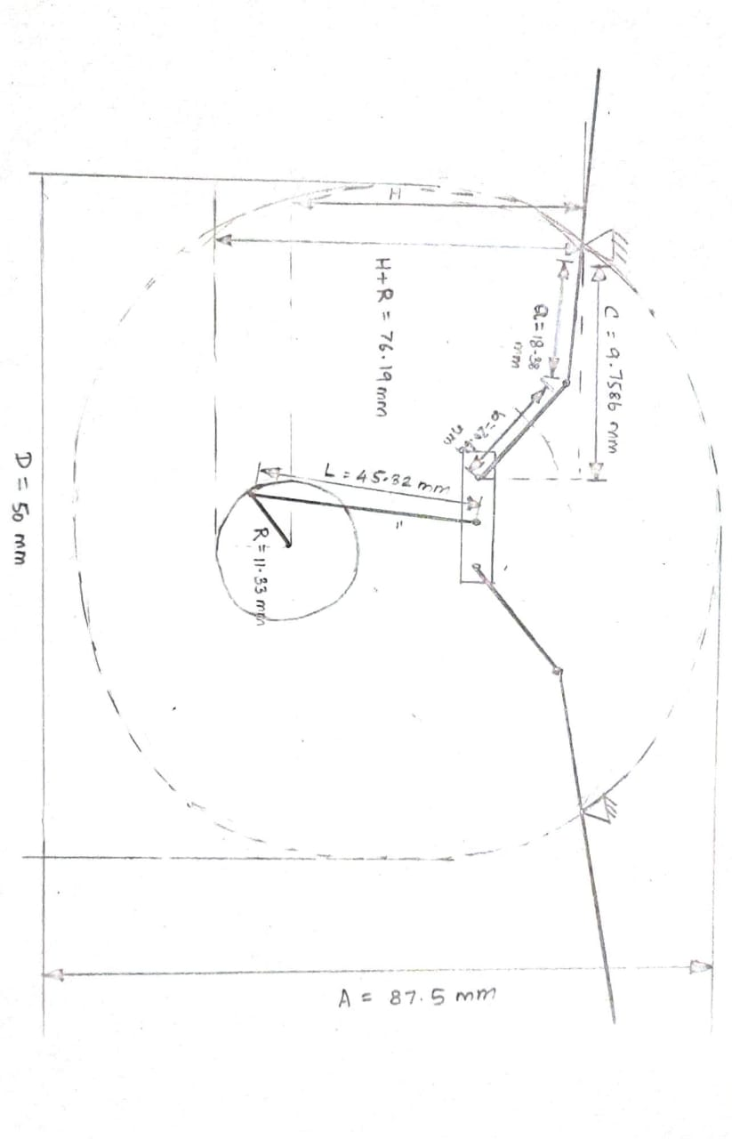

Figure 9: Front View

# References

1. Bie, D., Li, D., Xiang, J., Li, H., Kan, Z., & Sun, Y. (2021). Design, aerodynamic analysis and test flight of a bat-inspired tailless flapping wing unmanned aerial vehicle. Aerospace Science and Technology, 112, 106557.
2. Ramezani, X. Shi, S. Chung and S. Hutchinson, "Bat Bot (B2), a biologically inspired flying machine," 2016 IEEE International Conference on Robotics and Automation (ICRA), 2016, pp. 3219-3226, doi: 10.1109/ICRA.2016.7487491.
3. J. Hoff, N. Jeon, P. Li and J. Kim, "Bat Bot 2.0: bio-inspired anisotropic skin, passive wrist joints, and redesigned flapping mechanism," 2021 IEEE/RSJ International Conference on Intelligent Robots and Systems (IROS), 2021, pp. 8424-8430,
4. Chen, A., Song, B., Wang, Z., Xue, D., & Liu, K. (2021). A Novel Actuation Strategy for an Agile Bio-inspired FWAV Performing a Morphing-coupled Wingbeat Pattern. arXiv preprint arXiv:2111.02118.
5. Festo_BionicFlyingFox_en.pdf
6. DeLaurier, J. D. (1993). An aerodynamic model for flapping-wing flight. The Aeronautical Journal, 97(964), 125-130.
7. Hassanalian, M., & Abdelkefi, A. (2019). Towards improved hybrid actuation mechanisms for flapping wing micro air vehicles: analytical and experimental investigations. *Drones*, *3*(3), 73.
8. https://hobbyking.com/en_us/turnigy-1200mah-1s-1c-lipoly-w-2-pin-jst-ph-connector.html?queryID=cea1adccf4d2a357706dc3ae76313be0&objectID=60075&indexName=hbk_live_products_analytics&___store=en_us
9. https://hobbyking.com/en_us/turnigy-2000mah-1s-1c-lipoly-w-2-pin-jst-ph-connector.html?queryID=cea1adccf4d2a357706dc3ae76313be0&objectID=60076&indexName=hbk_live_products_analytics