Workflow

The following workflow process was followed:

Sketches inspired from nature, that were made earlier, have been analyzed to estimate power required and approximately size the model. The first sketch – that consists of a combination of bat wings with owl serrations/feathers is the model that has been taken for analysis.

1. Initially, the sizing procedure from [1] was followed, and sizing was done for the bat species – Falco Tinnunculs. However, on comparing the obtained data with available wing morphology from literature data, the values did not match.
2. Hence, instead of sizing using algorithms, literature data from [3] was used as the initial bat dimension, and power was estimated accordingly, similar to the process followed in [2]

Power estimation and morphological data for 2 of the bat species from the reference were obtained as follows. These 2 species were chosen specifically because of their mass and size fall under the category of SUAV and/or MAV:

|  |  |
| --- | --- |
| Species of bat: Tadarida australis  Wingspan = 0.4625 m  Planform area = 0.02584 m2  Mass = 0.0353 kg  AR = 8.27  Mean aerodynamic chord = 0.055 m  Flapping Frequency = 6.838 Hz  Average CL of bat wing = 0.784  Total drag = 0.0267 N  Total power required = 0.16044 W  Total energy required = 433.209 J | Species of bat: Taphozous hilli  Wingspan = 0.4616 m  Planform area = 0.027 m2  Mass = 0.0241 kg  AR = 7.789  Mean aerodynamic chord = 0.0592 m  Flapping Frequency = 5.825 Hz  Average CL of bat wing = 0.63  Total drag = 0.0232 N  Total power required = 0.1392 W  Total energy required = 375.960 J |

1. A similar algorithm was used to estimate power for birds as well.
2. Next, constraint analysis using a T/W vs W/S plot was attempted, to find the minimum T/W for a general bird/bat. This has to be rechecked to give conclusive remarks.
3. A method to combine different unique aspects of birds that help in achieving the mission requirements is being researched (owl serrations on bat wings, birds camouflage on a VTOL (Vertical Take-Off and Landing) etc.)
4. Additionally, literature data on few inseccts with favourable flying characteristics was conducted.

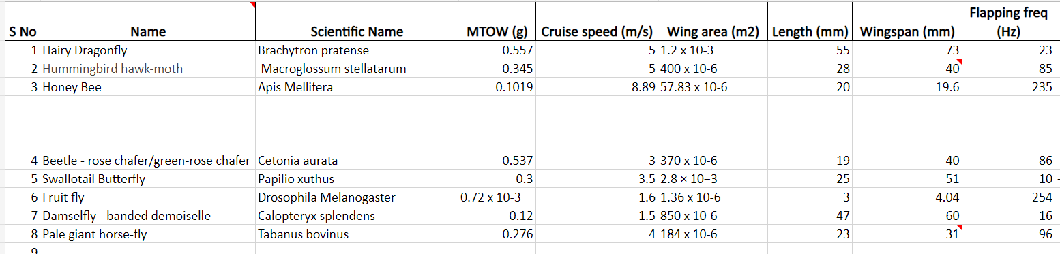

References

1. Hassanalian, M., Abdelkefi, A., Wei, M. et al. A novel methodology for wing sizing of bio-inspired flapping wing micro air vehicles: theory and prototype. Acta Mech 228, 1097–1113 (2017)
2. Bie, D., Li, D., Xiang, J., Li, H., Kan, Z., & Sun, Y. (2021). Design, aerodynamic analysis and test flight of a bat-inspired tailless flapping wing unmanned aerial vehicle. Aerospace Science and Technology, 112, 106557.
3. R. D. Bullen, N. L. McKenzie; Scaling bat wingbeat frequency and amplitude. J Exp Biol 1 September 2002; 205 (17): 2615–2626. doi:

Rajashree Srikanth - CB.EN.U4AEE18030

Sandhitha Patnaik - CB.EN.U4AEE18034

Sanjiv Krishna - CB.EN.U4AEE18037

Yashas - CB.EN.U4AEE18049