

DESIGN OF A BIO-INSPIRED MICRO AERIAL VEHICLE



November 2021

MENTORS:

Dr. Rajesh Senthil Kumar T

Dr. Balajee Ramakrishnananda

Ananthu S Nair - Propulsion Engineer

Jerome Alex Revanth - Design/ Autonomous System Engineer

Thayalan K - Materials and Manufacturing Engineer

DONE BY:

Rajashree Srikanth - CB.EN.U4AEE18030

Sandhitha Patnaik - CB.EN.U4AEE18034

Sanjiv Krishna - CB.EN.U4AEE18037

Yashas - CB.EN.U4AEE18049

# Literature Study

## Birds

The table above tabulates basic morphological data for some birds and 2 specific species of bats that have characteristics relevant to the mission profile given [7-15].

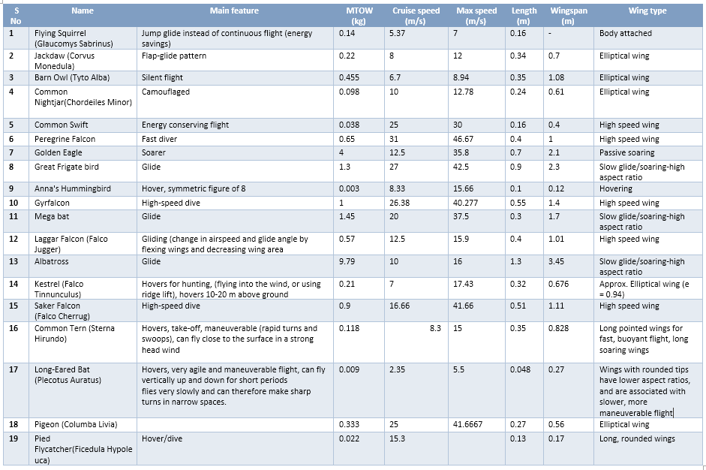

The conceptual sketches could be based on following two bird (chosen from the literature survey):

The Common Tern (Sterna Hirundo) and the Kestrel (Falco Tinnunculus) were chosen due to their compact size and ability to hover in the presence of a headwind. Additionally, the former can soar, thereby reducing the necessity to flap throughout the entire mission. **Wing area** for these birds were found to be **0.056 m2** and **0.368 m2** respectively.

## Bats

Data of 22 different species of bat were obtained from [3], and are tabulated below:



Two specific species of bats were chosen – *Tadarida Australis* and *Taphozous Hilli*. These have fairly high aspect ratios, making them easy to analyze aerodynamically, since lower aspect ratio models are much more susceptible to be affected by unsteady effects. Additionally, their masses are neither too high not too low, and their size is such that they can be made stealthy.

## Insects

A similar literature study was done for insects with hover capability [16-18]. This was a major condition while performing the study primarily because insects are known to be efficient at hovering.

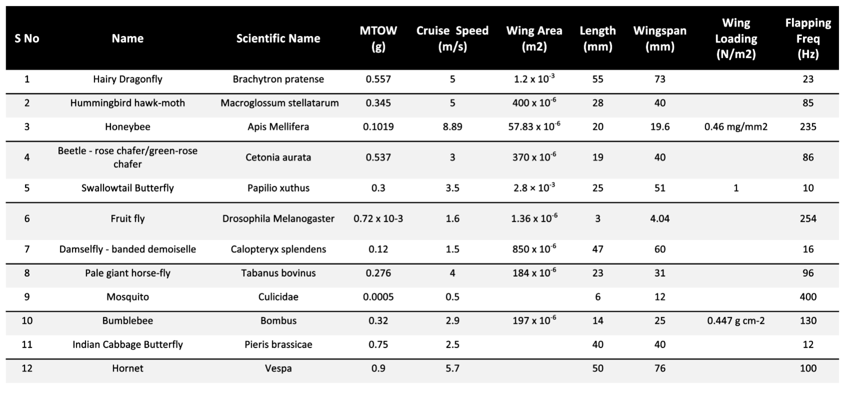

# Conceptual Sketches

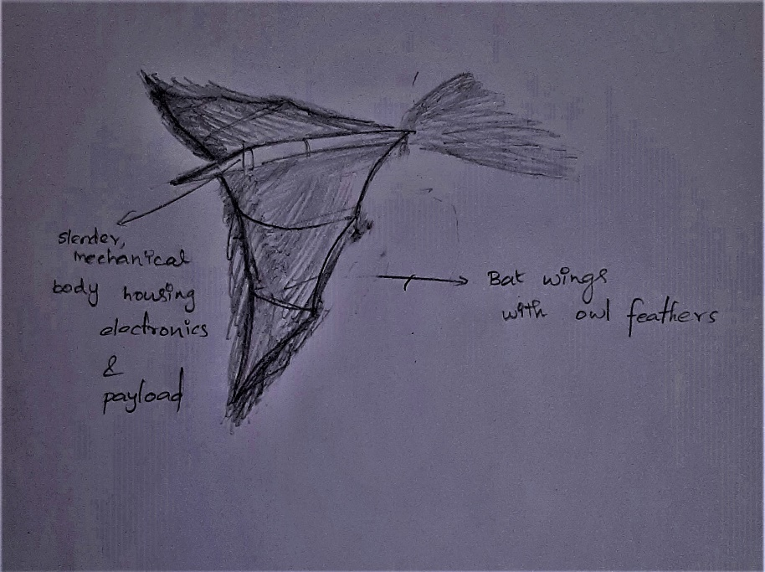

Figure : Bat with Owl Wings

The body is shaped like a bat considering the easier gliding and flapping motion of bats. Owl serrations over the wing are being considered as they have been found to reduce noise.

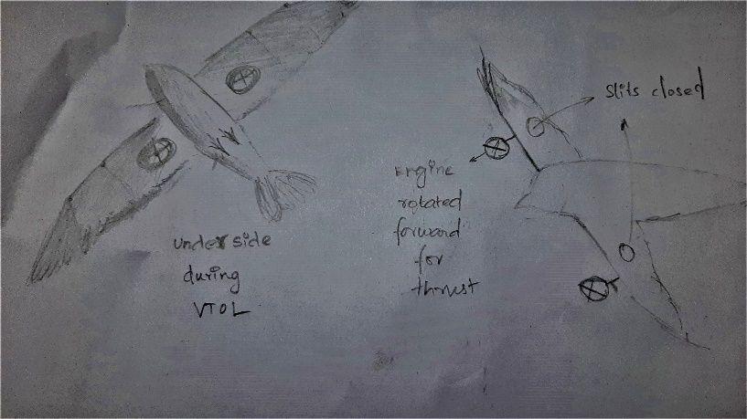

Figure : Common Tern with VTOL Capability by Introduction of Slits on Wing Planform

The idea is to incorporate the VTOL concept into a camouflaged MAV. The wing is shaped like the wing of a tern.

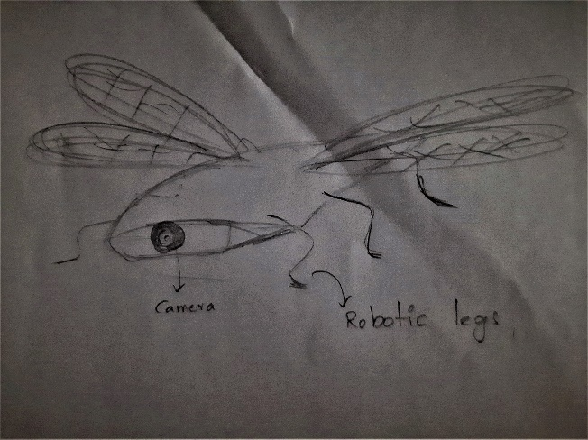

Figure : Insect-sized MAV inspired from Dragonfly

The main inspiration is the dragonfly, it has better hovering characteristics than most birds and insects. The body has been widened to accommodate avionics. Robotic legs for land operations.

# Sizing

The sizing procedure from [2] was used, in which the biological morphological data was used as the initial dimensions for the MAV/SUAV model. It is assumed that bird morphological and kinematic data can be used for an MAV model for similar characteristics [4], and hence, their flight speed was also taken for further calculations. A summary of the dimensions are as follows:

|  |  |  |  |  |  |  |
| --- | --- | --- | --- | --- | --- | --- |
| Species​ | Cruise Speed (m/s)​ | Mass (kg)​ | Wingspan (m)​ | Planform Area ​(m2) | Aspect Ratio​ | MAC​ (m) |
| Tadarida Australis​ | 11.9​ | 0.0353​ | 0.4625​ | 0.02584​ | 8.28​ | 0.055​ |
| Taphozous hilli​ | 10​ | 0.0241​ | 0.4616​ | 0.02736​ | 7.79​ | 0.059​ |
| Common Tern​ | 8.3​ | 0.118​ | 0.828​ | 0.056​ | 12.2​ | 0.067​ |

# Constraint Diagram

## Relations Used [1]

$$\frac{T_{SL}}{W}=\frac{1}{α}\left[\frac{qS}{W} \left\{k_{1}{\left(\frac{n}{q}\frac{W}{S}\right)}^{2}+2ψC_{f}\right\}+\frac{1}{U}\frac{dZ}{dt}\right]$$

Where,

$α = \left(\frac{T_{a} + 273.16}{T_{a} + 273.16- \left(0.001981 h_{0}\right)}\right)⋅{\left\{1 - \frac{0.001981*h_{0}}{288.16}\right\}}^{5.526}$, which describes the momentary thrust and sea thrust

$q=\frac{1}{2}ρV^{2}$, the dynamic pressure

$S$ is the wing planform area

$W$, the weight of the aircraft

$n$, the load factor for the specific phase of flight

$ψ =3.2$, ratio of the parasite drag coefficient of flapping wing ($C_{DP}$) to the frictional drag coefficient ($C_{f}$) for a flat sheet, and generally ranges from 2 to 4.4.

$C_{f}=0.455 {\left(\log_{10}{Re}\right)}^{-2.58}$, the frictional drag coefficient

$U,$ the free-stream velocity

$Z=h+\frac{U^{2}}{2g}$

The T/W vs W/S relation above is used for 6 different phases of flight:

1. Hand launch at stall speed
2. Cruise flight
3. Climbing flight
4. Horizontal acceleration
5. Accelerated climb
6. Coordinated turn

The plots corresponding to all 6 phases are combined into a single graph called the *Constraint Diagram* to obtain the design point. This constraint diagram is done for the 2 bat and the one bird species mentioned in the previous section. The plots are shown in the subsequent section.

The flapping frequency is given by the relation [5]

$$f=m^{\frac{3}{8}} g^{\frac{1}{2}} b^{-\frac{23}{24}} S^{-\frac{1}{3}} ρ^{-\frac{3}{8}}$$

Where, $m$ is the mass (in kg), $g$ the acceleration due to gravity (in m/s2), the wing span (in m), $S$ the planform area (in m2) and the density at flight altitude (in kg/m3).

## Plots

The constraint diagram was used to obtained the design point T/W, and hence, the power value. The diagrams for the *Tadarida Australis, Taphozous Hilli* and *the Common Tern* species are plotted below:

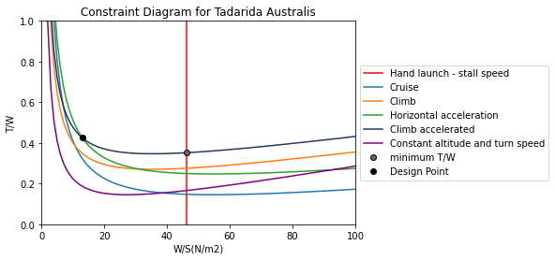

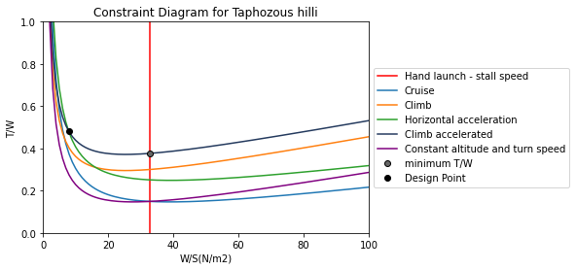

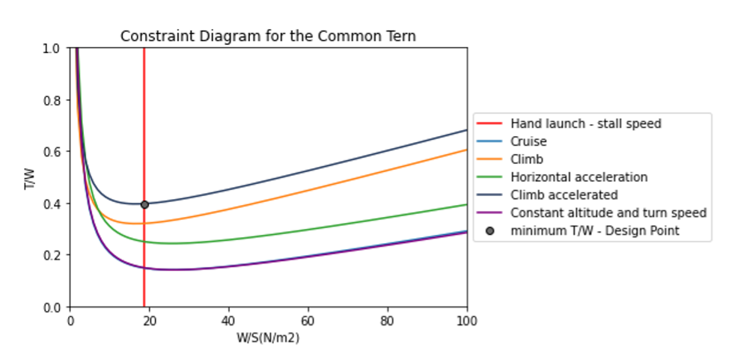

## Results

The results of the constraint plot are tabulated below.

|  |  |  |  |  |  |  |
| --- | --- | --- | --- | --- | --- | --- |
| Species​ | Reynolds number​ | Design point – W/S (N/m2)​ | Design Point – T/W ​ | Mass (kg)​ | Power required (W)​ | Flapping Frequency  (Hz) [5]​ |
| Tadarida Australis​ | 100,072​ | 13​ | 0.425​ | 0.0342​ | 1.698 ​ | 6.83​ |
| Taphozous hilli​ | 91,336​ | 8​ | 0.48​ | 0.0223​ | 1.05​ | 5.825​ |
| Common Tern​ | 135,983​ | 18.76​ | 0.39​ | 0.107​ | 3.456​ | 4.75​ |

# References

1. Hassanalian, M., Abdelkefi, A., Wei, M. et al. A novel methodology for wing sizing of bio-inspired flapping wing micro air vehicles: theory and prototype*. Acta Mech* 228, 1097–1113 (2017).​
2. Bie, D., Li, D., Xiang, J., Li, H., Kan, Z., & Sun, Y. (2021). Design, aerodynamic analysis and test flight of a bat-inspired tailless flapping wing unmanned aerial vehicle*. Aerospace Science and Technology*, 112, 106557.​
3. R. D. Bullen, N. L. McKenzie; Scaling bat wingbeat frequency and amplitude*. J Exp Biol* 1 September 2002; 205 (17): 2615–2626.​
4. Pennycuick, C., 2008. Modelling the flying bird. *Amsterdam: Academic Press*.​
5. Rayner, J. M. V. (1979). A vortex theory of animal flight. Part 2. The forward flight of birds. *Journal of Fluid Mechanics*, 91(04), 731.
6. Suhaimi, S., Shuib, S., Kadarman, A. H., & Yusoff, H. (2021). Lift Study of a Flapping MAV Wing Design Based on Bat Wings. *IOP Conference Series*
7. Audubon, “The silent Fight of owls, explained."
8. Wikipedia, “Common tern."
9. G. Spedding, “The wake of a kestrel (Falco tinnunculus) in gliding fight," *Journal of Experimental Biology*, vol. 127, no. 1, pp. 45-57, 1987.
10. J. M. Rayner, “A new approach to animal Fight mechanics," Journal of Experimental Biology, vol. 80, no. 1, pp. 17-54, 1979.
11. U. Norberg, “Aerodynamics of hovering Fight in the long-eared bat plecotus auritus," *Journal of Experimental Biology,* vol. 65, no. 2, pp. 459-470, 1976.
12. V. A. Tucker and G. C. Parrott, “Aerodynamics of gliding flight in a falcon and other birds," *Journal of Experimental Biology*, vol. 52, no. 2, pp. 345-367, 1970.
13. Wikipedia, “List of bird flights based on speeds."
14. T. A. Ward, M. Rezadad, C. J. Fearday, and R. Viyapuri, “A review of biomimetic air vehicle research: 1984-2014," *International Journal of Micro Air Vehicles*, vol. 7, no. 3, pp. 375-394, 2015.
15. G. Spedding, “The wake of a kestrel (falco tinnunculus) in flapping flight," *Journal of experimental biology*, vol. 127, no. 1, pp. 59-78, 1987.
16. Ellington Charles Porter, “The aerodynamics of hovering insect flight. II. Morphological parameters”, *Phil. Trans. R. Soc. Lond*. B30517–40, 1984.
17. Osborne, M. F. M. Aerodynamics of flapping flight with application to insects. *Journal of Experimental Biology*, *28*(2), 221-245, 1951.
18. Mao, S., Gang, D. Lift and power requirements of hovering insect flight. *Acta Mech Sinica* **19,**458–469 (2003)