# Literature study for the statistical equation

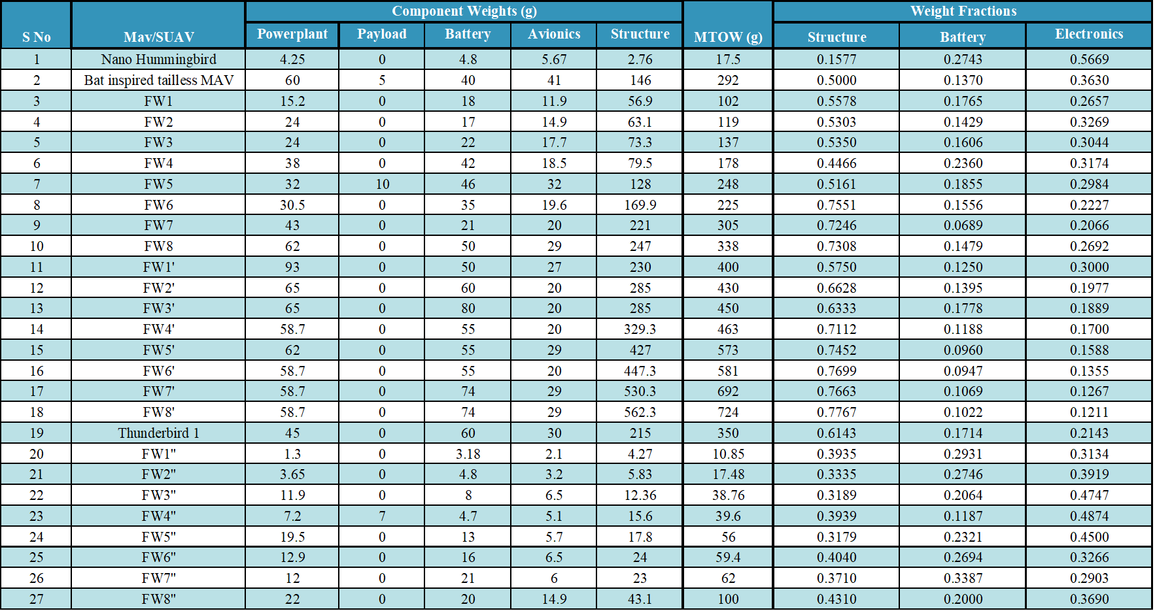

# Bibliography (for the statistical analysis)

[1] Hassanalian, M., Abdelkefi, A., Wei, M., & Ziaei-Rad, S. (2017). A novel methodology for wing sizing of bio-inspired flapping wing micro air vehicles: theory and prototype. *Acta Mechanica*, *228*(3), 1097-1113.

[2] Bie, D., Li, D., Xiang, J., Li, H., Kan, Z., & Sun, Y. (2021). Design, aerodynamic analysis and test flight of a bat-inspired tailless flapping wing unmanned aerial vehicle. *Aerospace Science and Technology*, *112*, 106557.

[3] Hassanalian, M., Abdelkefi, A., Wei, M., & Ziaei-Rad, S. (2017). A novel methodology for wing sizing of bio-inspired flapping wing micro air vehicles: theory and prototype. *Acta Mechanica*, *228*(3), 1097-1113.

[4] Keennon, M., Klingebiel, K., & Won, H. (2012, January). Development of the nano hummingbird: A tailless flapping wing micro air vehicle. In *50th AIAA aerospace sciences meeting including the new horizons forum and aerospace exposition* (p. 588).