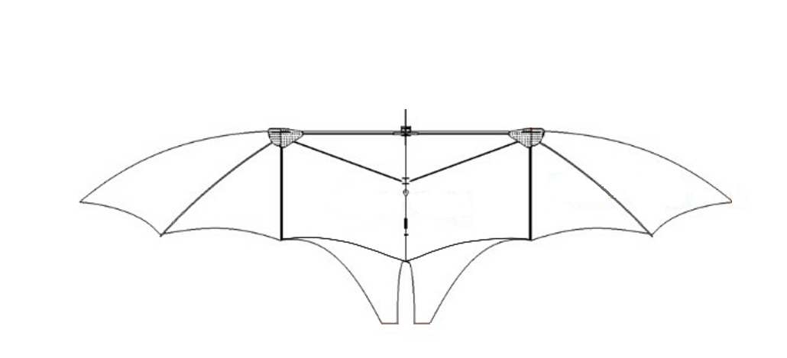

*dr*

*c(r)*

*r*

*R = b/2*

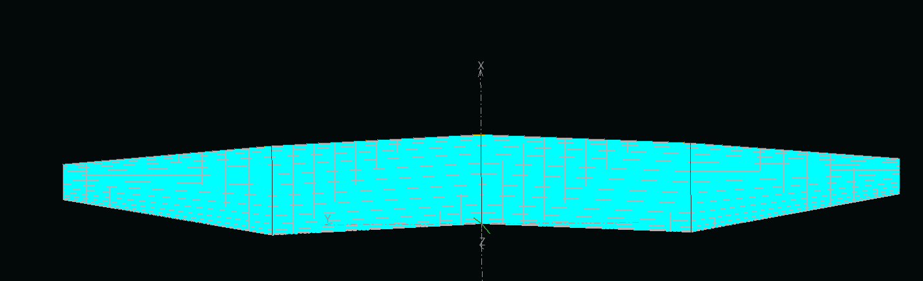

*r*

*c(r)*

*R = b/2*