Aeroelastic Design of an Ornithopter Wing
Moble Benedict¹, K. Sudhakar², P.M. Mujumdar³, K. Kurien Issac⁴
Indian Institute of Technology, Bombay, Powai, Mumabi-4000076, India

Abstract
Aeroelastic analysis for a flexible wing has been developed for an imposed harmonic flapping motion about the root chord of the wing. A Matlab code was written based on the analysis. This code was used to find the average lift and thrust of a wing of known aerodynamic and structural properties. The results compared well with the published results.

Introduction
Research groups in University of Toronto have successfully built and flown ornithopters. The design and development of an ornithopter is a complex multidisciplinary task. Department of Aerospace Engineering, IIT Bombay, has presently initiated a project to design, build and fly an ornithopter. Present work is towards this effort.
Design and development of an efficient wing is a primary requirement towards making an ornithopter. Ornithopter wings have its flapping motion accompanied by a twisting motion. The flapping motion is the rotation of the outboard wing about the hinge line along the root chord. The twisting motion is the rotation of aerofoil sections at each spanwise location about a chordwise location. Early researchers have shown that a definite relation exists between flapping and twisting for optimum aerodynamic performance. An actuation system is required for the flapping motion. The twisting motion can be produced in a number of ways:
- By using distributed actuators on the wing to get the required twist distribution along the span.
- By having one actuator at the tip to rotate the tip of the wing relative to the root. This along with suitable aeroelastic tailoring of the wing can bring about the required twist distribution.
- By using one external flapping actuator and relying on the aerodynamic and inertial loads along with suitable aeroelastic tailoring of the wing to bring about the required twisting motion.
In this work, the flapping and twisting motion using only one external actuator is attempted. This actuator is for producing the flapping motion. To obtain the required twist distribution we need to suitably tailor the flexibility of the wing. This is called the aeroelastic tailoring of the wing.

¹Dual Degree Student, Department of Aerospace Engineering, moble@aero.iitb.ac.in
²Professor, Department of Aerospace Engineering, sudhakar@aero.iitb.ac.in
³Professor, Department of Aerospace Engineering, mujumdar@aero.iitb.ac.in
⁴Professor, Department of Mechanical Engineering, kurien@me.iitb.ac.in

To accomplish this task, an aeroelastic model of the flapping wing is developed using strip theory [1,2,4]. For a structurally and aerodynamically defined wing and a specified kinematics at the actuation point, the aeroelastic model gives the bending and twisting deformations and aerodynamic and inertial loads as a function of time. The aeroelastic model of the wing is validated with results given in the literature.

Structural Modelling of the Ornithopter Wing
The structural analysis was done for a generic ornithopter wing [2]. The wing is divided into a number of strips in the spanwise direction as shown in figure 1. The bending displacements 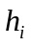 and the twist 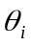 of the wing are considered at each of these strips. It is assumed that the structural properties and geometric properties such as 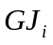 and 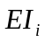 are constant on each of these strips. However, these properties may vary from one strip to the other strip. Using these properties, the flexibility matrix of the wing is calculated [3,5]. If the wing is divided into N spanwise segments, the order of the flexibility matrix will be 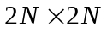 as shown below.
Flexibility matrix (C) = 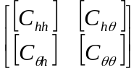
Where 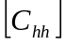, 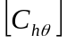, 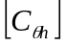 and 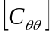 are the flexibility matrices, each of order 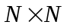.

Aeroelastic modeling of the flapping wing
The bending and twisting displacements at N segments of the wing are given by the column vectors 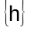 and 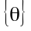.
The spar is assumed to have an imposed time varying displacement, 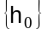, from the external actuation at the root and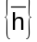 is the elastic displacement, so that
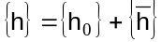 …(1)
The over-bar denotes the elastic displacement. Likewise, consists of the flapping-axis angle 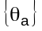, a built in pre-twist distribution. 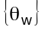 and an elastic component, 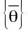.
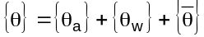 …(2)
The loads and pitching moment respectively, acting on different spanwise segments of the wing are represented by column vectors {N} and {M}. Each element of the load vector, N_{i} acts perpendicular to the chord and each element of the moment vector, M_{i} acts about the elastic axis and has the same sense and orientation as θ_{i} as shown in figures 2 and 3. Therefore, the loads and deformations are related through the structural flexibility influence coefficients as follows.

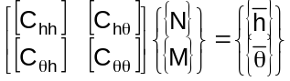 …(3)

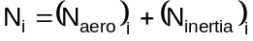 …(4)

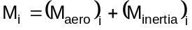 …(5)

The expression for 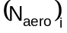 is given in equation (26). The expressions for the inertial terms, 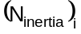 and 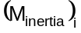, are given in ref [3].

…(6)

where is the distance of the elastic axis from the leading edge. 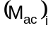 is the moment about the aerodynamic center.

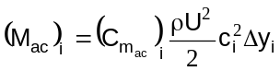 …(7)

The expressions for 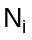 and 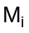 can be separated to static and dynamic terms.

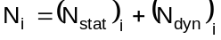 …(8)
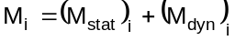 …(9)
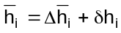 …(10)
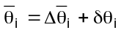 …(11)
where 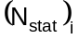 and 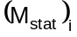 are the aerodynamic and gravity loads on a non-flapping wing; and 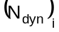and 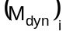, are the aerodynamic and inertial loads generated by wing’s motion. The mean values, 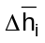 and 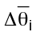 are the non-flapping elastic deformation, relative to zero wind configuration. 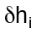 and 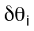are the time varying elastic deformations relative to the mean value. Substituting equations (8), (9), (10) and (11) in the equation (3) we get,
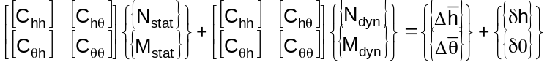 …(12)

By separating the static part and dynamic parts of the equation (12), one can write the static part as,

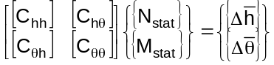 …(13)

When the expressions of and given by equations (4), (5), (8) and (9) are substituted in the above equation, it expands to the form below.
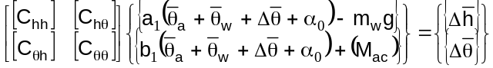 …(14)
where
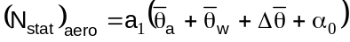 …(15)
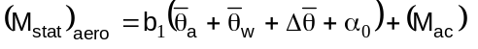

The expressions for the aerodynamic coefficients a₁ and a₂ are given in the ref [3]. m_{w} denotes the mass of the wing and α₀ is angle of section’s zero lift line with the chord. The equation (14) is further simplified to,
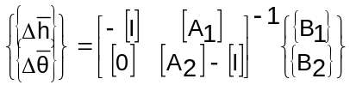 …(16)

The matrices 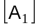, 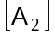, 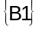 and 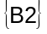 incorporate the structural influence coefficients and the coefficients from the expressions of and . The details of this derivation are given in ref 3. The above matrix equation can be solved for getting the static deformation distribution 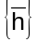 and 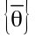 along the span.

Dynamic part of equation (12) is given by,

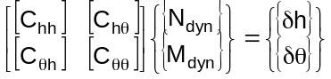 …(17)
Substituting the expression for N_{dyn} and M_{dyn} in the above equation ,

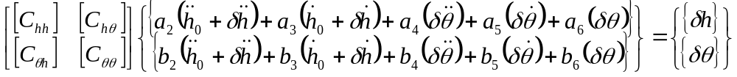 …(18)

The expressions for the aerodynamic coefficients (a₂...a₆ and b₂…b₆) are given in the ref [3]. The above equation can be expanded to the equation below,

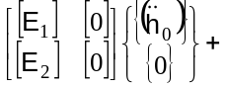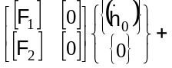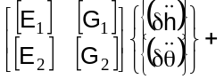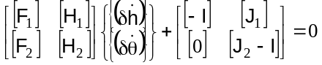
…(19)

Where the matrices 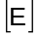, 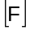, 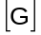, 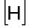 and 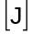 incorporate the structural influence coefficients and the coefficients from the expressions of and . The details of the derivation are given in ref [3].
.
The imposed motion is harmonic. It is given by,
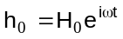 …(20)
H₀ is a real number
And the dynamic response is,
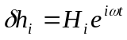 …(21)
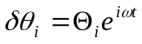 …(22)
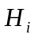 and 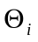 complex numbers.

Substituting equations (20), (21) and (22) in equation (19) we get

…(23)
Moreover, 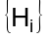 and 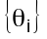 can be found out from the above equation.

Aerodynamic Performance
The static and the dynamic deformations obtained through the above aeroelastic model are used to calculate the aerodynamic performance of the wing [1].
Normal force calculation
The wing’s aspect ratio is assumed large enough that there is no flow in the spanwise direction. That means the flow over each section is essentially chordwise. Further, the wing is designed in such a way that none of the panels stalls during the entire flap cycle. The sections normal force due to circulation is given by
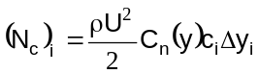 …(24)
The normal force due to apparent mass acting at the midchord and is given by
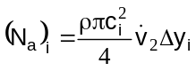 …(25)

Therefore, the section’s total aerodynamic normal force is given by:
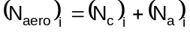 …(26)
The above equations are explained in ref [3].

Chordwise force calculation
The forces acting in the chordwise direction are mainly due to camber, leading-edge suction and viscosity. Chordwise forces are different depending on whether the flow is attached or separated.
The chordwise force due to camber is given by
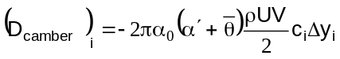 …(27)
The expression for the chordwise force due to leading-edge suction is given by
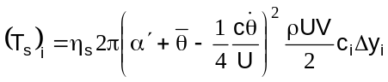 …(28)
where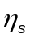 is the efficiency factor.
There is a chordwise friction drag due to viscosity. It is given by
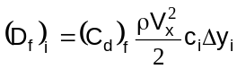 …(29)
The total force in the chordwise direction is given by
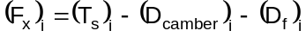 …(30)

The above equations are explained in ref [3].

Calculation of lift and thrust
By taking the components of the normal and chordwise force in the direction perpendicular and parallel to the flow we can get the instantaneous lift and thrust values. Therefore, they are given by the following expressions,
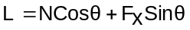 …(31)
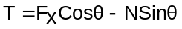 …(32)
These values are for one section. To get the instantaneous lift and thrust values for the entire wing, integration along the span has to be done. Further, these instantaneous lift and thrust values are averaged for the whole flapping cycle.

Results and Discussion
The model described above was coded in Matlab. The results obtained are shown in figures (4) and (5). These results are obtained for a particular flexibility distribution. The planform of the wing is given in figure (1). The airfoil chosen is S1020. Other details of the wing such as the flexibility distribution and the airfoil characteristics are given in ref [3].
From figure (4), it is clear that the major portion of the lift comes from the circulatory lift. That is the reason why there is no appreciable change in the average lift due to the increase in flapping frequency. However, there is still a gradual increase. After 3.8 Hz the lift begins to fall slightly because many of the panels starts stalling. The average thrust value linearly increases as shown in figure (5). These results are validated with the results given in the journal.

Conclusion
The paper describes a method to analyze the aeroelastic behaviour of a flexible flapping wing. The wing should have prescribed aerodynamic properties, structural properties and kinematics at the actuation point. The aeroelastic analysis gives the deformation of the wing as a function of time due to the aerodynamic and inertial forces acting on it. When this information is plugged into the aerodynamic equations, we obtain the average lift and thrust of the wing. The results seem to concur with some standard results given in Ref [2]. These results also throw some light towards the feasibility of flapping flight.

References

[1] DeLaurier, J.D. An Aerodynamic Model for Flapping-Wing Flight, Aeronautical Journal, Vol. 97, April 1993, pages 125-130.

[2] DeLaurier, J.D. The Development of an Efficient Ornithopter Wing, Aeronautical Journal, Vol. 97, May 1993, pages 153-162.

[3] http://www.casde.iitb.ac.in/IMSL/flapping-wing/formulation.htm

[4] Ramji Kamakoti, Mats Berg, Daniel Ljungqvist and Wei Shyy. A Computational Study of Biological Flapping Wing Flight, Transactions of the Aeronautical Society of the Republic of China, Vol 32, No 4, pages 266-279 (2000).

[5] Raymond L. Bisplinghoff, Holt Ashley and Robert L. Halfman. Aeroelasticity. Addison-Wesley Publishing Company, Inc, Massachusetts, USA, 1955.

Figures
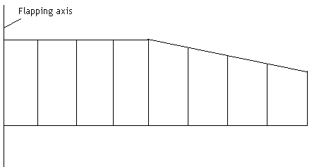

Fig 1. The plan view of ornithopter wing divided into equal strips

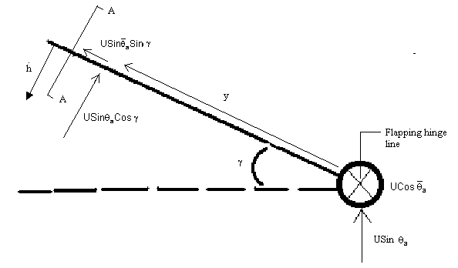

M_{ac}
D_{camber}
D_{f}
T_{s}

Fig 2. The front view of the flapping wing
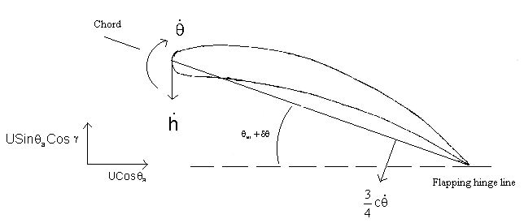
Fig 3. A schematic figure showing wing section at AA
N_{c}
N_{a}
M_{ac}
D_{camber}
D_{f}
T_{s}

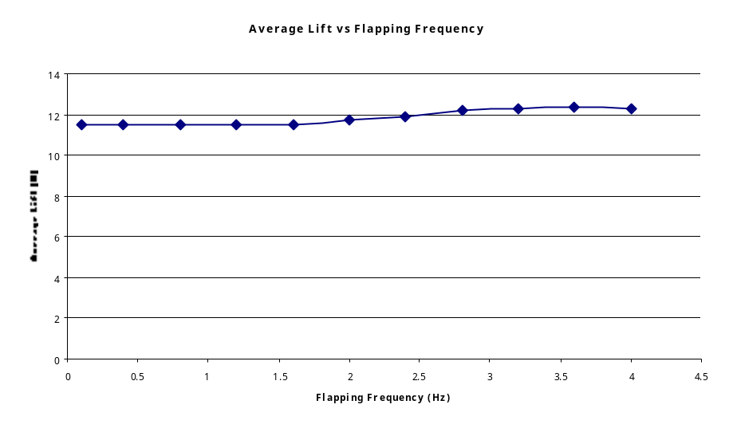

Fig 4. The graph of Average lift Vs Frequency

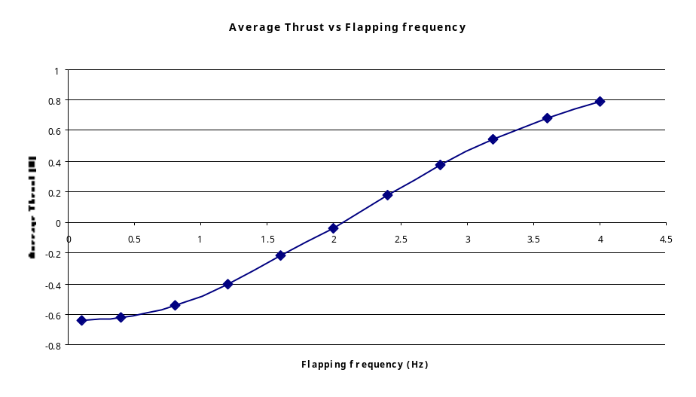

Fig 5. The graph of Average thrust Vs Frequency

