PROJECT DOCUMENT
POCKETSMART AI
Personal Budget Planning and Expense Management System

1. Introduction
PocketSmart is a web-based personal finance and budget planning application designed to help users plan their money, manage budgets, and keep track of financial activity. The application provides a simple dashboard through which users can create and manage different types of budget plans.

2. Objectives
- To provide a simple platform for personal budget planning.
- To help users organize their financial plans in one place.
- To provide separate budget planning options for different needs.
- To maintain and display recent budget-related activity.
- To provide a clear and user-friendly interface for managing personal finances.

3. Project Overview
The project starts with a landing page that introduces PocketSmart and its purpose. Users can log in to access their account and view the dashboard. The dashboard displays budget planners such as Home Budget Planner, Party Budget Planner, and Jewellery Budget Planner. Users can start the required planner and manage their budget information.
The application also contains navigation options for Home, Planners, and History. The History section displays previously created or available budget plans, allowing users to review their financial planning activity.

4. Main Modules

4.1 Home / Landing Page
Introduces PocketSmart with the message 'Plan Your Money. Live Smarter.' and provides options to get started or log in.

4.2 User Login
Provides a login screen where the user can enter an email/username and password to access the application.

4.3 Dashboard
Displays a welcome message, budget planner cards, and recent activity after successful login.

4.4 Budget Planners
Provides different planners including Home Budget Planner, Party Budget Planner, and Jewellery Budget Planner.

4.5 Budget History
Displays previous budget planner entries and their corresponding amounts/details.

4.6 Navigation
Allows users to move between Home, Planners, History, and account-related pages.

5. Key Features
- User login and account access.
- Dashboard-based budget management.
- Multiple category-specific budget planners.
- Budget history and recent activity display.
- Simple and responsive web interface.
- Clear navigation between major sections.

6. Technology
Based on the demonstrated application interface, PocketSmart is implemented as a web application accessed through a web browser. The exact programming language, framework, database, and hosting technology are not identifiable with certainty from the demonstration video alone.

7. System Workflow
- Open the PocketSmart website.
- Choose the login option.
- Enter the required login details.
- Access the user dashboard.
- Select the required budget planner.
- Enter/manage budget information.
- Review recent activity or budget history.

8. Screenshots / Project Demonstration

Figure 1: PocketSmart interface (0 seconds)
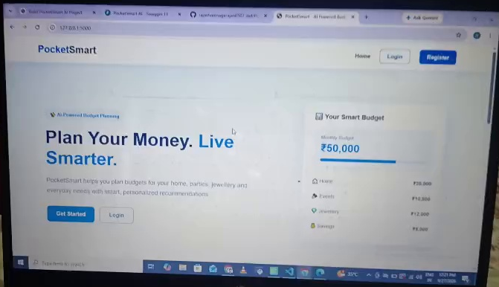
Figure 2: PocketSmart interface (48 seconds)
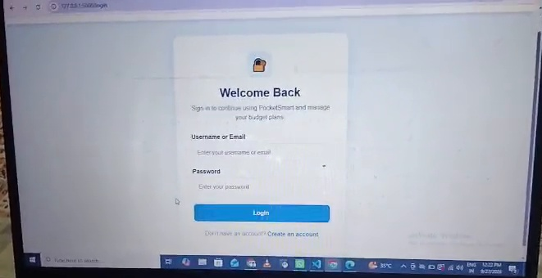
Figure 3: PocketSmart interface (65 seconds)
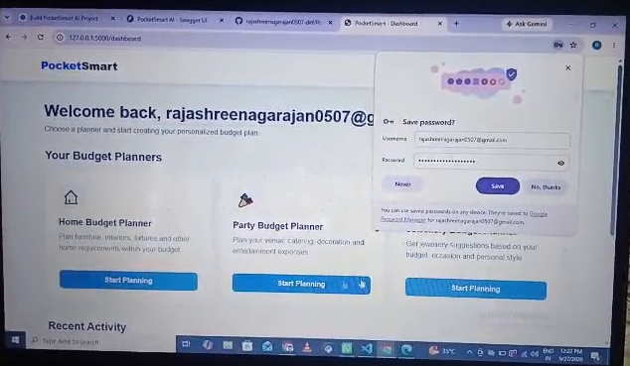
Figure 4: PocketSmart interface (81 seconds)
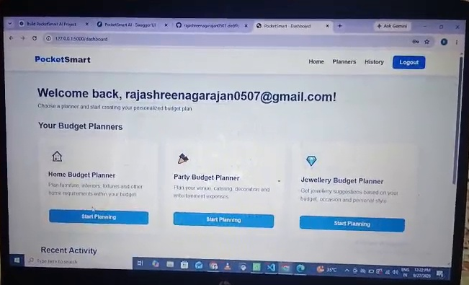
Figure 5: PocketSmart interface (113 seconds)
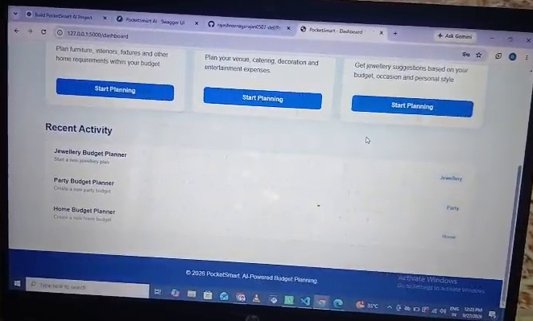
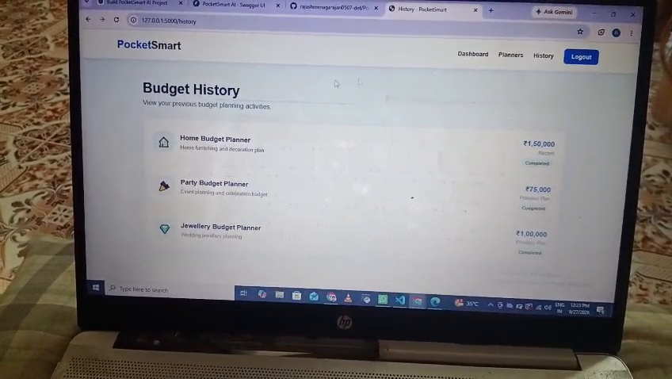
Figure 6: PocketSmart interface (129 seconds)
Figure 7: PocketSmart interface (162 seconds)
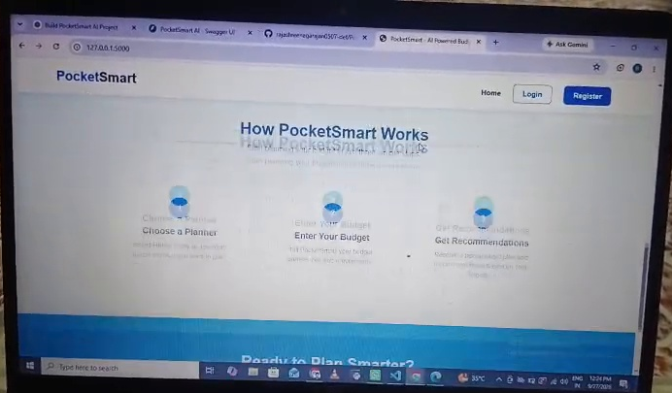

9. Advantages
- Easy-to-understand budget planning interface.
- Helps organize different financial planning requirements.
- Provides a centralized dashboard for budget activities.
- Allows users to review budget history.
- Category-based planners make budget management more organized.

10. Future Enhancements
- Add graphical charts for income and expenses.
- Add monthly and yearly budget reports.
- Add expense reminders and notifications.
- Add secure database-backed user accounts.
- Add export options such as PDF or Excel reports.
- Add mobile-friendly and mobile-app support.

11. Conclusion
PocketSmart is a personal budget planning web application that focuses on making financial planning simple and organized. The demonstrated system provides login access, a dashboard, category-based budget planners, recent activity, and budget history. With additional reporting, notification, and analytics features, the system can be further developed into a more complete personal finance management solution.

