MealBridge Backend Project Report
1. Title
MealBridge: Food Donation and Volunteer Management Backend System

2. Introduction / Description
MealBridge is a backend-based food donation management project created using Python Fast API and MongoDB. The main purpose of this project is to connect food donors with volunteers so that extra food can be managed and distributed in a more organized way.
In this project, the backend allows users to perform different operations such as adding donors, adding volunteers, adding food donation details, viewing records, updating records, searching records, and deleting records. The project uses REST APIs, which help the frontend or user interface communicate with the backend and database.
This project does not focus on heavy frontend design. It mainly focuses on backend development, database handling, and API operations.

3. Objective
The main objectives of this project are:
- To create a backend system for managing food donations.
- To store donor, volunteer, and food donation details in MongoDB.
- To perform CRUD operations like create, read, update, and delete.
- To understand how REST APIs work in a real project.
- To connect Fast API with MongoDB.
- To make the project simple, useful, and easy to understand.
- To help manage surplus food in an organized way.

4. Tech Stack / Tools Used
Tool / Technology | Version | Purpose
Python | Python 3.13.7 | Main programming language
Fast API | 0.136.3 | Used to create REST APIs
Uvicorn | 0.49.0 | Used to run the Fast API server
MongoDB | 8.3.2 | Used as the database
PyMongo / Motor | 4.17.0 | Used to connect Python with MongoDB
Visual Studio Code | 1.119.1 (974500e) | Used for writing and managing code
Swagger UI | Built into Fast API | Used to test APIs in browser
Command Prompt / Terminal | System tool | Used to run commands
Web Browser | Any browser | Used to open and test API documentation

5. Flow of the Project
The flow of the MealBridge project is simple:
- The user opens the Fast API project in the browser.
- Fast API provides a Swagger UI page where all APIs can be tested.
- The user selects the required section such as donor, volunteer, or food donation.
- The user enters data such as donor name, contact details, food quantity, location, or volunteer details.
- The request goes from the browser to the Fast API backend.
- Fast API processes the request.
- The backend connects with MongoDB.
- MongoDB stores, updates, searches, or deletes the data.
- The result is sent back to the user in JSON format.
- The user can see the response directly on the Swagger UI page.
In simple words, the project flow is:
User → Fast API → Python Logic → MongoDB Database → Response back to User

6. REST API Used and How It Helped in the Project
REST API stands for Representational State Transfer Application Programming Interface. In this project, REST APIs are used to connect the user actions with the backend database.
REST APIs helped in the project by allowing different operations like adding, viewing, updating, searching, and deleting records. Each operation has a separate API endpoint. This makes the project organized and easy to test.
For example, when a user wants to add a donor, a POST API is used. When the user wants to view all donors, a GET API is used. When the user wants to update details, a PUT API is used. When the user wants to delete a record, a DELETE API is used.
REST API made the project easy to understand because every task has a clear method and clear purpose.

7. Methods Used in the Project
API Method | Simple Meaning | MongoDB Operation | Use in Project
GET | To view or find data | find / findOne | Used to display donor, volunteer, and donation details
POST | To add new data | insertOne | Used to add new donor, volunteer, or food donation
PUT | To update existing data | updateOne | Used to edit donor, volunteer, or donation details
DELETE | To remove data | deleteOne / deleteMany | Used to delete unwanted records
SEARCH | To find specific data | find with filter | Used to search records based on name, location, or other details

8. Methods Explained with Project Flow
1. POST Method — Add Data
The POST method is used when the user wants to add a new record.
Flow:
User enters details → Fast API receives data → Data is sent to MongoDB → MongoDB stores the data → Success message is returned
Example in project:
- Add new donor
- Add new volunteer
- Add new food donation

2. GET Method — View Data
The GET method is used when the user wants to see stored records.
Flow:
User clicks view API → Fast API asks MongoDB for data → MongoDB finds records → Data is shown to the user
Example in project:
- View all donors
- View all volunteers
- View all food donations
- View one specific record

3. PUT Method — Update Data
The PUT method is used when the user wants to change already saved information.
Flow:
User enters updated details → Fast API receives request → MongoDB finds the record → MongoDB updates the record → Updated result is returned
Example in project:
- Update donor contact number
- Update volunteer details
- Update food donation quantity or status

4. DELETE Method — Remove Data
The DELETE method is used when the user wants to remove a record from the database.
Flow:
User selects delete API → Fast API receives delete request → MongoDB finds the record → MongoDB deletes the record → Delete confirmation is shown
Example in project:
- Delete a donor
- Delete a volunteer
- Delete a food donation record
- Clear records from a section

5. Search Operation — Find Specific Data
The search operation is used when the user wants to find a particular record instead of viewing all records.
Flow:
User enters search value → Fast API receives search request → MongoDB searches matching records → Matching data is displayed
Example in project:
- Search donor by name
- Search volunteer by name
- Search donation by location or food item

9. Final Flowchart
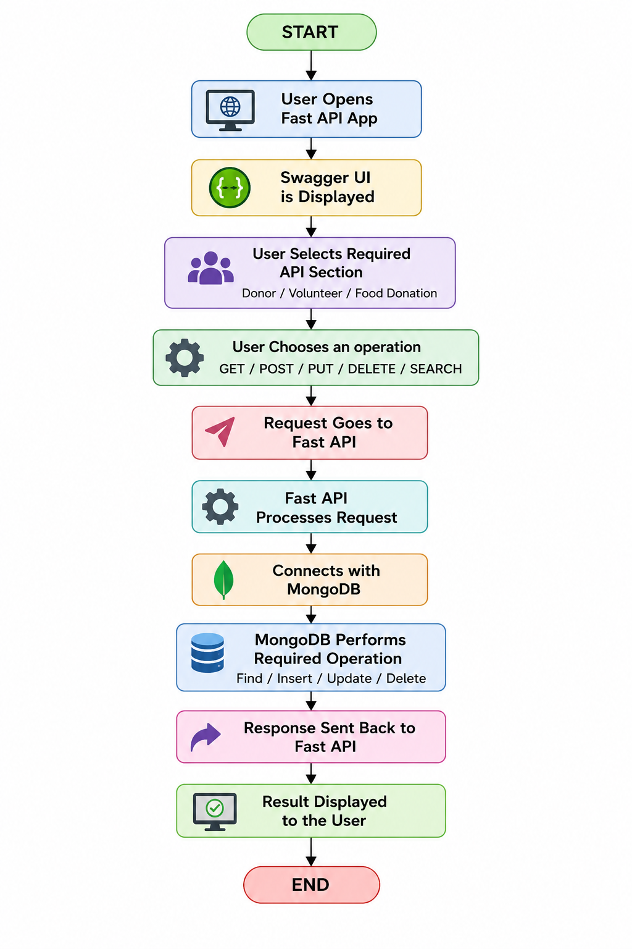

10. Conclusion
The MealBridge backend project helped in understanding how a real backend system works. Through this project, donor details, volunteer details, and food donation records can be managed using REST APIs and MongoDB.
This project also helped in learning important backend concepts such as API creation, database connection, CRUD operations, request-response flow, and testing APIs using Swagger UI. The project is simple but useful because it shows how technology can be used to manage food donation activities in a better and more organized way.
Overall, MealBridge is a beginner-friendly backend project that explains the working of Fast API, MongoDB, and REST APIs clearly.

