MONGO DB CONNECTION: -
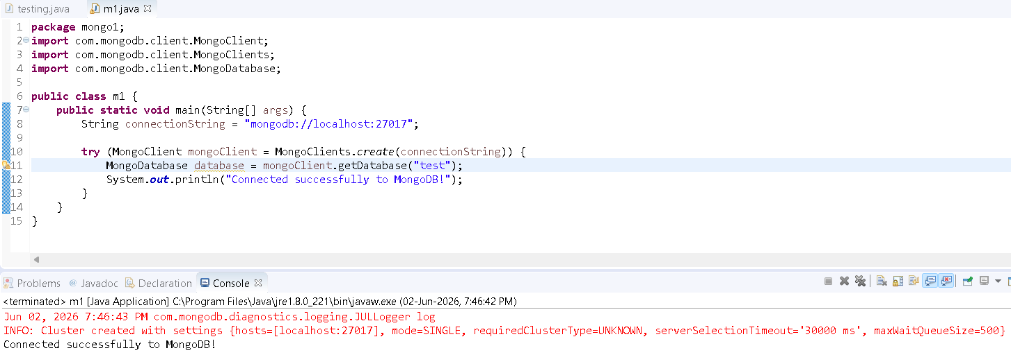
SQL WORK: -
package crud_operations;

import java.sql.Connection;
import java.sql.PreparedStatement;
import java.sql.ResultSet;

public class CRUD_Test {

public static void main(String[] args) {

CRUD_Test obj = new CRUD_Test();

// Insert Record
obj.create_data(201, "Arun", "arun@gmail.com");

// Read Record
obj.read_data(201);
}

public void create_data(int sl_no, String name, String email) {

try {

DB_Connection db = new DB_Connection();
Connection con = db.get_connection();

String query =
"INSERT INTO user(sl_no,name,email) VALUES(?,?,?)";

PreparedStatement ps =
con.prepareStatement(query);

ps.setInt(1, sl_no);
ps.setString(2, name);
ps.setString(3, email);

int count = ps.executeUpdate();

System.out.println(count + " Row Inserted");

con.close();

} catch (Exception e) {
e.printStackTrace();
}
}

public void read_data(int sl_no) {

try {

DB_Connection db = new DB_Connection();
Connection con = db.get_connection();

String query =
"SELECT * FROM user WHERE sl_no=?";

PreparedStatement ps =
con.prepareStatement(query);

ps.setInt(1, sl_no);

ResultSet rs = ps.executeQuery();

while (rs.next()) {

System.out.println("Sl No : "
+ rs.getInt("sl_no"));

System.out.println("Name : "
+ rs.getString("name"));

System.out.println("Email : "
+ rs.getString("email"));

System.out.println("----------------");
}

con.close();

} catch (Exception e) {
e.printStackTrace();
}
}
}
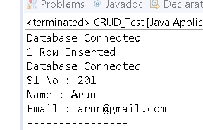
package crud_operations;
import java.sql.Connection;
import java.sql.PreparedStatement;
import java.sql.ResultSet;

public class CRUD_Test {

public static void main(String[] args) {

CRUD_Test objTest = new CRUD_Test();

objTest.read_data();
}

public void read_data() {

DB_Connection obj_DB_Connection = new DB_Connection();
Connection connection = obj_DB_Connection.get_connection();
System.out.println("Program is running");
PreparedStatement ps = null;
ResultSet rs = null;

try {

String query = "select * from user";

ps = connection.prepareStatement(query);

rs = ps.executeQuery();

while (rs.next()) {

System.out.println("Sl no - " + rs.getString("sl_no"));
System.out.println("Name - " + rs.getString("name"));
System.out.println("Email - " + rs.getString("email"));
System.out.println("---------------------");
}

} catch (Exception e) {
System.out.println(e);
}
}
}
