Day : Basic Input/Output and Operators (2-8-2025)

1.write a C program to add two integers.

Input: get 3 values as input say a,b,c.

Process: we add two integers, assigned the value for a,b , the formula c=a+b.

Output: the output store in c.

Program:

#include<stdio.h>

void main()

{

float a,b,c;

scanf("%f%f",&a,&b);

c=a+b;

printf("%f",c);

}

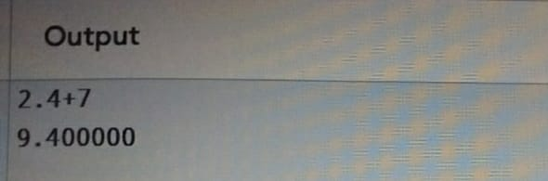

2.write a program to swap two numbers using a temporary variable.

Input: to get 3 values as input ,say a,b,temp.

Process: to swap two numbers using temporary third variable is introduced to hold the value of one variable swap.

Output: to exchange the two values.

Program:

#include <stdio.h>

void main()

{

int a,b,temp;

scanf("%d%d",&a,&b);

printf("before swapping:a=%d,b=%d\n",a,b);

{

temp=a;

a=b;

b=temp;

}

printf("after swapping:a=%d,b=%d\n",a,b);

}

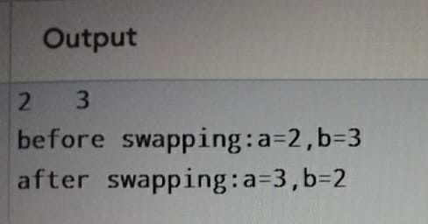

3.write a program to swap two numbers without using a temporary variable.

Input: get 3 values as input,say a,b,c.

Process: print before swapping a=a+b;b=a-b;a=a-b; after that the value will swapped.

Output: the value will swapped.

Program:

#include<stdio.h>

void main()

{

int a,b,c;

float d;

scanf("%d%d%d",&a,&b,&c);

d=(a\*b\*c)/100;

printf("%f",d);

}

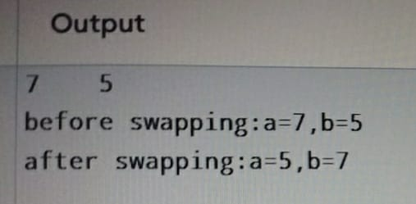

4.Write a program to find the ASCII value of a character.

Input: to get ASCII program by using char ,printf and stores in character varaiable.

Process:to print char variable using modulor d,c convert char into ASCII value.

Output:the value using printf(n).

Program:

#include <stdio.h>

void main()

{

int n,a;

char c='a';

n=c;

printf("%d",n);

}

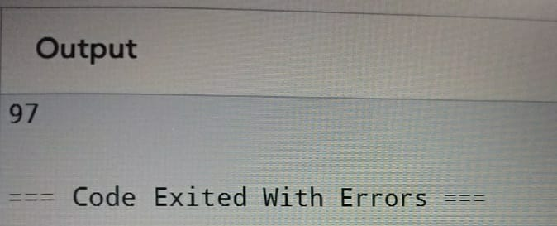

5.Write a program to calculate the area and perimeter of a rectangle.

Input: get 4 values as input say area, perimeter,l,w.

Process:to find the area and perimeter of a rectangle by using area=l\*w;perimeter2\*(l+w).

Output: the output in area and perimeter.

Program:

#include<stdio.h>

void main()

{

float l,w,area,perimeter;

scanf("%f%f",&l,&w);

{

area=l\*w;

perimeter=2\*(l+w);

}

printf("Area = %.2f\n", area);

printf("Perimeter= %.2f\n", perimeter);

}

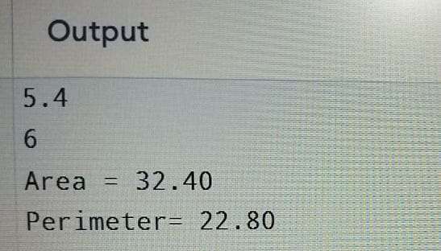

6.Write a program to compute the simple interest

Input: to get 3 values as input say a,b,c.

Process: to fint the simple interest by d=(a\*b\*c)/100.

Output:the out put is store in d.

Program:

#include<stdio.h>

void main()

{

int a,b,c;

float d;

scanf("%d%d%d",&a,&b,&c);

d=(a\*b\*c)/100;

printf("%f",d);

}

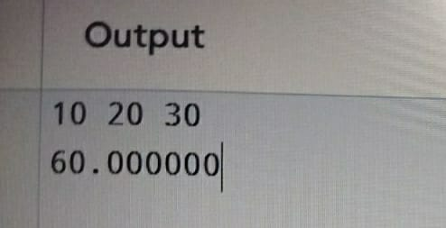

7.Write a program to convert temperature from Celsius to Fahrenheit

Input: get 2 values as input say a,b.

Process: to convert temperature from celcius to Fahrenheit by b=(a\*9/5)+32.

Output:the output will be store in b.

Program:

#include<stdio.h>

void main()

{

float a,b;

scanf("%f",&a);

b=(a\*9/5)+32;

printf("%f",b);

}

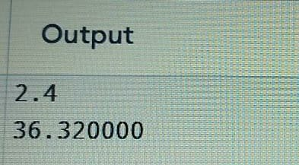

8.write a program to find the quotient and remainder of two integers.

Input:get 4 values as input , say divide,divisor,remain,q.

Process:q equal to divide/divisor;remain equal to divide modulor divisor.

Output: the out will be store in q and remain.

Program:

#include<stdio.h>

void main()

{

int divide,divisor,remain,q;

scanf("%d%d",&divide,&divisor);

{

q=divide/divisor;

remain=divide%divisor;

}

printf("q=%d\n",q);

printf("remain=%d\n",remain);

}

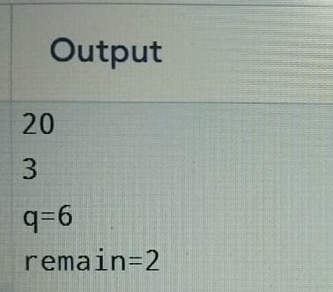

9.write a program to check whether a number is even or odd.

Input: get 1 value as input, say a.

Process: assigned the value for a and if(a%==0) print even,else, print odd.

Output: a is even or odd.

Program:

#include <stdio.h>

void main()

{

int a;

scanf("%d",&a);

if(a%2==0)

{

printf("a is even");

}

else

{

printf("a is odd");

  }

}

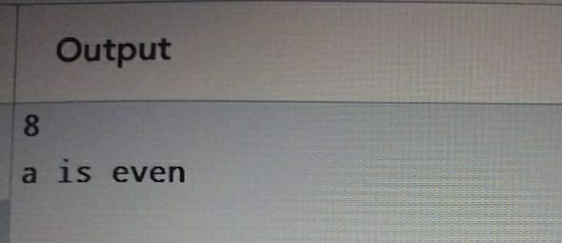

10. Write a program to calculate the square and cube of a number.

Input: get 3 values as input, say a,square,cube.

Process: assigned the value value for a, square equal to a \*a , cube equal to a\*a\*a.

Output:the output will be store in square, cube.

Program:

#include<stdio.h>

void main()

{

float a,square,cube;

scanf("%f",&a);

square=a\*a;

cube=a\*a\*a;

printf("square=%f\n",square);

printf("cube=%f\n",cube);

}

