1-Created user management database and then created one table i.e hired candidates

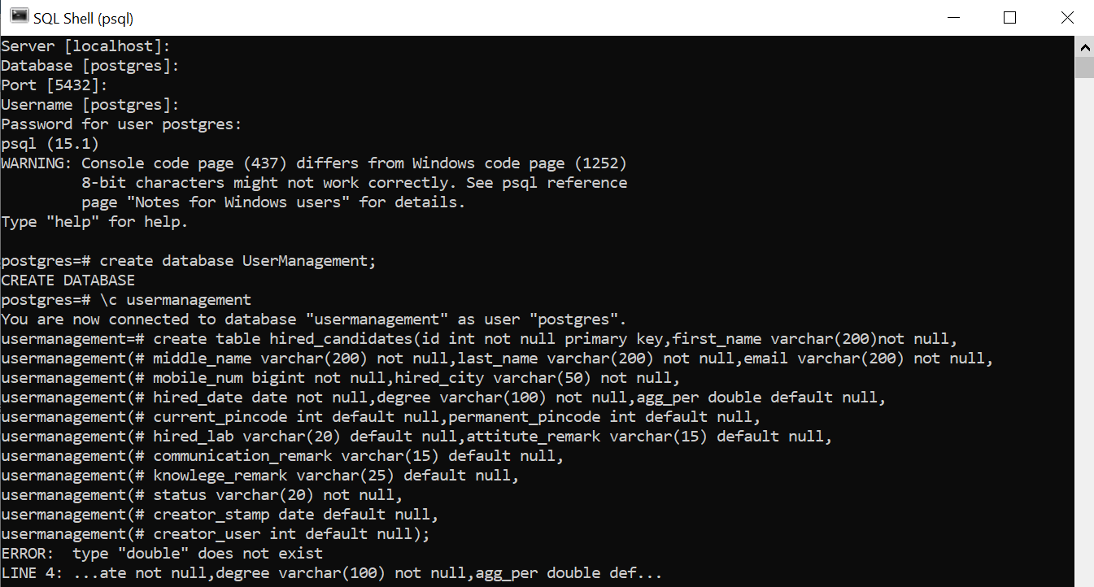

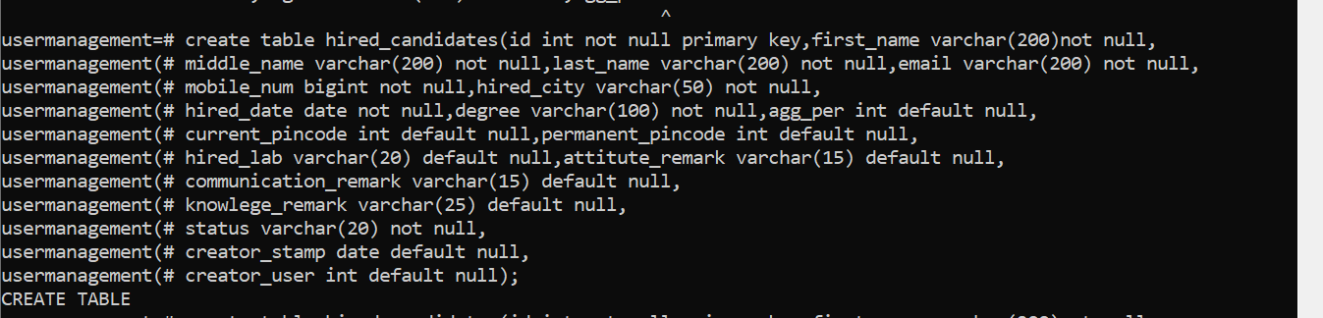

2-Create second table- felloship candidate—not creating in sql shell so excuted through pgadmin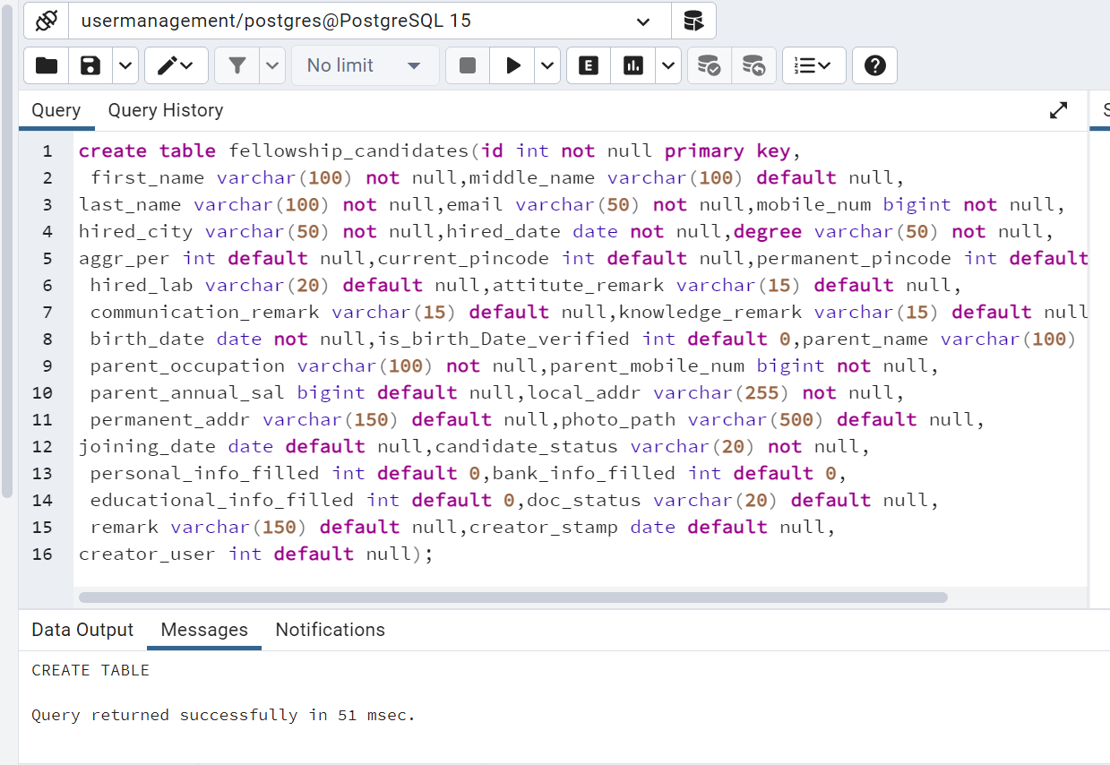

3-Inserted records using insert command

4-Created table

