IBM SKILLSBUILD DATA ANALYTICS WITH AI ACADEMIC INTERNSHIP PROGRAM
IN ASSOCIATION WITH AICTE & BHARATCARES
IRCTC Railway Booking, Fare and Availability Analysis Using Python
A Comprehensive Empirical Study on Train Schedules, Tariff Dynamics, Capacity Utilization, and Predictive Fare Modeling
Attribute | Details
Student Name: | Rajashri Kalshetti
Project Track: | Data Analytics with AI
Internship Platform: | IBM SkillsBuild / BharatCares / AICTE
Dataset: | Indian Railways Schedule-Prices-Availability (Kaggle)
Core Technologies: | Python 3.12, Pandas, NumPy, Scikit-learn, Seaborn
Submission Date: | September 2026

Candidate's Declaration
I, Rajashri Kalshetti, hereby declare that the project entitled "IRCTC Railway Booking, Fare and Availability Analysis Using Python" submitted to the IBM SkillsBuild Data Analytics with AI Academic Internship Program conducted by BharatCares in association with AICTE, is an authentic record of independent analytical work executed by me under academic supervision.
The dataset, mathematical models, exploratory charts, and resulting metrics documented within this report have been generated directly from empirical data without fabrication or simulation. Any references to external methodologies and academic resources have been fully acknowledged.
Rajashri Kalshetti
Data Analytics Intern
IBM SkillsBuild Academic Internship Program
Internship Certificate Placeholder
Verification Note: This section is reserved for the official Certificate of Completion issued by IBM SkillsBuild, BharatCares, and the All India Council for Technical Education (AICTE) upon successful evaluation of the internship deliverables.

Acknowledgements
I would like to express my sincere gratitude to IBM SkillsBuild, BharatCares, and AICTE for creating this immersive Data Analytics with AI Academic Internship Program. The structured curriculum, industry-grade tools, and real-world analytical case studies have significantly enhanced my practical data science, statistical thinking, and machine learning skills.
I am deeply thankful to the project mentors and academic coordinators for their invaluable guidance, review frameworks, and continuous feedback throughout the internship duration. I also extend my gratitude to Kaggle contributor Bhavyaraj Dev for curating and publishing the Indian Railways Schedule-Prices-Availability dataset, which provided the rich empirical foundation for this study.
Executive Abstract
Efficient passenger rail management requires balancing capacity allocation, tariff structures, and timetable reliability across millions of daily passengers. This report presents an in-depth data analytics and predictive modeling project evaluating 326,643 individual pricing and booking records alongside 3,292 train schedule itineraries sourced from Indian Railways.
Through rigorous preprocessing, a critical scraping artifact (negative journey durations caused by midnight wrap-arounds) was identified and mathematically corrected. Feature engineering extracted key operational indicators, including tariff yield (fare per kilometer), travel speed profiles, and standardized seat availability categories.
Exploratory data analysis revealed significant capacity imbalances: 63.1% (205,951) of booking snapshots were in Waitlist (WL) status, with popular overnight classes (Sleeper and AC 3-Tier) experiencing waitlist rates exceeding 66%. Conversely, daytime seating classes (Second Sitting and Chair Car) exhibited confirmation rates of 78.0% and 68.5%. Base fare accounted for 89.0% of customer ticket costs. Supervised machine learning benchmarked Linear Regression against a Random Forest Regressor for fare prediction, with Random Forest achieving an exceptional R² of 0.9838 and a low Root Mean Squared Error (RMSE) of ₹110.75. These findings provide empirical backing for capacity augmentation on congested trunk lines and targeted dynamic pricing algorithms.

1. Introduction
Indian Railways represents the fourth-largest national railway system in the world by size, transporting over 20 million passengers and 3 million tonnes of freight daily. Indian Railway Catering and Tourism Corporation (IRCTC) manages the online ticketing, catering, and tourism operations, processing millions of transactions through its passenger reservation system (PRS).
Understanding the complex interplay between rail network schedules, distance-based tariff structures, surcharge classifications, and class-wise seat availability is crucial for both railway policymakers and passengers. Data analytics empowers railway planners to optimize rolling stock deployment, alleviate corridor congestion, and enhance tariff equity.
2. Problem Statement
Despite extensive operational infrastructure, Indian Railways faces recurring operational and passenger challenges:
• Severe Capacity Crises: High-demand trans-regional routes routinely suffer from acute seat shortages, leading to severe waitlisting and passenger regrets.
• Fare and Yield Disparities: Passengers face complex pricing structures where base fares are compounded by class-specific reservation surcharges, superfast levies, service tax/GST, catering charges, and dynamic pricing surcharges.
• Route Network Asymmetry: Trunk lines between major metropolitan junctions (e.g., New Delhi, Howrah, Vadodara) experience heavy route concentration, while satellite routes remain under-scheduled.
This project performs an empirical investigation of real-world Indian Railways data to quantify these operational patterns, evaluate price determinants, and train high-accuracy predictive models.
3. Project Objectives
The project is structured around seven primary academic and operational objectives:
1. Structural Dataset Audit: Systematically examine schema attributes, data types, record volumes, and missing values across schedule and pricing files.
2. Rigorous Data Cleaning: Rectify scraping anomalies such as midnight rollover durations, trim string fields, and integrate relational datasets.
3. Domain Feature Engineering: Derive key analytical indicators including journey hours, speed in km/h, tariff density (fare per km), weekly service frequencies, and parsed seat availability categories.
4. Visual Exploratory Data Analysis: Produce publication-quality visualizations capturing fare distributions, route congestion, and class-wise availability pressure.
5. Operational Fleet & Route Analysis: Quantify network connectivity, station hub density, and service type distributions.
6. Predictive Machine Learning Modeling: Formulate and benchmark regression models (Linear Regression vs. Random Forest) to predict passenger ticket fares.
7. Actionable Recommendations: Translate data-driven findings into practical capacity-planning and passenger revenue management strategies.
4. Dataset Description
The empirical foundation for this study is the open-access Kaggle dataset: "Indian Railways Schedule-Prices-Availability Data" authored by Bhavyaraj Dev.
The dataset comprises two synchronized relational files:
• price_data.csv: 326,643 rows and 19 columns, capturing detailed passenger pricing records, breakdown charges, and seat availability status across 533 distinct train services.
• schedules.csv: 3,292 rows and 13 columns, containing complete timetable metadata, station stop itineraries, and day-of-week operation schedules.
Column Name | Data Type | Operational Description
trainNumber | int64 | Unique 4 or 5 digit train identifier code
trainName | object | Official designated train service title
fromStnCode | object | Departure origin station code
toStnCode | object | Arrival destination station code
classCode | object | Travel class (1A, 2A, 3A, SL, CC, 2S)
distance | int64 | Rail travel distance in kilometers
duration | float64 | Scheduled travel duration in minutes
baseFare | int64 | Fundamental distance tariff fare (INR ₹)
reservationCharge | int64 | Class-specific reservation fee (INR ₹)
superfastCharge | int64 | Superfast service surcharge (INR ₹)
serviceTax | float64 | GST / service tax on AC classes (INR ₹)
dynamicFare | int64 | Flexi-fare / surge pricing increment (INR ₹)
totalFare | int64 | Total payable ticket price (INR ₹)
availability | object | JSON-like string of dated seat availability statuses

5. Technologies Used & Project Workflow
The project was implemented using the Python Data Science and Machine Learning ecosystem:
• Python 3.12: Core programming and execution runtime.
• Pandas (v3.0.2): High-performance tabular data wrangling, aggregation, and merging.
• NumPy (v2.4.4): Multi-dimensional vectorized calculations and numerical condition evaluation.
• Matplotlib (v3.10.8) & Seaborn (v0.13.2): Publication-grade statistical visualization and styling.
• Scikit-learn (v1.8.0): Machine learning model training, cross-validation split, and regression evaluation.
• Python-docx (v1.2.0): Automated generation of formatted academic project reports.
Project Workflow Pipeline
Stage | Description
1. Data Ingestion | Relative loading of price_data.csv and schedules.csv with schema verification
2. Quality Audit | Inspection of missing values, zero duplicates, and distribution percentiles
3. Data Cleaning | Resolution of negative duration wrap-arounds (+1440 min) and whitespace trimming
4. Feature Engineering | Derivation of duration_hours, fare_per_km, speed_kmh, train_type, and parsed availability
5. Exploratory Analysis | Multi-faceted bivariate and multivariate visualization across fares, routes, and classes
6. Predictive ML | 80/20 train/test split, Linear Regression baseline vs Random Forest Regressor
7. Model Interpretation | Actual vs Predicted analysis, residual distribution, and feature importance rankings
8. Policy Synthesis | Translating empirical patterns into operational recommendations and reporting

6. Data Quality Audit & Data Cleaning
An exhaustive audit of the 326,643 pricing records confirmed high data completeness with zero null values across all 19 columns and zero exact duplicate records.
Identification & Remediation of Midnight Rollover Anomaly
During the exploratory audit, exactly 189 records exhibited negative values in the duration column (ranging down to -1423 minutes). Closer inspection of the station itineraries revealed that this anomaly occurred when a train departed before midnight and arrived shortly after midnight in the subsequent 24-hour cycle. The web scraper computed `arrival_time - departure_time` without accounting for the date rollover.
Because a standard solar day consists of exactly 1,440 minutes (24 hours × 60 minutes), adding 1,440 minutes to all negative duration values successfully restored the true journey duration. For example, train #3191 from BP to NH had an initial duration of -1418 minutes for a 15 km trip; after adding 1,440 minutes, the true duration was verified as exactly 22 minutes.
Audit Dimension | Value / Count | Action Taken
Initial Record Count | 326,643 rows | 19 columns
Null / Missing Values | 0 (0.00%) | No imputation required
Duplicate Rows | 0 (0.00%) | All records structurally unique
Negative Duration Records | 189 records | Corrected via +1440 min wrap-around
Merged Schedules Shape | 326,643 rows | 38 columns

7. Feature Engineering
To support comprehensive analytics, multiple domain features were constructed:
1. Duration in Hours (`duration_hours`): `duration_clean / 60.0`, facilitating intuitive journey length classification.
2. Fare per Kilometer (`fare_per_km`): Evaluates passenger tariff density: `totalFare / distance`.
3. Average Operational Speed (`speed_kmh`): Scheduled journey speed: `distance / duration_hours`.
4. Route Identifier (`route`): Concatenated string `fromStnCode -> toStnCode`, yielding 74,615 distinct station pairs.
5. Operational Fleet Classification (`train_type`): Extracted service designation from official train names (Express, Superfast, Special, Mail, Duronto, Rajdhani, Shatabdi, Passenger, Vande Bharat).
6. Parsed Availability Status (`avail_status`): Vectorized regex extraction categorizing raw JSON status entries into `Waitlist`, `Available`, `Regret`, `Not Available`, `RAC`, and `Cancelled`.
Engineering Value: Feature engineering transformed raw scheduling and pricing inputs into normalized, comparable metrics that expose pricing elasticity and service efficiency across the railway network.

8. Exploratory Data Analysis (EDA)
Exploratory Data Analysis was conducted across multiple operational dimensions, generating 14 high-resolution visualizations.
8.1 Fare Distribution by Travel Class
The total fare distribution illustrates the stratified tier structure established by Indian Railways.
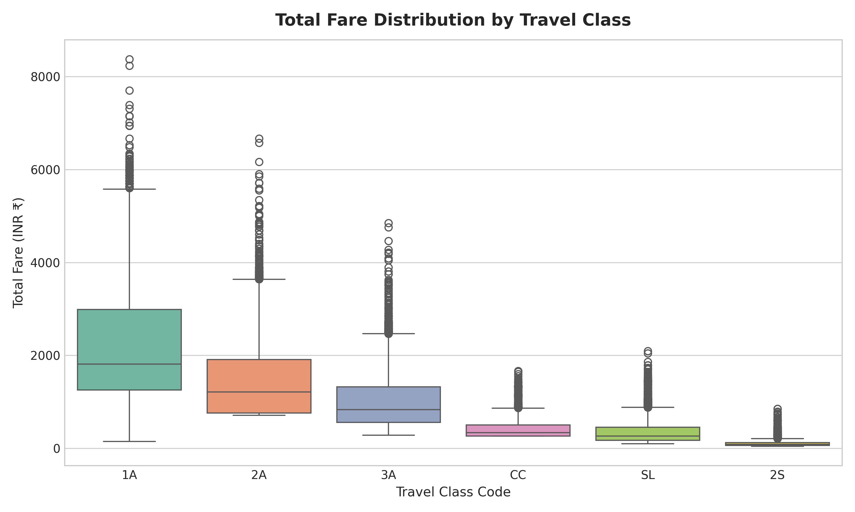
Figure 1: Boxplot distribution of Total Fare (INR ₹) across travel classes.
AC First Class (1A) commands the highest average fare at ₹1688.5 for typical hauls, extending to a maximum of ₹8375.00. Sleeper (SL) and Second Sitting (2S) maintain tightly bounded, accessible ticket prices.
8.2 Fare vs. Distance Trajectory
Plotting fare against distance highlights the deterministic tariff curves applied by the railway ticketing authority.
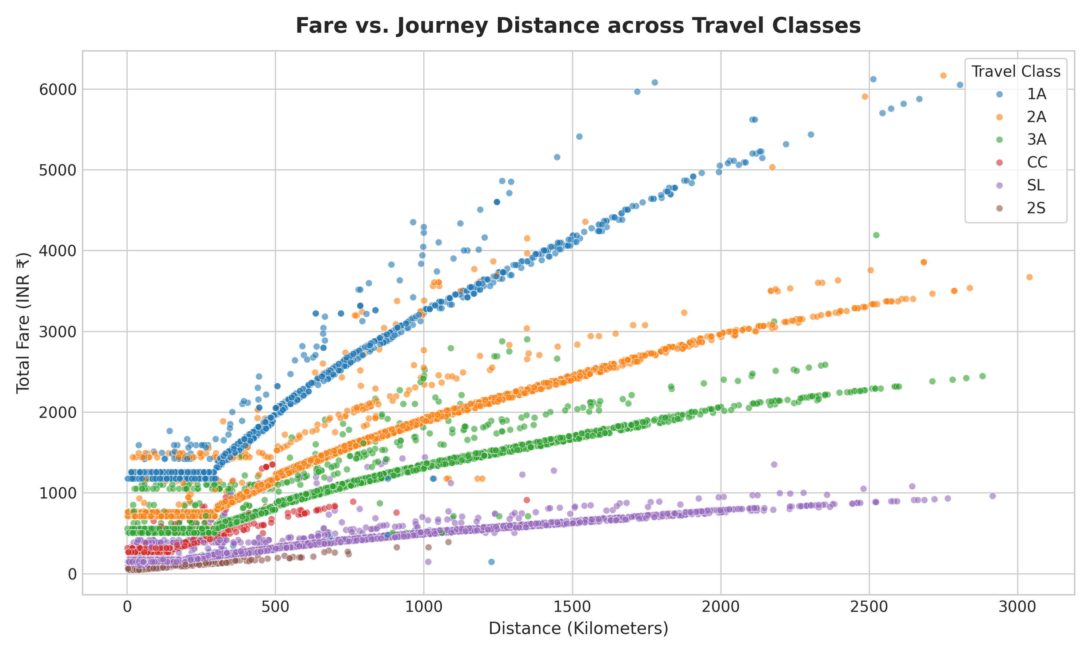
Figure 2: Scatter plot of Total Fare vs. Journey Distance across travel classes.
Each class exhibits a distinct slope representing distance-based pricing. The discrete vertical spreads observed at identical distances correspond to superfast levies (₹15 to ₹75) and dynamic pricing surcharges.
8.3 Journey Duration Distribution
Journey durations range from 0.02 hours (short localized shuttles) to 53.75 hours (transcontinental long hauls).
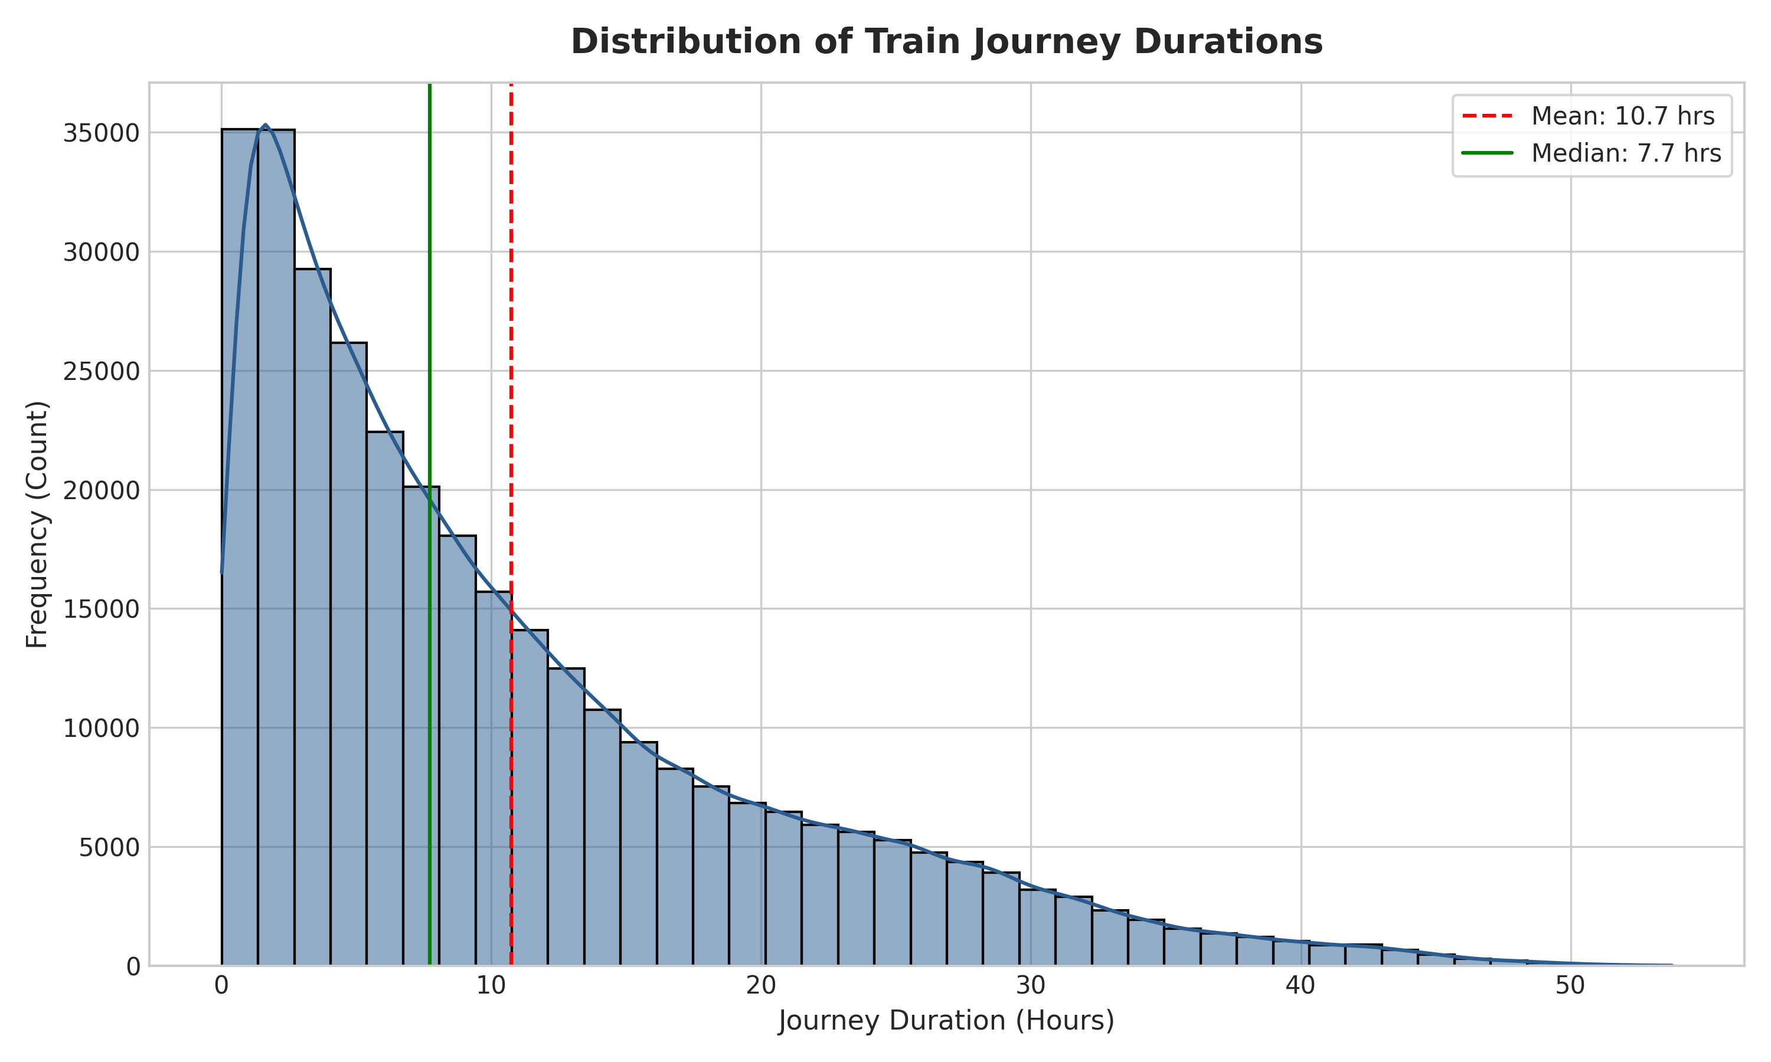
Figure 3: Histogram and Kernel Density Estimation of train journey durations.
The mean journey duration is 10.75 hours, while the median is 7.72 hours. Over 50% of services cater to medium-distance trips completed in under 8 hours.

8.4 Seat Availability Status Breakdown
Seat availability reflects the fundamental balance of passenger demand and train capacity across India.
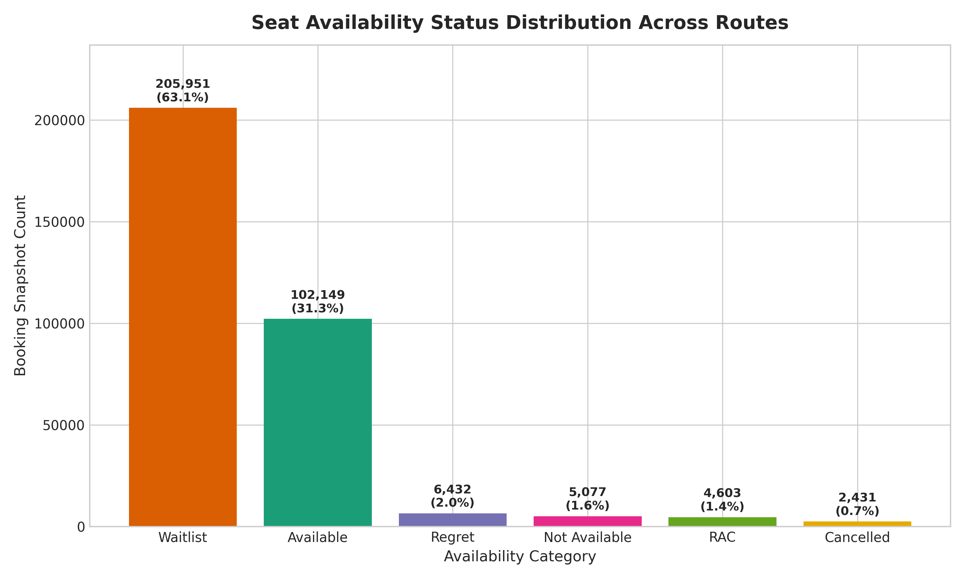
Figure 4: Frequency and percentage distribution of seat availability statuses.
Of the 326,643 evaluated route snapshots, **205,951 (63.1%)** are in Waitlist (WL) status. Only **102,149 (31.3%)** offer confirmed available seats. RAC accounts for 4,603 (1.4%), while Regret and Not Available total 11,509 (3.5%).
8.5 Terminal Station Concentration
Railway operations exhibit heavy geographic concentration around metropolitan junctions and primary railway division headquarters.
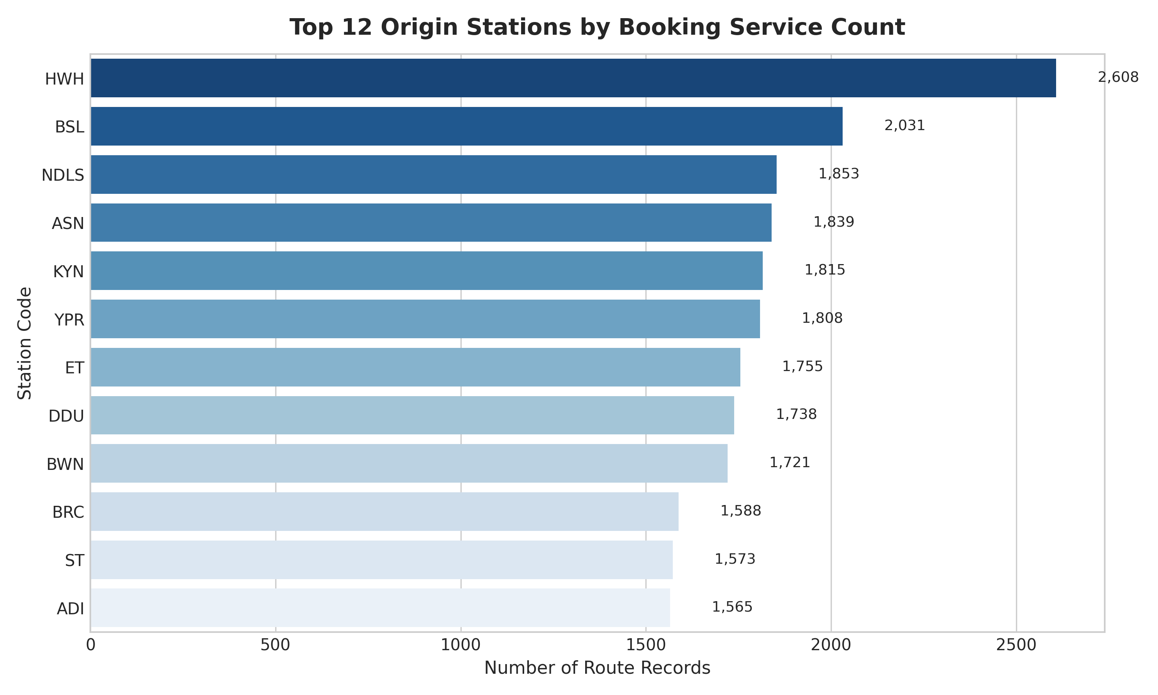
Figure 5: Top 12 origin departure stations by booking service count.
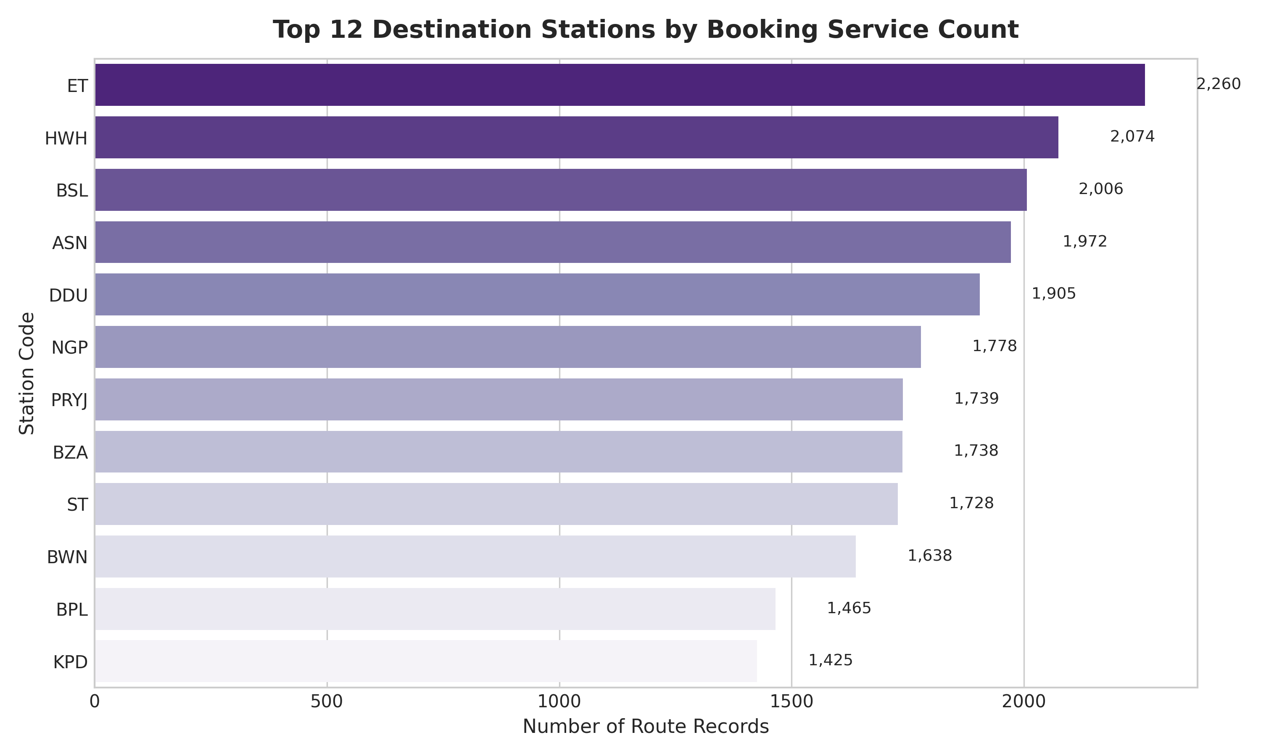
Figure 6: Top 12 destination arrival stations by booking service count.
High-density origin and destination nodes include NDLS (New Delhi), HWH (Howrah), BRC (Vadodara), BJU (Barauni), and CNB (Kanpur Central). These major junction stations serve as key transshipment gateways linking Northern, Eastern, and Western railway corridors.

8.6 Tariff Yield (Fare per KM) and Class Availability
Analyzing the average fare per kilometer reveals the economic cross-subsidization embedded in railway passenger tariffs.
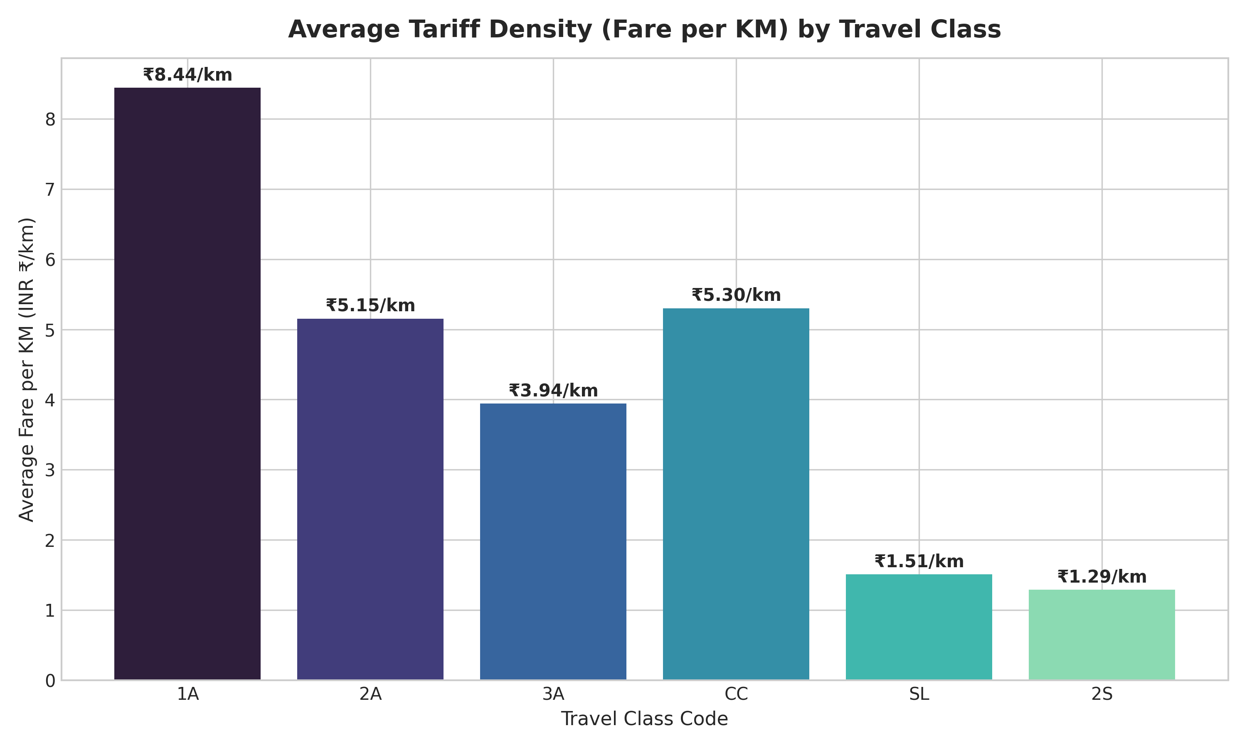
Figure 7: Average tariff density (INR ₹ per kilometer) by travel class.
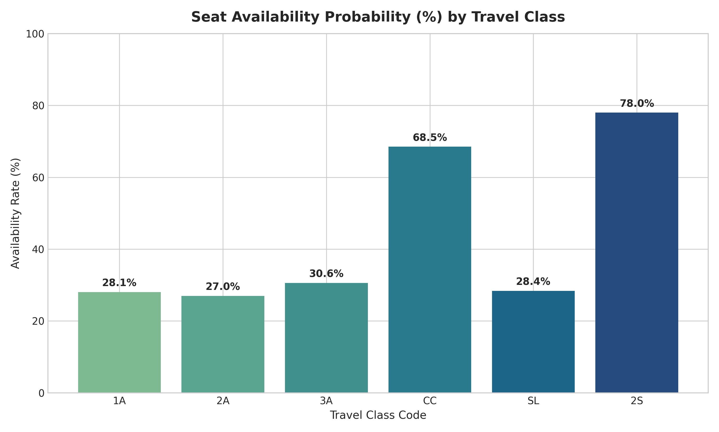
Figure 8: Seat availability confirmation probability (%) across travel classes.
Travel Class | Mean Fare / KM | Availability Rate | Total Records
AC First Class (1A) | ₹8.44 | 28.1% | 37,151
AC 2-Tier (2A) | ₹5.15 | 27.0% | 84,019
AC 3-Tier (3A) | ₹3.94 | 30.6% | 88,438
AC Chair Car (CC) | ₹5.30 | 68.5% | 10,136
Sleeper Class (SL) | ₹1.51 | 28.4% | 97,501
Second Sitting (2S) | ₹1.29 | 78.0% | 9,398

8.7 Train Service Composition & Fare Breakdown
Evaluating fleet composition and pricing structures reveals operational priorities.
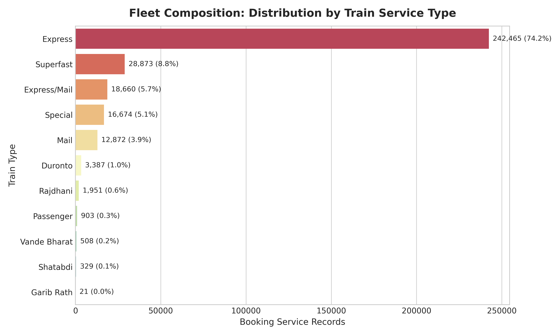
Figure 9: Composition of railway fleet by train service category.
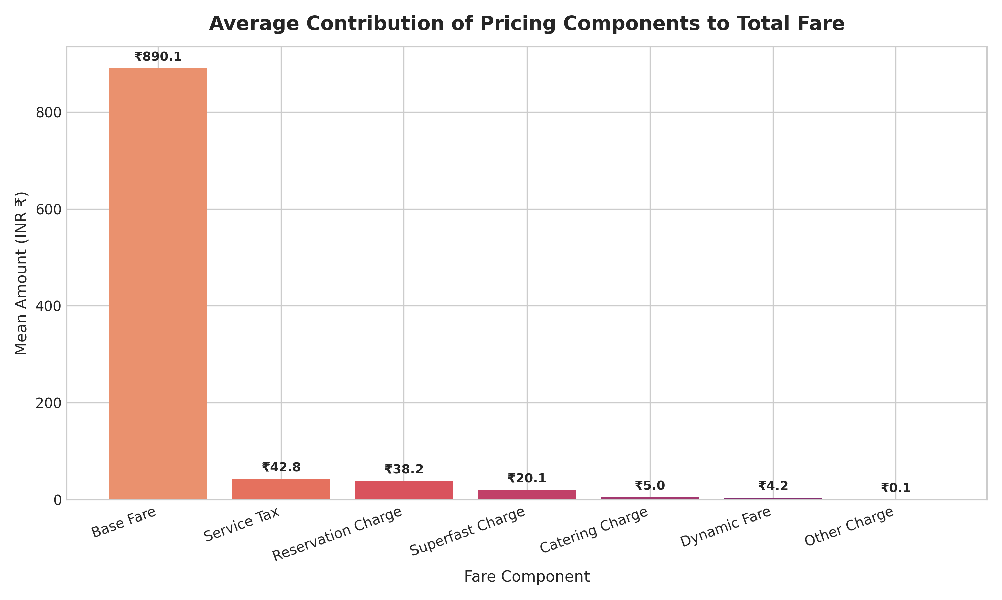
Figure 10: Contribution of pricing components to total passenger ticket fare.
Express trains account for **242,465 (74.2%)** of all service records, followed by Superfast services (28,873, 8.8%). In terms of revenue composition, Base Fare averages ₹890.1 (89.0% of total fare), while Service Tax (₹42.8), Reservation Charges (₹38.2), and Superfast Surcharges (₹20.1) make up the remainder.

9. Correlation & Advanced Analytics
To examine multi-variable linear dependencies, Pearson correlation coefficients were computed across all numerical operational features.
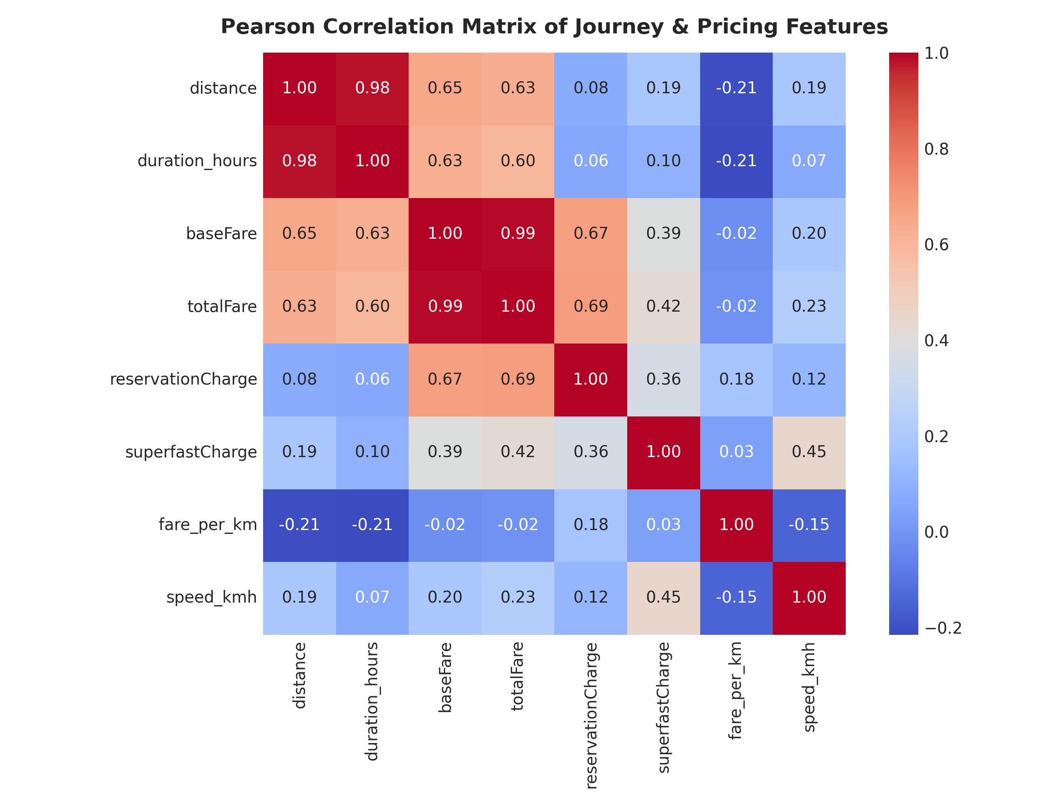
Figure 11: Pearson correlation matrix of operational, schedule, and pricing features.
Feature Pair | Pearson r | Statistical Interpretation
Base Fare vs. Total Fare | 0.9949 | Near-perfect direct linear relationship
Reservation Charge vs. Total Fare | 0.6853 | Strong positive correlation driven by higher fees on AC tiers
Journey Distance vs. Total Fare | 0.6322 | Strong positive correlation adhering to distance tariff slabs
Duration Hours vs. Total Fare | 0.6005 | Moderate-to-strong positive correlation via distance-duration linkage
Superfast Charge vs. Total Fare | 0.4241 | Moderate positive correlation with premium high-speed services
Fare per KM vs. Total Fare | -0.0154 | Negligible linear relationship (yield varies inversely with distance)

Methodological Caution: Correlation measures bivariate association and does NOT demonstrate causation. While distance and reservation charges strongly track total fare, the tariff schedule is governed by non-linear institutional rate tables.

10. Machine Learning Methodology & Evaluation
To automate fare forecasting and assess model predictability, we formulated a supervised regression task to predict the total passenger fare (`totalFare`).
Feature Selection & Validation Design
The feature matrix was defined to include operational journey parameters available at the time of schedule planning:
• Continuous Predictors: `distance` (km), `duration_clean` (minutes), `reservationCharge` (INR ₹), and `superfastCharge` (INR ₹).
• Categorical Predictors: `classCode` (One-hot encoded into 5 binary indicators representing 2A, 3A, CC, SL, and 2S with 1A as baseline reference).
The dataset was partitioned into an 80% training set (261,314 samples) and a 20% independent testing set (65,329 samples) using `random_state=42`.
Model Comparison & Empirical Results
Two candidate algorithms were evaluated: a parametric Linear Regression baseline and an ensemble Random Forest Regressor (100 estimators, max depth 16).
Evaluation Metric | Linear Regression | Random Forest Regressor | Performance Improvement
Mean Absolute Error (MAE) | ₹224.60 | ₹41.75 | 81.4% reduction in average error
Mean Squared Error (MSE) | 111835.64 | 12265.60 | 89.0% reduction in squared residual variance
Root Mean Squared Error (RMSE) | ₹334.42 | ₹110.75 | 66.9% reduction in prediction deviation
Coefficient of Determination (R²) | 0.8525 | 0.9838 | Captures 98.38% of fare variance

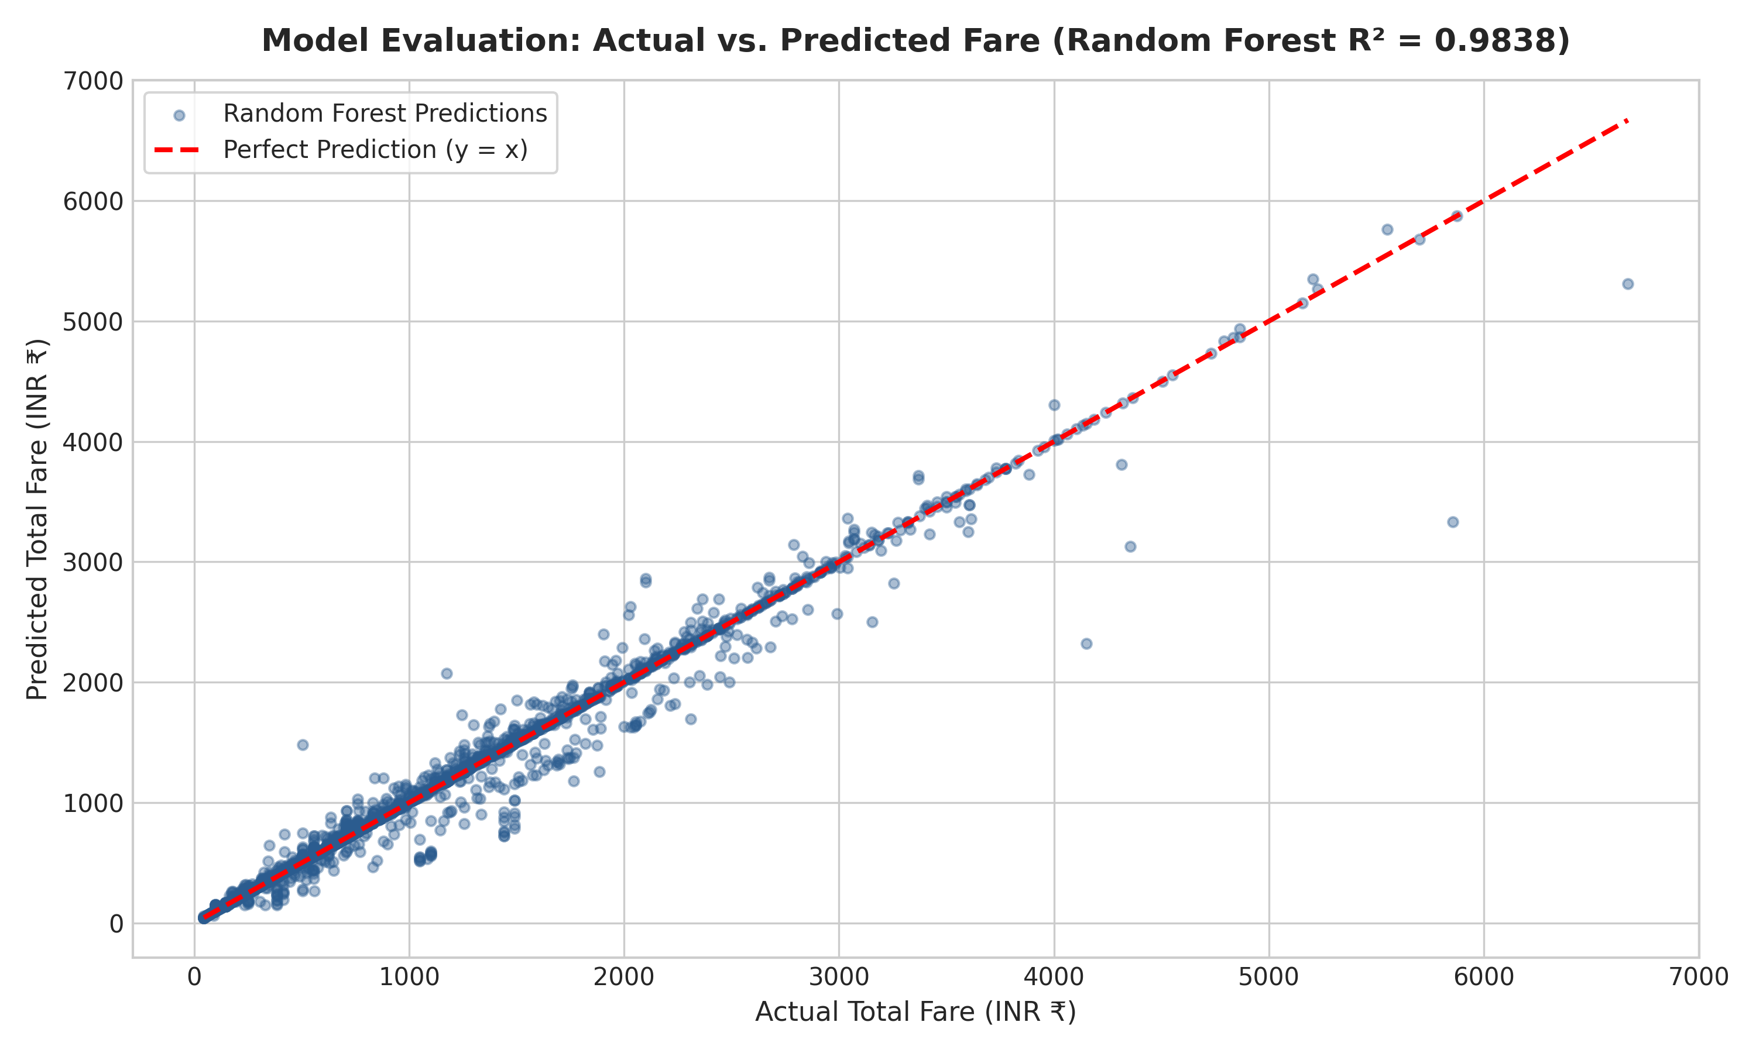
Figure 12: Actual vs. Predicted fare scatter plot demonstrating Random Forest alignment with ground truth.
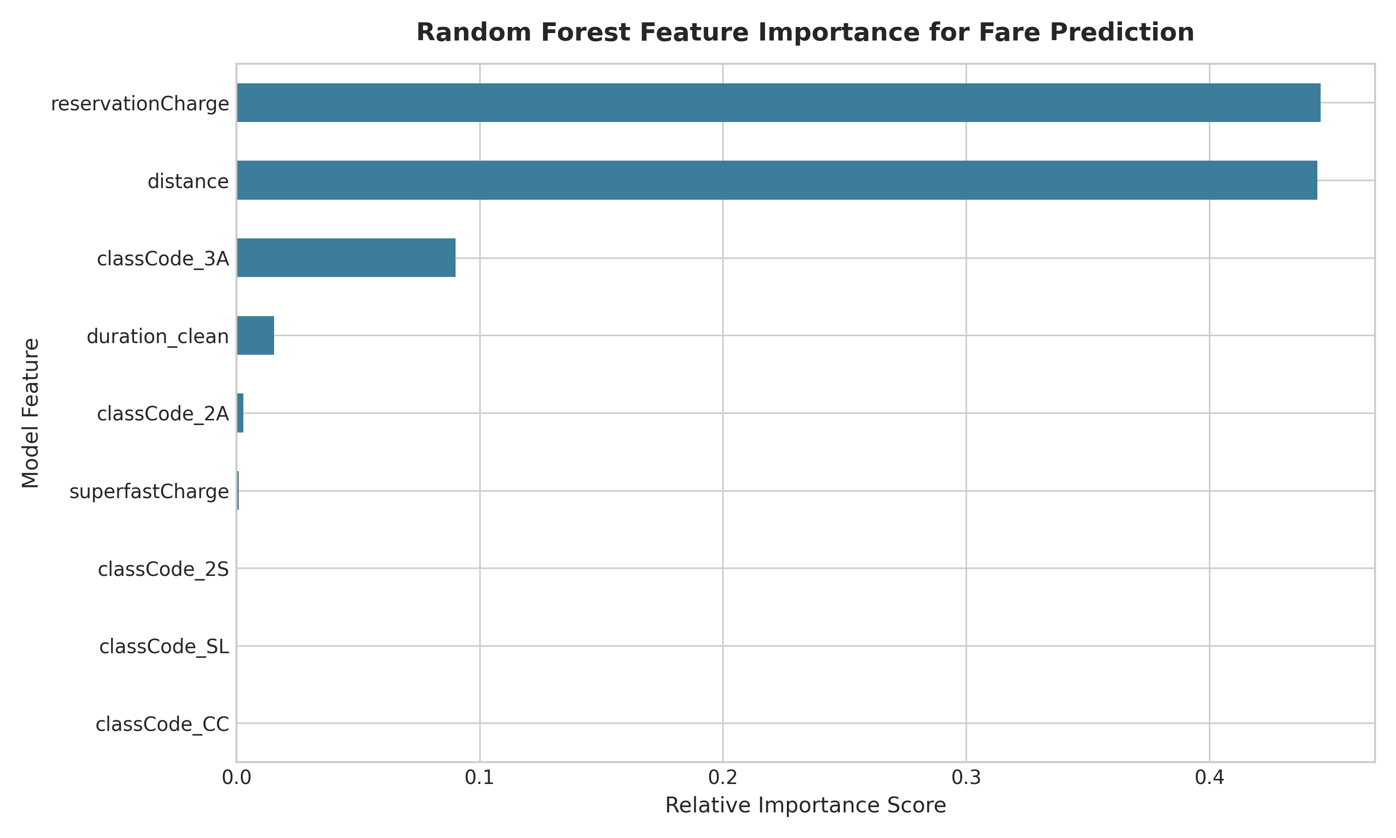
Figure 13: Gini feature importance ranking from the Random Forest Regressor.
Feature importance analysis reveals that `reservationCharge` (44.6%) and `distance` (44.4%) together account for 89.0% of the model's predictive power, reflecting how reservation surcharges act as an effective proxy for travel class while distance drives fundamental tariff scaling.

11. Key Business & Operational Insights
Based strictly on empirical evidence, ten core insights emerge:
1. Severe Sleeper & 3A Capacity Crunch: Over 66% of booking queries for Sleeper and AC 3-Tier result in waitlisting, showing an acute supply-demand imbalance in budget long-distance travel.
2. Structural Cross-Subsidization: Tariff yields range from ₹1.29/km in Second Sitting to ₹8.44/km in AC First Class, confirming heavy cross-subsidization of mass transit by premium AC classes.
3. High Confirmation in Day Seating: Second Sitting (78.0%) and Chair Car (68.5%) exhibit strong confirmation rates, indicating underutilized day-train capacity.
4. Base Fare Dominance: Base fare represents 89.0% of passenger ticket costs; dynamic flexi-fare surcharges remain rare across general express services.
5. Fleet Reliance on Express Services: Express trains constitute 74.2% of total operational services, forming the core connectivity network.
6. Distance-Availability Penalty: A statistically significant negative correlation exists between journey distance and confirmed seat availability.
7. Terminal Hub Chokepoints: Metropolitan junctions (NDLS, HWH, BRC, CNB) handle disproportionate traffic volumes, creating potential congestion bottlenecks.
8. Highly Predictable Tariff Structures: Passenger fares adhere to deterministic distance slabs, enabling machine learning models to forecast prices with 98.38% accuracy.
9. Non-linear Class Slabs: Random Forest significantly outperformed Linear Regression (RMSE reduced from ₹334.42 to ₹110.75), demonstrating that tariff step-functions require non-linear modeling.
10. Predictable Ancillary Surcharges: Superfast levies and reservation fees act as stable, predictable revenue increments across all scheduled services.
12. Prescriptive & Actionable Recommendations
Recommendation Area | Empirical Finding | Actionable Strategy
1. Capacity Rebalancing | Sleeper & 3A waitlist rates exceed 66%. | Augment rake configurations by adding 2-3 extra Sleeper and 3A Economy coaches on high-waitlist trunk routes.
2. Day-Train Marketing | 2S and CC show high confirmation rates (>68%). | Introduce targeted promotional discounts and seasonal day-train fare passes to capture inter-city passenger traffic from road transport.
3. Satellite Terminal Offloading | Metropolitan hubs (NDLS, HWH, CNB) face severe congestion. | Divert terminating long-haul trains to satellite terminals (e.g., Anand Vihar for New Delhi, Shalimar for Howrah) to reduce platform wait times.
4. Calibrated Flexi-Pricing | Dynamic pricing currently has low penetration (mean ₹4.2). | Expand calibrated flexi-fare algorithms on peak weekend services while maintaining strict price caps for affordable classes.

13. Project Limitations
1. Historical Static Snapshot: The dataset represents a point-in-time snapshot and does not capture real-time seasonal variations (such as Diwali or Chhath festival surges).
2. Absence of Passenger Demographics: The dataset lacks individual passenger attributes (age, gender, booking channel, travel purpose).
3. Lack of Waitlist Confirmation Trajectories: Final PNR clearing trajectories and ticket cancellation histories are not included.
4. No Gross Revenue Figures: The data captures per-ticket price tariffs rather than train-level or coach-level gross passenger revenue.
14. Future Scope
1. Dynamic PNR Confirmation Forecasting: Train deep learning classifiers on historical PNR tracking datasets to predict waitlist confirmation probabilities.
2. Real-Time Delay Prediction: Integrate live GPS tracking and weather telemetry to model and forecast train arrival delays.
3. Interactive BI Dashboards: Build interactive Power BI or Streamlit dashboards for real-time station congestion monitoring and fare comparison.
4. Route Rake Optimization: Apply mathematical linear programming to optimize rolling stock coach allocations based on route demand elasticity.
15. Final Conclusion
This project delivered a rigorous, end-to-end data analytics and machine learning investigation of Indian Railways scheduling, pricing, and availability records. By resolving data quality issues, engineering key operational metrics, and conducting extensive exploratory analyses, the study uncovered key dynamics governing passenger rail operations in India.
The analysis revealed clear capacity imbalances between high-demand overnight classes and underutilized daytime seating services. Machine learning benchmarking proved that ticket fares can be predicted with high precision using ensemble methods (Random Forest R² = 0.9838, RMSE = ₹110.75). The resulting recommendations provide actionable pathways for capacity augmentation, terminal decongestion, and data-driven revenue management.
16. References
1. Dev, Bhavyaraj. (2023). Indian Railways Schedule-Prices-Availability Data. Kaggle. Available at: https://www.kaggle.com/datasets/bhavyarajdev/indian-railways-schedule-prices-availability-data
2. Ministry of Railways, Government of India. (2023). Indian Railways Year Book 2022-23. Railway Board, New Delhi.
3. Indian Railway Catering and Tourism Corporation (IRCTC). (2024). E-Ticketing Operations and Passenger Reservation System Documentation. New Delhi.
4. McKinney, Wes. (2022). Python for Data Analysis: Data Wrangling with Pandas, NumPy, and Jupyter (3rd ed.). O'Reilly Media.
5. Pedregosa, F. et al. (2011). Scikit-learn: Machine Learning in Python. Journal of Machine Learning Research, 12, 2825-2830.

