1. **What is Multicluster and Multinamespace Management?**
   * Define multi-cluster management and its importance in Kubernetes.
   * Discuss why organizations use multi-cluster, multi-namespace setups (e.g., disaster recovery, high availability, multi-cloud strategies).

**Multicluster management:**

* Orchestrating multiple clusters often deployed across multiple environments (like cloud providers)
* Supports workload distribution, scaling, and policy enforcement across clusters.

**Importance:**

* **Disaster Recovery:** If one cluster fails, workloads can failover to another cluster, minimizing downtime.
* **High Availability:** Distributes workloads across clusters to avoid single points of failure.
* **Compliance and Isolation:** Clusters can be isolated for regulatory requirements or workload segregation (e.g., production vs. development).
* **Performance Optimization:** Workloads can be placed closer to end users or optimized for specific environments (e.g., GPU-heavy workloads on certain clusters).

**Multi-Namespace Management:**

* Refers to partitioning a single cluster into namespaces, dividing resources and managing workloads within the cluster
* Simplifies resource organization for teams, applications, or environments.

**Importance:**

* **Team Collaboration:** Each team or project can operate within its namespace without interfering with others.
* **Access Control:** Role-Based Access Control (RBAC) can be applied at the namespace level for fine-grained permissions.
* **Efficient Resource Usage:** Quotas ensure that namespaces don’t overconsume cluster resources.

**Why Use Multi-Cluster, Multi-Namespace Setups?**

* Disaster recovery
* High availability
* Multi-Cloud and Hybrid Strategies:
  + Allows leveraging multiple cloud providers to avoid vendor lock-in.
* Scalability
  + Multi-cluster setups enable scaling across geographic regions, while namespaces ensure logical separation within each cluster.
* Environment segregation
  + Multi cluster segregrates production, development, staging environments
  + Multi namespace setup segregates on a smaller scale like teams

1. **Understanding Kubeconfig**:

Explain how kubeconfig files are used in multi-cluster, multi-namespace environments, including how contexts, users, and clusters are defined and accessed.

Demonstrate how to merge kubeconfig files from different clusters.

kubeconfig file:

* It is a configuration file that Kubernetes uses to authenticate and communicate with cluster.
* Contains information about clusters, users, and contexts, allowing a user to interact with multiple clusters and namespaces efficiently.

Components of a kubeconfig file:

1. Clusters:

* Represents the Kubernetes API servers
* Include the API server URL and a certificate to authenticate the server.

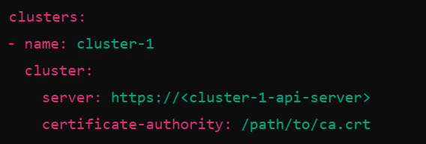

1. Users:

* Define credentials for accessing the clusters.
* Can include tokens, client certificates, or basic authentication details
* Basically, a role you are going to have when switched to that cluster

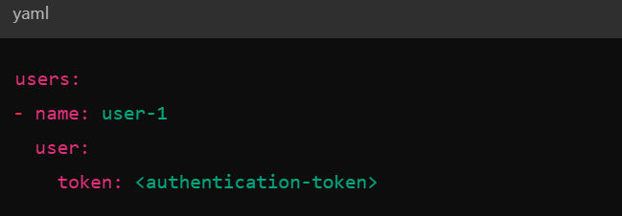

1. Contexts:

* A context specifies which cluster and namespace the user interacts with.

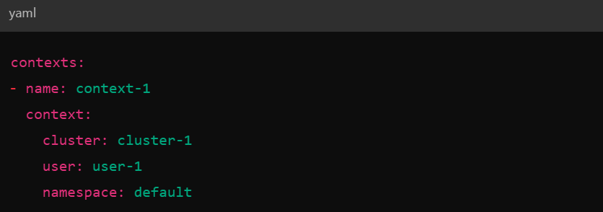

A context in multi-cluster setup:

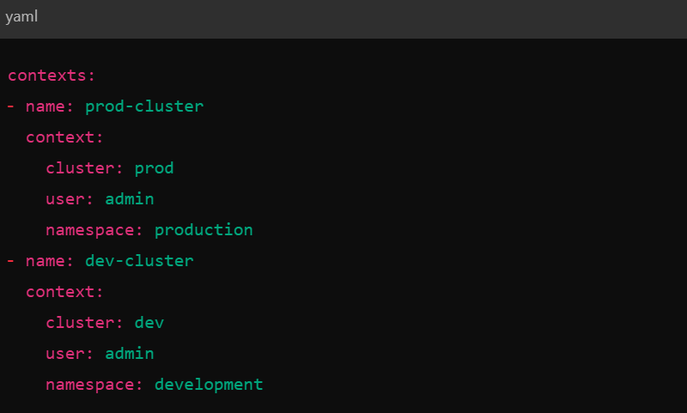

Switch between contexts using:

*kubectl config use-context dev-cluster*



**Merging Kubeconfig Files:**

When working with multiple clusters, you may have separate kubeconfig files for each. Merging them allows you to manage all clusters from a single kubeconfig.

This can be done in various ways:

Method-1:

export KUBECONFIG=/path/to/kubeconfig1:/path/to/kubeconfig2

Method-2:

kubectl config view --merge --flatten > merged-kubeconfig.yaml #merge

export KUBECONFIG=/path/to/merged-kubeconfig.yaml #use the merged file

--flatten:

Certificates, keys, and paths from the original kubeconfig files are embedded as inline values (encoded in base64). This ensures portability — you can move the merged-kubeconfig.yaml to another machine without needing external files.

**Some commands:**

View current context: *kubectl config current-context*

List All Contexts: *kubectl config get-contexts*

Switch Context: *kubectl config use-context <context-name>*

Set context*: kubectl config set-context dev-context --cluster=dev-cluster --namespace=development*

Set Namespace Permanently: *kubectl config set-context --current --namespace=development*

**Exam Tips for Multi-Cluster, Multi-Namespace Tasks**:

You can save time by creating aliases for repetitive commands

* alias kctx = 'kubectl config use-context'
* alias kns = 'kubectl config set-context --current --namespace'

Minukube kubeconfig file: (😉)

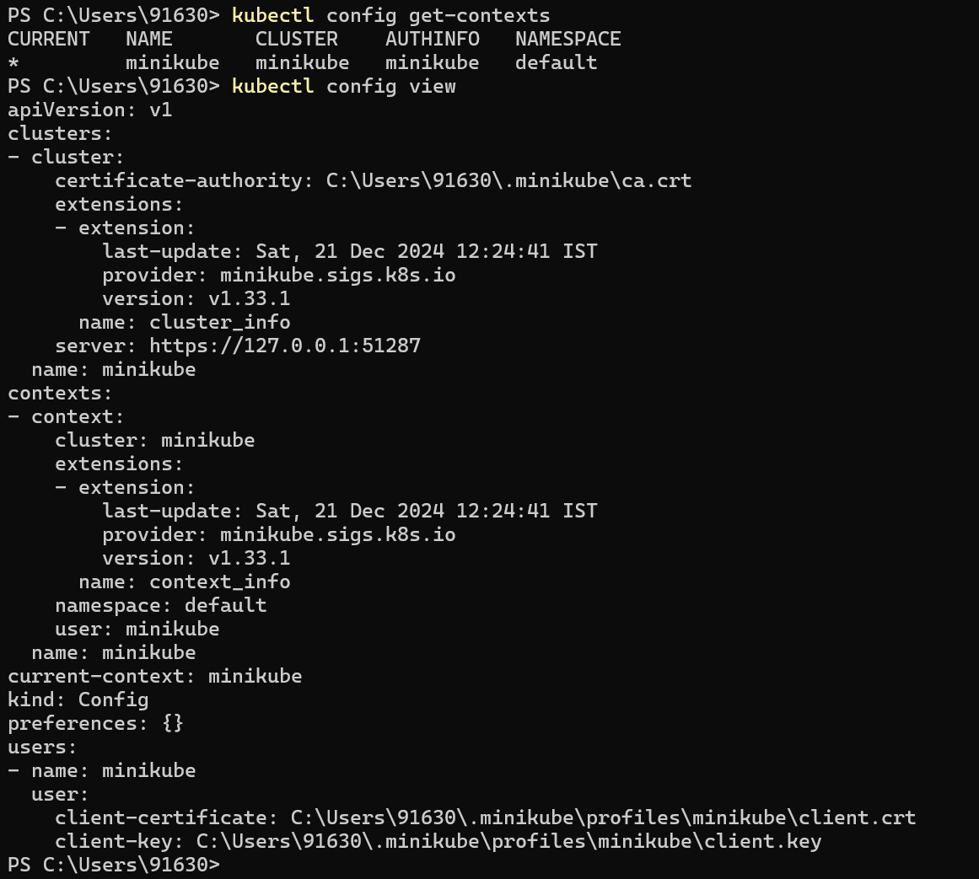

**Create cluster using kind:**

Prerequisites:

Docker

Installation: (reference- <https://kind.sigs.k8s.io/docs/user/quick-start/#installation> )

Windows: *winget install Kubernetes.kind*

Confirm installation: kind version

**Step-1**: Create a kind cluster config file

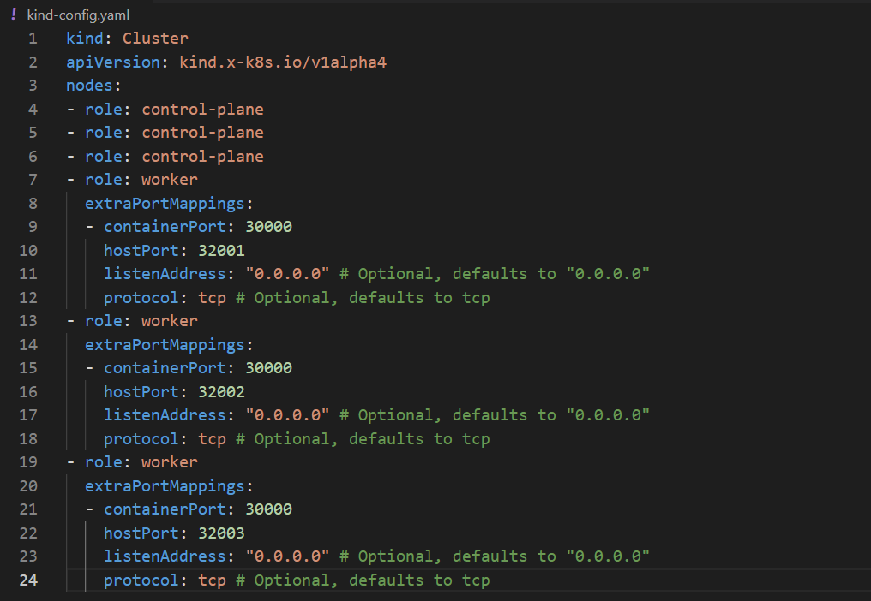

**Step-2**: Start the cluster

*kind create cluster --config <filename> --name <clustername>*

(make sure docker desktop is running before creating)

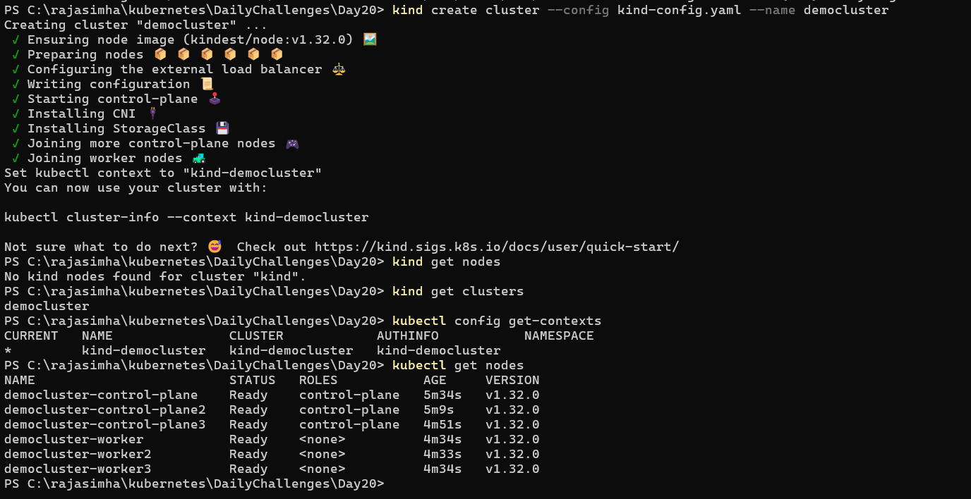

**Delete cluster:**

Kind delete cluster --name democluster

**Load a docker image into the kind cluster**: (getting-started is image name)

kind load docker-image <imageName>:tag --name <clusterName>

Now, we can use the loaded image in a deployment file. Like this:

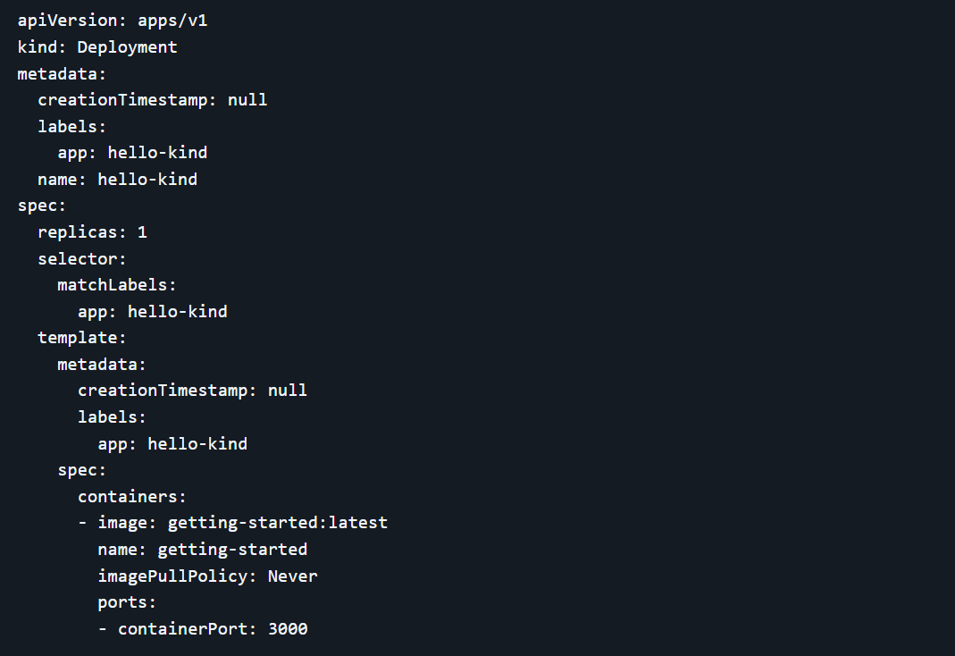

apiVersion: apps/v1

kind: Deployment

metadata:

creationTimestamp: null

labels:

app: hello-kind

name: hello-kind

spec:

replicas: 1

selector:

matchLabels:

app: hello-kind

template:

metadata:

creationTimestamp: null

labels:

app: hello-kind

spec:

containers:

- image: getting-started:latest

name: getting-started

imagePullPolicy: Never

ports:

- containerPort: 3000

kubectl apply -f deployment.yml 🡪 this will deploy the file