**Kubernetes log directory structure** - this is your starting point for any troubleshooting journey.

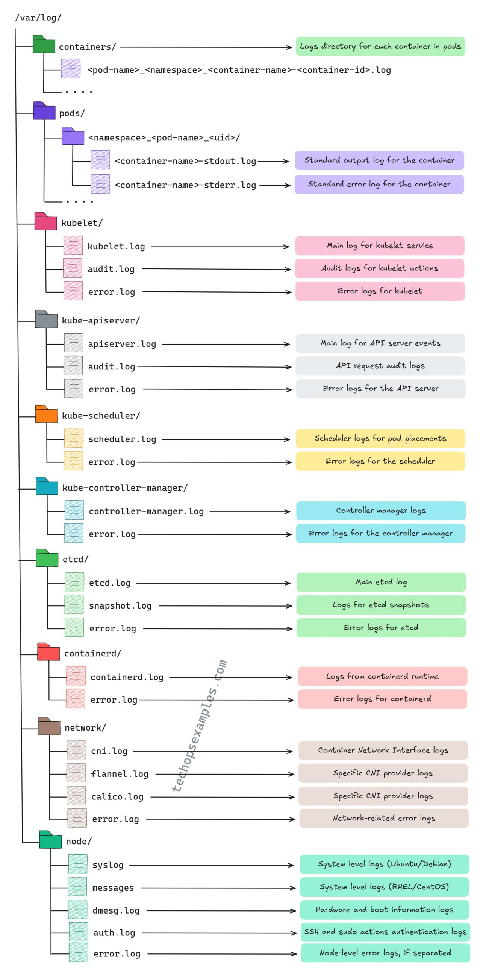

Top Kubernetes Troubleshooting Commands Every DevOps Engineer Must Know

* **kubectl get pods --all-namespaces:** Check pod statuses across all namespaces.
* **kubectl describe pod <pod_name>:** Gather detailed information about a specific pod.
* **kubectl logs <pod_name> -c <container_name>:**View logs of a specific container.
* **kubectl get events --sort-by='.metadata.creationTimestamp':** Review recent events for errors.
* **kubectl get nodes:** Verify the health and status of cluster nodes.
* **kubectl drain <node_name> --ignore-daemonsets:** Safely evacuate pods from a node.
* **kubectl cordon <node_name>:** Mark a node as unschedulable.
* **kubectl uncordon <node_name>:** Mark a node as schedulable again.
* **kubectl delete pod <pod_name> --grace-period=0 --force:** Forcefully delete a crashed pod.
* **kubectl rollout undo deployment <deployment_name>:**Roll back a problematic deployment.
* **kubectl exec -it <pod_name> -- /bin/sh:** Access a container for debugging.
* **kubectl get componentstatuses:**Check the health of core cluster components.
* **kubectl top nodes:** Monitor node resource usage for bottlenecks.
* **kubectl top pods --all-namespaces:**Identify resource-hungry pods.
* **kubectl get ingress:**Verify ingress resources and their statuses.
* **kubectl describe <resource_type> <resource_name>:** Detailed information for a resource.
* **kubectl delete node <node_name>:**Remove a failed node from the cluster.
* **kubectl port-forward <pod_name> <local_port>:<remote_port>:**Forward a local port to a pod.
* **kubectl get endpoints <service_name>:**Verify service endpoints.
* **kubectl apply -f <backup.yaml>:**Restore configurations from a backup manifest.
* **kubectl taint nodes <node_name> key=value:NoSchedule**: Prevent scheduling on a problematic node.
* **kubectl debug <pod_name>:** Launch an ephemeral container for troubleshooting.
* **kubectl edit <resource_type> <resource_name>:**Manually modify resource configurations.
* **kubectl proxy:** Start a proxy to the Kubernetes API for debugging.