Documentation file

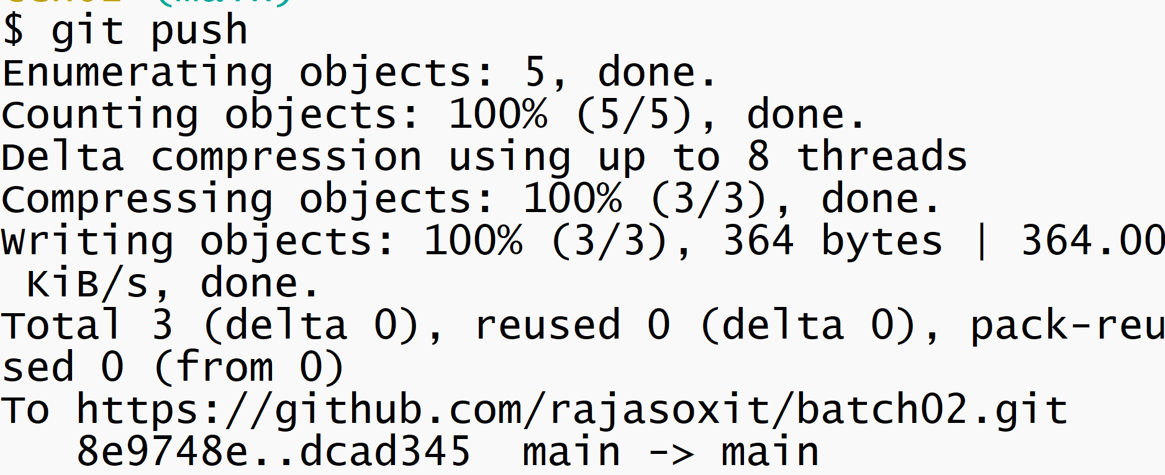

Git push 🡪 it pushes latest local code to central repository