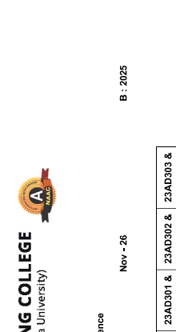 | 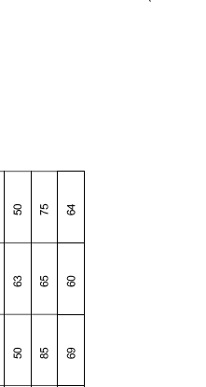
ERODE SENGUNTHAR ENGINEERING COLLEGE
B.Tech - Artificial Intelligence and Data Science

Student Detailed Correction Report
Roll No | Name of Student | 23BS305 - Discrete Mathematics | 23MC003 - Indian Constitution | 23TPS03 - Quantitative Aptitude and Logical Reasoning - I | 23HS301 | 23CS301 - Data Structures | 23AD301 - Artificial Intelligence | 23AD302 | 23AD303 - Digital Computer Organization and Architecture
ES25AD01 | AADHARSINI S H |  |  | – |  | – |  |  | –
ES25AD02 | ABARNA G H | – | – | – |  | – | – | – | –
ES25AD03 | ABISHEK K D |  | – | – |  |  | – | –
ES25AD05 | AHISH D D |  | – |  |  | – | – | –
ES25AD06 | AJAYSHARMA C D | – | – | – |  | – | – | –
ES25AD07 | AKILAN K D |  | – |  |  | – |  | –
ES25AD08 | AKSHAYA SHREE N D | – | – | – |  | – | – | – | –
ES25AD09 | ANISH R D | – | – | – |  | – | – | –
ES25AD10 | ANISHA F D | – | – | – |  | – | – | – | –
ES25AD11 | ANUSRI C D | – | – | – |  | – | – | – | –
ES25AD12 | ARUN J D | – | – | – |  | – | – | – | –
ES25AD13 | ASHWINIR H | – | – | – |  | – | – | – | –
ES25AD14 | ASWINTH K H |  |  | –
ES25AD15 | ATCHAYA G H | – | – | – |  | – | – | – | –
ES25AD16 | BALAMURUGAN M H | – | – | – |  | – | – | – | –
ES25AD17 | BALAN K M H | – | – | – |  | – | – | – | –
ES25AD18 | BALASUBRAMANI R H | – | – | – |  | – | – | – | –
ES25AD19 | BHARATH S D | – | – | – |  | – | – | – | –
ES25AD20 | BHAVAN SREE M H | – | – | – |  | – | – | – | –
ES25aD21 | BHISMEELA D |  | – |  |  | – | – | –
ES25AD22 | DEEPAK RAJ K D | – | – | – |  | – | – | – | –
ES25AD23 | DEEPAK V D | – | – | – |  | – | – | – | –
ES25AD24 | DEEPIKA V D | – | – | – |  | – | – | – | –
ES25AD25 | DHANUSRI R D |  | – | – |  | – | – | –
ES25AD26 | DHARANIDHARAN D D | – | – | – |  | – | – | – | –
ES25AD27 | DHARIKA THILO P D | – | – | – |  | – | – | – | –
ES25AD28 | DHARINI K D | – | – | – |  | – | – | – | –
ES25AD29 | DHARSHINI S D | – |  | – |  | – | – | – | –
ES25AD30 | DHILIPAN K H |  | – | – |  | – | – | –
ES25AD32 | DINESH M H | – | – | – |  | – | – | – | –
ES25AD33 | DIVYA S K H | – | – | – |  | – | – | – | –
ES25AD34 | DIVYADHARSHINI T H | – | – | – |  | – | – | – | –
ES25AD35 | DIWAKAR M H | – | – | – |  | – | – | – | –
ES25AD36 | DIWAN P D |  | – | – |  | – | – | – | –
ES25AD37 | DURGADEVI M H | – | – | – |  | – | – | – | –
ES25AD38 | GAYATHIRI M H | – | – | – |  | – | – | – | –
ES25AD40 | GOKUL R H |  |  | – |  |  |  | –
ES25AD42 | GOWTHAM A D |  | – |  |  | – | – | –
ES25AD43 | GOWTHAM G D | – | – | – |  | – | – | – | –
ES25AD45 | GUNAA S D | – | – | – |  | – | – | – | –
ES25AD46 | GURUDEEP C D | – | – | – |  | – | – | – | –
ES25AD47 | HARINI S H |  | – |  |  | – | – | –
ES25AD48 | HARISH D H | – | – | – |  | – | – | – | –
ES25AD49 | HARISH R S H | – | – | – |  | – | – | – | –
ES25AD50 | INDHUJA V D | – | – | – |  | – | – | – | –
ES25AD51 | ISHWARYA | H | – | – | – |  | – | – | – | –
ES25AD52 | JAINAF S D | – | – | – |  | – | – | – | –
ES25AD53 | JANAGALAKSHMI K H | – | – | – |  | – | – | – | –
ES25AD55 | JANANI P H | – | – |  |  | – | – | – | –
ES25AD57 | JAYAPRADHA M D | – | – | – |  | – | – | – | –
ES25AD58 | JESUKRIESHKESH G H |  | – | – |  | – | – | – | –
ES25AD59 | KAMALESHWARAN S D |  |  | – |  | – |  |  | –
ES25AD60 | KANIMOZHI S H |  |  | – |  | – | – | – | –
ES25AD61 | KANISHKA S D | – | – | – |  | – | – | – | –
ES25AD62 | KARTHIKEYA V H | –
ES25AD63 | KAVINKUMAR P M D | – | – | – |  | – | – | – | –
ES25AD64 | KAVIYARASU M H | – | – | – |  | – | – | – | –

