Lab 3

Confusion Matrix

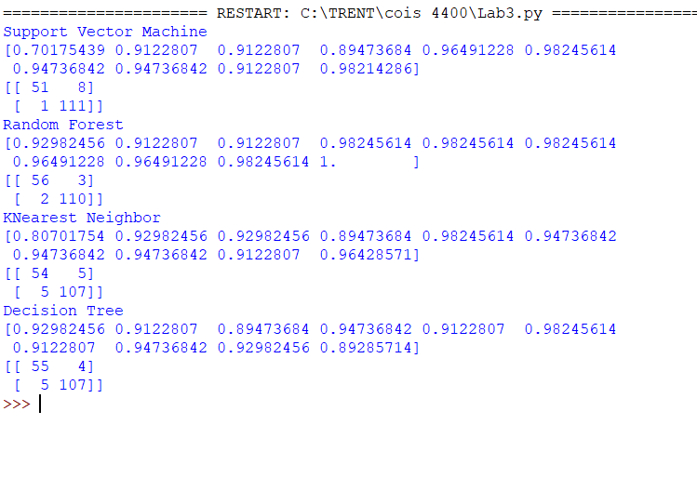

From the confusion matrix of the different classifiers, we can observe that Random Forest Classifier predicted less number of incorrect values(5),3 of them being false positive and 2 of them being false negative, whereas KNearest neighbour Classifier produced the highest number of incorrect values(10), 5 of each being false positive and false negative. Support vector produced 9 incorrect values, 8 being false positive and 1 being false negative. Decision tree produced 9 incorrect value as well, but 4 of them being false positive and 5 of them being false negative. Support Vector Machine predicted **162** correct values where 51 of them is true positive and 111 of them is true negative. Random Forest predicted **166** correct values in total where, 56 of them are true positive and 110 of them are true negative. KNearest neighbour predicted **161** correct values, where 54 of them are true positive and 107 are true negative. Decision tree predicted **162** correct values, where 55 are true positive and 107 are true negative. From this observation we can clearly see that Random Forest Classifier is the most accurate model for this dataset and KNearest is the least accurate model since it produced more incorrect values and the least number of correct values. However, all the models seems to be pretty accurate because clearly the difference is not that big.