**Business Home Game – High level package communication design:**

Communication between packages

1. Controller uses models
2. Models uses dbaccesslayer
3. dbaccesslayer reads Config.properties
4. controller, models and dbaccesslayer uses utils

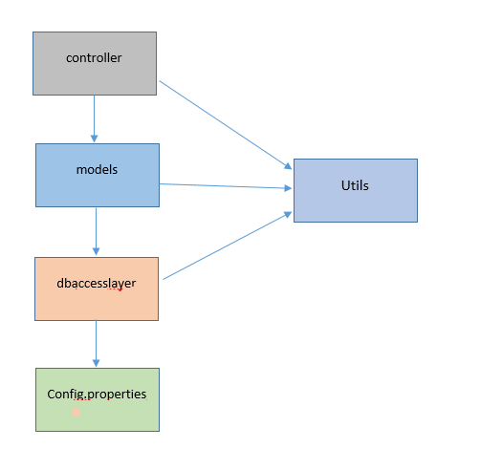

**Business Home Game - Source code structure:**

**org.businesshousegame.controller**

Has the controller class (Acts as a triggering point for the business house game)

**org.businesshousegame.dbaccesslayer**

Has the classes that accesses the Configuration properties file.

This has been introduced so that when the backend is changed to a database or other services, then we need to change only this layer instead of changing the entire application.

**org.businesshousegame.models**

Has all the class definitions to represent the business board game

**org.businesshousegame.utils**

Has the constants (like "Y" for YES, "J" for Jail, etc) and common methods that can be shared across other packages.

Constants are introduced so that if we wish to make "JAIL" to represent "Jail" cell, then it is sufficient to change at a single point instead of changing in multiple layers across the application.

**Resources folder:**

Contains the Config.properties file.

User can change the configuration of the business board game through this file.

This ensures that there is no need for rebuilding the source for changing configurations and also makes the application highly flexible.

**Development Environment:**

* Language: Java
* IDE: Eclipse
* Java version: Java 8
* Configurations done through: Properties file
* Operating system: windows 10

**Unit Testing**

* From my understanding, I believe that Junit test cases cannot be written to validate the correctness of the application since the output value is not defined for any run. Since the dice value is generated randomly for the same configurations, 2 different runs may not produce the same result.

**Deliverables**

* Source code in Github
* BusinessHouseGame.jar file
* BusinessHouseGame.bat file
* Config.properties file
* Documentation
  + Application_design.docx
  + Application_workflow_and_constraints.docx
  + Sample_run.docx

**Test Environment**

* Java 8 installed and JAVA_HOME correctly set
* BusinessBoardGame.bat file and Config.properties file to be placed in same folder
* Application tested in win7 and win10