**Test run and output**

**Test 1: With correct configuration**

1. Config.properties:

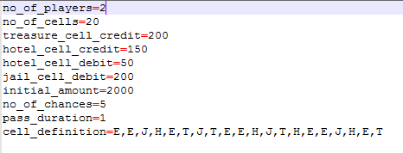

1. BusinessHomeGame.jar, BusinessHomeGame.bat and Config.properties file placed in the same location



1. Screenshot of the application output:

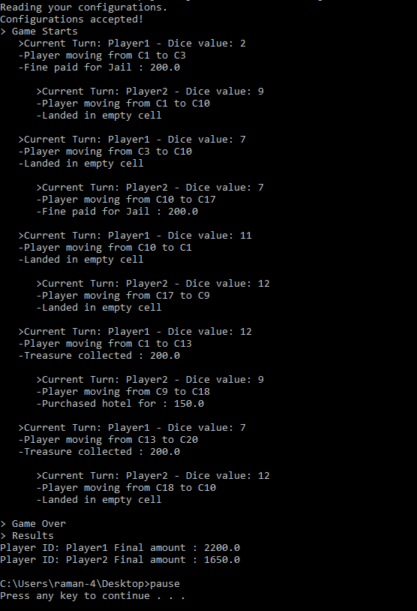

**Test 2: With incorrect configuration**

1. Properties file not placed along with jar file / if it is missing



1. Application detects the missing user configuration and checks with the user whether to load the game with default configuration

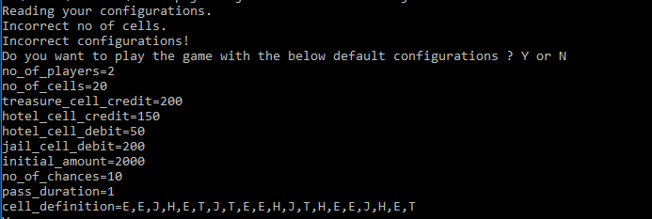

1. When user enters, "Y", game continues with default data

