IACSD



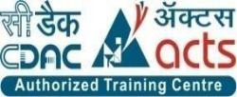

INSTITUTE FOR ADVANCED

COMPUTING AND

SOFTWARE DEVELOPMENT

AKURDI, PUNE

Documentation On

**“VINEYARD”**

PG-DAC FEB 2020

*Submitted By:*

**Group No: 26**

**Rajat Kesarwani (1074)**

**Shubham Vidhawan (1091)**

**Mr. Prashant Karhale**

**Centre Coordinator**

**Mr.Kashinath Patil**

**Project Guide**

IACSD

**Table of Contents**

**1. Introduction 1**

Document Purpose 2

Problem Statement 2

Product Scope 2

Aim & Objectives 2

**2. Overall Description 3**

Product Perspective 3

**Benefits of online Liquor Delivery System………………………………………………....3**

User and Characteristics 4

Operating Environment 4

Design and Implementation Constraints 5

**3. Requirements Specification 6**

External Interface Requirements 6

**4. System Diagram ..8**

Use Case Diagram ..8

ER Diagram. ..9

**5. Table Structure 10**

Admin Table 10

User Table 10

Product Table 10

Cart Table 11

1. Conclusion**………………………………………………………………………….….…12**

**FutureScope………………………………………………………………………………12**

**7. References 13**

IACSD

**List of Figures**

Figure 1 Use Case Diagram 16

Figure 2 ER Diagram 16

IACSD

1. **Introduction**

Generally, if a customer wants to buy any liquor based products then he has to visit the brick and mortar shop and hence there is no scope of any online facility to provide them with this service.So we with this online project we aim to bridge this gap literally and provide them with this facility of online booking products and viewing product catalog.Then it also gives shop owner with the stock management facility.

**1.1 Document Purpose**

The advancement in Information Technology and internet penetration has greatly enhanced various business processes and communication between liquor shop owners and their customers.

Enhance Business Processes:

To be able to use internet technology to project to the global world instead of limiting their services to their local domain alone, thus increase their return on investment (ROI).

Online Liquor Delivery (VINEYARD):

A Tool through which gives the shop owner stock management facilities and also provides liquor ordering and viewing system for the end users .

1

IACSD

**1.2 Problem Statement**

Existing Scenario of the current market of a liquor industry is that the ever increasing demand of customers and their increasing number causes heavy load on the physical store of a liquor vendors specially on weekends and festivals which leads to huge amounts of rush and confusion on the local market some times resulting into long queues. To overcome these in convince and to cop with the surge of the customers we created this online system.

**1.3 Product Scope**

This project traverses a lot of areas ranging from business concept to computing field, and required to perform several researches to be able to achieve the project objectives. The area covers include:

1. Liquor industry: This includes study on how the day to day liquor shops operates and the different liquor products.
2. J2EE Technology used for the development of the application.
3. General customers as well as the society’s staff will be able to use the system effectively.
4. Web-platform means that the system will be available for access 10/7 except when there is a temporary server issue which is expected to be minimal.

**1.4 Aims & Objectives**

Specific goals are: -

1. To produce a web-based system that allow the admin to add and edit products and provide functionalities to edit them .
2. Ease of Accessibility of Liquor Products for Customers.
3. Avoidance of Rush and saving of fuel and time for Customers.

2

IACSD

**2.0 Overall Description**

**2.1 Product Perspective:**

Existing system function:

Existing situation of the market is such that the customer has to visit the brick and mortar shop which results in loss of time and fuel and after office hours the rush is such that they cant even view the proper product range and categories and varieties leading to uncertainty and money not being utilized correctly.This might further lead to loss in customers which are sometimes non trackable . Our new online system tracks not only the product stock but also provides an online catalogue with a nice User friendly UI.Proposed system also provides the facility to view and as well as add to cart and order at their location .For Shop Owners they will have the facilities of managing users and products providing more power and control over their business.

* **III. PROPOSED SYSTEM**

Product functionality:

Liquor Management System(Vineyard) provides the features for Admin, customer. It includes several functionalities describes as below:

*Shop Owner Management:*

It provides facility to add, update, delete and view the products available in the system

**2.2 Benefits of online Liquor Delivery System**

* **1**. Vineyard is fully functional and flexible.
* **2**. It is very easy to use.
* **3**. This online liquor management system helps in back office administration by streamlining and standardizing the procedures.
* **4**. It saves a lot of time, money and labour.
* **5**. The application acts like a shop that is open 10/7.
* **6**. It increases the efficiency of the management at offering quality services to the customers.
* **7**. It provides custom features development and support with the application.

3

IACSD

**2.3 Users and Characteristics:**

Admin:

**1**.Admin can login to the system.

**2**.View the list of all Products in the stock..

**3**.Add new Product.

1. Delete Product.

**5**.Update Product Details

Customer:

**1**.Customer can login to the system.

**2**.View his/her details.

**3**.View product catalog.

**4**.Add the preferred products to cart.

**5**.Pay and checkout for order

**2.4 Operating Environment:**

**Software Requirements**

:

* **Operating System :** Windows XP, Windows7 And above.
* **Language :** Java Runtime Environment
* **Browser :** Any of Mozilla, Opera, Chrome, etc
* **Web Server :** Tomcat 9
* **Software Development Kit :** Java JDK 1.8 or Above
* **Scripting Language Enable :** Angular for Frontend
* **Database JDBC Driver :** MySQL Connector

**Hardware Requirements:**

* **Processor :**Xeon Processor 3500 Series
* **RAM :** Min 1 GB
* **Hard disk :** Min 30 GB
* **Monitor :** 15” color monitor
* **Keyboard :** 122 keys

4

IACSD

**2.5 Design and Implementation Constraints:**

**1**. The application will use JavaScript, Angular,HTML and CSS as main web technologies.

**2**. HTTP and FTP protocols are used as communication protocols. FTP is used to upload the web application in live domain and the client can access it via HTTP protocol.

**3**. Several types of validations make this web application a secured one and SQL Injections can also be prevented.

**4**. Since Vineyard is a web-based application, internet connection must be established.

**5**. The Liquor Management System will be used on PCs and will function via internet or intranet in any web browse.

5

IACSD

**3.0 Specific Requirement**

**3.1 External Interface Requirements:**

User Interfaces:

1.All the users will see the same page when they enter in this website. This page asks the users a username and a password.

2. After being authenticated by correct username and password, user will be redirect to their corresponding profile where they can do various activities.

3. The user interface will be simple and consistence, using terminology commonly understood by intended users of the system. The system will have simple interface, consistence with standard interface, to eliminate need for user training of infrequent users.

Hardware Interfaces:

* 1. No extra hardware interfaces are needed.
* 2. The system will use the standard hardware and data communication resources.
* 3. This includes, but not limited to, general network connection at the server/hosting site, network server and network management tools.

6

IACSD

Application Interfaces:

**OS:** Windows 7 and above.

**Web Browser:**

The system is a web-based application; clients need a modern web browser such as Mozilla Firebox, Internet Explorer, Opera, and Chrome. The computer must have an Internet connection in order to be able to access the system.

Communications Interfaces:

1. This system uses communication resources which includes but not limited to, HTTP protocol for communication with the web browser and web server and TCP/IP network protocol with HTTP protocol.
2. This application will communicate with the database that holds all the booking information. Users can contact with server side through HTTP protocol by means of a function that is called HTTP Service. This function allows the application to use the data retrieved by server to fulfil the request fired by the user.

7

**IACSD**

**4.0 System Diagram**

**4.1 Use Case Diagram**

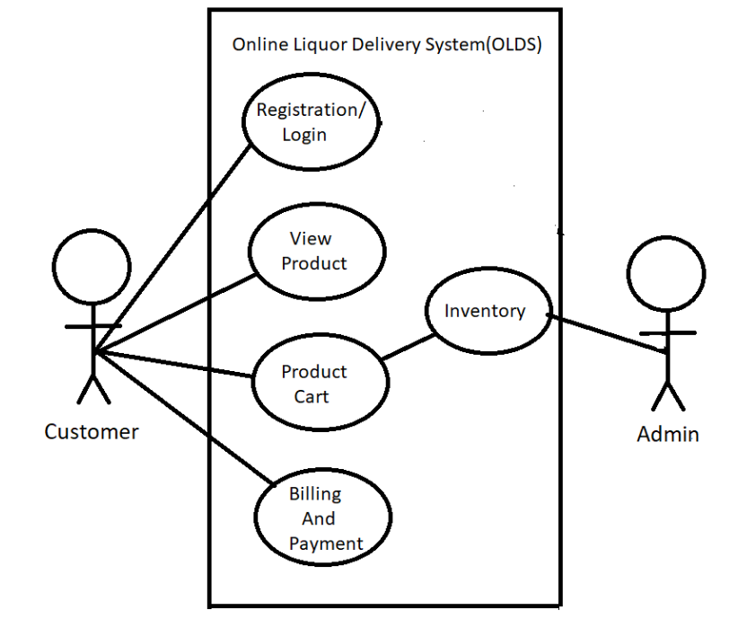

**Figure 1: Use Case Diagram**

8

IACSD

**4.2 ER Diagram**

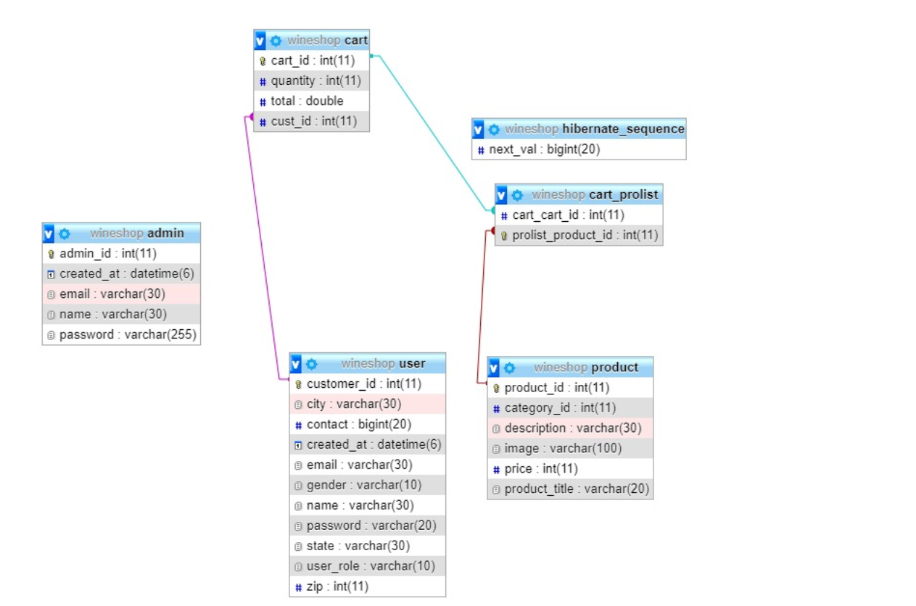

**Figure 2: ER Diagram**

9

IACSD

**5. Table Structure**

**Admin:**

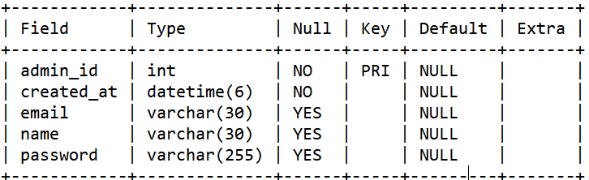

**User:**

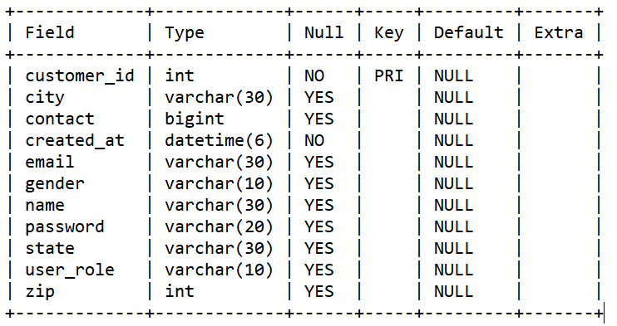

**Product:**

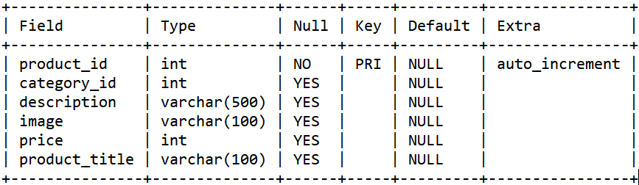

10

IACSD

**Cart:**

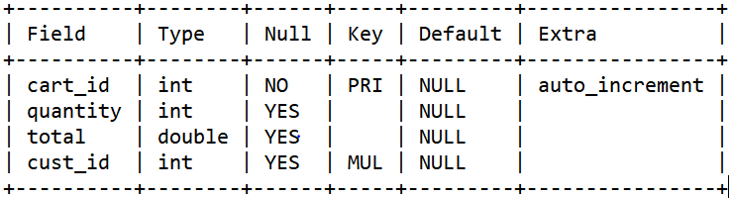

11

IACSD

**6.0 Conclusion**

Liquor management system puts forth the actual working of a liquor shop. Admin will have full control over what products to show and also synchronized the virtual stock with the physical one

**Future Scope**

This project can be enhanced further by adding coupon system discount , Festive Sale, online payment facility for the members to reduce the extra work of the admin. The software is flexible enough to be modified and implemented as per future requirements. We have tried our best to present this free and user–friendly website to customers. Message and Email alerts for various happenings in the society can be added to the system so that users do not miss the updates and happenings of the society.

**12**

**IACSD**

**7.0 References**

* www.marketviewliquor.com
* Images --- https://unsplash.com

13