Class Time Table Generation System
Software Requirements Specification

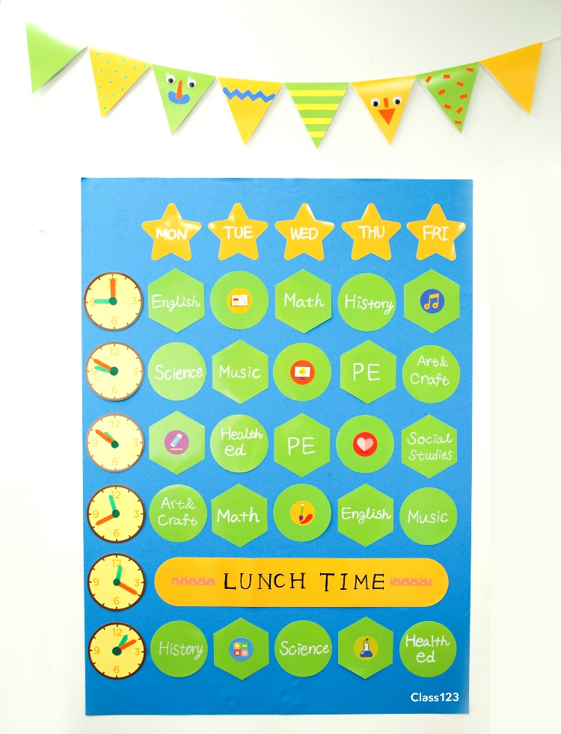

Submitted By :

Rajat Mangla (B15CS029)
Pradeep Choudhary (B15CS042)
Revision History
Date | Version | Description | People
16 Jan 2017 | 1.0 | First draft – Added introduction and its subparts | Pradeep Choudhary  Rajat Mangla
31 Jan 2017 | 2.0 | Second draft – Added Overall Description and its parts , Use case description  Updated Glossary  Updated Assumptions | Pradeep Choudhary  Rajat Mangla
1 March 2017 | 3.0 | Third Draft –  Admin Use Case Diagram Updated  - View Information Use Case changed to Edit / Delete Information  - Made changes in Use Case Description

Table of Contents
1. Introduction 4
1.1 Purpose 4
1.2 Scope 4
1.3 Constraints 4
1.4 Assumptions and Dependencies 4
1.5 Definitions, Acronyms and Abbreviations 4
1.6 References 4
1.7 Organization of the Document 4
2. Overall Description 4
2.1 Product Functions 4
2.2 User Characteristics 4
3. Specific Requirements 5
3.1 Use case description 5
3.2 Reliability 5
3.3 Performance Requirements 5
3.4 Supportability 5
3.5 Design Constraints 5
3.6 Online User Documentation and Help System Requirements 5
3.7 Interfaces 5
4. Supporting Information 6

Software Requirements Specification

Introduction
The manual time table scheduling demands considerable time and efforts along with lots of paper work. So our project Time Table Generation System in which we find the solution that satisfies the given set of constraints which are described below. Such scheduling of time table has been in human requirements since the thought of managing time effectively. This technique is widely used in other schools and other field of teaching. If such management is done manually by a person or some group then it’ll take lot of effort and time. While scheduling, even the small constraints can take a lot of time and it is even worse when the number of constraints or data sets are considerably large. Other case that can cause problem is when the number of faculty is less. So to cater such problems automated time table management is a very convenient method.

Purpose
Almost all colleges have lots of different departments and each department has various courses. Now there are limited faculties, each faculty teaching more than one course in a semester. So the time table management system is needed to schedule the classes at provided time slots in such a way the timings do not overlap and time table scheduler makes the best use of all the demands reducing manual and paperwork.

Scope
Our time table generation system will –
- Enable students and faculty to see their respective schedule on the go(Handheld device)
- Generate time table keeping in mind the:
  - availability of faculty members
  - availability and capacity of physical resources such as classrooms, labs, etc.

Constraints
Constraints are divided into two parts:
Strong Constraints –
- A classroom is not assigned to more than one lecture at the same time
- A teacher cannot take more than one class at the same time
- A student cannot attend more than one lecture at the same time
- All classrooms should be spacious enough to occupy all the students who have undertook the course
- The classroom should be well equipped with necessary facilities

Weak Constraints –
- The lectures are not allotted to time slots which come under the lecturer’s prohibited time zones.
- The teaching hours on an teacher should be limited within the allowed maximum hours.
- The classes should be scheduled in accordance with the teacher’s specific time zones.
- A break for lunch must be allotted to the teachers and students.
- The theory courses are scheduled on Monday and Tuesday, and the practical courses are scheduled on Wednesday, Thursday, and Friday.
- Lectures for the same course should be scheduled consecutively, if possible.
- As far as possible, classes should be carried out in their respective department’s exclusive-use classrooms.
- The classrooms should be allocated in such a manner that the distances between adjoining lecture’s classrooms is minimized.

It is desirable for timetables to satisfy all strong and weak constraints. However, it is typically not easy for all these constraints to be satisfied. It is a must for the strong constraints to be met at all times, but the weak constraints can be abandoned in order to find convenient timetables.

Assumptions and Dependencies
Assumptions:
- Data set regarding courses and teachers will be provided by the office of academics
- Lectures are of fixed duration, i.e., 1 hour
- There will be no backlogs
- User must have good internet connection
- Optimum number of rooms are available as per the number of courses and faculty
Dependencies:
- Data set of courses, students and faculty
- Internet connection
- Some rooms have extra facility like projectors, extra seating capacity, etc.

Definitions, Acronyms and Abbreviations

Term | Definition
Batch | Group of students belonging to same department and same year
Database/Data set | The collection of the data to be used for the generation of time table
Office of Academics | Authority that will provide all the data (Courses, Students, Faculty, etc.)
User | Person who will use the software system (Faculty, students, etc.)
Admin | Who will make changes in the database as and when required
Faculty | Teacher assigned to teach courses mentioned in the time table
Student | Person who will attend the courses that he registered for during enrollment

References
[1] IEEE. IEEE Std. 830-1998 IEEE Recommended Practice for Software

[2] Requirements Specifications. IEEE Computer Society, 1998

Organization of the Document
The rest of the SRS ….

Overall Description

Product Functions
The Time Table Generation Software will be able to produce a time schedule for the institute which speciﬁes the time and room assignments for the diﬀerent courses. The Constraints (Mainly Hard Constraints) Specified above are taken into account as far as possible. Following this our software will be able to generate time table

Functional Requirements
- Our Software will be an Android Platform Application mainly displaying the optimal time table based on entered data set
- Users can view their Specific Time Table and other related information
- Admin will be able to add new data and update the existing one
- Time Table will be generated whenever some changes are made in the data or when Admin wants to generate it

Use Case Diagram

- User - Use Case Diagram

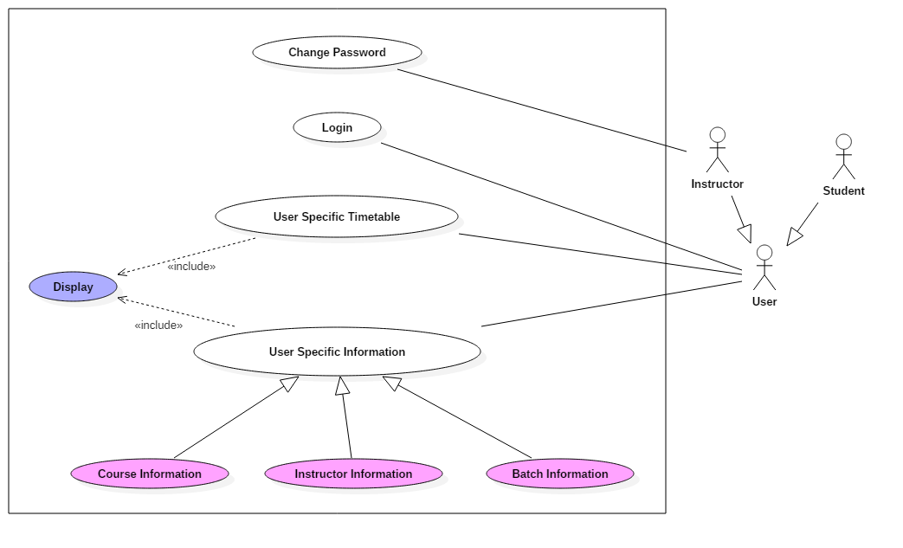

Description
Above use case diagram describes what are the functionalities a user can have in the system . It considers the users (Teacher and Student ) point of view

- Admin – Use Case Diagram
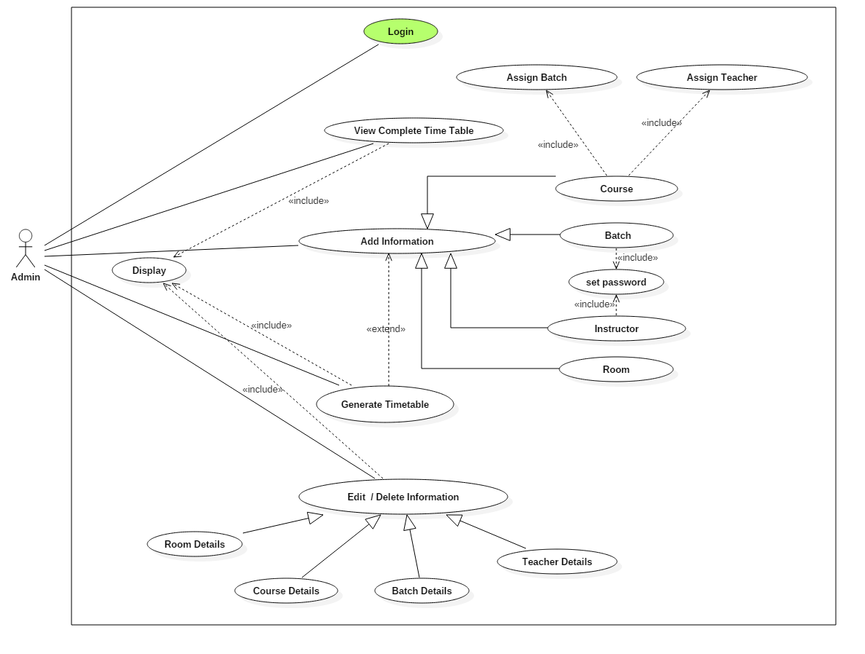

Brief Description
This use case diagram describes about the Admin functionalities in software . The Admin has various provision like adding and updating information , setting up password for the Users , can view and edit the information about the Users .

Class Diagram

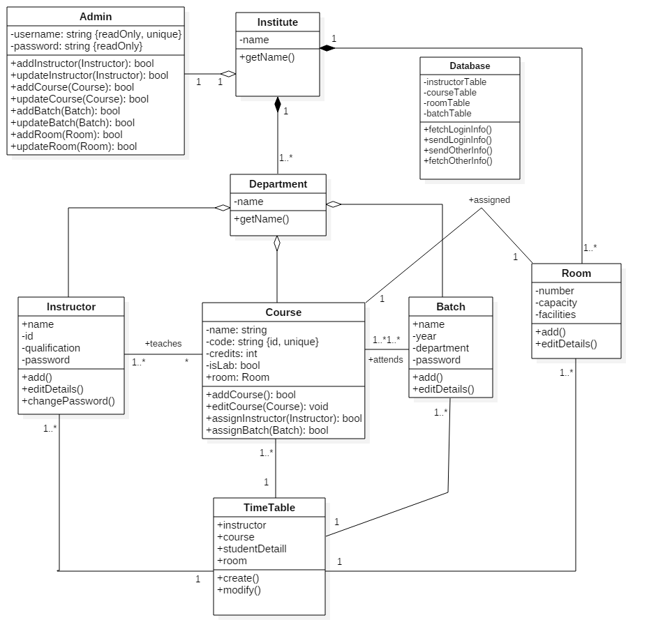

Sequence Diagram
- Login Sequence Diagram – The Various Processes involved during Login Process represented in a Sequence Diagram .
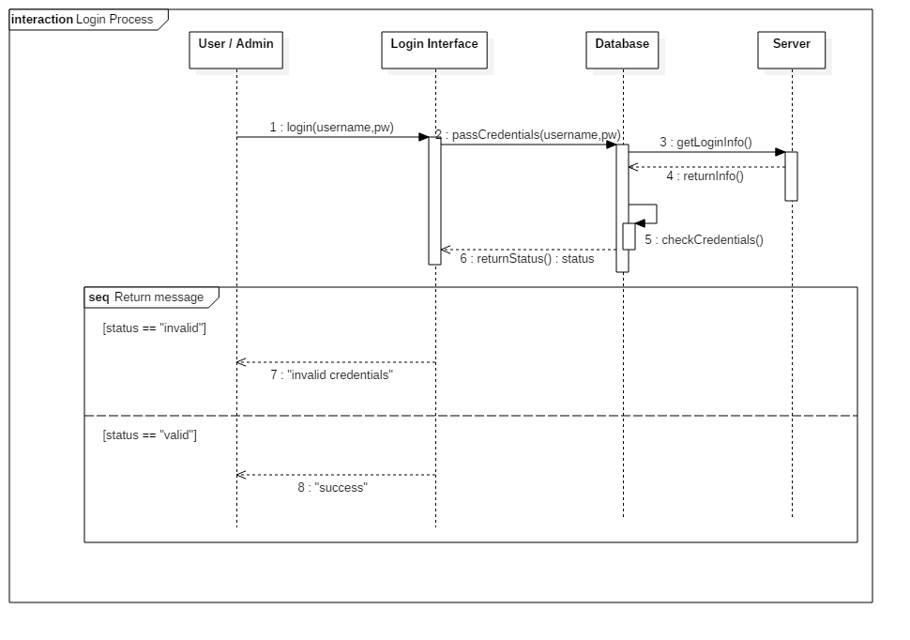

- Below Sequence Diagram show the processes involved in viewing the time table when the User Views the timetable .
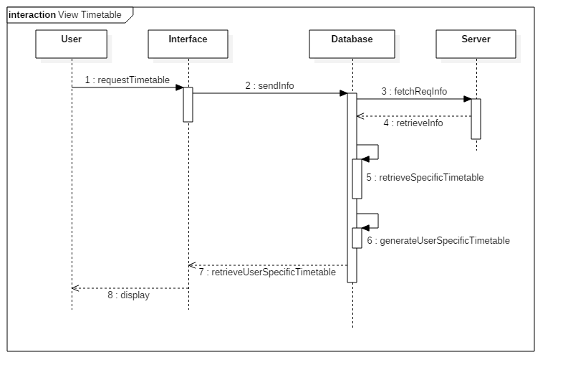
- Add information (info) – shows the steps involved while adding information .

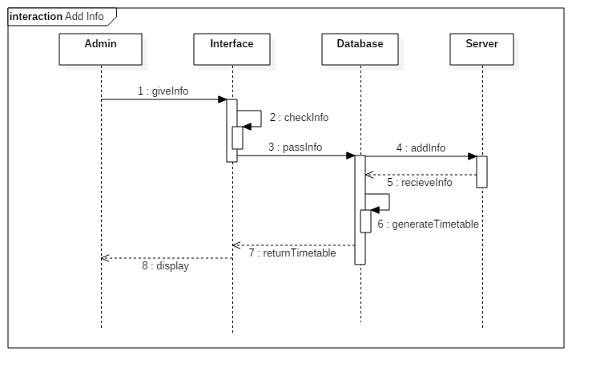
- Update information (info) – shows the steps involved while updating information .

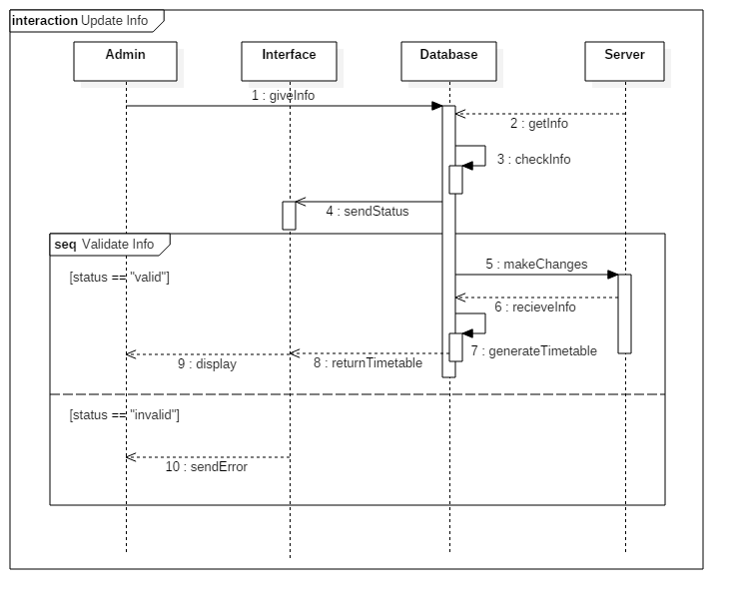

Activity Diagram

- Login Activity Diagram – Steps Involved during the login interface

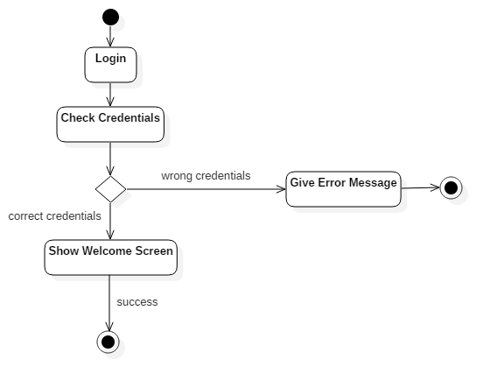

- User Activity Diagram – Steps Involved when the User Uses the Software .

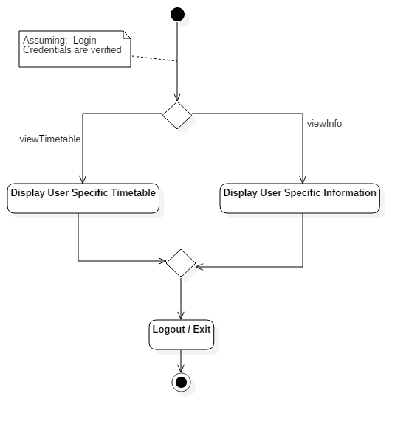
- Admin Activity Diagram – Steps Involved when the Admin Uses the Software .

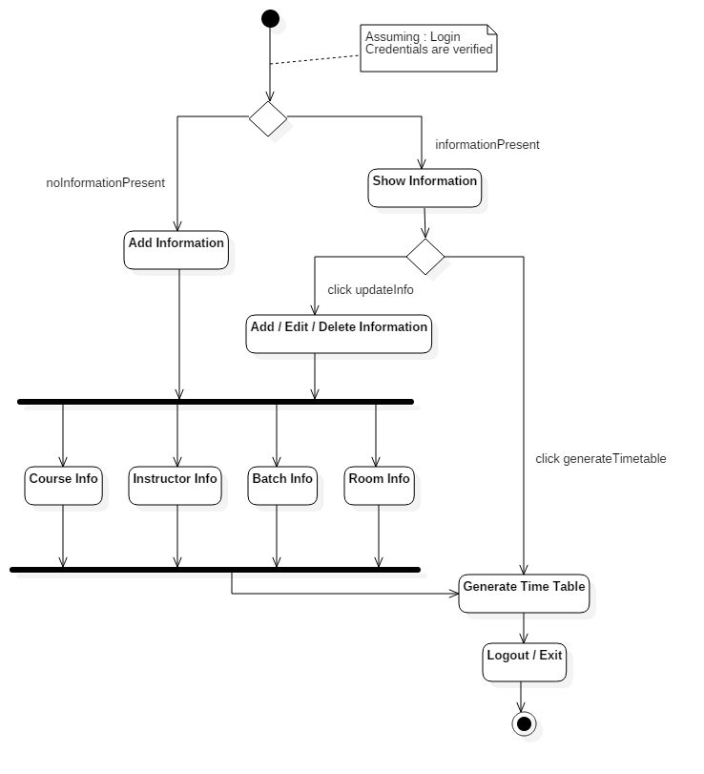

Non-Functional Requirements

- Our Application can be used easily by anyone have a smartphone
- The Application can used by at most 100 people at the same time due to some database limitations
- Data can be viewed within seconds if users have a good internet connection

User Characteristics
- Users using the Software must have an Android Smartphone with minimum API 15 i.e Ice Cream Sandwich Platform
- User must Know how to Use an Android Smartphone

Specific Requirements

Use case description

Login
Name: | Login
Short description: | A user/admin logs into the software
Precondition: | The user/admin is registered into the software
Post condition: | The user/admin is logged into the software
Error situations: | The user/admin is not having an account
System state in the event of an error: | The user/admin is not logged into the software
Actors: | Admin, User
Trigger: | Login button is clicked
Standard process: | (1) User/Admin enters credentials  (2) System checks to see if credentials are valid  (3)If valid user/admin is logged into the system
Alternative processes: | None

Display
Name: | Display
Short description: | Displays information
Precondition: | Information to be displayed must be present in database
Post condition: | Information is displayed
Error situations: | Information is not present or not loaded properly (due to internet connectivity)
System state in the event of an error: | Information is not displayed
Actors: | Admin, User
Trigger: | User/Admin wants to see some information
Standard process: | (1) User/Admin clicks some button to display information  (2) Information gets displayed on the screen
Alternative processes: | Related Information can be seen on the server

Change Password
Name: | Change Password
Short description: | Admin/Teacher wants to change his/her password
Precondition: | Teacher must know current password and should be logged in
Post condition: | Password is changed successfully
Error situations: | Current password is wrong
System state in the event of an error: | Password remains the same
Actors: | Admin , Teacher
Trigger: | Instructor clicks on change password button
Standard process: | (1) Teacher gives current password and new password  (2) Current password is checked  (3) If correct then the password is changed
Alternative processes: | None

User Specific Timetable
Name: | User Specific Timetable
Short description: | User can see timetable only for his/her courses
Precondition: | User must be logged in
Post condition: | Timetable specific to the user gets displayed on the screen
Error situations: | User is not logged in
System state in the event of an error: | Timetable doesn’t get displayed
Actors: | User ( Teacher or Student)
Trigger: | User clicks button to see his timetable
Standard process: | (1) User clicks button  (2)Timetable is displayed on the screen
Alternative processes: | None

User Specific Information
Name: | User Specific Information
Short description: | User can see his courses and other Information
Precondition: | User must be logged in
Post condition: | Information is displayed on the screen
Error situations: | User is not logged in
System state in the event of an error: | No formation is displayed
Actors: | User ( Teacher or Student)
Trigger: | User clicks button to see information
Standard process: | (1) User clicks button  (2) Information is displayed
Alternative processes: | None

View complete timetable
Name: | View complete timetable
Short description: | Admin can see the complete timetable
Precondition: | Admin must be logged in
Post condition: | Complete timetable gets displayed on the screen
Error situations: | Admin is not logged in
System state in the event of an error: | Timetable doesn’t get displayed
Actors: | Admin
Trigger: | Admin clicks button to see complete timetable
Standard process: | (1) Admin clicks button  (2) Timetable is displayed on the screen
Alternative processes: | None

Add Information
Name: | Add Information
Short description: | Admin can add course, batch, instructor, room information
Precondition: | Admin should be logged in
Post condition: | Admin adds the information
Error situations: | Admin is not logged in
System state in the event of an error: | Admin is unable to change any information
Actors: | Admin
Trigger: | Admin clicks a button depending upon what type of information he wants to add
Standard process: | (1) If Admin is logged in  (2) Admin adds the information he wants to add  (3) Added information is sent to the database
Alternative processes: | None

Generate Timetable
Name: | Generate Timetable
Short description: | Admin generates the complete timetable
Precondition: | The software should have complete database of courses and instructors
Post condition: | Timetable gets generated and is displayed on the screen
Error situations: | Adequate data is not available for generation of Timetable
System state in the event of an error: | Timetable is not generated
Actors: | Admin
Trigger: | Admin clicks a button to generate timetable
Standard process: | (1) Admin clicks button to generate timetable after giving all information  (2) Timetable gets generated and is displayed on the screen
Alternative processes: | None

Edit / Delete Information
Name: | Edit / Delete Information
Short description: | Admin is edit or delete the information related to courses, instructors, etc.
Precondition: | Admin should be logged in
Post condition: | Information is updated according to the operation
Error situations: | Related Information doesn’t exists
System state in the event of an error: | Information doesn’t gets changed
Actors: | Admin
Trigger: | Admin clicks button to edit or delete information
Standard process: | - Admin clicks button  - Make specific changes  - Information gets changed
Alternative processes: | None

Reliability

Maintenance

Maximum bug rate
There will be a maximum of 1 bug/KLOC.

Security Considerations

Performance Requirements

Response time

Capacity

Deadline sensitivity

Supportability

Naming Convention
All code will be written as specified by the Hungarian Naming Convention.

Coding Standards

Design Constraints

Software Language

Online User Documentation and Help System Requirements

Interfaces

User Interfaces

Hardware Interfaces

Software Interfaces

Communications Interfaces

Supporting Information

Appendix A – Data Flow Diagrams

Appendix B – Data Dictionary

