

# SCHOOL OF INFORMATION TECHNOLOGY & ENGINEERING

**MCA**

# ITA5001 – Software project management

**Digital Assignment 1**

# on

**Stepwise project planning of Online Shopping Website Software (BUY ME)**

# By 22MCA0139-Rajat Singh

**Online Shopping Website (BUY ME)**

**OBJECTIVE:**

Offline market places are gradually shifting towards the possibility of shifting to some kind of shipping mechanism that makes their products available over a large geographical area. This particular functionality can be achieved by more than one way these days. We have social media marketplaces that makes advertisements of products easy, then we have remote kiosk systems and most popularly we have the online based stores systems, or online shopping websites. As attractive a prospect this might be, to actually develop a fully functional shopping website is tricky and requires meticulous planning.

BUY ME is an online market place that brings togethers shops and customers. The idea is simple, the sellers list their products on the store and the buyers place orders from the comfort of their homes and get the items delivered to them as soon as feasible. This website provides for a vast and diverse customer base for the sellers, and also it gives the buyers a lot of options to choose from.

The software life-cycle steps for BUY ME:

* The Requirements Gathering
* Design for the software
* Implementation or Development
* Testing the Product
* Maintenance.

Requirements gathering is the first step. It is a very crucial part in the software development. It consists of 25% of the development time alone. For understanding the customer requirements and to understand the project better, a minimum of 4 people need to be assigned to sit with the customer representatives. This phase is crucial in terms of understanding what the customers want and check if it is feasible to do or not. After the requirements are laid down straight, proper documentation needs to be done for future reference. On the basis of documentation, the design team consisting of not more that 2 people will create GUI designs for the various pages in the website. The database design for this project also needs to be done in this phase as well along with the connections designs between all three components of the website: Front-End, Back-End and the database.

The phase of Implementation and Development starts with the assignment of the project to the developers. The developing team needs to comprise of 8 people, 2 for the frontend work, 4 for backend and database and 2 senior developers for integration of the frontend and backend. During the Development phase, the senior developers are in-charge of code quality and to check if the software being developed strictly sticks with the design. Unit testing will be done by the developers itself**.** The project will be handed to the maintenance team for deployment and maintenance.

The Various Modules of BUY ME website are:

1. Login or Register
2. Customer module

* Product browser window
* Cart
* Wishlist
* User window
* Orders Dashboard

1. Business module

* Business Dashboard
* Products listing window
* Shipping carrier choice window
* Business Statistics

1. Transactions module

* Customer Transaction
* Business Transaction

All these modules come together with the Development phase. The login and register functionality are available for both customer and business. Clearly the customers branch refers to the actual customers of products and the Business branch caters to different sellers who wish to sell their products on the store.

After login, customers will be able to browse different products and add them to the cart or a wish list. Cart is meant to be the final shopping list that can be ordered there forth, the wish list functionality is given to the user to save particular products for future shopping.

Similarly for Sellers, the business module is there to give them an online workspace to manage their listings and transactions. It should be very organized so that a vast variety of sellers feel comfortable with the website. The sellers will be able to list the different products they want to sell on the website, they will have an option to add different premiums or discounts to their products while listing.

Both of these modules connect at the Transaction module. Here a buyer will be able to pay directly to the seller through debit/credit card, UPI transaction, etc. Sellers will have a detailed view of the customers who have paid for the products ordered (phone number, address, etc) to process the delivery. Now the seller can choose a delivery partner (shipping carrier) to send the products to the customers.

# STEPWISE PROJECT PLANNING: STEPS:

1. Select project
2. Identify project scope and objectives
3. Identify project infrastructure
4. Analyze project characteristics
5. Identify project products and activities
6. Estimate effort for each activity.
7. Identify activity risks.
8. Allocate resources
9. Review / Publicize plan
10. Execute plan / lower level of planning

Each step is described in detail below.

***Step 0: Select project***

The selected project is an online shopping website named “BUY ME”.

BUY ME (an online shopping solution):

***Step 1: Identify project scope and objectives***

This step is focused on the clarity of the scope and objectives of the project before moving forward.

# Step 1.1: Identify objectives and practical measures of the effectiveness in meeting those objectives

**OBJECTIVES OF THE PROJECT:**

* The main aim of this project is to connect small to medium business with a vast market on a large geographical level.
* This web application will work as the glue between the sellers and the buyers, thus in the process benefiting both the groups.
* Other than the seller and buyers, there are more people to be benefitted like the delivery carrier and people working for all the parties.
* Sellers will get the correct price and buyers will not be hassled by inflated market.
* Buyers will be able to buy items that are not available in their home town.
* The operating cost of sellers will reduce because 90 percent of the workload will be online.
* In the long term, small businesses need not manage big shops that increase their cost, they can run the business from their home itself.

# Step 1.2: Establish project authority

The project Authority for this particular project is the Development team which consists of a team of 6 developers and 2 senior developers. On project lead will be answerable for the entire team and will talk to the customer representatives about requirements. Project lead will be the main project authority.

# Step 1.3: Identify all stakeholders in the project and their interest.

* + **Business (Seller):** The small, medium or large business that want to sell there products on the website.
  + **Customer:** The person who wants to buy the products listed by the seller and who is able to pay for the said product.
  + **Delivery Carrier:** The people responsible for delivering the product from seller to customer.
  + **Maintenance team:** The team responsible for maintenance work of the website and its smooth functioning.
  + **BUY ME admin:** The admin of the website, the actual customer of the project being developed.

# Step 1.4: Modify objectives in the light of stakeholder analysis.

As of now there is no modification of objectives needed from the stakeholders. But maybe in future the customers’ requirements changes and a new feature need to be added to the website or some existing feature need to be altered. In such cases the changes should be incorporated very carefully or else the entire system may collapse.

# Step 1.5: Establish method of communication

Communication between the development team and the customers should be smooth and swift. Any misunderstanding of any criterion can lead to large level complications in the final result of the project. It should be periodically checked that the project is taking the shape of customers imagination. Obviously, it is the task of the Project lead to talk with the customers about realistic expectations regarding the project. To make sure there is sound communication between both parties, weekly review meetings should be held. This would be the opportunity for the development team to show their progress and answer the concerns of the customers if any.

***Step 2: Identify project infrastructure***

Projects are rarely carried out in a vacuum. There is usually some kind of infrastructure into which the project must fit. An understanding of the project infrastructure is important for clarity of vison by the Project lead.

# Step 2.1: Identify relationship between the project and strategic planning Why they need this project?

The customer needs this project in order to establish an online marketplace between Buyers and Sellers. This particular website will connect people from remote locations into a business transaction.

# Step 2.2: Identify installation standards and procedures.

The main user base of the website and its features is going to be the customers and the businesses who might be non-technical. Thus, they need to be delivered with a good looking simple graphical user interface. The website should look attractive to the new customers. The domain of this project is highly based on marketing strategy of different sellers, so ample opportunity for that should also be given. Lastly, monetary transactions should be safe and fast.

On the developers end, all the progress regarding the development work must be documented correctly to facilitate smooth and quick change in the working hands. All these should be monitored by the project lead.

# Step 2.3: Identify project team organization.

In this project the project manager should organize the team and he should separate of the works of each person in their team and he should have some control over the project as well as project team members.

***Step 3: Analyze project characteristics.***

The general purpose of this part of planning operation is to ensure that the appropriate methods are used for the project.

# Step 3.1: Distinguish the project as either objective- product driven

The given project is an Object based project. In an object-based project, the problem is stated by the users/customers, understood by the Lead and solved by the developers. Also, there is a clear objective of bringing together the buyers and businesses for doing fruitful and fair business.

# Step 3.2: Analyze other project characteristics (including quality –based ones)

The BUY ME website is going to be a **“Commercial System”.** Through this system the customers will be able to browse and buy different products and the sellers will be able to sell their products to a vast range of customers. Malfunction of this system is a possibility by ill-willed individuals who will try to find weakness in the system to exploit for monetary gains.

# Step 3.3: Identify high level project risks

One major high-level risk is the change in requirements of the customer. To accommodate the changes mid ways during development, Incremental model will be helpful and easy. Another high-level risk is the change in working professionals working on the project. New people allocated to the development team might get confused. Moreover, while maintenance there might be a problem of new team members. Both of these problems can be avoided if the development team keeps good documentation.

# Step 3.3: Take into account user requirement concerning implementation.

The user doesn’t specify any model or procedure that the development team should take into consideration while developing.

# Step 3.4: Select development methodology and life cycle approach.

The vision is to iteratively deploy the product with the user satisfaction. The development methodology selected for this project is **“Incremental or Iterative Based Development”**.

***Step 4: Identify project products and activities***

The more detailed planning of the individual activities now takes place. The longer-term planning is broad and in outline, while the more immediate tasks are planned in some detail. This step is for detailed planning of smaller or individual activities. Here the resources to be used is selected along with the tools of development to be used.

# Step 4.1: Identify and describe project products (or deliverables)

Clear difference between different sun-components of every module needs to be identified. All of these sub-components together make a product. In this step we will document the relationship between the product and the components or a sub-sub component is documented in the form of **“Product breakdown Structure”.**

# Step 4.2: Document generic product flows

In this the Product Flow diagram will be drawn to specify the program.

# Step 4.3: Record product instance

Totally there will be four modules and each module.

# Step 4.4: Produce ideal activity network

It describes the activities and transformation.

# Step 4.5: Modify the ideal to take into account need for stages and Checkpoints

After completion of module 1 and module 2 we can have the checkpoints.

***Step 5: Estimate effort for each activity.***

# Step 5.1: Carry out bottom-up estimates Effort:

The effort needed for the system is 4 members of staff to work for two full

ways each the effort expended is 8 days.

# Elapsed Time:

If the four members of staff start and finish at same time then the elapsed time for the activity is 56 days.

# Step 5.2: Revise plan to create controllable activities.

The long activities make a project difficult to control. In order to avoid this, we must divide the product into sub-sub tasks, like coding for 2 weeks and testing for 1 week etc.

***Step 6: Identify activity risks.***

# Step 6.1: Identify and quantify activity-based risks

Here the risk identification part of the application is kept in mind. A general risk is the loss of users due to neglective business practices by the business(seller). This kind of a problem is business related and highly depends on the customer and how he uses the app. But the infrastructure should be able to handle this situation.

# Step 6.2: Plan risk reduction and contingency measures where appropriate

Based on the risks we need to plan certain fail safes. For examples, if the customers what to unregister, the backend should make sure that all the data directly related to the user only is deleted if stored.

# Step 6.3: Adjust overall plans and estimates to take account of the risks

Tell the developers team to implement an extra module for unregistering customers and businesses

***Step 7: Allocate resources***

# Step 7.1: Identify and allocate resources

The allocation of Staffs for each and every phase is listed here: Requirements: 2 Members

Design: 4 Members Coding: 8 Members Testing: 6 Members Deployment: 2 members

After completion of requirements, they will do parallel works like design, coding, testing and then deploying the final Product.

# Step 7.2: Revise plans and estimates to take into account resource constraints

It might happen that the time exceed the deadline, so proper time estimates for each project phase is important. In order to avoid this, we should have alternate staffs for the important phases. If one is not available then we can go with other. Similarly, the hard-ware components requirements should be considered if it is needed.

***Step 8: Review / Publicize plan***

# Step 8.1: Review quality aspects of the project plan.

If any of the work remains uncompleted in any phase that will lead to a great loss, so we should review each and every phase works weekly or monthly.

# Step 8.2: Document plans and obtain agreement.

Proper Documentation of each and every work should be properly made and the person who is going to read this should understand clearly in this way the document should be made.

***Step 9 & 10: Execute plan / lower level of planning***

# Description:

Once the project is underway, plans will need to be drawn up in greater detail for each activity as it becomes due. Detailed and lower level of planning of the later stages will need to be delayed because more information will be available nearer the start of the stage. Project planning is an iterative process. As the time approaches for the particular activities to be carried out they should be re- planned in more detail.

# Execute Plan:

Now we can start executing this plan.

# TOOL DESCRIPTION:

**TOOL NAME:** Gantt Project 2.8.6



* + Gantt Project is an offline tool that makes the work of the software team easier. The Tool is mainly used for the Resource and time Scheduling.
  + Additional Features like adding new features, Adding new resources and tasks. Allocation of that particular person to a particular task is also done with this.
  + The Final Output is Gantt chart, Resource Chart and the Pert Chart is Made out of the inputs given to the tool. As the Case Study has various modules
  + The resources list are high so the Gantt Project is best suitable for these kinds of Projects.

|  |  |  |  |
| --- | --- | --- | --- |
| Development phase | Start date | End date | People |
| Requirements gathering and  analysis | 06.03.19 | 15.03.19 | 2 People |
| Designing, architecture and  GUI | 28.03.19 | 01.04.19 | 3People |
| Implementation  and unit testing | 05.04.19 | 09.04.19 | 3People |
| Testing | 08.04.19 | 18.04.19 | 2 People |

OUTPUT REPORT:

The Final report shows the effective work done by the tool to manage a project like Instant-Vtop.

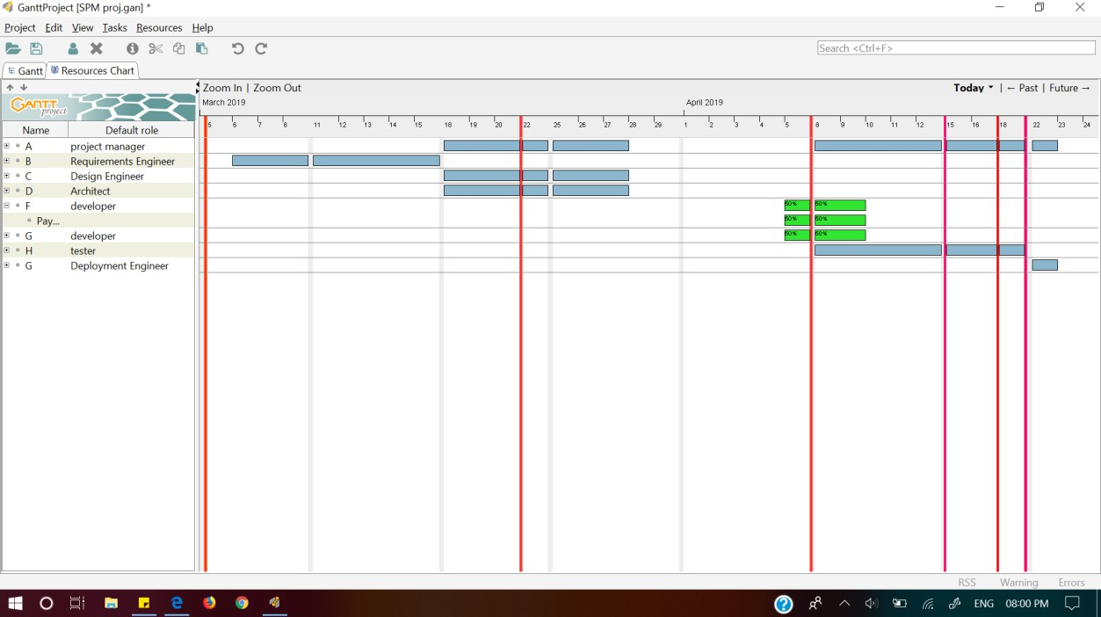RESULTS AND SNAPSHOTS: RESOURCE CHART:

PERT CHART:

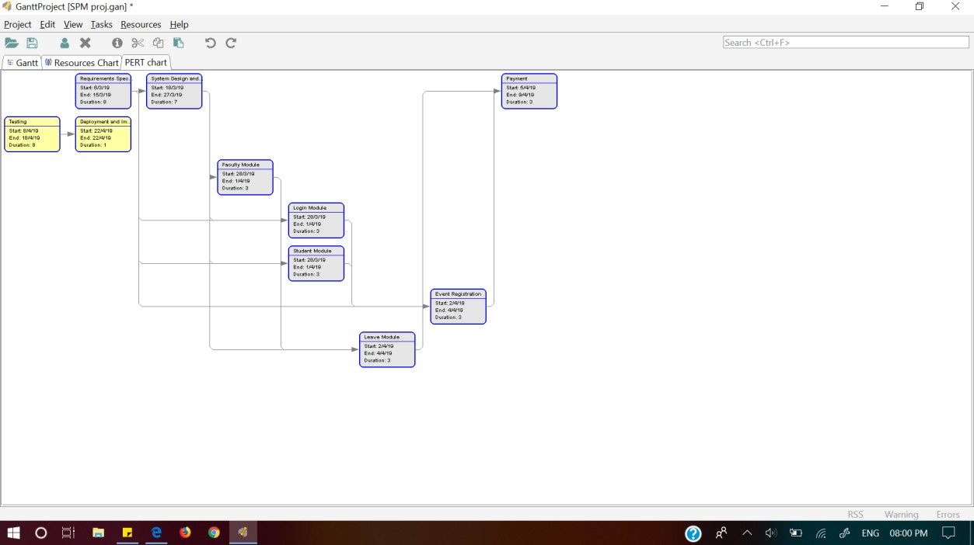

GANTT CHART:

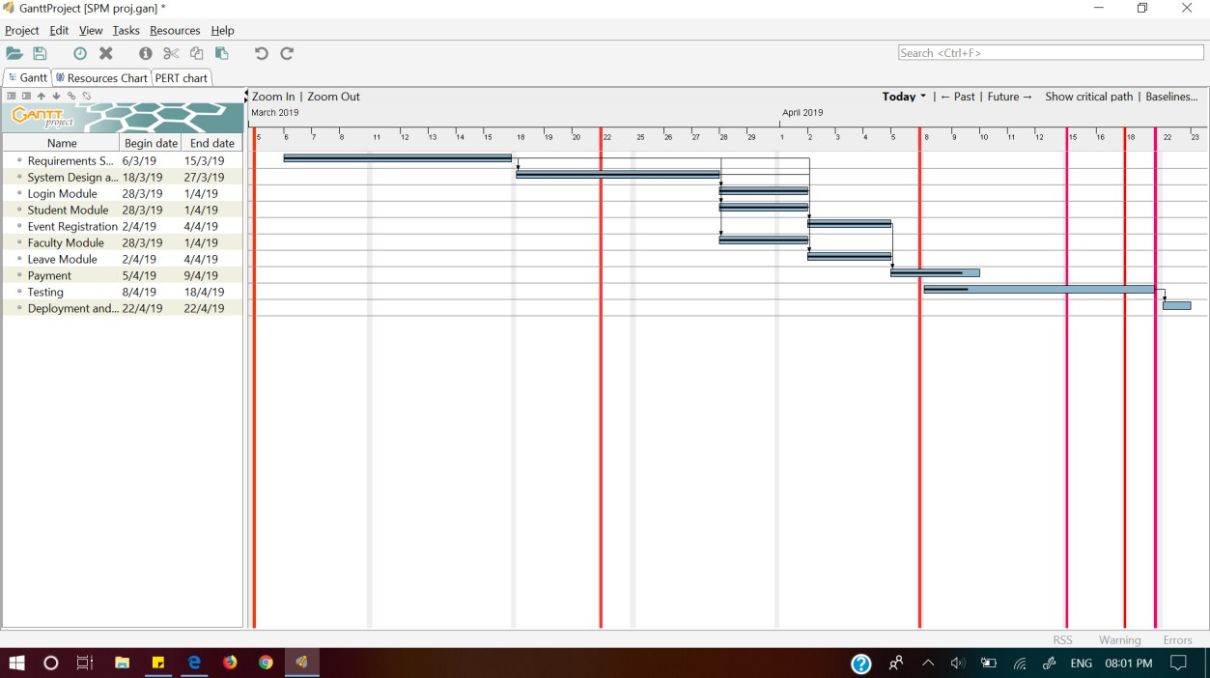

MODULES:

