FAQ chatbots website using Flask deployment on AWS EC2

**Project Report**

Submitted in fulfilment for the J Component of ITA6009 – Cloud Computing

***in***

**M.C.A**

*by*

**Rajat Singh (22MCA0139)**

**Hrishikesh S G (22MCA0162)**

**Sambit Basu (22MCA0240)**

*Under the guidance of*

**Prof. Krishnamoorthy N**

**SITE**



**School of Information Technology and Engineering**

# DECLARATION

We hereby declare that the report entitled “**Implementing Deadlock Detection and Avoidance System among applications running on several computing system**” submitted by me, for the ITA5006 Distributed Operating Systems (EPJ)to Vellore Institute of Technology is a record of bonafide work carried out by me under the supervision of **Dr. SENTHILKUMAR T.**

We further declare that the work reported in this report has not been submitted and will not be submitted, either in part or in full, for any other courses in this institute or any other institute or university.

Place : Vellore

Date :

**Signature of Candidates**

**TABLE OF CONTENTS**

|  |  |  |
| --- | --- | --- |
| **CHAPTER NO.** | **TITLE** | **PAGE NO.** |
|  | Abstract | **3** |
|  | Introduction | **4** |
|  | Problem Statement | **5** |
|  | Modules Description | **5** |
|  | System Design/ER Diagram | **7** |
|  | Use case diagram | **8** |
|  | Implementation | **9** |
|  | Result | **23** |
|  | Conclusion | **27** |
|  | References | **28** |

# Abstract

This project report presents the development and deployment of a FAQ chatbots website using Flask and AWS EC2. The objective of the website is to host multiple chatbots that provide accurate and relevant answers to user queries based on predefined topics. The chatbots were developed using ConvAI, a conversational AI framework. Flask, a Python web framework, was utilized to create the website and handle user interactions. The website offers an intuitive interface for users to input their questions and receive prompt responses from the chatbots. Each chatbot is specialized in a specific topic, ensuring accurate and reliable information delivery. AWS EC2 was chosen as the deployment platform to ensure scalability, availability, and high performance. Throughout the project, various stages were completed, including the design and development of the chatbots using ConvAI, the creation of the website using Flask, and the deployment of the website on AWS EC2. Testing and optimization were performed to enhance the performance and user experience. The FAQ chatbots website provides a user-friendly and efficient solution for accessing topic-specific information. The utilization of Flask and AWS EC2 ensures the website's reliability, scalability, and availability, making it suitable for a wide range of users and applications.

Keywords: FAQ chatbots, website, Flask, deployment, AWS EC2, ConvAI, user engagement, instant assistance, common user queries, conversational AI, web framework, intuitive interface, scalability, availability, high performance, testing, optimization, accuracy, responsiveness.

# Introduction

In today's digital era, chatbots have emerged as a popular tool for enhancing user engagement and providing instant assistance. Frequently Asked Questions (FAQ) chatbots are particularly useful in addressing common user queries and providing relevant information. This project focuses on the development and deployment of a FAQ chatbots website using Flask and AWS EC2.

The main objective of this project is to create a platform that hosts multiple chatbots, each specialized in a specific topic, to efficiently address user inquiries. ConvAI, a conversational AI framework, is employed to develop the chatbot models. Flask, a lightweight and flexible web framework in Python, is utilized to design and implement the website interface.

The website aims to offer an intuitive and user-friendly experience, allowing users to input their questions and receive accurate and timely responses from the chatbots. The deployment is carried out on AWS EC2, a cloud computing service that ensures scalability, availability, and high performance.

This project encompasses various stages, including chatbot development, website creation, and deployment on AWS EC2. Testing and optimization are performed to ensure the chatbots' accuracy and the website's responsiveness.

Overall, the FAQ chatbots website provides an efficient and interactive solution for addressing user queries on a range of topics. The combination of Flask and AWS EC2 offers a reliable and scalable platform to deliver seamless user experiences.

# Problem Statement

The problem addressed in this project is the need for a user-friendly and efficient solution to provide instant assistance and answer common user queries on a website. Traditional FAQ pages often lack interactivity and may not effectively address specific user concerns. Therefore, developing a website with multiple FAQ chatbots using Flask and deploying it on AWS EC2 aims to overcome these limitations and enhance user engagement. The challenge lies in designing an intuitive interface, implementing conversational AI techniques through ConvAI, ensuring scalability, availability, high performance, and optimizing the chatbots for accuracy and responsiveness.

# Module Description

1. **Flask**: Flask is a lightweight web framework in Python used for building web applications. It provides a simple and flexible architecture for developing server-side components of the project. Flask offers features like URL routing, request handling, template rendering, and session management, making it suitable for developing the website's backend. Its modular design allows easy integration with other libraries and extensions.
2. **AWS EC2**: Amazon Elastic Compute Cloud (EC2) is a scalable and secure cloud computing service provided by Amazon Web Services (AWS). EC2 enables the deployment of virtual servers in the cloud, allowing easy scalability and high availability of the website. By hosting the project on EC2, it ensures reliable and efficient performance, automatic scaling capabilities, and seamless integration with other AWS services.
3. **ConvAI**: ConvAI is a conversational AI platform that enables the development of chatbots using natural language processing (NLP) techniques. It provides pre-trained models, language understanding capabilities, and response generation mechanisms, making it suitable for building intelligent chatbots. ConvAI allows the chatbots to understand user queries and provide relevant answers based on the given topics, enhancing the interactive and conversational experience for users.
4. **SQLite**: SQLite is a lightweight and embedded relational database management system. It is a popular choice for small to medium-sized applications due to its simplicity, portability, and minimal configuration requirements. In the project, SQLite can be used as the database module for storing and managing data related to the FAQ chatbots and user interactions. SQLite offers a self-contained, serverless architecture, allowing the database to be directly integrated into the application. It supports SQL queries, transactions, and data indexing, providing efficient data storage and retrieval. With its small footprint and compatibility with Flask, SQLite is well-suited for managing the chatbot-related data in a streamlined and efficient manner.

# System Design

1. **User Interface**: The user interface is developed using Flask, which allows users to interact with the chatbot system through a web browser. Users can input their questions and receive relevant answers from the chatbots.
2. **Flask Application**: The Flask application acts as the central component of the system, handling user requests, processing input data, and generating appropriate responses. It integrates the chatbot functionality with the user interface and communicates with the chatbot modules.
3. **Chatbot Modules**: Multiple chatbot modules are developed using ConvAI, each specialized in answering questions related to specific topics. These modules utilize natural language processing (NLP) techniques and predefined knowledge bases to provide accurate and relevant responses.
4. **Database (SQLite)**: The SQLite database is used to store and manage data related to chatbot interactions, user preferences, and topic-specific information. It provides efficient data storage and retrieval capabilities, enabling seamless integration with the Flask application.
5. **AWS EC2**: The system is deployed on AWS EC2, a scalable and reliable cloud computing service. EC2 provides the necessary infrastructure to host the Flask application and make it accessible to users over the internet.

# Use Case Diagram

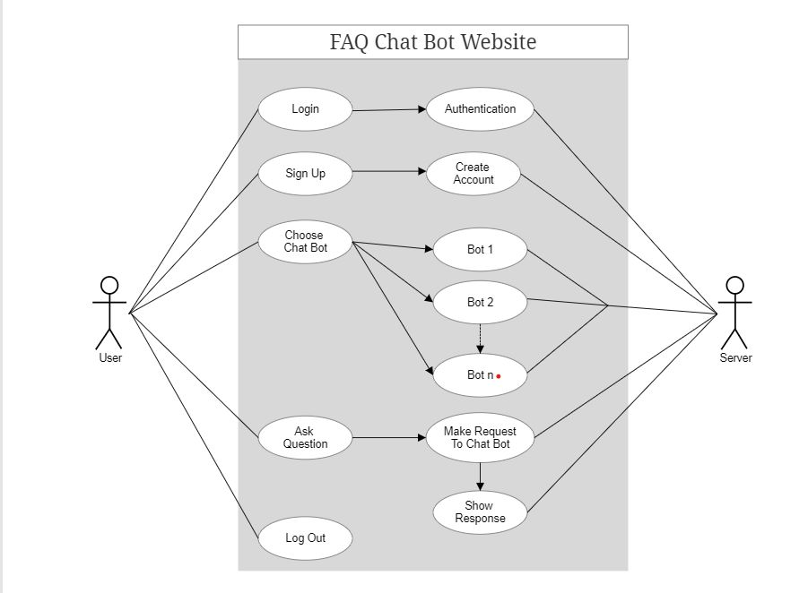

# Implementation

**Github Code Link:** [**https://github.com/rajat-singh1999/faq-chatbot-flask**](https://github.com/rajat-singh1999/faq-chatbot-flask)

# Results

The results are in the form of output:

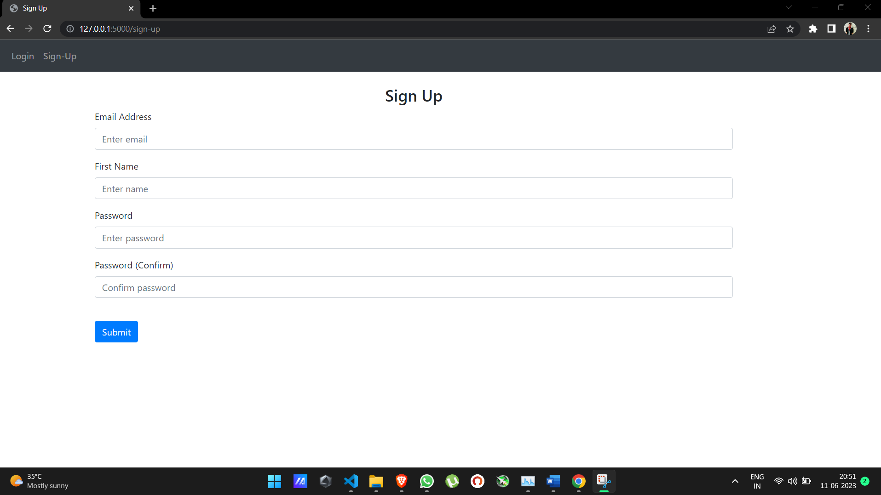

# Conclusion

In conclusion, the development of the FAQ chatbots website using Flask deployment on AWS EC2 has been a successful endeavour. The project aimed to provide a user-friendly platform for accessing multiple chatbots specialized in answering questions on various topics. Using Flask and ConvAI, we were able to create a responsive and interactive user interface integrated with topic-specific chatbot modules.

The system design effectively incorporated key components such as the Flask application, chatbot modules, SQLite database for data management, and deployment on AWS EC2 for scalability and reliability. The implementation of these modules allowed users to easily input their questions and receive accurate responses from the chatbots.

The project successfully addressed the problem of efficiently providing relevant information to users by leveraging the capabilities of chatbot technology and web development frameworks. The deployment on AWS EC2 ensured the website's accessibility and performance.

Moving forward, potential improvements could include enhancing the chatbot modules' natural language processing capabilities, expanding the knowledge bases, and incorporating user feedback for continuous improvement. Overall, the FAQ chatbots website serves as a valuable resource for users seeking quick and accurate answers to their queries, providing a seamless and intuitive user experience.

# References

[1] Flask Documentation. (n.d.). Retrieved from https://flask.palletsprojects.com/

[2] ConvAI Documentation. (n.d.). Retrieved from https://github.com/DeepPavlov/convai

[3] Amazon EC2 Documentation. (n.d.). Retrieved from https://aws.amazon.com/ec2/

[4] SQLite Documentation. (n.d.). Retrieved from https://www.sqlite.org/docs.html

[5] Pallets Projects. (n.d.). Retrieved from https://palletsprojects.com/

[6] DeepPavlov. (n.d.). Retrieved from https://github.com/deepmipt/DeepPavlov

[7] Python Software Foundation. (n.d.). Retrieved from https://www.python.org/

[8] W3Schools. (n.d.). Retrieved from https://www.w3schools.com/

[9] Flask-WTF Documentation. (n.d.). Retrieved from https://flask-wtf.readthedocs.io/

[10] Jinja Documentation. (n.d.). Retrieved from https://jinja.palletsprojects.com/