SalesForge Testing - Bug Report
Prepared by: Konderu Deepika
Project: SalesForge CRM

Bug 1 – Webhooks Module
Validation message: 'Select at least one event' when no event is selected.
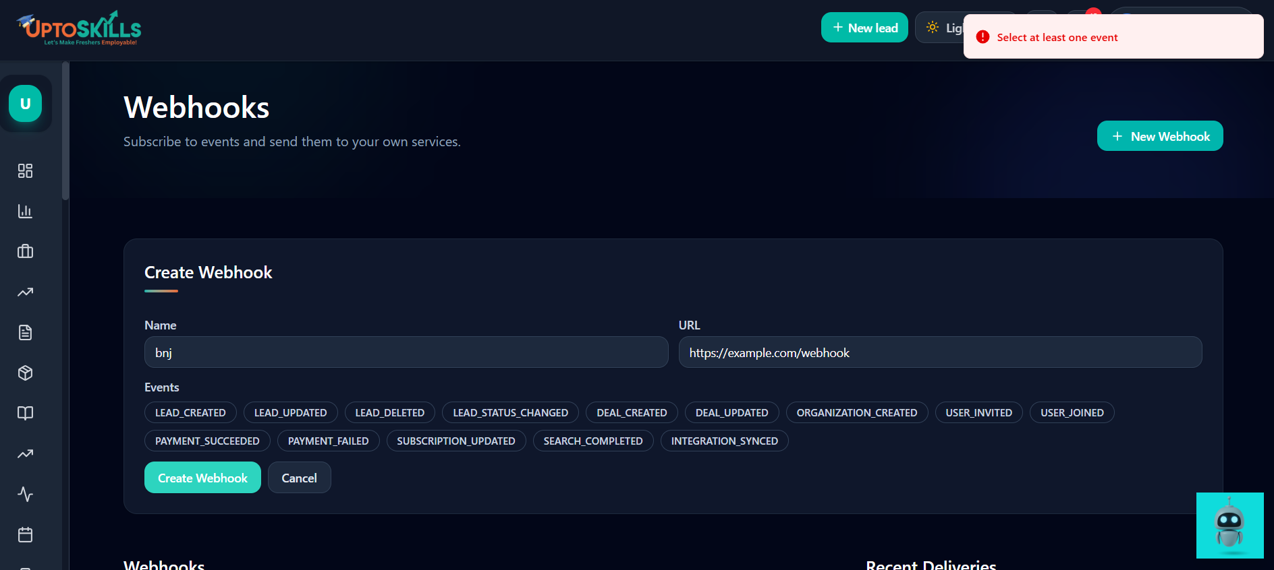

Bug 2 – Calls Module
Issue: Route not found: POST /api/calls
Expected: Call should be logged successfully.
Actual: API route not found.
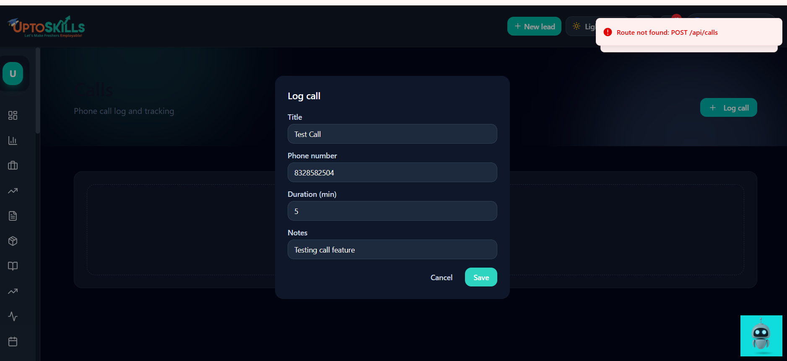

Bug 3 – Contracts Module
Issue: name is required.
Expected: Contract should be created successfully.
Actual: Error 'name is required' even though Title is filled.
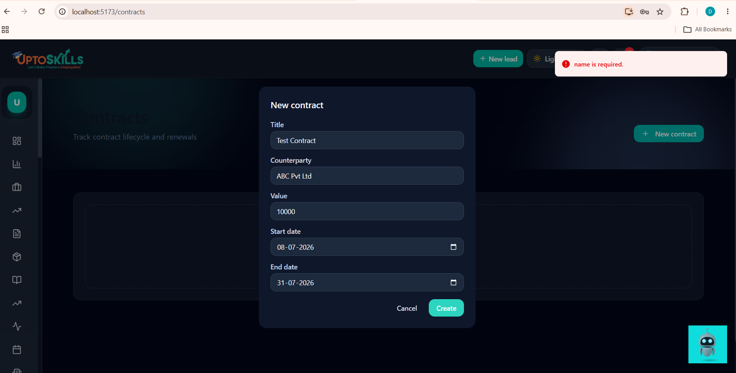

Bug 4 – Documents Module
Documents page screenshot captured for testing.
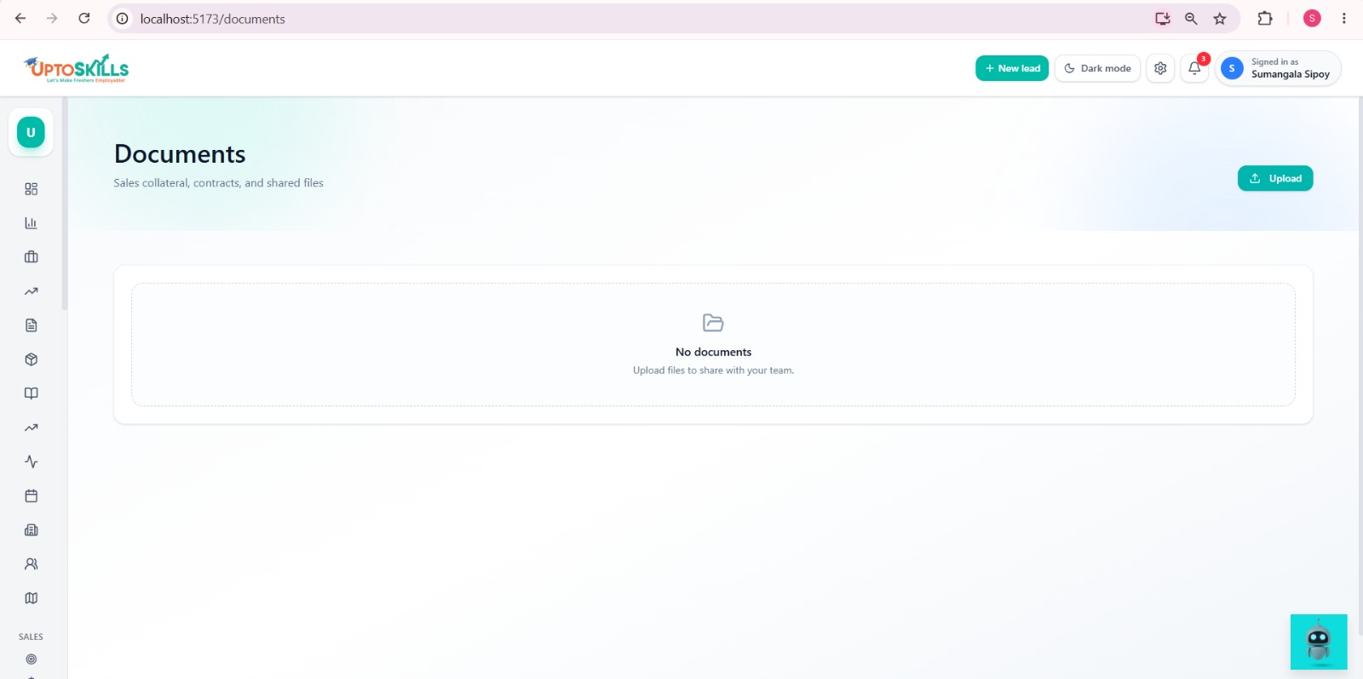

Bug 5 – Campaigns Module
Issue: Internal server error while creating a campaign.
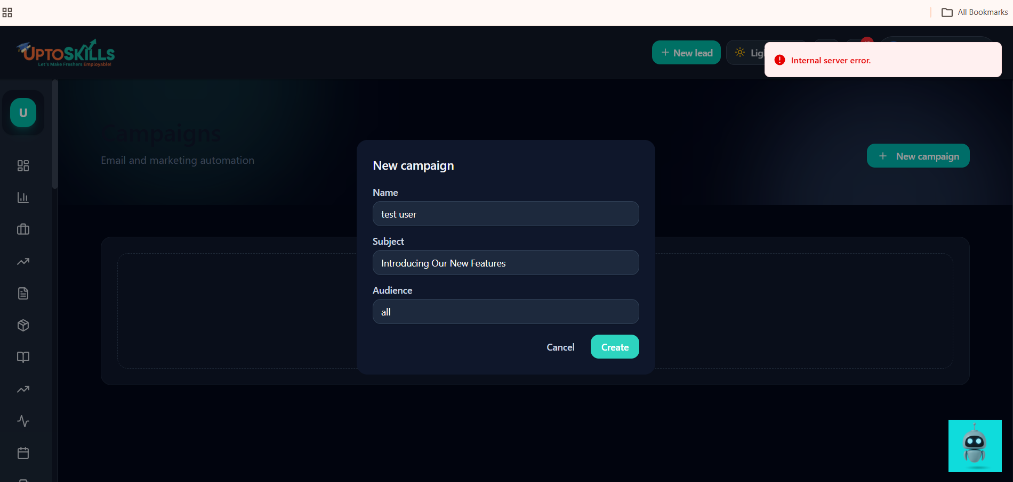

Bug 6 – Sales Quotas Module
Issue: Internal server error while creating a quota.
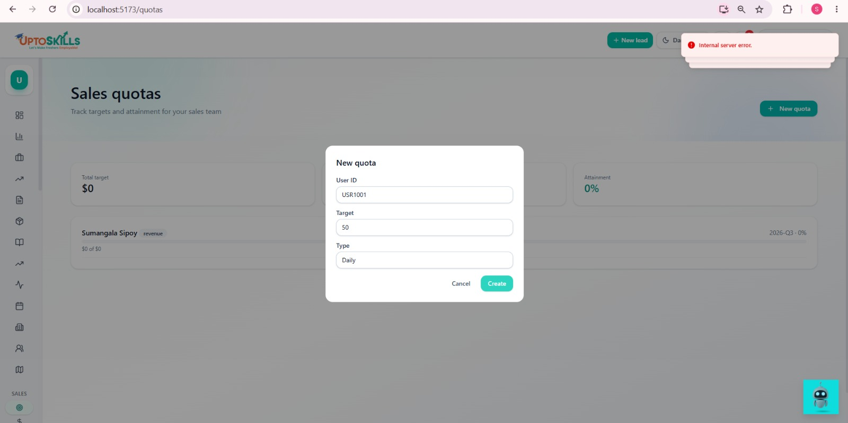

Contacts Module
Issue: Internal server error while creating a contact.
