**Strategic Sustainability & Risk Management**

**SME Enterprises, Registered Clubs, NFP Organizations**

*File: SS&RM.June.2017.doc*

Ian Kirkwood PhD, MBA, DipMechEng, MAICD, JP

Ian Kirkwood is a business academic specialising in strategic sustainability and corporate responsibility. His career includes more than 30 years in engineering, business development and executive roles plus the last 10 years in training and academia. He interfaces with a range of local and international businesses. [*www.iankirkwood.org*](http://www.iankirkwood.org)

[*https://www.linkedin.com/in/ianrobertkirkwood*](https://www.linkedin.com/in/ianrobertkirkwood)

**Keywords**

SME business analysis, business-sustainability, business transformation, strategic sustainability, SME training, risk management, sustainable business, Business analysis and transformation planning

# 

**Definitions**

The words ‘business, company, or enterprise’ are all interchangeable and can include Not for Profit (NFP) organisations or registered clubs with a formal charter

Small Medium Enterprises (SME) are generally defined as organisations larger than Micro businesses and smaller than Large or International businesses. Size by turnover or staff numbers is fluid and not easy to define

Contents

[Keywords 1](#_Toc484352722)

[Definitions 1](#_Toc484352723)

[Overview 2](#_Toc484352724)

[1. Introduction 2](#_Toc484352725)

[2. Parker Hannifin’s response to the ‘appetite of society’ 3](#_Toc484352727)

[3. Single bottom line (SBL) versus multiple bottom line (MBL) 3](#_Toc484352728)

[4. Six Phases of Sustainability 4](#_Toc484352729)

[5. The Solution – a Five Step Plan to achieve Provable Sustainability 5](#_Toc484352733)

[6. Conclusion 7](#_Toc484352740)

[7. References 7](#_Toc484352741)

**Overview**

Directors, and executives bear the responsibility to ensure their companies are ‘provably’ sustainable in all areas, not just financially, for the benefit of all stakeholders and for the company’s survival. The world of business governance is changing rapidly and out-dated business metrics may not be valid to ensure overall sustainability going forward. Business concepts and methods need to be updated to best suit 21st century society and to ‘prove’ evidentially that the business is sustainable. Simply hoping the business is ‘legally’ sustainable and will survive is flawed and inadequate today.

This paper introduces two terms: *Strategic Sustainability & Risk Management* ***(SS&RM)***, and *Business Analysis and Transformation* *planning* ***(BAT)***. These two terms relate to a rogressive and essential shift in business education for SME sized enterprises. It is no longer sufficient to focus simplistically on the top and bottom lines of financial reports. SME owners, directors and executives need to recognise the risks associated with their planning procedures and the many undetected issues hindering and suppressing realistic sustainable analysis and development.

The aim of this paper is to validate the need for a paradigm shift in SME business management, and to offer the means to move ahead into full sustainability. Higher levels of risk management and strategic thinking are essential when it comes to planning and managing sustainable business operations into the future. With basic training and a ***BAT*** plan implemented, any SME sized entity can become *provably* sustainable in all key areas.

**1. Introduction**

This paper identifies how businesses can face the challenges of local, national, and offshore environments, and how they can become more responsible, more accountable and provably sustainable, going forward. This is examined through a case study of Parker Hannifin Australia, the local subsidiary of an American fortune 500 industrial company. The scope allows for a broader discussion assigning greater responsibility to business education and training in order to devise and develop more feasible and pertinent business solutions to help SME businesses. It is therefore important to highlight how executives and directors of SME’s can improve their responsiveness to the rapidly changing needs of modern business. Current research shows that changes are both necessary and essential to solve business problems to guarantee businesses have a sustainable future. The vast majority of business people in Australia have been educated with methods and practices that were relevant for the past but not necessarily relevant for the future. The most recent survey conducted by the Australian Institute for Company Directors (AICD) found the number one issue that keeps Directors ‘awake at night’ is whether their business is genuinely sustainable and will it survive (AICD, 2017)!

**Background Information**

This case study is framed around two issues: Parker Hannifin (as an example), and current research in strategic sustainability and risk management for SME sized enterprises.

Parker Hannifin (Aust.) Pty Ltd is an Australian industrial company which commenced its life when an American company, Parker Hannifin Corporation, acquired an old Australian manufacturing company, RE Jefferies Pty. Ltd. In the early days, it had a succession of general managers, and the fourth one went on to manage this business quite successfully for over 20 years. But in his first year of leadership, he uncovered numerous irregularities, particularly regarding inventory control, asset valuations, and errors in the reporting of gross margins. He determined that the company had not been governed appropriately for a range of reasons, and that errors in asset valuations had accumulated unchecked. The focus of the business to that point in time had mostly been on sales growth with insufficient attention being paid to other areas. Needless to say with this discovery, the company traded that particular year with a substantial loss, representing more than 30% of the then gross revenues. This loss wiped out all the profits the company had made in the previous 4 or 5 years. Regardless of the company or the situation, a loss of this proportion is significant.



The general manager was subsequently summoned to meet with corporate executives at the company’s headquarters in Cleveland Ohio where discussions were centered on the pending cessation of the Australian operation. However, the new general manager pleaded a strong case for a new focus on risk management and financial sustainability, and was allowed to continue trading provided many new governance procedures were instigated. To help in this regard, the executives in Cleveland sent two management consultants to Australia for a month of intensive training with the local management team, the writer being one of the local managers. From this training, improved management methods were created and from the following year, the Australian operations were profitable with the implementation of higher standards of governance, visibility and accountability.

The company has since flourished and developed into the industry giant it is today. Was the transformation easy? No, it was not but it was extremely exciting and highly challenging with many people working extraordinarily long hours just to get all the new plans implemented. It was complex and difficult with many enhancements made throughout the whole organization plus numerous changes made to management methods and subsequent financial reporting. From the fortuitous decision made back in Cleveland Ohio, the company was assured a positive outlook for the future. Then by buying low cost land on the outskirts of Sydney at Castle Hill where there was abundant local labour, and from selling the original high value site in the inner Sydney suburb of Artarmon, the move to purpose-designed, brand new premises was internally funded with net positive cash flow. With new premises came new hope, a new vision, and renewed passion for excellence. From that year onward, with new governance procedures in place with very tight and transparent controls on all key areas including revenues, costs, social conditions, and (some) environmental issues, the company was well set up for the future.

**2. Parker Hannifin’s response to the ‘appetite of society’**

Modern societies are fuelled by mass consumerism which drives most industries which creates work for the masses who in turn are also consumers. Employment gives society its identity through the ongoing generation of wealth that is converted into social infrastructure which subsequently forms the basis of modern life. In a simplistic manner, one could say that consumer demand drives all forms of supply, and the act of supplying goods and services creates employment which then contributes to and builds the overall economy. Hence modern cities like Logan and Brisbane are based on the natural assumption that people will have gainful local employment and the logical extension that employment will be sufficient, satisfactory, sustaining, and sustainable. This logic-string brings us to the point of this paper; sustainability of industries and the wide range of SME enterprises that operate within them require current, well researched knowledge and information embedded into management training. Outdated knowledge will not achieve the goals and expectations of the twenty first century when business decisions are still being based on outdated knowledge.

In the case of Parker Hannifin, if the same situation occurred today, a more sophisticated approach would be warranted to accommodate all the key elements of a multiple bottom line (MBL) approach: financial, socio-cultural, environmental, ethically & legally sound governance – not just a financial turnaround.

Managers and executives often miss the point concerning long-term sustainability when planning their operations. Discussions relating to the term ‘sustainability’ often get diverted to other more comfortable topics that managers prefer to discuss as the term ‘sustainability’ is often misconstrued as simply being an ecological issue. In fact, management meetings within Parker Hannifin had sales quotas and gross margin results as first items on almost every agenda, before moving on to solve staffing and other problems. As a result of this original issue with Parker Hannifin and several similar more recent experiences, whilst different in detail but similar in the overarching issues concerned, it is considered the term sustainability has a skewed interpretation for business people and that the term s*trategic sustainability and risk* *management* (SS&RM) (Kirkwood, 2012) adds greater clarity to the situation.

These days, the term ‘sustainability’ mostly sits in the green-space, the carbon trading space, the town-planning space, or the climate change arena, and unfortunately has either negative meanings or misunderstood connotations for many business people.

This paper proposes a way forward for modern business education and training to bring the SS&RM concept to the fore for all business people in a way that everyone can clearly understand what sustainability is about within a modern business context. It matters not whether a company is a manufacturer such as Parker Hannifin, or any company in any industry, the SS&RM pattern could well be applied partially or fully.

# 3. Single Vs Multiple bottom line

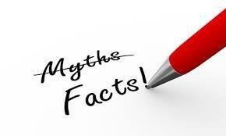

A single bottom line approach in business (profit is king) is now 100% dead. If any business is still operating with a single bottom line focus, it is probably doomed. Modern business sustainability now goes beyond even the triple bottom line concept that was introduced around 20 years ago (Elkington 1998) to include two more areas: ethics and governance.

Businesses need to make a ***profit*** simply to stay in business. However, the profit a company makes is really the bottom-line end-result from doing many other things properly first including winning, keeping and growing a loyal customer base. Hence if making a profit is the primary goal then most likely the business is unsustainable. Economic performance includes prudent financial planning and the use of appropriate risk management systems to assure the continued ability to operate profitably. A sustainable business is generally transparent in its operations with respect to the stakeholders it serves: its employees, its customers, and the communities in which it operates. All externalities, where possible, need to be absorbed or eliminated.

Then, businesses need to consider ***people*** highly in their planning processes, as people crave opportunities for full participation as stakeholders in all activities and decision-making processes. Social performance includes a philosophy that values human and cultural-capitals, and seeks to tap widespread resource productivity improvements coupled with effective design to allow more people to enjoy satisfying employment and financial wellbeing measured in terms of security and social contact. People need to be viewed much more than simple consumers or units of energy to be taken advantage of for commercial gain. And people also need to be the initiators of change which requires certain intelligence and sensitivity as a result of relevant and meaningful education.

The ***planet*** needs to be considered from a stewardship perspective rather than as a source of cheap resources, and the ability to produce goods and services with a net zero ecological impact. Environmental performance includes using processes and systems that are non-polluting, conserving of energy and natural resources (especially those that are non-renewable), economically efficient, safe and healthful for everyone. Sustainable manufacturers need to implement pollution prevention practices, use recycled and non-toxic input materials wherever possible, and produce safe and recyclable products in recyclable packaging.

Finally, the concepts of ***ethics*** and ***governance*** need to be addressed as this is where many SME businesses fail by operating unethically or operating with poor oversight and inadequate governance- particularly for financial and legal compliance. This area can be addressed by staying up to date with regulatory compliance matters.

In Parker Hannifin’s case in Australia, the focus of the business in its formative years was two-fold: (1) meeting corporate requirements for returns on sales and assets, then (2) the progressive replacement of the original RE Jefferies products with imported Parker products.

# 

# 4. Six Phases of Sustainability

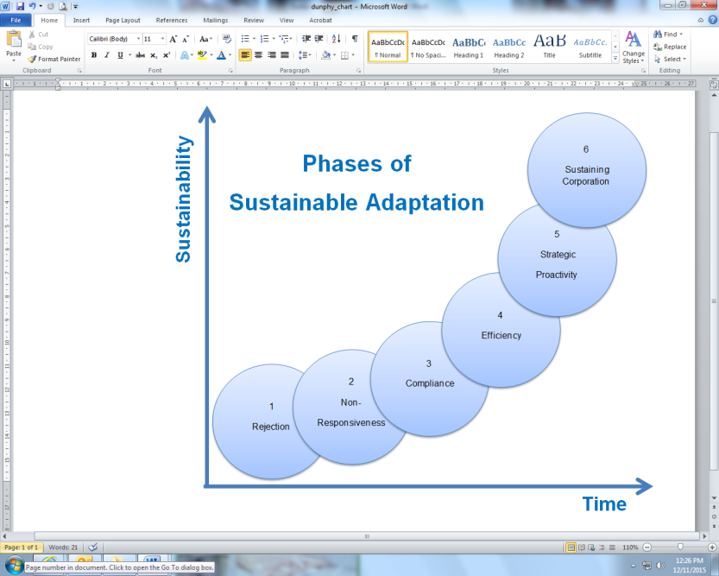An excellent book on business health (Dunphy et al 2000) identified six phases of sustainability that businesses operate within, either partially or wholly. These six phases are shown here on this page and by using these as a guide, the identification and understanding of sustainability is simple.

It is easy to identify whether a business is unsustainable (Phases 1 & 2), probably sustainable (Phases 3 & 4), and definitely sustainable (Phases 5 & 6). Whether there are better variants on this theme is not important as this model is more than adequate to be used as a functional metric today. The most logical and ideal phase for any business to aspire to is Phase 5 (strategic sustainability) however, more and more businesses are now aspiring to Phase 6 (transformative-ideological sustainability).

**Both diagrams** adapted from: Dunphy et al. (2007)

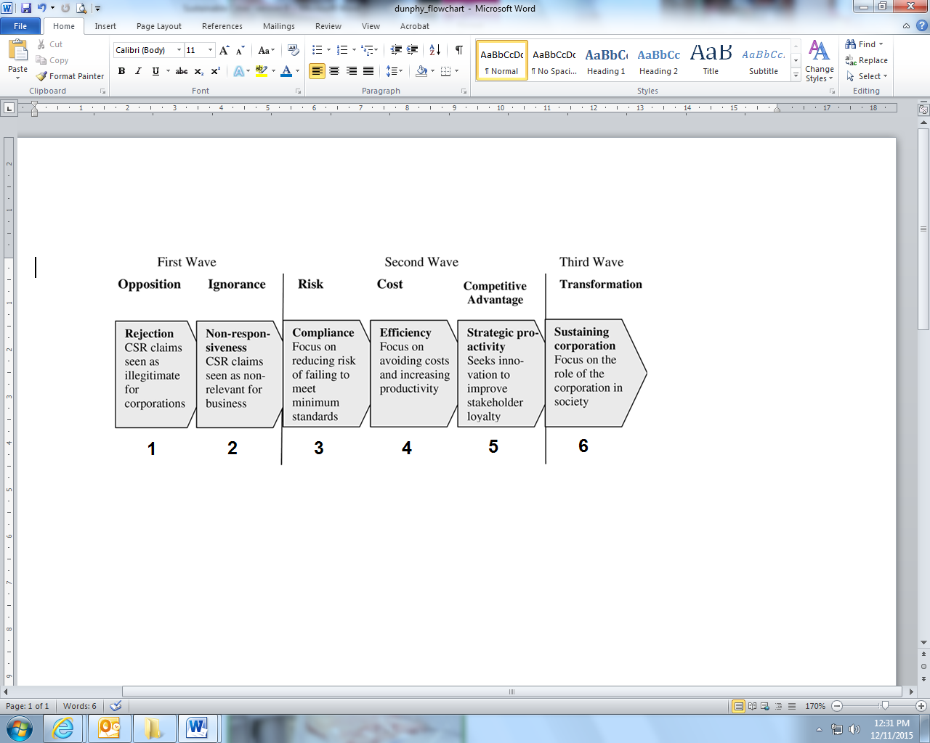

In the case of Parker Hannifin during the time-period being discussed, six key areas of the business would be fairly represented by the following tabulation (Figure 3). It should also be borne in mind that this time period pre-dated most notions relating to multiple bottom lines, but certainly did not pre-date corporate governance or enterprise risk management (ERM) systems.

**The six phases of sustainability CSR =** Corporate Social Responsibility

**Figure 2: The six phases of sustainability with descriptions**

|  |  |  |  |  |  |  |  |
| --- | --- | --- | --- | --- | --- | --- | --- |
|  | ISSUE | Phase 1 | Phase 2 | Phase 3 | Phase 4 | Phase 5 | Phase 6 |
| 1 | Revenues |  |  |  | C:\Users\jikd01\AppData\Local\Microsoft\Windows\Temporary Internet Files\Content.IE5\BH5VWL0F\Check_mark_23x20_02.svg[1].png1 |  |  |
| 2 | Gross Margins |  |  | C:\Users\jikd01\AppData\Local\Microsoft\Windows\Temporary Internet Files\Content.IE5\BH5VWL0F\Check_mark_23x20_02.svg[1].png2 |  |  |  |
| 3 | Inventory control | C:\Users\jikd01\AppData\Local\Microsoft\Windows\Temporary Internet Files\Content.IE5\BH5VWL0F\Check_mark_23x20_02.svg[1].png3 |  |  |  |  |  |
| 4 | Asset management |  | C:\Users\jikd01\AppData\Local\Microsoft\Windows\Temporary Internet Files\Content.IE5\BH5VWL0F\Check_mark_23x20_02.svg[1].png4 |  |  |  |  |
| 5 | Ecological issues | C:\Users\jikd01\AppData\Local\Microsoft\Windows\Temporary Internet Files\Content.IE5\BH5VWL0F\Check_mark_23x20_02.svg[1].png5 |  |  |  |  |  |
| 6 | Socio-cultural issues |  |  | C:\Users\jikd01\AppData\Local\Microsoft\Windows\Temporary Internet Files\Content.IE5\BH5VWL0F\Check_mark_23x20_02.svg[1].png6 |  |  |  |

### 

**Figure 3: Parker (Aust.) Pty. Ltd. circa 1970-1980**

**4.1 Parker Hannifin’s effort - interpretation of Figure 3:**

**Note 1:** Revenues at phase 4: growing but needed constant salesmanship as revenues came from a mixture of end user accounts, small and medium sized Original Equipment Manufacturers (OEMs), and several scattered resellers. From understanding this issue, a plan was devised to remodel the business into a much stronger focus on strategically located industry based distributors, a stronger focus on OEMs and a selective focus on large end user accounts.

**Note 2:** Gross margins at phase 3: usually meeting corporate requirements but often (as proved) based on inaccurate costs which reflected higher than actual gross margins. This required a change in product costings, both locally manufactured and imported.

**Note 3:** Inventory control at phase 1: poorly maintained based on old fashioned non-computerized systems using inaccurate input data. Scrap metal and components not costed into products. Excess stock of slow moving items. Out of date or non-saleable stock nor properly written down or written off.

**Note 4:** Asset management at phase 2: old machines being used ineffectively. Poor use of space due to over-crowded factory area. No proper accounting for age and stage of plant and equipment.

**Note 5:** Ecological issues at phase 1: zero ecological thinking, particularly regarding machine oil disposal, hydraulic oil use and disposal, using fluorescent dye in water to test for leaks in hydraulic tanks, zero recycling, no focus on water or energy consumption.

**Note 6:** Socio-cultural issues at phase 3: people were considered important if they were productive but ‘released’ if considered unproductive or unimportant to the business.

**Note 7:** None of the above six notes can be supported evidentially but they accurately represent the writer’s recollection of events.

### 

### 4.2 The six phases

***Phase 1*** is classified as rejection (*don’t know & don’t care*). Basically, the environment is exploitable, pollution is unavoidable, people are basic units of energy, safety is done to comply with laws, training is considered an expense, and the outside community is not of any concern. Ethics is variable, and governance is a foreign language. ***Phase 2*** is classified as non-responsiveness(*do know but still don’t care*) and basically only the issues that are really important and unavoidable are addressed. ***Phase 3*** is classified as compliance (*we will do it if we must*) where all laws and rules are complied with but no more. Decisions are often made ‘on the fly’ with little cognizance of strategy. ***Phase 4*** is known as efficiency where ISO standards such as ISO 9000 could be used to gain competitive advantage but community issues beyond the business are neither acknowledged nor addressed. ***Phase 5*** is called strategic proactive sustainability whereby businesses see ‘sustainability’ as being an important issue and one that, if embedded into their corporate strategic DNA, could make the business look better, be perceived better by all stakeholders, and produce more profits and better outcomes. ***Phase 6*** being an ideological commitment to total sustainability is possibly only achievable by businesses that do not follow the ‘Milton-Friedman’ model of business but follow a more holistic, better balanced view of the role businesses play in society. Note: The term ‘Milton Friedman model’ simply means that the primary and often singular focus of business is to increase the wealth of the shareholders to the exclusion of everything else, other than remaining ‘legal’.

**4.3 Risk management**

When trying to analyze which phase a business is currently at, risks become apparent and all risks, either potential good or potentially bad need to be analyzed. Every business has a desire to increase profits and improve cash flows but by avoiding risks, cash flow can be destroyed. The question is whether risk management can be undertaken while implementing an SS&RM program and the reality is that risk management is inherently included in an SS&RM plan.

For instance, a customer boycott of a company’s products arising from perceived social or environmental risks could have a far worst impact on a company’s bottom line than that of a natural disaster. Or the negative effects on cash-flows from staff ‘working to rules’ where their concerns are not being addressed or are being denied by the management. In fact there are many issues that need to be considered with seven of them being identified below. According to Blackburn (2008), and Aon (2007), an SS&RM plan must be completely compatible with corporate objectives that include these seven points: reputation, effective products, productivity, trust, supply chain efficiencies, capital costs, and legal liabilities. This does not exclude other issues but these are the key issues that must be addressed. Other issues could include points that are relevant to a particular industry or type of enterprise such as a registered club or an NFP.

An crucial point that needs to be taken into account is that a company may well be operating at different phases simultaneously, depending on the area under investigation. For instance, the business may well be operating highly profitably but be operating poorly in, say, manufacturing processes or supply chain costs etc.

**5. The Solution – a Five Step Plan to achieve *Provable Sustainability***

These days’ directors and executives need a more sophisticated approach to risk management and the following five points have been developed over the last seven years from supervising hundreds of MBA and EMBA students writing sustainability assignments. Most of these students were strongly focused on gaining advanced knowledge for their current and/or future careers.

The Strategic Sustainability and Risk Management (SS&RM) approach was found to be the simplest and most realistic way to approach sustainability for business students and managers alike. By adopting the basic steps in the SS&RM plan, extraordinary results can be (and have been) achieved in a time frame that can be styled to suit any business. Implementation of a sustainability program starts with an understanding of a company’s basic principles and values.

***This is the Business Analysis & Transformation (BAT) Plan***

**Step 1: Current State: what is your business today (Point A)**

The current state can be considered as Point A. A sound starting point is to analyze the current state of the business by using Dunphy’s Six Phases model (Dunphy 2000). It is recommended that a fully detailed analysis of the ‘current state’ of the entire enterprise including all upstream and downstream touch-points be undertaken as knowledge of the ‘current state’ is essential in determining what needs to change or what could be improved. From actual cases conducted, it has been found that it is easiest to start with one section of the company at a time, for instance, Human Resources (HR), as a high percentage of businesses tend to be more tactical than strategic in this aspect. To do this it is recommended that internationally recognized performance indicators be used, such as the Global Reporting Initiative (GRI) indicators. All areas and all issues within a company when analysed may vary from poor through average to good when measured using GRI indicators and Dunphy’s model.

## 

## Step 2: Future State: what could your business become? (Point B)

The next step is to consider the ideal future for the enterprise and this is Point B. The best way to analyse or visualize a ‘desired end-point’ for any business is to use Dunphy’s model (see Figures 1 & 2). The absolute ideologically best goal for any enterprise is Phase 6 however Phase 5, ‘Strategic Sustainability’, may well be the best that any business could achieve. It should be noted that Phases 1, 2 & 3 should not be considered as valid end-points as they could allow or cause a business to lose value, lose competitiveness, or even drive the business into liquidation. Using GRI indicators, the desired end point for each and every function, aspect, department etcetera can be determined so that gaps between Point A and Point B can be measured and analyzed. Multiple gaps can be found when analyzing a business holistically. For instance a gap in human resource training outcomes needs to be dealt with differently to the way a gap in inventory control management would be handled. Then, fixing a gap in sales revenues from a specific market channel needs different treatment to, for instance, fixing an increase in warranty claims from failure of electronic components. Hence different aspects of the business all need to be identified and handled in their own way.

When Point B is known for all the areas where Point A has been analyzed, the gaps between the various points can be quantified and assessed. This then shows what changes are needed in the business, and it allows for the creation of a time-based, fully costed plan to be created. To do this simply but effectively it is best to get people to dissect the business into key areas and to analyse each area separately, analyse connection points with all other areas of the business, and analyse all touch-points with upstream and downstream suppliers, customers, providers, etcetera. It can then be figured out what Dunphy-phase any specific area of the business could be elevated to. Risks need to be separated into positive and negative so that all known risks can be assessed. A clear view of Points **A** and **B** and the differences between them can now be assessed. This assessment highlights all the benefits that could be achieved from changes made, and identifies all positive and negative risks if changes are made or are not made.

**Step 3: Business Case for Sustainability (BCS)**

From the data and information gathered in the first two steps, a BCS can now be developed, if required. If gaps between Points A and B are obvious, a BCS may not be required; however, if the cost to convert the company to Point B is high, then a BCS analyzing all the key aspects may well be a necessity. This BCS needs to address all the main points including risks to the business from not converting, particularly if the company stands to lose support from customers, staff, and/or shareholders. The BCS identifies the costs involved in making any changes to the business and the benefits that would result from these changes – both financial and non-financial. This now allows for well-considered decisions to be made whereby all stakeholders understand what must be done, by whom, in what time frame, with fairly accurate costings and expected outcomes.

The business case offers an accurate assessment of the current business plus the potential ‘future’ business with all associated costs, possibilities, time frames and risks fully identified. As this step naturally flows on from Steps 1 & 2 where the current state was identified, and from identifying where and how the business could be improved, managers can now understand which areas or aspects of the business are currently underperforming and causing value-leakage.

The BCS identifies not only what could be improved, but both the logical and emotional reasons for the changes to be made. This BCS addresses all areas from a financial perspective (products, markets, gross margins, strategies, manufacturing etcetera), all areas from a People perspective (employees, shareholders, neighbours, customers, club members etcetera) and all areas from a Planet perspective (waste elimination, sourcing and use of natural resources, recycling etcetera). It addresses issues that may arise from unethical or wrong decision making, poor governance, energy consumption, and overall minimisation of errors and waste.

**A summary so far:** up to now we’ve examined the ‘before’ and ‘after’ situations and the possible need for a business case. What follows on from here is the actual work of transforming or reshaping the enterprise. This is where the hard-yards start.

**Step 4: Business Analysis & Transformation (BAT) Plan**



From analyzing the differences between the current starting point (Point A) and the ideal end-point (Point B) it is now easy to determine what must change, what could ideally change, and what may never change. From this information, a complete transformation plan can be created including, for example, costs, timeframe, and involvement. The transformation plan identifies all the steps required to complete the overall transformation and this may take weeks for some aspects, months for others, and even years for the more complex issues.

In the case of Parker Hannifin, the overall time from discovering the loss to rectifying the system with all new processes in place took about a year, maybe a bit longer, but certainly less than two years.

A number of years later, the writer went through a comparable situation with another industrial company, David Brown Engineering and Hydraulics Pty Ltd in Sydney. This company-wide transformation also took around 12 months and within a further 12 months, ended up not only very profitable, but totally debt free.

A well-documented case involving a large carpet manufacturer (Interface, 2008) where the management believed the company needed to become sustainable to avoid future litigation and to maintain viability in a globalizing market. The entire journey, as yet unfinished, will take more than 20 years to complete. However, according to the CEO, if the company is not wholly converted, he and his fellow Directors could end up in Jail.

In summary, the ultimate purpose of this transformation plan is the transformation of a company from Point A to Point B. Is transformation easy and simple? Rarely, but it is critical for long term survival – and to help Directors sleep better at night. And it is certainly much better to do it as a matter of principle and not when it’s a matter of survival.

**Step 5: Maintenance of Point B**

A realistic monitoring system can now be created that will be used to monitor all relevant activities within the business so as to maintain the business at Point B – the desired future state. By using this approach, no money is wasted, anyone can be included in the process, and total visibility can be created for any interested party. The monitoring system can and should include aspects of the entire company that (a) need to remain sustainable, and (b) have the potential to degrade over time. This aspect is exactly the same as sitting in a management meeting at month’s end analyzing financial results from the previous month. In fact analyzing monetary performance against budgets is a monitoring system with the indicators of performance being the budgeted figures. This stage of the program could be established in conjunction with or upon the completion of Step 4. However, the importance of this step is to ensure that ongoing monitoring and subsequent maintenance is undertaken to eliminate any backsliding. Monitoring of the changes made could be performed in much the same way as any ongoing reporting is conducted, possibly on a monthly or quarterly basis.

**6. Conclusion**

The case study used in this paper about Parker Hannifin Australia’s situation more than thirty years ago was deliberately chosen as the same mentality that occurred then is still pervasive in many businesses today. Fiduciary and legal metrics are often used to the exclusion of social and ecological metrics, and certainly scant attention is paid to ideological or ethical issues. This clearly indicates the need for improvements in modern business decision making and overall governance.

The SS&RM method is a simple but comprehensive way of looking at sustainability and risk management within any business or any organisation. The SS&RM model incorporates the additional risk factors of environmental and social performance into the total business analysis. While it can build on past efforts that have implemented risk management or sustainability programs, it can also operate where neither of these programs has been undertaken before. The SS&RM method uses existing information then develops additional data required to perform a risk analysis so as to create response alternatives that are consistent with the company’s overall values, plus the ethical requirements of modern society. These are all aimed at achieving objectives that provide sustainable eco-structure and human solutions, whilst maintaining economic viability. With reasonable training, educators or trainers could realistically include the SS&RM model into any business training program or degree subject.

The minutiae of business sustainability have been omitted from this paper but it is important to identify the value of inputs from all the referenced sources in the development of these ideas and concepts. In reality, no specific differentiation can be made between the inputs from all sources as so much has been blended into the SS&RM model. But like baking a cake, the finished product is invariably greater than the sum of the parts.

**7. References**

Ahmed, N. M. (2010). A user’s guide to the crisis of civilization – and how to save it. Pluto Press UK & Palgrave Macmillan USA

AICD (2017). Director sentiment index. Retrieved May 2017 from <https://aicd.companydirectors.com.au/advocacy/research/director-sentiment-index-first-half-2017>

Aon (2007). Beyond risk management. Retrieved 2010 from [www.aon.com](http://www.aon.com).

Blackburn, W. (2008). The sustainability handbook: the complete management guide to achieving social, economic, and environmental responsibility. Environmental Law Group, Washington, DC, USA

Brockett, A. & Rezaee, Z. (2012) Corporate Sustainability: Integrating Performance and Reporting*.* John Wiley and Sons, Hoboken, New Jersey, USA

Dunphy, D., Benveniste, J., Griffiths, A., Sutton, P. (2000). Sustainability: the corporate challenge of the 21st century. Allen & Unwin, Sydney, AUS. (Dunphy’s model is used herein due to its simplicity)

Dunphy, D., Griffiths, A., & Benn, S. (2007). (2nd Ed) Organisational change for corporate sustainability: A guide for leaders and change agents of the future. Routledge, AUS

Elkington, J. (1998). Cannibals with forks: the triple bottom line of 21st century business. New Society Publishers. USA

Galea, C. (2004). Teaching business sustainability, Vol 1 – from theory to practice. Greenleaf Pub.UK

Grace, D., & Cohen, S. (2008). Business Ethics: Australian problems and cases (2nd Ed). OUP, Melb. AUS,

GRI. (ND). Global reporting initiative. Reporting Framework. Information retrieved 2013 from https://www.globalreporting.org/reporting/reporting-framework-overview/Pages/default.aspx

Interface (2008). Sustainability. Retrieved 2015 from http://www.interfaceglobal.com/Sustainability.aspx

Kirkwood, I. (2012). Strategic sustainability and risk management: a user’s guide. (James Cook University, Brisbane)

Rezaee, Z. (2014). Integrating sustainability education in to business curriculum: an analysis of existing syllabi. Journal of Business & Economics, ISSN 2155-7950, USA, 2014, Vol 5, No10,