**INFO 6205**

**PROGRAM STRUCTURES AND ALGORITHMS**

**FALL 2018**

**ASSIGNMENT 2**

1. **CONCLUSION:**

M ~ ½*N*ln(N)

Where

* M=number of pairs generated randomly to connect N different nodes in a system.
* N= number of different nodes in a system from 0 to N-1
* Ln= natural log of N.

I have run the experiment for 20 different values of N ie. N starting from 2^1 to 2^20 and have run each experiment for 100 times and taken the mean.

In the code itself I have calculated M/N and also ln(N) and hence plotted a graph between those 2.

1. **GRAPHICAL REPRESENTATION**

The experiment has been run for 20 different values of N and for each value a mean has been taken by running 100 times.

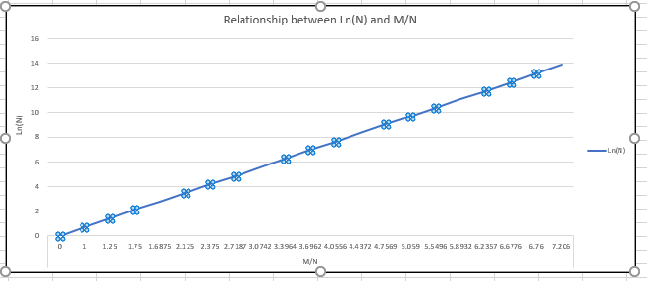

Below is the screenshot for the values:



As we can see from the above graph (i.e a straight line) ln(N)=slope*M/N;

where M=number of pairs generated, N=number of nodes to be connected;

Let's take any point on the line and find out the slope.

**PROOF:**

For M/N=3.6962, Log(N)=6.931

hence slope m=6.931/3.6962 = 1.875;

ln(N)=1.875*M/N

Hence M=1/1.875*N*ln(N)

i.e M=0.533*N*ln(N)

**Finally, M ~ 0.5 *N*ln(N) proved.**