Software Requirement Specification (SRS) and Design Document (SDD)

TIME TABLE MANAGEMENT SYSTEM

Submitted for fulfillment of award of

Bachelor of Technology

In

Computer Science & Engineering

By

Gaurav Chauhan
Megha Mishra

Rachit Gupta
Rashmi Arya

Under the Guidance of

Mr. Deepak Rai


AJAY KUMAR GARG ENGINEERING COLLEGE,

GHAZIABAD

YEAR: 2016-2017

GAURAV CHAUHAN MR. DEEPAK RAI

MEGHA MISHRA

RACHIT GUPTA

RASHMI ARYA

1

 | TABLE OF CONTENTS
1.0 Introduction |  | 4
1.1 | Purpose | 4
1.2 | Scope of Project | 4
2.0 Overall Description of the project
2.1 SRS |  | 5
2.1.1 | Functional Requirements | 5
2.1.2 | Non-functional Requirements | 6
2.2 Diagrams with detailed explanation |  | 8
2.2.1 | Database Schema Diagram | 8
2.2.2 | Use Case Diagram | 11
2.2.3 | Sequence Diagram | 12
2.2.4 | Zero level DFD | 14
2.2.5 | One level DFD | 15
3.0 Glossary |  | 17
4.0 References |  | 18
List of Figures |  | 3

2

List of Figures

Figure 2.2.1 - Database Schema Diagram | 8
Figure 2.2.2 - Use Case Diagram | 11
Figure 2.2.3.1 - Sequence Diagram for LOGIN | 12
Figure 2.2.3.2 - Sequence Diagram for FACULTY REGISTER | 13
Figure 2.2.4.1 – Zero Level DFD for ADMIN LOGIN | 14
Figure 2.2.4.2 – Zero Level DFD for FACULTY LOGIN | 14
Figure 2.2.4.1 – One Level DFD for ADMIN LOGIN | 15
Figure 2.2.4.1 – One Level DFD for FACULTY LOGIN | 16

3

- INTRODUCTION

- Purpose:

The objectives of the system are-
- To reduce paperwork involved in making the timetable.
- Reduced operational time.
- Increased accuracy and reliability.
- Increased operational efficiency.
- Data security.

This software package can be readily used by non-programming personal avoiding human handled chance of error.

Students can view the timetable of their class. The Administrator has the authority to upload the time table, edit the time table, manage the time table.

Faculty has the authority to see their respective time table and have to notify whether they are available in the class or not.

CR can notify the admin that the teacher is present in the class or not.

Application can be upgraded according to user’s and administrator’s requirements with little changes.

New features can be added as per requirements.

1.2 Scope:

This project has a large scope as it has the following features which help in making it easy to use, understand and modify it:

- Automation of Time table making and management procedure.
- No Need to do Paper Work.
- To save the environment by using paper free work.
- To increase the accuracy and efficiency of the Time table management procedure.
- Management of data of time table.

This software package can be readily used by non-programming personal avoiding human handled chance of error.

This project is used by two types of users –
- Students
- Faculty
- Admin
- Class Representative

4

2.0 Overall Description of the project

- SRS

  - Functional Requirements

1. STUDENTS

- Login- Students can login into the system by providing the user name and password. The login will take to next activity if username and password is correct otherwise error will be displayed.

- Documents- Once the student is logged in, what all activities he/she can perform includes:

- View Time Table: Students can view their time table according to the class given and they could see the cases they have.

- Check presence or absence of teacher: the admin can check if the teacher is present in the class or not by the notification that he will receive every day.

- Admin Login – the admin can also login and change the properties he wish to change and modify during their own login.

2. FACULTY

- Registration- The guest user needs to get registered for storing the records and getting them authenticated by the table management system. The registration is done by taking the username and password for the teacher. Once the teacher is registered, he/she can further move to login.

- Login- Once the teacher is registered, he/she can now login by providing username and password which is matched with the one already stored. If both matches, then the login is successful otherwise re login is required.

- Documents- Once the teacher is registered and logged in, what all activities he/she can perform includes:

- Teacher Time Table: Teachers can view their own timetable according to the day and the timings they have.

- They can mark the absent if not present in the class through the app and also if he is present. The notification will be reached to the admin he will otherwise substitute another teacher in that class.

5

3. ADMIN

- Registration- The guest user needs to get registered for storing the records and getting them authenticated by the table management system. The registration is done by taking the username and password for the teacher. Once the teacher is registered, he/she can further move to login.

- Login- Once the teacher is registered, he/she can now login by providing username

and password which is matched with the one already stored. If both matches, then the login is successful otherwise re login is required.

- Documents- Once the teacher is registered and logged in, what all activities he/she can perform includes:

- He will view the database and feed the timetable in database and do the modification if needed anytime.

- If there teacher is not present in the class the notification will be send to the admin he will apply all the substitution he has to perform to make teacher available to that class.

- Non-Functional Requirements:

1. Product Requirements

Usability Requirement

The system shall allow the users to access the table managements system from the app and he will be using the server provided by the admin to access the time table app. The system uses a web browser as an interface. Since all users are familiar with the general usage of browsers, no special training is required. The system is user friendly and online help makes using the system easy to view the timetable.

Availability Requirement

The system is available 100% for the user and is used 24 hrs a day and 365 days a year. The system shall be operational 24 hours a day and 7 days a week.

Efficiency Requirement

Mean Time to Repair (MTTR) - Even if the system fails, the system will be recovered back up within an hour or less.

6

Performance Requirement

The information is refreshed at regular intervals depending upon whether some update shave occurred or not. The system shall respond to the member in not less than two seconds from the time of the request submittal. The system shall be allowed to take more time when doing large processing jobs.

Responses to view information shall take no longer than 5 seconds to appear on the screen.

Reliability Requirement

The system has to be 100% reliable due to the importance of data and the damages that can because by incorrect or incomplete data. The system will run 7 days a week, 24 hours a day.

Maintainability and Portability Requirements

Changes (new patrons’ addition, password changes, database changes) must be verified once per day at least. The system should provide automatically notification to patrons by reservation results, availability of reserved item and etc .

2. Requirement Analysis:-

• HARDWARE REQUIRED:-

PROCESSOR: Intel/AMD processor

MAIN HARDWARE: SMART-PHONE

HARD DISK SPACE: 3-4 GB (minimum)

RAM: 4 GB & above

- SOFTWARE REQUIRED:-

OPERATING SYSTEM: WINDOWS 8/8.1/10

MAIN SOFTWARE: ADNROID VERSION LOLLIPOP

7

2.2 Diagrams with detailed explanation

2.2.1 Database Schema Diagram

A database schema is the skeleton structure that represents the logical view of the entire database. It defines how the data is organized and how the relations among them are associated. It formulates all the constraints that are to be applied on the data.

A database schema defines its entities and the relationship among them. It contains a descriptive detail of the database, which can be depicted by means of schema diagrams.

It’s the database designers who design the schema to help programmers understand the database and make it useful.

A database schema can be divided broadly into two categories −

- Physical Database Schema − This schema pertains to the actual storage of data and its form of storage like files, indices, etc. It defines how the data will be stored in a secondary storage.

- Logical Database Schema − This schema defines all the logical constraints that need to be applied on the data stored. It defines tables, views, and integrity constraints.

8

 |  | TEACHES
 |  | TEACHES |  |  |  | SECTION
SUBJECTS |  | tech_id |  |  |  | section_id
 |  | tech_id |  |  |  | section
 |  | faculty_id |  |  |  | section
subcode |  | faculty_id
subcode |  | subcode
subname |  | subcode
subname |  | section |  |  |  | SEMESTER
 |  | semester |  |  |  | semester
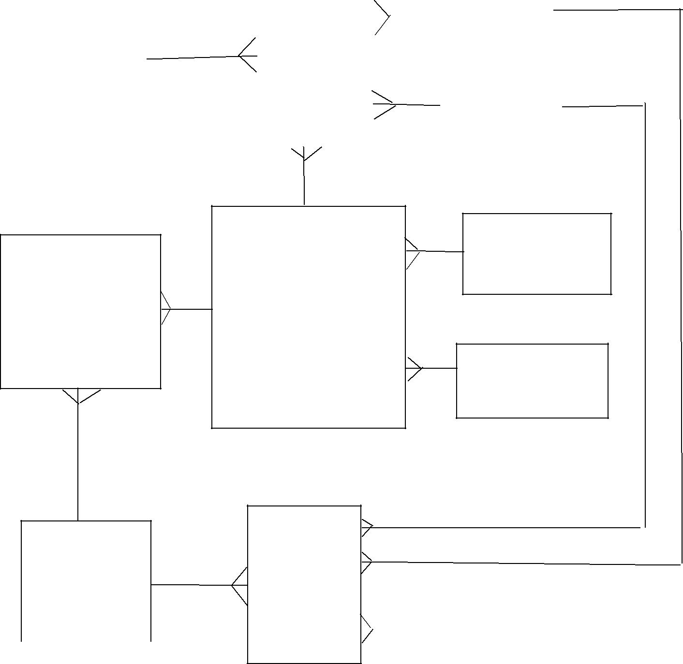

 | FACULTY_DETAILS | DEPARTMENT
AVAILABILITY | faculty_id | department_id
 | faculty_id | department
 | name | department
date | name
date | designation
lecture_id | designation
lecture_id | department
faculty_id | department
faculty_id | mobile
status | mobile
status | email | DESIGNATION
 | password | designation_id
 | user_type | designation
LECTURES | ASSIGN

lecture_id | day
lecture_id | lecture_id
Start
Start | semester
Start |  |  |  | DAY_OF_WEEK
end |  |  |  | DAY_OF_WEEK
end | section |  |  | DAY_OF_WEEK
 | section |  |  | id
 | faculty_id |  |  | id
 |  |  |  | day

Figure 2.2.1 Database Schema Diagram

9

2.2.2 Use Case diagram

Use case diagrams shows business use cases, actors, and the relationships between them. The relationships between actors and business use cases state that an actor can use a certain functionality of the business system.

It consists of actors, use case, Association, Relationship, Subject and much more. The following use case diagram consists of user and admin as actors.

The role of admin is to collect datasets, gathers sentimental value from the dataset and train dataset. The role of the user is to get sentimental value from the link, search a product, comparison between products and find sentimental value of the tending projects.

In this diagram Admin is responsible for creating, modifying, viewing and deleting time table. It also keeps track of the availability of the faculties for doing arrangements when some faculty is on leave or busy. Faculty can view time table class wise, lab wise or faculty wise and they have to mark their attendance in order to show their availability for attendance so that proper arrangements can be done.

10
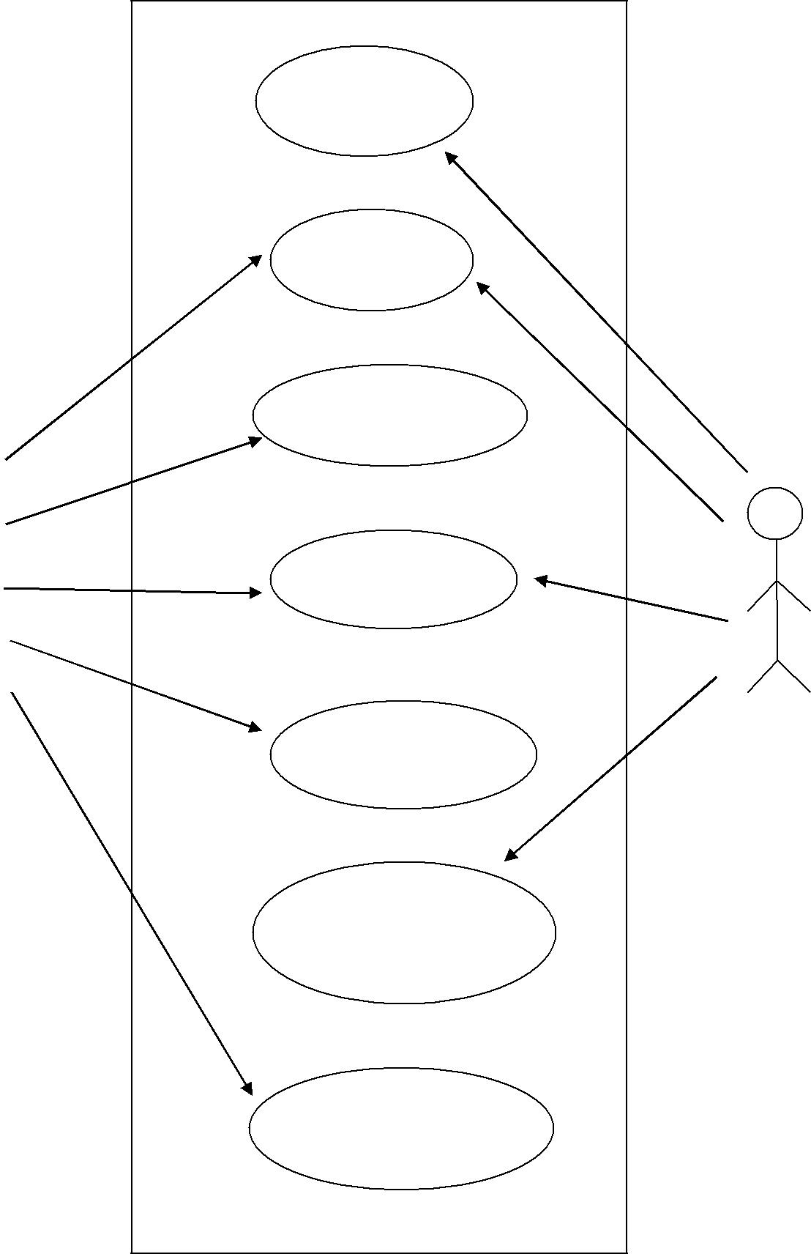

REGISTER

LOGIN

CREATE

TIME TABLE
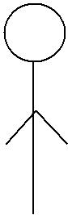

VIEW TIME
TABLE


FACULTY
ADMIN | MODIFY
TIME TABLE

UPDATE
AVAILABILITY
STATUS

CHECK

AVAILABILITY

Figure 2.2.2 Use Case Diagram

11

2.2.3 Sequence Diagram

A Sequence diagram is an interaction diagram that shows how objects operate with one another and in what order. It is a construct of a message sequence chart. A sequence diagram shows object interactions arranged in time sequence.
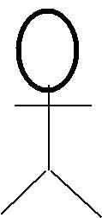

ADMIN/FACULTY |  | FRONT END |  | DATABASE
<<ACTOR>> |  | <<ENTITY>> |  | <<ENTITY>>
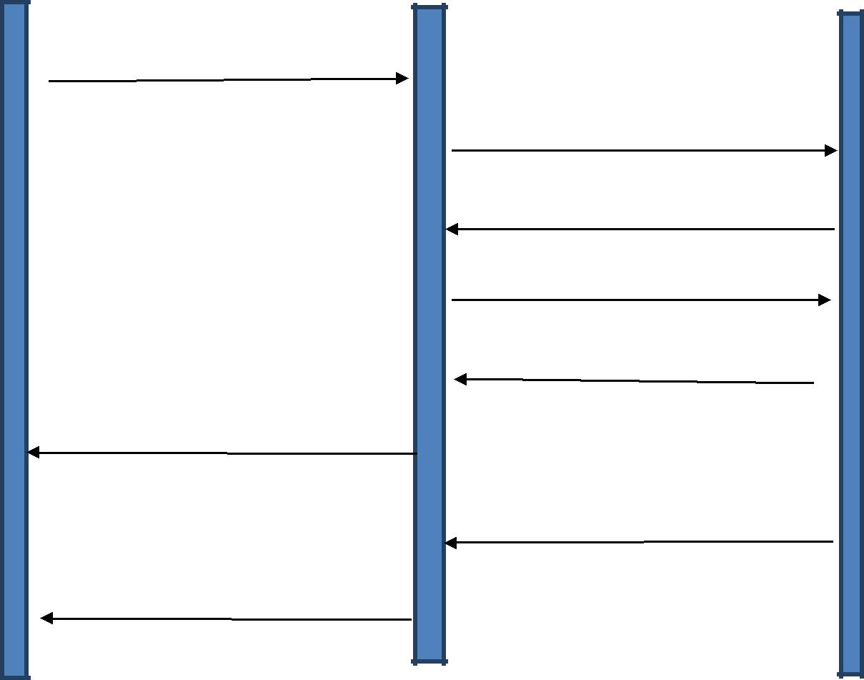

USERNAME/PASSWORD

CHECK VALIDATION

SUCCESSFUL VALIDATION

VERIFY USER

USER VERIFIED

OPEN DASHBOARD

UNSUCCESSFUL VALIDATION

ERROR MESSAGE

Figure 2.2.3.1 Sequence Diagram for LOGIN

12
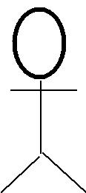

ADMIN |  | FRONT END |  | DATABASE
<<ACTOR> |  | <<ENTITY>> |  | <<ENTITY>>
>
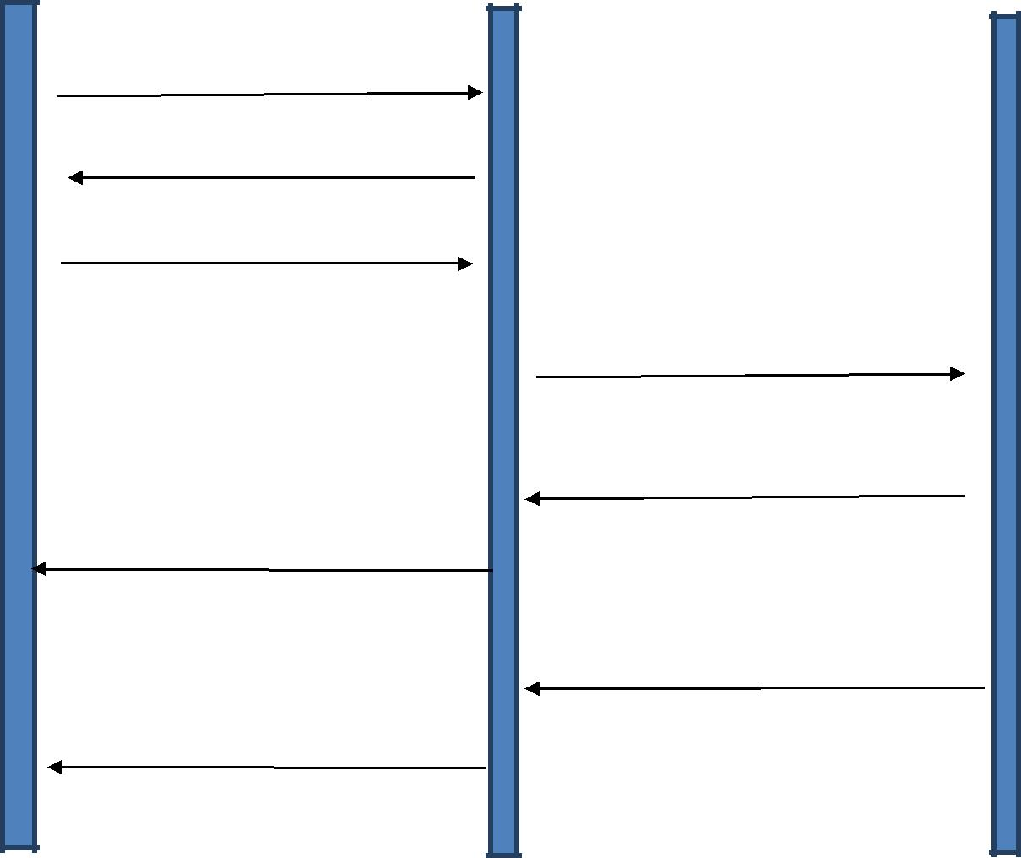

REQUEST ADD FUNCTION

DISPLAY ADD FUNCTION

INFORMATION FILLED

SENDS FIELDS

DATA VALIDATION

SUCCESSFUL

MESSAGE (DATA IS SAVED)

UNSUCCESSFUL

ERROR MESSAGE

Figure 2.2.3.2 Sequence Diagram for FACULTY REGISTRATION

13

2.2.4 Zero Level DFD:

A data flow diagram (DFD) illustrates how data is processed by a system in terms of inputs and outputs. As its name indicates its focus is on the flow of information, where data comes from, where it goes and how it gets stored.

The following diagram shows the process flow. Whenever the admin or faculty tries to access or modify system, it sends a request to the system which further verifies and authenticates the request and then allow it to access the database.
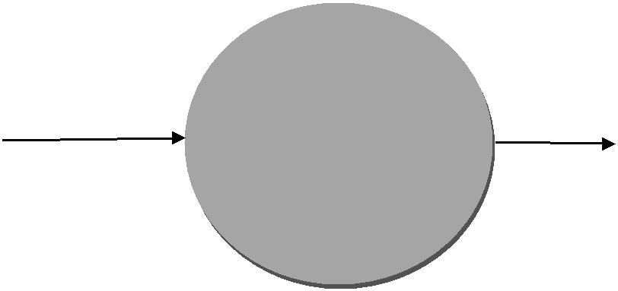

 |  |  | Admin panel
 | Admin | LOGIN | Admin panel
 |  | LOGIN | Dashboard

Figure 2.2.4.1 Zero Level DFD for Admin Login
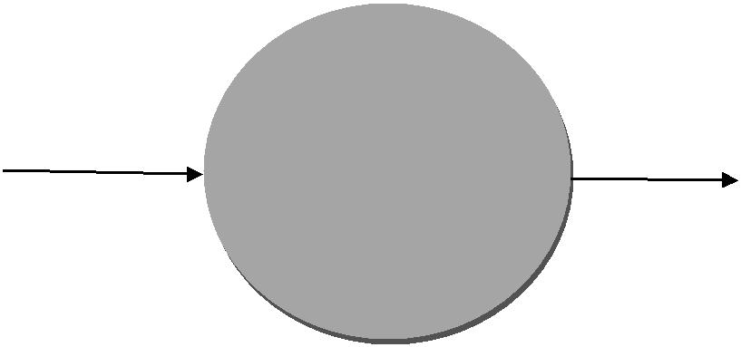

 |  |  | Faculty panel
 | Faculty | LOGIN | Faculty panel
 |  | LOGIN | Dashboard

Figure 2.2.4.2 Zero Level DFD for Faculty Login

14

2.2.5 One Level DFD:

The Level 1 DFD shows how the system is divided into sub-systems (processes), each of which deals with one or more of the data flows to or from an external agent, and which together provide all of the functionality of the system as a whole.

In this diagram, the oval-shaped components are the actors. The cylindrical shaped figure denotes database and the rectangular boxes are the functions that each actor performs. The arrows shows the direction in which the information flows from one end to the other.
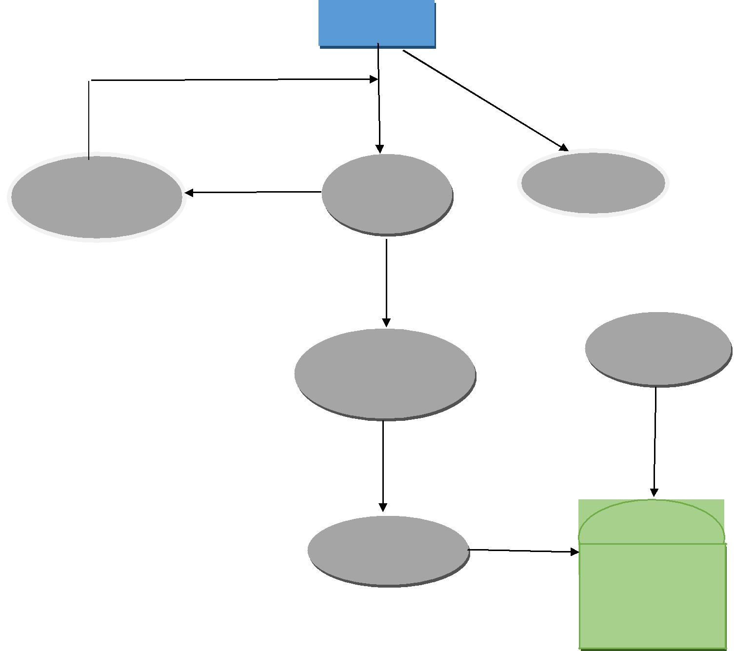

Faculty

Return to home page

Invalid
Display

Error

_{Login} Register

Valid

Faculty

Dashboard

Modules

Output

Database

Figure 2.2.5.1 One Level DFD for Faculty

15

Return to home page

Invalid
Display

Error

Admin
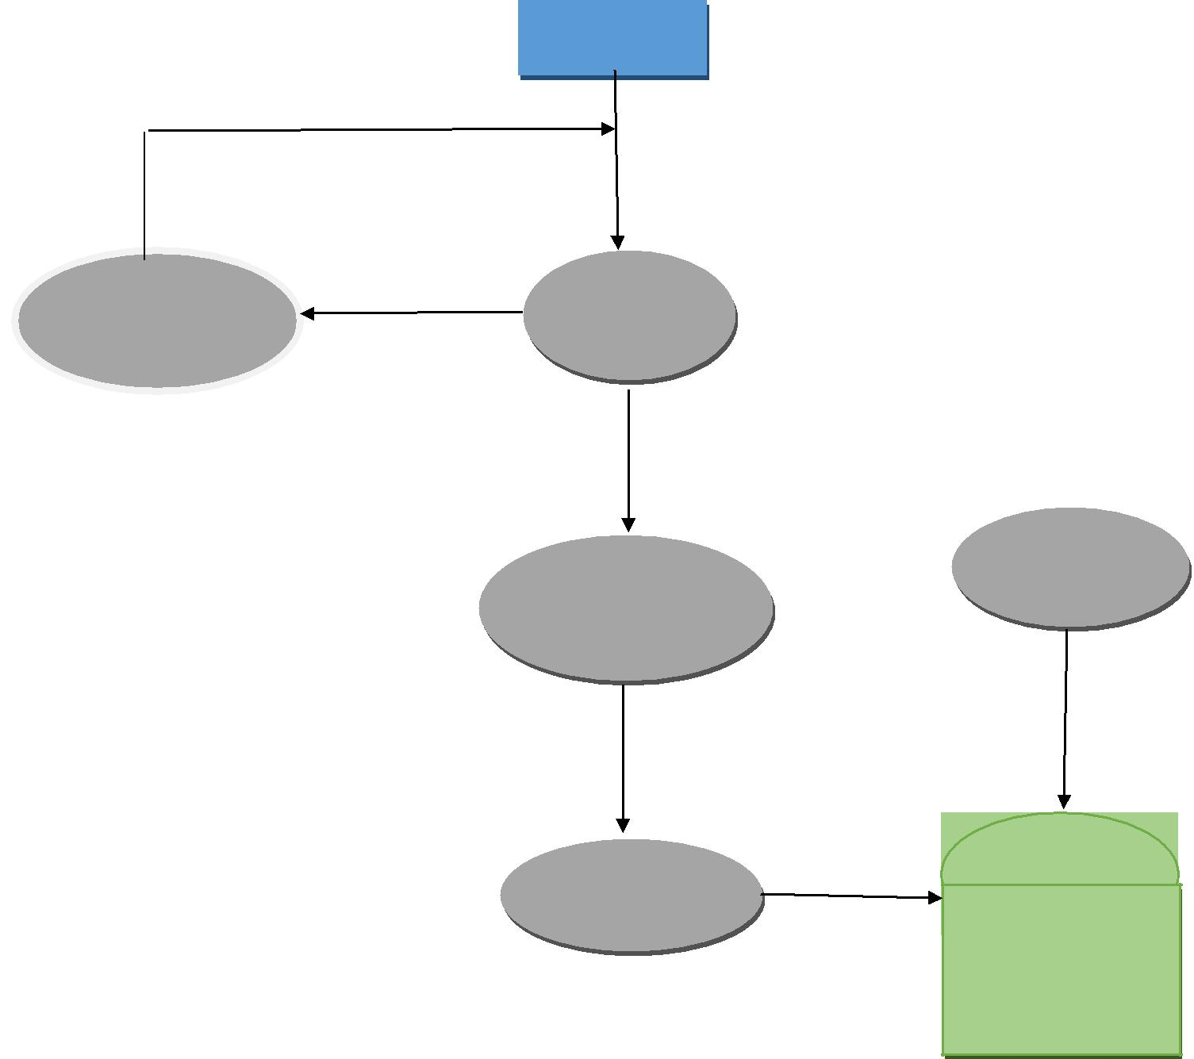

Login

Valid

Admin

Dashboard

Modules

Output

Database

Figure 2.2.5.2 One Level DFD for Admin

16

- Glossary

  - Activity diagram: An analysis model that shows a dynamic view of a system by depicting the flow from one activity to another. Similar to a flow chart.

  - Actor: A person, software system, or hardware device that interacts with a system to achieve a useful goal. Also called a user role.

  - Analysis requirements: The process of classifying requirements information into various categories, evaluating requirements for desirable qualities, representing requirements in different forms, deriving detailed requirements from high-level requirements, negotiating priorities, and so on.

  - Architecture: The structure of a software-containing system, including the software and hardware components that make up the system, the interfaces and relationships between those components, and the component behaviors that are visible to other components.

  - Assumption: A statement that is believed to be true in the absence of proof or definitive knowledge.

  - Class: A description of a set of objects having common properties and behaviors, which typically correspond to real-world items (persons, places, or things) in the business or problem domain.

  - Class diagram: An analysis model that shows a set of system or problem domain classes and their relationships.

  - Constraint: A restriction that is imposed on the choices available to the developer for the design and construction of a product.

  - Data flow diagram: An analysis model that depicts the processes, data collections, and flows among them that characterize the behavior of a business process or of a software system.

  - Dependency: A reliance that a project has on an external factor, event, or group outside its control.

  - Entity: An item in the business domain about which data will be collected and stored.

  - Entity-relationship diagram: An analysis model that identifies the logical relationships between pairs of entities.

  - Flowchart: An analysis model that shows the processing steps and decision points in the logic of a process or of a program.

17

- References

  - www.github.com
  - www.stackoverflow.com
  - https://developer.android.com
  - www.quora.com

  - android app webkiosk

18

