**JAYPEE INSTITUTE OF INFORMATION TECHNOLOGY, NOIDA**

Department of CSE & IT



**Project Report**

Algorithm and Problem Solving

**Military Defense System**

**Submitted To: Submitted By:**

Ms.Indu Chawla Mansi Agarwal – 17103042

Rohan Jain – 17103056

Parth Agarwal – 17103060

Rajat Kr. Garg – 17103062

(B-10)

**INTRODUCTION**

Our project introduce algorithmic analysis and solutions to the various problems of the military (wartime and day-to-day). We try to solve the problems relating to war strategies, day-to-day resource/ammo allocation, troop development, communication, cryptography, warship deployment, missile interception systems, aircraft/warships collision detection systems, border defense etc.

**ALGORITHMS**

* Dijkstra’s
* MST algorithms
* Backtracking
* String algorithms
* Knuth Morris Pratt
* Huffman Coding
* Rabin Karp Algorithm
* Finite automata matcher
* Cryptography Algorithms
* Job scheduling Algorithms

**APPROACH**

* Greedy approach
* Divide & Conquer approach
* Dynamic Programming

**OUTPUTS**

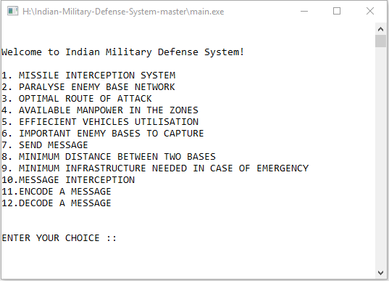

Menu

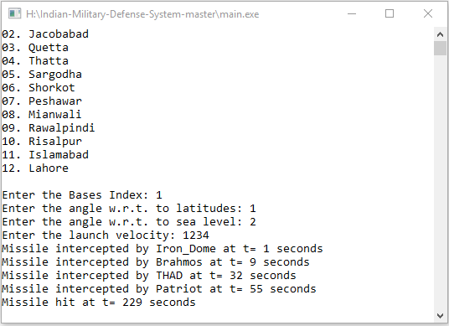

Missile Interception System

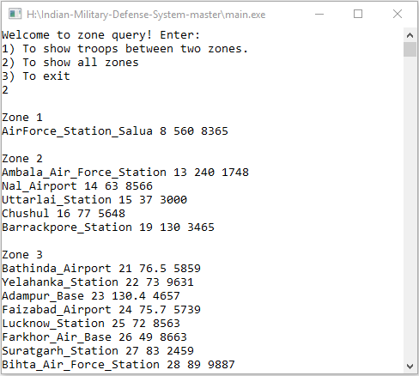

Zone Queries

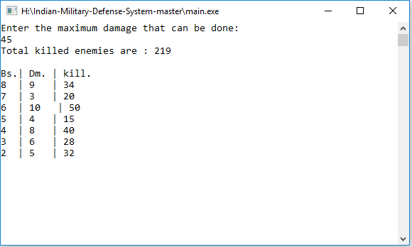

Important Enemy bases to capture

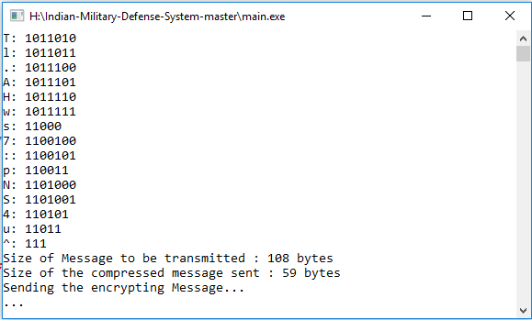

Message Encoding…

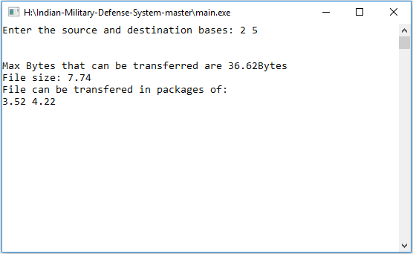

Message sending in packages

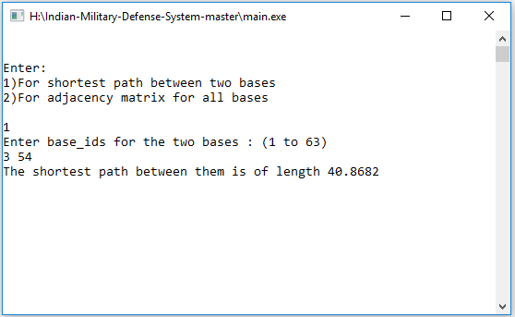

Distance Between two Bases